Assignment
Name: Natasha Khan STUDENT ID:15981

Course Title: Human Physiology Instructor: Dr Sara Naeem Total Marks: 80
Questions:
- Take any viral disease as an example. How will you classify different types of immunity keeping your example in mind.

- Explain any medical condition of lymph nodes. Give a lab test report as well if needed.

- Give different types of ECG’s for heart diseases.

- Give different medical ways of management of kidney stones.

QUESTION#1:
Take any viral disease as an example. How will you classify different immunity keeping your example in mind.
ANSWER:
VIRAL DISEASE:
Taking corona viral disease as an example.
Types of immunity:
- Innate immunity
- Acquired immunity
Acquired immunity further classified into two types:
Natural:
- Passive(maternal)
- Active(infection)
Artificial:
- Passive( antibody transfer)
- Active( immunity)

QUESTION#2:
Explain any medical condition of lymph nodes. Give a lab test report as well if needed.
ANSWER:
Hodgkin lymphoma:
It is curable lymphoma.
Classification:
- Nodular sclerosis
- Mixed cellularity
- Lymphocyte-depleted sub type
- Lymphocyte-rich sub type
- Nodular lymphocyte predominant type
Signs and symptoms:
- Drenching night sweats
- Extreme high fever
- Extreme weight loss with in over 6 months.
Lab test:
- CBL
- Low red blood cell count( anemic)
- Lymphoma ( low white blood cells count)
- Excess neutrophil
- eosinophils
- Raised ESR
- Raised EDH
- Excisional lymph node biopsy

QUESTION#3:
Give different type of ECG’s for heart diseases.
ANSWER:

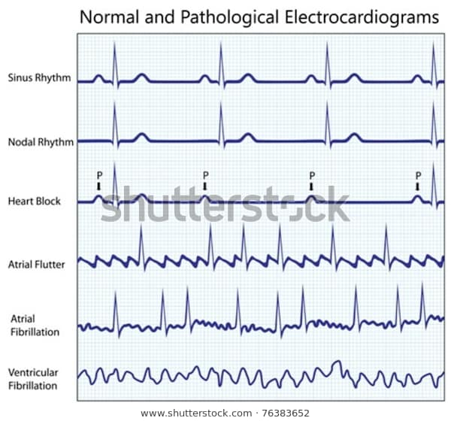

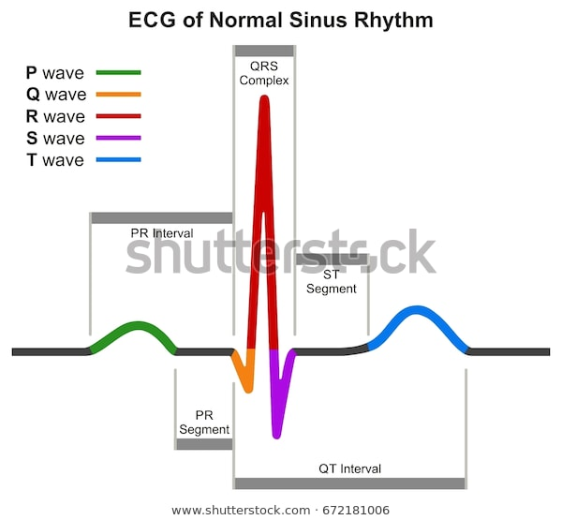

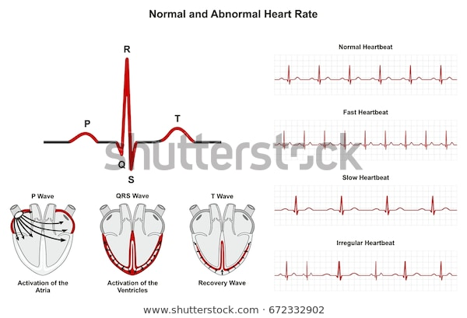

QUESION#4:
Give different ways of management of kidney stones.
ANSWER:
MANAGEMENT OF KIDNEY STONES:
Small stones with minimal symptoms:
Most small kidney stones wont require invasive treatment. You may be able to pass a small stone by:
- Drinking water:
Drinking as much as 2-3 quarts a day will keep you urine dilute and may prevent stones from forming.

- Pain relievers:
Passing a small stone can cause some discomfort for which doctors prescribe few pain relievers.
- Medical therapy:
The doctor gives a type of medication that is known as alpha blocker, relaxes the muscle in your ureter,helping you pass the kidney stone more quickly vand with less pain.

LARGE STONE AND SYMPTOMS:
Kidney stones that are too big pass on their own or cause bleeding,kidney damage or ongoing urinary tract infections may require non-extensive treatment.
Using sound waves to breakup stones:
Certain kidney stones depending on size and location your doctor may recommend a procedure called extracorporeal shock wave lithotripsy ( ESWL)
These sound waves creates strong vibrations that breaks the stones into tiny pieces that can be passed in your urine. This procedure lasts about 40-60 mins and can cause moderate pain.

