NAME : ZARAK SALEEM GUL
ID :16264
PROGRAM:DISCRETE STRUCTURES
DEPT :SOFTWARE ENGINEERING
SECTION:A

Question 1:
(a):
Biconditional

• The biconditional of p and q is “p if, and only if, q”
• Denoted by p ↔ q
• " ↔" is the biconditional operator
• Biconditional statement is true if both p and q have the same truth values and false if p and q have opposite truth values
• “If and only if” is abbreviated as if
Examples:
1. “1+1 = 3 if and only if earth is flat” True
2. “Sky is blue iff 1 = 0” False
3. “Milk is white iff birds lay eggs” True
4. “33 is divisible by 4 if and only if horse has four legs” False
5. “x > 5 iff x2 > 25”
(b)
1: | p↔q
2: | r↔~p
3: | (r↔q)˄(~p)
4: | r˄p˄q

QUESTION : 2
ANSWER :
- q↔p | - It is sunny if and only if it is hot today
- p↔(q˄r) | - It is hot today iff it is sunny and it is raining
- p↔(q˅r) | - It is hot today iff it is sunny or it is raining
- r↔(p˅q) | - It is raining iff it is hot today or it is sunny

Question 3
Explain Argument with proper examples. Differentiate Valid and Invalid argument through proper examples, also construct a truth table showing valid and invalid arguments. (Note: Examples and truth table should not belongs to your book or slides)
Answer:
Argument
Argument is a list of statements (premises or assumptions or hypotheses) followed by a statement (conclusion)
P1 Premise
P2 Premise
. . . . .. . . . .
Pn Premise
______
∴ C Conclusion

For example, given the premises:
• "if it is cloudy outside, then it will rain"
• "it is cloudy outside"
a conclusion might be "it will rain". Intuitively, this seems valid.

Or

An argument is a sequence of statements. All statements except the final one are called premises (or assumptions or hypotheses). The final statement is called the conclusion.
• An argument is considered valid if from the truth of all premises, the conclusion must also be true. • The conclusion is said to be inferred or deduced from the truth of the premises Arguments
• Test to determine the validity of the argument:
– Identify the premises and conclusion of the argument
– Construct the truth table for all premises and the conclusion
– Find critical rows in which all the premises are true
– If the conclusion is true in all critical rows then the argument is valid, otherwise it is invalid
• Example of valid argument form:
– Premises: p ∨ (q ∨ r) and ~r, conclusion: p ∨ q • Example of invalid argument form: – Premises: p → q ∨ ~r and q → p ∧ r, conclusion: p → r

Differentiate Valid and Invalid argument

Valid & Invalid Argument
• Argument is valid if the conclusion is true when all the premises are true or if conjunction of its premises imply conclusion.
(P1∧ P2 ∧ P3 ∧ . . . ∧ Pn) → C is a tautology.
• Argument is invalid if the conclusion is false when all the premises are true or if conjunction of its premises does not imply conclusion.
(P1∧ P2 ∧ P3 ∧ . . . ∧ Pn) → C is a Contradiction.
• A valid argument may have:
• true premises and a true conclusion
• or false premises and a false conclusion
• or false premises and a true conclusion
• but it cannot have all true premises and yet a false conclusion
• Arguments may either valid or invalid; and statements may either true or false
Or
Valid: an argument is valid if and only if it is necessary that if all of the premises are true, then the conclusion is true; if all the premises are true, then the conclusion must be true; it is impossible that all the premises are true and the conclusion is false.
Invalid: an argument that is not valid. We can test for invalidity by assuming that all the premises are true and seeing whether it is still possible for the conclusion to be false. If this is possible, the argument is invalid.
Valid and Invalid Examples:
#1
Anyone who lives in the city Honolulu, HI also lives on the island of Oahu.
Kanoe lives on the island of Oahu.
Therefore, Kanoe lives in the city Honolulu, HI.

#2
Anyone who lives in the city Honolulu, HI also lives on the island of Oahu.
Kanoe does not live on the island of Oahu.
Therefore, Kanoe does not live in the city Honolulu, HI.

#3
Anyone who lives in the city Honolulu, HI also lives on the island of Oahu.
Kanoe does not live in the city Honolulu, HI.
Therefore, Kanoe does not live on the island of Oahu.

#5 #6
All crows are black. Only crows are black.
John is black. John is black.
Therefore, John is a crow. Therefore, John is a crow.
Answers:
#1 Invalid
#2 Valid
#3 Invalid
#4 Valid
#5 Invalid
#6 Valid
truth table showing valid and invalid arguments
Premises:
P-> q : if my computer crashes, I will lose all my photos.
~ q : I haven’t lost all my photos.
Conclusion:
~p : My computer hasn’t crashed.
Argument:
[ ( p -> q ) ˄ ~q ] -> ~P

P q ~P ~q p -> q [ ( p -> q ) ˄ ~q ] [ ( p -> q ) ˄ ~q ] -> ~P
T T F F T F T
T F F T F F T
F T T F T F T
F F T T T T T

Question 4
a)
Concept of union:
A union is a special data type available in C that allows to store different data types in the same memory location. You can define a union with many members, but only one member can contain a value at any given time. Unions provide an efficient way of using the same memory location for multiple-purpose.
Explanation:
A truth table is a handy little logical device that shows up not only in mathematics but also in Computer Science and Philosophy, making it an awesome interdisciplinary tool. The notation may vary depending on what discipline you’re working in, but the basic concepts are the same.

Unary Operators:
Unary operators are the simplest operations because they can be applied to a single True or False value.

Identity:
The identity is our trivial case. It states that True is True and False is False.

Negation:
The negation operator is commonly represented by a tilde (~) symbol. It negates, or switches, something’s truth value.
We can show this relationship in a truth table. A truth table is a way of organizing information to list out all possible scenarios. We title the first column p for proposition. In the second column we apply the operator to p, in this case it’s ~p (read: not p). So as you can see if our premise begins as True and we negate it, we obtain False, and vice versa.

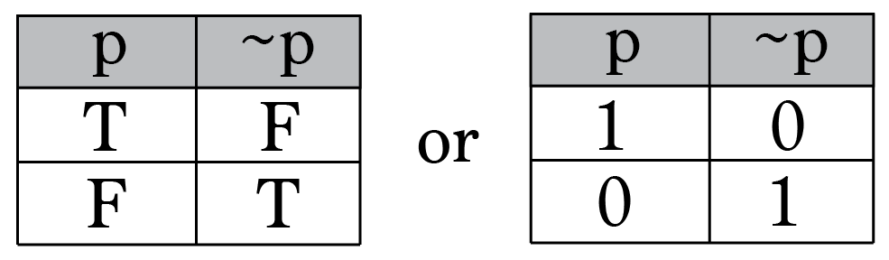

Table for union:
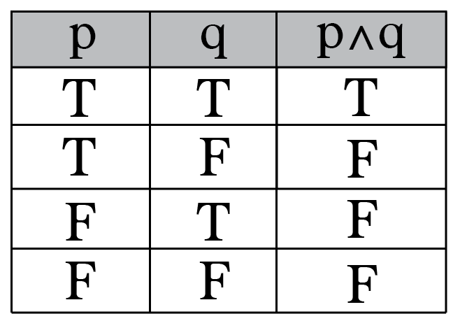
The AND operator (symbolically: ∧) also known as logical conjunction requires both p and q to be True for the result to be True. All other cases result in False. This is logically the same as the intersection of two sets in a Venn diagram.

b)
Concept of intersection:
An intersection is a point where two lines or streets cross. There are two places you're most likely to find intersections in math class and in traffic. In math, an intersection is the spot where two lines cross.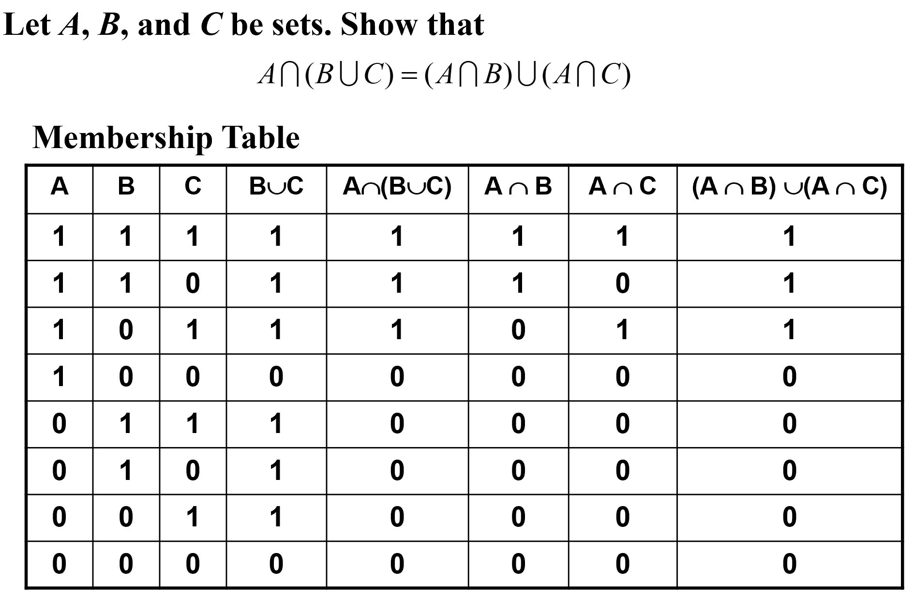

Question 5
a)
Venn diagram:
A Venndiagram is an illustration that uses circles to show the relationships among things or finite groups of things. Circles that overlap have a commonality while circles that do not overlap do not share those traits. Venndiagrams help to visually represent the similarities and differences between two concepts.
Example:
A number of computer users are surveyed to find out if
they have a printer, modem or scanner. Draw separate Venn
diagrams and shade the areas, which represent the following
configurations.
(i) modem and printer but no scanner
(ii) scanner but no printer and no modem
(iii) scanner or printer but no modem.
(iv) no modem and no printer.
Solution: Let P, M, and S represent the set of computer users having
printer, and scanner respectively as shown below:
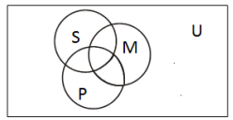

Venn Diagram:
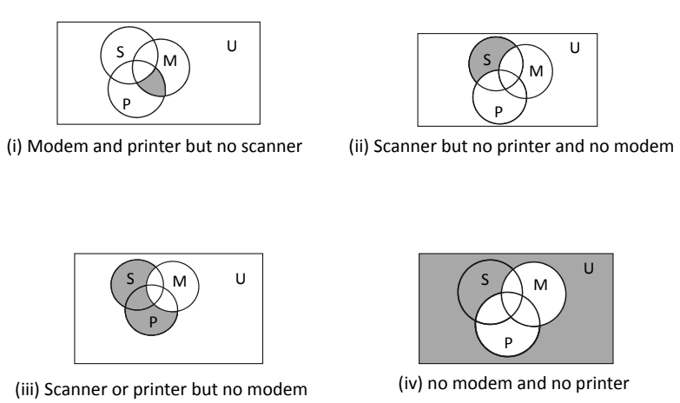

b)
Given the set P is the set of even numbers between 15 and 25. Draw and label a Venn diagram to represent the set P and indicate all the elements of set P in the Venn diagram.
Solution:
List out the elements of P.
P = {16, 18, 20, 22, 24} ← ‘between’ does not include 15 and 25
Draw a circle or oval. Label it P . Put the elements in P.
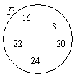

c)
Draw and label a Venn diagram to represent the set
R = {Monday, Tuesday, Wednesday}.
Solution:
Draw a circle or oval. Label it R . Put the elements in R.
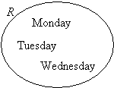

d)
Given the set Q = {x : 2x – 3 < 11, x is a positive integer }. Draw and label a Venn diagram to represent the set Q.
Solution:
Since an equation is given, we need to first solve for x.
2x – 3 < 11 ⇒ 2x < 14 ⇒ x < 7
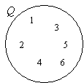
So, Q = {1, 2, 3, 4, 5, 6}
Draw a circle or oval. Label it Q .
Put the elements in Q.

