Subject: Human Anatomy II .
Instructor: Dr. Arooba.
Class: Dental Technology, 2nd semester
Section: B
MidTerm Assignment, Spring 2020. Total marks: 30.
Name = Aisha bibi
Id= 16906
Select the best option.

1. A muscle known for tailor master:
A. Iliacus
B. Psoas major
C. Sartorius (√)
D. Pectineus

2. Which of the quadricep femoris muscles performs extension as well as flexion?
A. Vastus lateralis
B. Vastus medialis
C. Vastus intermedias
D. Rectus femoris (√)

3. Which of the following muscles crosses two joints?
A. Vastus lateralis
B. Vastus medialis
C. Vastus intermedius
D. Rectus femoris (√)
4. It is the largest and longest bone of the body:
A. Hip bone
B. Femur (√)
C. Vertebra
D. Tibia

5. It is the union of three bones:
A. Sternum
B. Femur
C. Hip bone (√)
D. Tibia
6. The true foot drop occurs because of:
A. Sciatic nerve (√)
B. Common peroneal nerve
C. Tibial nerve
D. Posterior cutaneous nerve
7. Peripheral hearts are located in:
A. Thorax
B. Abdomen
C. Thigh
D. Leg (√)
8. Which of the following structure does not take part in the formation of the knee joint?
A. Condyle of tibia
B. Head of fibula (√)
C. Medial femoral condyle
D. Lateral femoral condyle
9. It is inserted to the quadrate tubercle:
A. Quadriceps femoris (√)
B. Quadratus plantae
C. Quadratus femoris
D. Rectus femoris
10. How many tarsal bones are there?
A. 12
B. 14 (√)
C. 16
D. 18

Give brief answers to the following questions. Add diagrams/ picture where needed.
Each question carries 5 marks.

1. GIVE REASONS:
a) Why hip joint is more stable than shoulder joint?
Ans: This is because the socket is deeper and the ligaments and muscles much bigger and stronger. As a result we can't get the same range of movement from our hips as from our shoulders but in return the hip is more stable and much less likely to dislocate than the shoulder
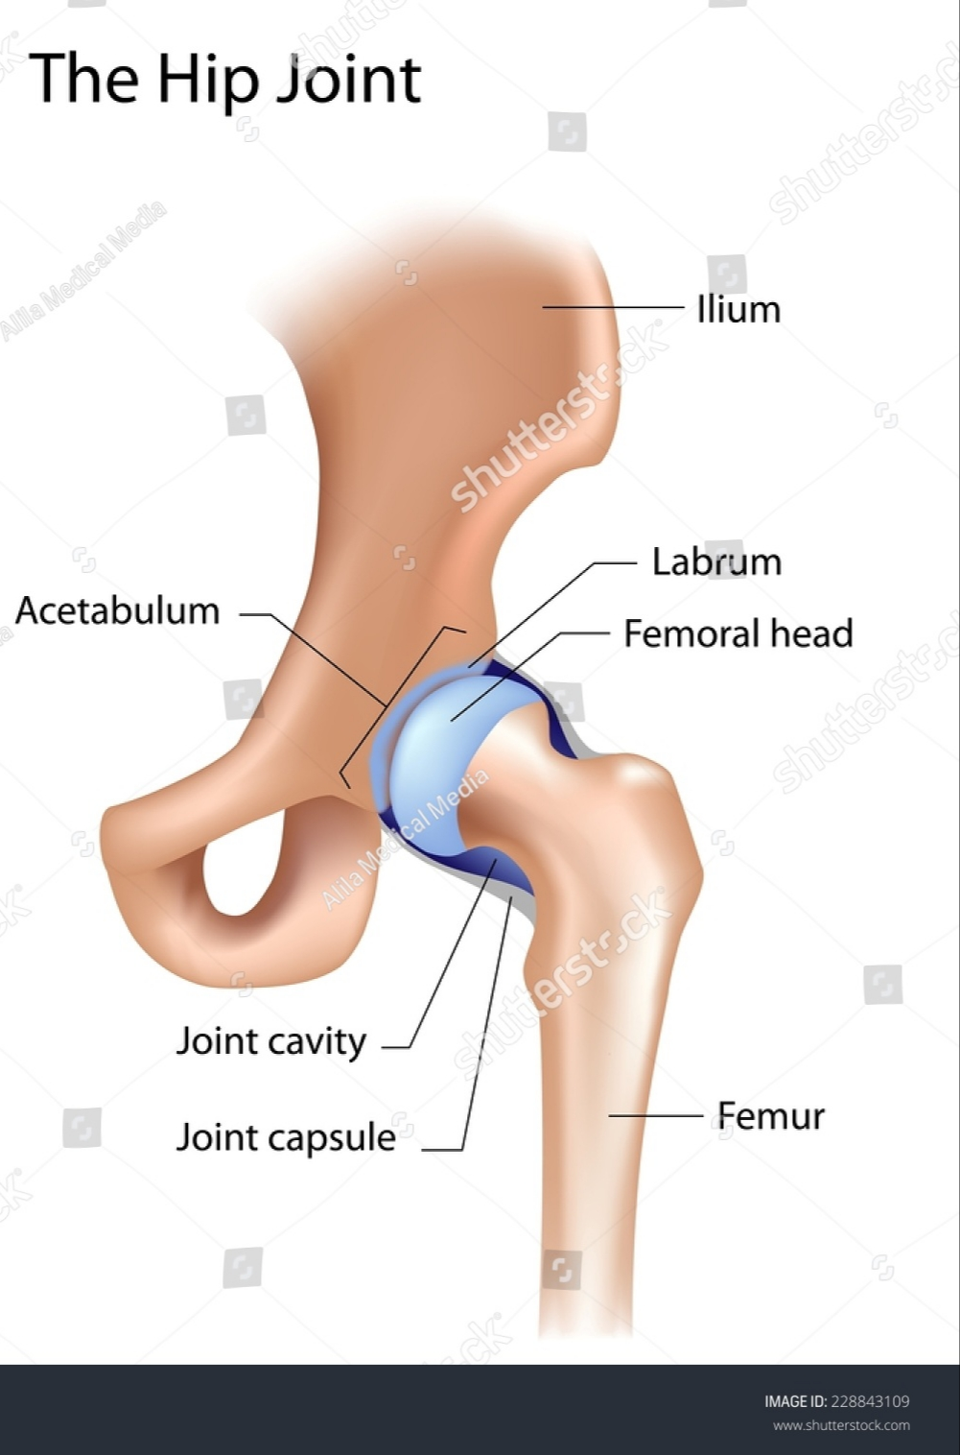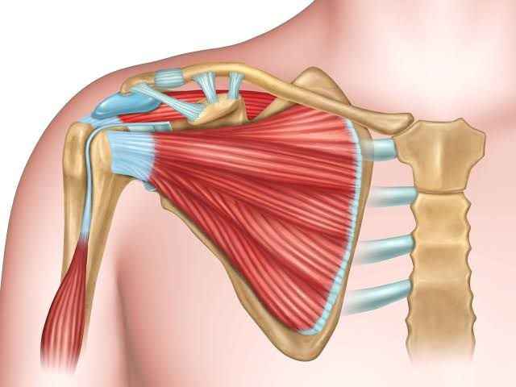
b) Why flexor compartment of lower limb is directed posteriorly?
Ans: In the lower part of the leg the muscle belly combine with the soleus to form the calcaneal tendon with insert on the calcaneus.

c) Why varicose veins are more common in prolonged standing working persons?
Ans: Prolonged standing can cause veins to overwork and blood may pool in the leg veins, increasing pressure in those veins, causing the valves to become weak and inefficient leading to varicose veins. ... Prolonged sitting also causes blood to pool in the legs, which increases vein pressure and may lead to varicose veins
2. What do you know about the ligaments of hip joint?
Ans: Ligament of hip joint:
The hip joint consists of an articulation between the head of femur and acetabulum of the pelvis.
Ligaments:
The ligaments of the hip joint act to increase stability. They can be divided into two groups – intracapsular and extracapsular:
Intracapsular: The only intracapsular ligament is the ligament of head of femur. It is a relatively small structure, which runs from the acetabular fossa to the fovea of the femur.
It encloses a branch of the obturator artery (artery to head of femur), a minor source of arterial supply to the hip joint.
Extracapsular: There are three main extracapsular ligaments, continuous with the outer surface of the hip joint capsule:
* Iliofemoral ligament – arises from the anterior inferior iliac spine and then bifurcates before inserting into the intertrochanteric line of the femur.
* It has a ‘Y’ shaped appearance, and prevents hyperextension of the hip joint. It is the strongest of the three ligaments.
* Pubofemoral – spans between the superior pubic rami and the intertrochanteric line of the femur, reinforcing the capsule anteriorly and inferiorly.
* It has a triangular shape, and prevents excessive abduction and extension.
* Ischiofemoral– spans between the body of the ischium and the greater trochanter of the femur, reinforcing the capsule posteriorly.
* It has a spiral orientation, and prevents hyperextension and holds the femoral head in the acetabulum.
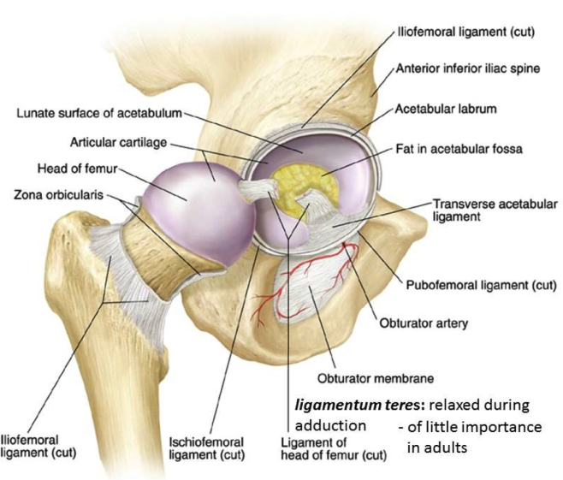

3. Write a note on the movements and stability of talocrural joint.
Ans: Movement: The ankle joint is a hinge type joint, with movement permitted in one plane.
Thus, plantarflexion and dorsiflexion are the main movements that occur at the ankle joint. Eversion and inversion are produced at the other joints of the foot, such as the subtalar joint.
•Plantarflexion – produced by the muscles in the posterior compartment of the leg (gastrocnemius, soleus, plantaris and posterior tibialis).
•Dorsiflexion – produced by the muscles in the anterior compartment of the leg (tibialis anterior, extensor hallucis longus and extensor digitorum longus).

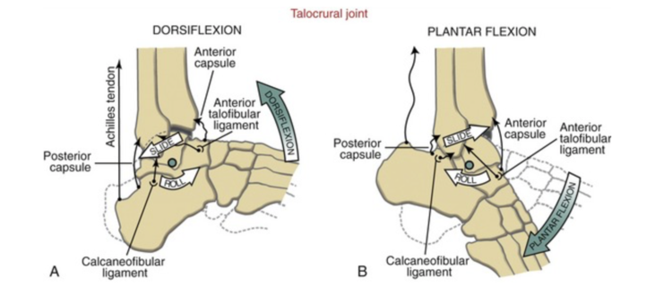

Stability: The bony architecture of the talocrular joint is most stable in dorsiflexion. Thus, a sprained ankle is more likely to occur when the ankle is plantar-flexed, as ligamentous support is more important in this position. ... Another ligament that can be injured in a severe ankle sprain is the calcaneofibular ligament.
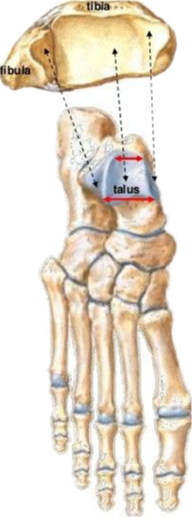
4. Write a note on the transverse arch of the foot.
Ans: At the posterior part of the metatarsus and the anterior part of the tarsus the arches are complete, but in the middle of the tarsus they present more the characters of half-domes the concavities of which are directed downward and medialward, so that when the medial borders of the feet are placed in apposition a complete tarsal dome is formed.
The transverse arches are strengthened by the interosseous, plantar, and dorsal ligaments, by the short muscles of the first and fifth toes (especially the transverse head of the Adductor hallucis), and by the Peroneus longus, whose tendon stretches across between the piers of the arches.
