Final-Term Assignment

Course Title: Human Physiology II
Rad 2nd semester section A
Instructor: Dr. M .Shahzeb khan (PT)
Marks: 50
NAME: KINZA BASHIR
I.D: 15925
Note:
- Attempt all questions, all questions carry equal marks.
- Answer Briefly and to the point, avoid un-necessary details

Q1: (A) How stimulus of smell moves from nostril to brain? Make a Diagram as well.
ANSWER
SENSE OF SMELL:
- Sense of smell called Olfaction.
- The organ that is responsible for the sense of smell in the nose.
- The cavity of the nose is lined with mucous membranes.
- These mucous membranes have smell receptors connected to the olfactory nerve.
- The smells themselves consist of vapours of various substances.
- The sense of smell might get temporarily lost when a person has a cold.
PHYSIOLOGY OF SMELL:
- The sense of smell is a chemical sense.
- They are called chemical senses because they detect chemicals in the environment,
- The floating vaporized odour molecules in the air reach the nostrils and dissolve in the mucous.
- The mucous is on the roof of each nostril.
- Underneath the mucous, in the olfactory epithelium, specialized receptor cells called olfactory receptor neurons are present.
- These are responsible for detecting the odour.
- These neurons are capable of detecting thousands of different odours.
- The olfactory receptor neurons transmit the information to the olfactory bulbs, which are located at the back of the nose.
- The sensations are carried from the olfactory bulbs through olfactory tract to olfactory area in the temporal lobe of cerebral cortex.
- These brain centres then perceive odours.
- The brain centres in response also access memories to remind us about places, people and events that are associated with that smell.

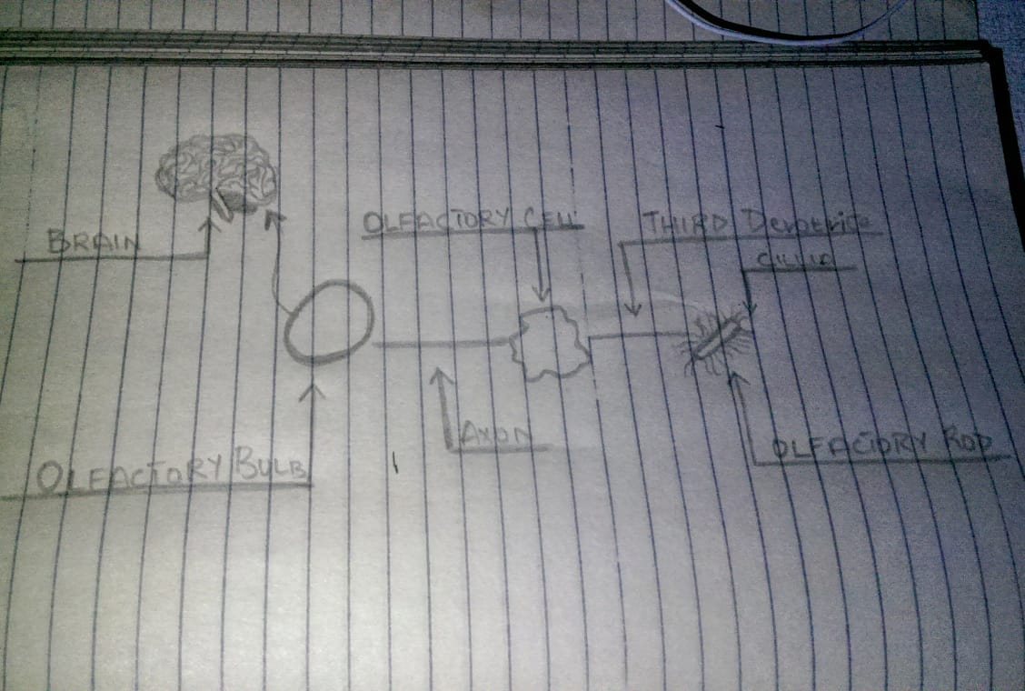

Q 2: (A) What iS the difference between Haemostasis, Haematopoiesis and Homeostasis.
ANSWER
HAEMOSTASIS:
Haemostasis is defined as arrest or stoppage of bleeding.
Stages of Haemostasis:
It occurs in three stages.
- Vasoconstriction
- Platelet plug formation
- Coagulation of blood.
HAEMATOPOIESIS:
It is the process of formation of blood cells i.e. RBC’S, WBC’S and platelets.
The sites where it occurs are known as hemopoietic tissues or organs that includes bone marrow, liver, spleen.
HEMATOPOIETIC STEM CELLS:
- Cells responsible to do the function of hemopoiesis are first seen in the yolk sac of embryo in the third week of embryonic development.
- These cells are called hematopoietic stem cells.

HOMEOSTASIS:
Homeostasis is the state of steady internal, physical, and chemical conditions maintained by living systems.
Homeostasis is the ability to maintain a relatively stable internal state that persists despite changes in the world outside.
All living organisms must regulate their internal environment to process energy and ultimately survive.
DIFFERENCE:
The difference between Haemostasis, Haematopoiesis and Homeostasis is that:
- Haemostasis is stopping of the blood flow in animals.
- Whereas the process of haematopoiesis is the production of human blood cells, regulation and maintenance.
- And Homeostasis is the balance between cellular growth and death, including human blood cells.

(B) What is Erythroblastosis fetalis?
ANSWER
ERYTHROBLASTOSIS FETALIS:
- Erythroblastosis fetalis is a disease common in a fetus and new-born child.
- It is characterized by agglutination and phagocytosis of the fetus’s red blood cells.
CAUSE OF THE DISEASE:
- In most cases, the mother is Rh-negative and the father Rh-positive.
- The baby inherits the Rh-positive antigen from the father, and the mother develops anti-Rh agglutinins from exposure because of Rh-antigen present in the baby.
- In turn, the agglutinins of the mother diffuse through the placenta into the fetus that would cause red blood cell agglutination.
SIGN AND SYMPTOMS:
Symptoms and signs in the fetus due to Erythroblastosis fetalis are :
- Enlarged liver spleen, or heart.
- Fluid build-up in the abdomen of the fetus.
Symptoms and signs in the newborn:
- Anaemia that creates the newborn baby appears to be pale in color.
- Causes yellow discolouration of the skin of a newborn baby.
- Enlargement of the liver and spleen.
- Severe oedema of the body.
- Difficulty breathing.

Q3: (A) What is Immunity? Explain different types of immunity.
ANSWER
IMMUNITY:
- Immunity is the ability of the body to protect against all types of foreign bodies which enter the body.
Foreign bodies include bacteria, virus, toxic substances etc.
- Immunity is done by the immune system which is a complex network of lymphoid organs such as bone marrow, thymus, spleen etc.

DISEASE RESISTANCE
- As it protects us from diseases it is also called disease resistance.
SUSCEPTIBILITY
- Lack of immunity is known as susceptibility.
TYPES OF IMMUNITIES:
- Human immunity is divided into two types:
- Innate immunity
- Acquired immunity
INNATE IMMUNITY:
- It’s a natural resistance that a person is born with.
- It is genetically inherited.
- It is also called natural or native immunity.
- It consists of mechanisms that exist before infection and is capable of rapid responses to microbes.
- It acts as the first line of defence against infections, microorganisms, their products before they cause disease.
TYPES OF INNATE IMMUNITY:
Innate immunity has three types
1) Species Immunity
2) Racial Immunity
3) Individual Immunity.
ACQUIRED IMMUNITY:
- Acquired or adaptive immunity is the immunity that is developed by the host in its body after exposure to suitable antigen.
- Also after the transfer of antibodies or lymphocyte from an immune donor.
TYPES OF ACQUIRED IMMUNITY
- Acquired Immunity is of two types which are :
- Active immunity
- Passive immunity

(B) What is difference between Antigen and Antibody?
Answer
DIFFERENCE BETEEWN ANTIBODY AND ANTIGEN:
- Antibodies are proteins that defend the body against pathogens by binding to antigens on the surface of these pathogens and stimulating their destruction.
- Antigens are foreign substances which stimulate the production of antibodies.
- Antibodies usually only bind to one specific antigen.
- Antigens are molecules capable of stimulating an immune response.
- Each antigen has distinct surface features, or epitopes, resulting in specific responses.
- Antibodies are Y-shaped proteins produced by B cells of the immune system in response to exposure to antigens.

Q4: (A) Write down different functions of Antibody.
ANSWER:
FUNCTIONS OF ANTIBODY:
- PHAGOCYTOSIS:
It plays a key role in the process of phagocytosis.
- NEUTRALIZATION OF INFECTIVITY:
It neutralizes the spread of infection.
- COMPLEMENT-MEDIATED LYSIS OF PATHOGENS:
Antibodies activate the complement system to destroy bacterial cells by lysis
ADCC is independent of the immune complement system that also lyses targets but does not require any other cell.
- CYTOTOXICITY:
Antibody-dependent cellular.

(B) Write difference between Primary and secondary response to an antigen.
ANSWER
DIFFERENCE BETWEEN PRIMARY AND SECONDARY RESPONSE:
- OCCURRENCE:
- The primary response occurs as a result of primary contact with an antigen, whereas the secondary response occurs as a result of second and subsequent exposure of the same antigen.
- RESPONDING CELLS:
- Responding cell of primary response is naïve B-cell and T-cell.
- Responding cell of secondary is memory cell
- LAG PHASE:
- Lag phase of primary response is often longer, about 4-7 days, sometimes as long as weeks or months.
- Whereas the Lag phase of secondary response is shorter, about 1-4 days due to the presence of memory cell
- LEVEL:
- Level of antibody in primary response reaches peak in 7 to 10 days.
- Level of antibody in secondary reaches peak in 3 to 5 days
- TIME PERIOD:
- It takes a longer time to establish immunity in primary response.
- Takes shorter time to establish immunity in secondary.
- FIRST ANTIBODY PRODUCED:
- First antibody produced in primary is mainly IgM.
- In secondary response mainly IgG antibody is produced. Although sometimes small amount of IgM are produced.

Q5: Write difference between cell mediated and Antibody Mediated Immunity.
ANSWER
CELL MEDIATE IMMUNITY:
- The cell mediated immunity is the second line of defence.
- It is the main defence against intracellular bacteria
PHYSIOLOGY OF CELL MEDIATE IMMUNITY:
- Mycobacterium tuberculosis enters the body that is ingested by Macrophage.
- The Bacterium is broken down and the antigen or epitopes appear on the surface of macrophage.
- The antigen-class II MCH protein complex interacts with a specific antigen receptor on the surface of helper T lymphocyte.
- Activation of the antigen-specific helper T cell occur as result of the production of interleukins.

- These activated helper T cell, are helped by activated macrophages and these cells mediate one important component of cellular immunity specifically against Myco Bacterium tuberculosis.

ANTIBODY MEDIATED IMMUNITY:
Antibody synthesis typically involves the cooperation of three cells
- Macrophage
- Helper T cells
- B cells
DIFFERENCE:
The difference between cell mediate and antibody mediated immunity is the :
- The cell mediate immunity is is the second line of defence and antibody mediated immunity is third line of defence.
- Also, the cell mediate immunity is defence against intracellular bacteria, whereas antibody mediated immunity is the main defence against extracellular encapsulated pyogenic bacteria like staphylococci and streptococci.

