Iqra National University Peshawar
Assignment ANATOMY
I’d (14075)
Sir ihsan
Umar faraz

cervical
The neck is part of a long flexible column, known as the spinal column or backbone, which extends through most of the body. The cervical spine (neck region) consists of seven bones (C1-C7 vertebrae), which are separated from one another by intervertebral discs.
What are the symptoms of cervical?
The symptoms of cervical spondylosis include:
- Neck stiffness and pain.
- Headache that may originate in the neck.
- Pain in the shoulder or arms.
- Inability to fully turn the head or bend the neck, sometimes interfering with driving.
- Grinding noise or sensation when the neck is turned.
- Where is the cervical?
- Cervical Vertebrae. The cervical vertebrae of the spine consist of seven bony rings that reside in the neck between the base of the skull and the thoracic vertebrae in the trunk. Among the vertebrae of the spinal column, the cervical vertebrae are the thinnest and most delicate bones.
- What is cervical problem?
- Cervical spondylosis is a common, age-related condition that affects the joints and discs in your cervical spine, which is in your neck. It's also known as cervical osteoarthritis or neck arthritis. It develops from the wear and tear of cartilage and bones.

Movements of the Cervical Spine
The cervical spine is the most mobile region of the spine. Head and neck motions typically involve one or more of the following movements of the cervical spine:
- Flexion. The cervical spine bends directly forward with the chin tilting down. Neck flexion typically occurs when looking downward or while in forward head posture, such as when sitting with poor posture at a computer.
- Extension. The cervical spine straightens or moves directly backward with the chin tilting up. Neck extension is common when performing overhead work.
- Rotation. The cervical spine and head turn to one side. Neck rotation is particularly useful when trying to look to the side or over the shoulder, such as when backing up a car.
- Lateral flexion. The cervical spine bends to one side with the ear moving toward the shoulder.
Some movements can be performed in combination, such as rotating the neck while also flexing it forward.

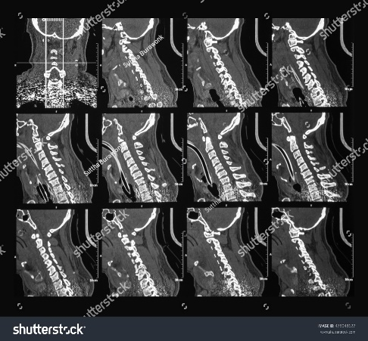
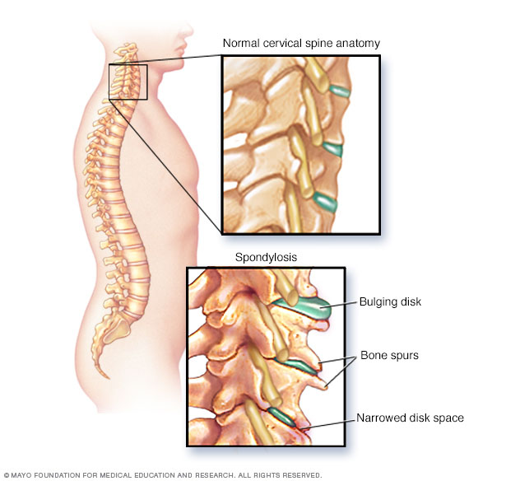
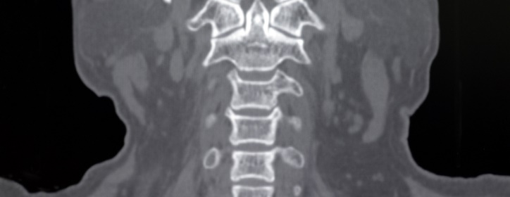
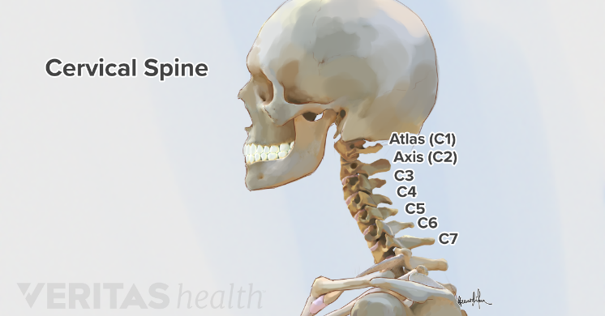

Thoracic
The thoracic spine is the second segment of the vertebral column, located between the cervical and lumbar vertebral segments. It consists of twelve vertebrae, which are separated by intervertebral discs. Along with the sternum and ribs, the thoracic spine forms part of the thoracic cage.
Where is the thoracic region?
The thoracic spine is located at the back of the chest (the thorax), mostly between the shoulder blades. It extends from the bottom of the neck to the start of the lumbar spine, roughly at the level of the waist

What does thoracic pain feel like?
The pain may increase with certain positions or movements of the neck. Thoracic spine — Symptoms of a thoracic disc herniation can be comprised of posterior chest pain radiating around one or both sides of the rib cage. Such pain is usually triggered by physical exertion and can even be caused by taking a deep breath.

What parts of the body are controlled by the thoracic spine?
Thoracic Spinal Cord Injuries
- T-1 through T-5 nerves affect muscles, upper chest, mid-back and abdominal muscles. These nerves and muscles help control the rib cage, lungs, diaphragm and muscles that help you breathe.
- T-6 through T-12 nerves affect abdominal and back muscles.
- What is the function of the thoracic spine?
- Thoracic (mid back) - the main function of the thoracic spine is to hold the rib cage and protect the heart and lungs. The twelve thoracic vertebrae are numbered T1 to T12. The range of motion in the thoracic spine is limited. Lumbar (low back) - the main function of the lumbar spine is to bear the weight of the body.

Thoracic Spine
The section of the spinal column called the thoracic spine begins below the cervical spine (C7, neck), roughly at shoulder level and continues downward until it reaches the first level of the low back (L1, lumbar spine). Twelve vertebrae, numbered T1 through T12 from top to bottom, make up the thoracic spine. When viewed from the side, a normal forward curvature called kyphosis (or kyphotic curve) is seen.
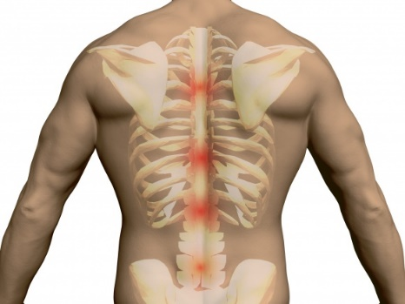
Its attachment to the rib cage affords the thoracic region of the spinal column greater stability and strength. Photo Source: iStock.com.
Because the ribs attach to the thoracic spine’s vertebrae, this section of the spine is strong and stabilizing, with less range-of-motion than the cervical (neck) levels. While the thoracic spine is less prone to injury than other sections of the vertebral column, it is the most common location for vertebral fracture due to osteoporosis. Scoliosis and abnormal kyphosis are other thoracic spinal disorders.
Why take time to learn about thoracic spinal anatomy? Because it can help you better understand possible causes of upper back and midback pain, the doctor’s diagnosis and why simple lifestyle changes can help keep your midback healthy.

Thoracic Spine Bone Basics
The thoracic spine helps support the body’s torso and chest areas and provides an attachment point for each of the rib bones, except the 2 at the bottom of the ribcage.
Like most other spinal vertebrae, the thoracic vertebral bodies are rounded. Bony arches project from the back of each vertebral body forming a hollow protective space containing the spinal cord. Thoracic facet joints are paired at the back each vertebrae and allow limited spinal movement.
The thoracic spine is the longest section of the spinal column. Photo Source: Shutterstock.com.

Multipurpose Thoracic Spinal Discs
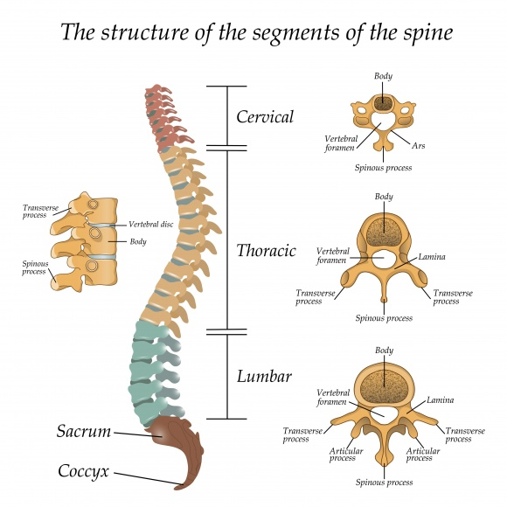
A fibrous pad of tissue called an intervertebral disc is held in place by a strong endplate attachment between each level’s upper (superior) and lower (inferior) vertebral body. Each disc acts as an interbody spacer creating disc height or space between its upper and lower vertebrae. This space creates open nerve passageways called foramen or neuroforamen at both sides. Nerve roots (or rootlets) branch off the spinal cord and exit the spinal canal through neuroforamen.

Soft Thoracic Supporting Structures Allow Movement Within Limits
Common to the entire spinal column are ligaments, tendons and muscles. These soft tissues attach to the bones and discs and work together to help stabilize the midback at rest and during movement.
- Ligaments are strong bands of fibrous tissue that connect and protect vertebrae and discs, provide spinal stability and help prevent excessive movement.
- Muscles help hold the body upright and allow spinal flexion (bend forward), extension (bend backward) and rotation (twist from side to side).
- Tendons are strong fibrous tissue that attaches muscle to bone.

Role of Thoracic Nerves
Twelve pair of thoracic nerve rootlets branch off the spinal cord and through the foramen to innervate or supply sensation (feeling) and function (movement) to specific areas of the body. These nerves feed the midback and chest regions, and transmit signals between the brain and major organs, including the lungs, heart, liver and the small intestine.

Types of Thoracic Spinal Disorders
- Osteoporosis increases the risk for thoracic spinal fracture. A common type is a vertebral compression fracture (VCF) that can cause one or more bony bodies to flatten or become wedge shaped resulting in spinal cord and/or nerve compression. Sudden and acute back pain is associated with a VCF.
- Different types of scoliosis—an abnormal side to side curvature of the spine—is well known to develop in the thoracic spine and may cause spinal deformity.
- Abnormal kyphosis is an exaggerated amount of forward thoracic spinal curvature. While humpback is not a kind expression, it aptly describes the appearance of a kyphotic deformity. Types of kyphosis include congenital (appearing at birth), posture related, or Scheuermann’s disease.
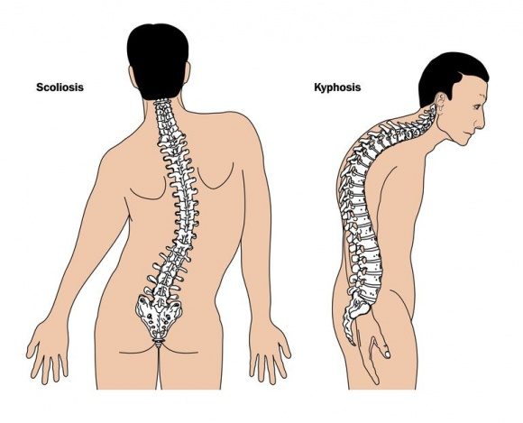
Scoliosis and kyphosis are 2 types of conditions caused by abnormal curvature of the thoracic spine. Photo Source: 123RF.com.
- Metastatic cancer (eg, traveling from a breast, lung) is a foremost cause of spinal tumors that can develop in the thoracic spine potentially leading to structural deterioration.
While cervical or lumbar disc herniations are common, thoracic disc herniation is not. This is because of the thoracic spine’s strength and stability created by its attachments to the ribcage.

Maintain Your Thoracic Spine
- Ask your doctor for stretches and exercises appropriate for you to keep your core and midback musculature strong to help prevent injury during flexion, extension and rotation type movements.
- Be aware of your posture; use good body mechanics.
- If you smoke or vape, consider quitting.
- Learn your personal risks for osteoporosis and put a preventive bone density maintenance plan in place with your healthcare providers’ help.
