NAME MEHBOOB SHABBIR
ID 13916
SUBJECT OBJECT ORIENTED ANALYSIS & DESIGN
ASSIGNMENT

USE CASE DIGRAM
Web Customer actor uses some web site to make purchases online. Top level use cases are View Items, Make Purchase and Client Register. View Items use case could be used by customer as top level use case if customer only wants to find and see some products. This use case could also be used as a part of Make Purchase use case. Client Register use case allows customer to register on the web site, for example to get some coupons or be invited to private sales. Note, that Checkout use case is included use case not available by itself - checkout is part of making purchase.
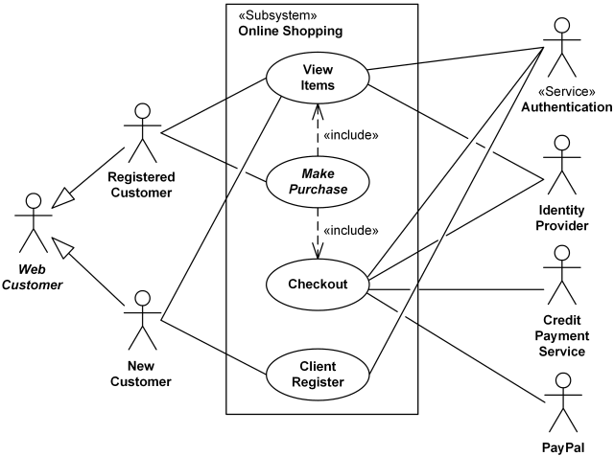

ACTIVITY DIGRAM
An example of activity diagram for online shopping. Online customer can browse or search items, view specific item, add it to shopping cart, view and update shopping cart, checkout. User can view shopping cart at any time. Checkout is assumed to include user registration and login.
This example does not use partitions, most of the actions are assumed to be fulfilled by online customer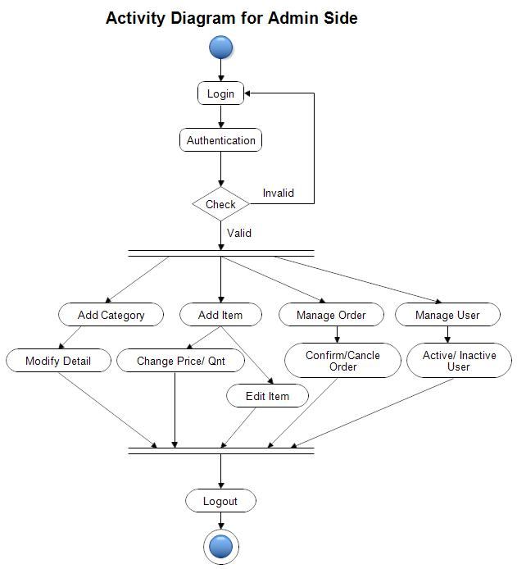

CLASS DIGRAM
Each customer has unique id and is linked to exactly one account. Account owns shopping cart and orders. Customer could register as a web user to be able to buy items online. Customer is not required to be a web user because purchases could also be made by phone or by ordering from catalogues. Web user has login name which also serves as unique id. Web user could be in several states - new, active, temporary blocked, or banned, and be linked to a shopping cart. Shopping cart belongs to account.
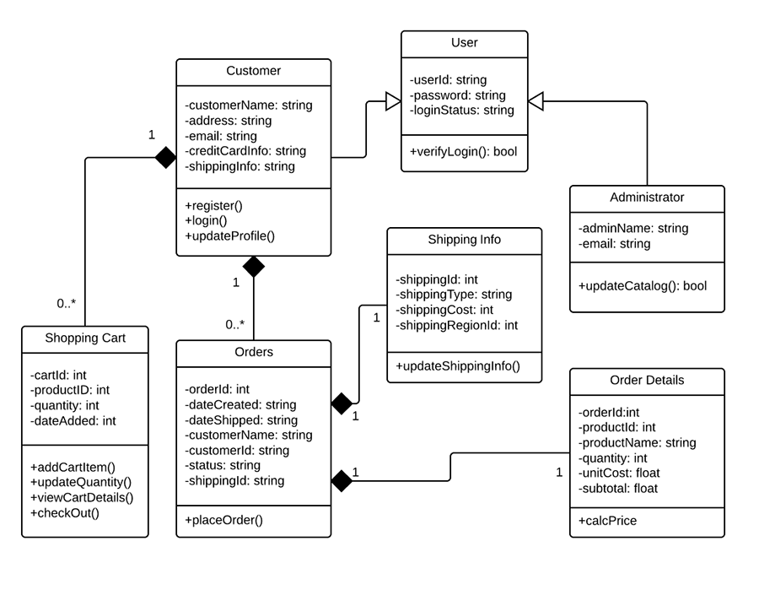

SEQUENCE DIGRAM
A Sequence diagram allows you to map out and illustrate a particular system, while also facilitating collaboration.

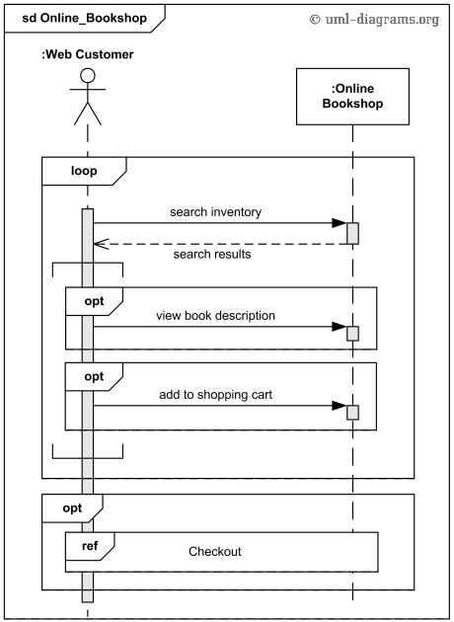

State chart diagram
This sample was created in Concept Draw PRO diagramming and vector drawing software using the UML State Machine Diagram library of the Rapid UML Solution from the Software Development area of Concept Draw Solution Park. This sample shows the work of the online store and can be used for the understanding of the online shopping processes, for projection and creating of the online store.
