Name: Umair Khan
ID: 16903
Program: BBA
Exam: Microeconomics (Final Term Assignment)
Instructor: Sir Zohaib
QUESTION No:1
Explain the following concepts.
- The benefit principle
- Lump- sum Taxes
- Marginal tax rate versus average tax rates
- Proportional tax
- Regressive tax
- Progressive tax
1.The Benefit Principle:
The benefit principle is a concept in the theory of taxation from public finance. It bases taxes to pay for public-goods expenditures on a politically-revealed willingness to pay for benefits received. The principle is sometimes likened to the function of prices in allocating private goods .In its use for assessing the efficiency of taxes and appraising fiscal policy, the benefit approach was initially developed by Knut Wick sell (1896) and Erik Lindahl (1919), two economists of the Stockholm School. Wicksell's near-unanimity formulation of the principle was premised on a just income distribution. The approach was extended in the work of Paul Samuelson, Richard Musgrave, and others. It has also been applied to such subjects as tax progressivity, corporation taxes, and taxes on property or wealth. The unanimity-rule aspect of Wicksell's approach in linking taxes and expenditures is cited as a point of departure for the study of constitutional economics in the work of James Buchanan.
2.Lump- sum Taxes:
A tax whose amount is not affected by the taxpayer's actions. If the lump-sum tax is the same for all taxpayers, it is called a poll tax. Lump-sum taxes can be varied across consumers, and may even be negative for some consumers. A negative lump-sum tax is called a lump-sum subsidy. The differentiation of lump-sum taxes across taxpayers results in redistribution. Lump-sum taxes have a central role in the theory of taxation due to their efficiency in raising revenue and achieving distributional objectives. As taxpayers cannot affect the level of a lump-sum tax by changing their behaviour, there is no distortion in choice. The imposition of lump-sum taxes therefore causes no deadweight loss. This allows revenue to be raised, and redistribution to be achieved, with no efficiency cost and, hence, permits decentralization of a first-best allocation. Unfortunately, the differentiation of lump-sum taxes across taxpayers requires the taxes to be levied on the basis of some unalterable characteristic. There are few characteristics that are both publicly verifiable and relevant for redistribution, which makes this differentiation difficult to implement in practice. See also optimal taxation.
3. Marginal tax rate versus average tax rates:
A marginal tax rate is the rate at which tax is incurred on an additional dollar of income. In the United States, the federal marginal tax rate for an individual increases as income rises. This method of taxation, known as progressive taxation, aims to tax individuals based upon their earnings, with low-income earners being taxed at a lower rate than higher-income earners. While many believe this is the most equitable method of taxation, many others believe this discourages business investment by removing the incentive to work harder. a marginal tax rate, taxpayers are most often divided into tax tax brackets or ranges, which determine the rate applied to the taxable income of the tax filer. As income increases, what is earned will be taxed at a higher rate than the first dollar earned. In other words, the first dollar earned will be taxed at the rate for the lowest tax bracket, the last dollar earned will be taxed at the rate of the highest bracket for that total income, and all the money in between is taxed at the rate for the range into which it falls.
4. Proportional tax:
A proportional tax is an income tax system that levies the same percentage tax to everyone regardless of income. A proportional tax is the same for low, middle, and high-income taxpayers. Proportional taxes are sometimes referred to as flat taxes. In contrast, a progressive tax or marginal tax system adjusts tax rates progressively by income. Low-income earners are taxed at a lower rate than high-income earners. A proportional tax allows people to be taxed at the same percentage of their annual income. Supporters of a proportional tax system propose that it gives taxpayers incentive to earn more because they are not penalized with a higher tax bracket. Also, flat tax systems make filing easier. Critics of flat taxes argue the system places an unfair burden on low-wage earners in exchange for lowering tax rates on the wealthy. Critics, however, believe that a progressive tax system is fairer than a flat tax system.In some instances, a sales tax can also be considered a type of proportional tax since all consumers, regardless of earnings, are required to pay the same fixed rate. The sales tax rate applies to goods and services, and the income of the purchaser is not a part of the equation. Other examples include poll taxes and the capped portion of the Federal Insurance Contributions Act (FICA) payroll deductions.
5. Regressive tax:
A regressive tax is a tax applied uniformly, taking a larger percentage of income from low-income earners than from high-income earners. It is in opposition to a progressive tax, which takes a larger percentage from high-income earners. A regressive tax affects people with low incomes more severely than people with high incomes because it is applied uniformly to all situations, regardless of the taxpayer. While it may be fair in some instances to tax everyone at the same rate, it is seen as unjust in other cases. As such, most income tax systems employ a progressive schedule that taxes high-income earners at a higher percentage rate than low-income earners, while other types of taxes are uniformly applied. Although the United States has a progressive taxation system when it comes to income tax, meaning higher income earners pay a higher percentage of taxes each year compared to those with a lower income, we do pay certain levies that are considered to be regressive taxes. Some of these include state sales taxes, user fees, and, to some degree, property taxes.
6. Progressive tax:
A progressive tax is a tax in which the tax rate increases as the taxable amount increases. The term "progressive" refers to the way the tax rate progresses from low to high, with the result that a taxpayer's average tax rate is less than the person's marginal tax rate. The term can be applied to individual taxes or to a tax system as a whole; a year, multi-year, or lifetime. Progressive taxes are imposed in an attempt to reduce the tax incidence of people with a lower ability to pay, as such taxes shift the incidence increasingly to those with a higher ability-to-pay. The opposite of a progressive tax is a regressive tax. An example of a regressive tax would be a sales tax, with a sales tax a larger proportion of income is taxed to the poor than the rich. The term is frequently applied in reference to personal income taxes, in which people with lower income pay a lower percentage of that income in tax than do those with higher income. It can also apply to adjustments of the tax base by using tax exemptions, tax credits, or selective taxation that creates progressive distribution effects. For example, a wealth or property tax, a sales tax on luxury goods, or the exemption of sales taxes on basic necessities, may be described as having progressive effects as it increases the tax burden of higher income families and reduces it on lower income families.
Progressive taxation is often suggested as a way to mitigate the societal ills associated with higher income inequality, as the tax structure reduces inequality, but economists disagree on the tax policy's economic and long-term effects. One study suggests progressive taxation can be positively associated with happiness, the subjective well-being of nations and citizen satisfaction with public goods, such as education and transportation.
QUESTION No:2
Define elasticity and explain the following elasticity concepts.
Elasticity:
Elasticity is a measure of a variable's sensitivity to a change in another variable, most commonly this sensitivity is the change in price relative to changes in other factors. In business and economics, elasticity refers to the degree to which individuals, consumers or producers change their demand or the amount supplied in response to price or income changes. It is predominantly used to assess the change in consumer demand as a result of a change in a good or service's price.
1. Income elasticity:
Income elasticity of demand is the response to market demand by consumers as their income changes. The ratio consists of the quantity of demand for a product over alterations to their income. This figure can help forecast future economic growth or the income of an individual in a particular region or country. Overall, companies need to strategically plan for shifts in the income elasticity of demand, so they cater their business activity toward the consumers' financial situation.
2. Price elasticity :
Price elasticity of demand is an economic measure of the change in the quantity demanded or purchased of a product in relation to its price change. Expressed mathematically, it is: Price Elasticity of Demand = % Change in Quantity Demanded / % Change in Price Price elasticity is used by economists to understand how supply or demand changes given changes in price to understand the workings of the real economy. For instance, some goods are very inelastic, that is, their prices do not change very much given changes in supply or demand, for example people need to buy gasoline to get to work or travel around the world, and so if oil prices rise, people will likely still buy just the same amount of gas. On the other hand, certain goods are very elastic, their price moves cause substantial changes in its demand or its supply. (Arc elasticity is the elasticity of one variable with respect to another between two given points.) Here, we will look just at how the demand side of the equation is impacted by fluctuations in price by considering the price elasticity of demand – which you can contrast with price elasticity of supply.
3. Cross price elasticity of demand:
The cross elasticity of demand is an economic concept that measures the responsiveness in the quantity demanded of one good when the price for another good changes. Also called cross-price elasticity of demand, this measurement is calculated by taking the percentage change in the quantity demanded of one good and dividing it by the percentage change in the price of the other good.
QUESTION No:3
(a) Define Monopoly and explain characteristics of Monopoly?
Monopoly:
A monopoly refers to when a company and its product offerings dominate a sector or industry. Monopolies can be considered an extreme result of free-market capitalism in that absent any restriction or restraints, a single company or group becomes large enough to own all or nearly all of the market (goods, supplies, commodities, infrastructure, and assets) for a particular type of product or service. The term monopoly is often used to describe an entity that has total or near-total control of a market.
Characteristics Of Monopoly:
The four key characteristics of monopoly are:
These four characteristics mean that a monopoly has extensive (boarding on complete) market control. Monopoly controls the selling side of the market. If anyone seeks to acquire the production sold by the monopoly, then they must buy from the monopoly. This means that the demand curve facing the monopoly is the market demand curve. They are one and the same. The characteristics of monopoly are in direct contrast to those of perfect competition. A perfectly competitive industry has a large number of relatively small firms, each producing identical products. Firms can freely move into and out of the industry and share the same information about prices and production techniques. A monopolized industry, however, tends to fall far short of each perfectly competitive characteristic. There is one firm, not a lot of small firms. There is only one firm in the market because there are no close substitutes, let alone identical products produced by other firms. A monopoly often owes its monopoly status to the fact that other potential producers are prevented from entering the market. No freedom of entry here. Neither is there perfect information. A monopoly firm often has specialized information, such as patents or copyrights, that are not available to other potential producers.
Single Supplier:
The essence of a monopoly is a market controlled by a single seller. The "mono" part of monopoly means single. This "mono" term is also the source of such words as monarch--a single ruler; monochrome--a single color; monk--a solitary religious figure; monocle--an eyeglass for one eye; and monolith--a single large stone. The "poly" part of monopoly means to sell. So the word itself, monopoly, means a single seller. The single seller, of course, is a direct contrast to perfect competition, which has a large number of sellers. In fact, perfect competition could be renamed multipoly or manypoly, to contrast it with monopoly. The most important aspect of being a single seller is that the monopoly seller IS the market. The market demand for a good IS the demand for the output produced by the monopoly. This makes monopoly a price maker, rather than a price taker. A hypothetical example that can be used to illustrate the features of a monopoly is Feet-First Pharmaceutical. This firm owns the patent to Amblathan-Plus, the only cure for the deadly (but hypothetical) foot ailment known as amblathanitis. As the only producer of Amblathan-Plus, Feet-First Pharmaceutical is a monopoly with extensive market control. The market demand for Amblathan-Plus is THE demand for Amblathan-Plus sold by Feet-First Pharmaceutical.
Unique Product:
To be the only seller of a product, however, a monopoly must have a unique product. Phil the zucchini grower is the only producer of Phil's zucchinis. The problem for Phil, however, is that gadzillions of other firms sell zucchinis that are indistinguishable from those sold by Phil. Amblathan-Plus, in contrast, is a unique product. There are no close substitutes. Feet-First Pharmaceutical holds the exclusive patent on Amblathan-Plus. No other firm has the legal authority to produced Amblathan-Plus. And even if they had the legal authority, the secret formula for producing Amblathan-Plus is sealed away in an airtight vault deep inside the fortified Feet-First Pharmaceutical headquarters. Of course, other medications exist that might alleviate some of the symptoms of amblathanitis. One ointment temporarily reduces the swelling. Another powder relieves the redness. But nothing else exists to cure amblathanitis completely. A few highly imperfect substitutes exists. But there are no close substitutes for Amblathan-Plus. Feet-First Pharmaceutical has a monopoly because it is the ONLY seller of a UNIQUE product.
Barriers to Entry and Exit:
A monopoly is generally assured of being the ONLY firm in a market because of assorted barriers to entry. Some of the key barriers to entry are:
(1) Government license or franchise
(2) Resource ownership
(3)Patents and copyrights
(4) High start-up cost
(5) Decreasing average total cost.
Feet-First Pharmaceutical has a few these barriers working in its favor. It has, for example, an exclusive patent on Amblathan-Plus. The government has decreed that Feet-First Pharmaceutical, and only Feet-First Pharmaceutical, has the legal authority to produce and sell Amblathan-Plus. Moreover, the secret ingredient used to produce Amblathan-Plus is obtained from a rare, genetically enhanced, eucalyptus tree grown only on a Brazilian plantation owned by Feet-First Pharmaceutical. Even if another firm knew how to produce Amblathan and had the legal authority to do so, they would lack access to this essential ingredient. A monopoly might also face barriers to exiting a market. If government deems that the product provided by the monopoly is essential for well-being of the public, then the monopoly might be prevented from leaving the market. Feet-First Pharmaceutical, for example, cannot simply cease the production of Amblathan-Plus. It is essential to the health and welfare of the public. This barrier to exit is most often applied to public utilities, such as electricity companies, natural gas distribution companies, local telephone companies, and garbage collection companies. These are often deemed essential services that cannot be discontinued without permission from a government regulation authority.
Specialized Information:
Monopoly is commonly characterized by control of information or production technology not available to others. This specialized information often comes in the form of legally-established patents, copyrights, or trademarks. While these create legal barriers to entry they also indicate that information is not perfectly shared by all. The AT&T telephone monopoly of the late 1800s and early 1900s was largely due to the telephone patent. Pharmaceutical companies, like the hypothetical Feet-First Pharmaceutical, regularly monopolize the market for a specific drug by virtue of a patent. In addition, a monopoly firm might know something or have a piece of information that is not available to others. This "something" may or may not be patented or copyrighted. It could be a secret recipe or formula. Perhaps it is a unique method of production. One example of specialized information is the special, secret formula for producing Amblathan-Plus that is sealed away in an airtight vault deep inside the fortified Feet-First Pharmaceutical headquarters. No one else has this information.
QUESTION No: 3
(B)Discuss price determination under monopoly?

PRICE DETERMINATION UNDER MONOPOLISTIC COMPETITION:
Under monopolistic competition, the firm will be in equilibrium position when marginal revenue is equal to marginal cost. So long the marginal revenue is greater than marginal cost, the seller will find it profitable to expand his output, and if the MR is less than MC, it is obvious he will reduce his output where the MR is equal to MC. In short run, therefore, the firm will be in equilibrium when it is maximising profits, i.e., when MR = MC
(a) Short Run Equilibrium: Short run equilibrium is illustrated in the following diagram:
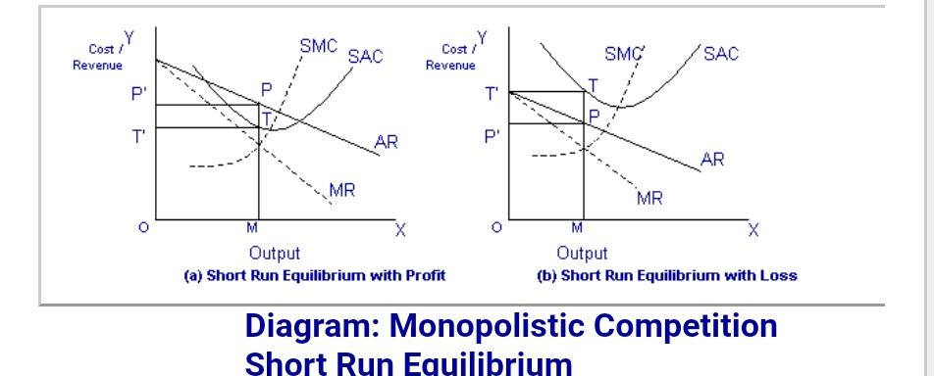
In the above diagram, the short run average cost is MT and short run average revenue is MP. Since the AR curve is above the AC curve, therefore, the profit is shown as PT. PT is the supernormal profit per unit of output. Total supernormal profit will be measured by multiplying the supernormal profit to the total output, i.e. PT × OM or PTT’P’ as shown in figure (a). The firm may also incur losses in the short run if it is facing AR curve below the AC curve. In figure (b) MP is less than MT and TP is the loss per unit of output. Total loss will be measured by multiplying loss per unit of output to the total output, i.e. TP × OM or TPP’T’.
(b) Long Run Equilibrium:
Under monopolistic competition, the supernormal profit in the long run is disappeared as new firms are entered into the industry. As the new firms are entered into the industry, the demand curve or AR curve will shift to the left, and therefore, the supernormal profit will be competed away and the firms will be earning normal profits. If in the short run firms are suffering from losses, then in the long run some firms will leave the industry so that remaining firms are earning normal profits. The AR curve in the long run will be more elastic, since a large number of substitutes will be available in the long run. Therefore, in the long run, equilibrium is established when firms are earning only normal profits. Now profits are normal only when AR = AC. It is further illustrated in the following diagram.
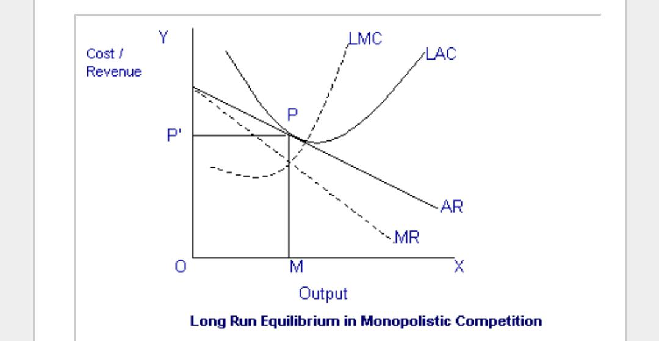
QUESTION No:4
Discuss the following models.
1. The Cournot Model:
Cournot competition is an economic model describing an industry structure in which rival companies offering an identical product compete on the amount of output they produce, independently and at the same time. It is named after its founder, French mathematician Augustin Cournot.
KEY TAKEAWAYS:
Cournot competition is an economic model in which competing firms choose a quantity to produce independently and simultaneously. The model applies when firms produce identical or standardized goods and it is assumed they cannot collude or form a cartel. The idea that one firm reacts to what it believes a rival will produce forms part of the perfect competition theory.
Understanding Cournot Competition Companies operating in markets with limited competition, called oligopolies, often compete by seeking to steal market share away from each other. One way to do this is to alter the number of goods sold. According to the law of supply and demand, higher output drives down prices, while lower output raises them. As a result, companies must consider how much quantity a competitor is likely to churn out to have a better chance of maximizing profits.
In short, efforts to maximize profit are based on competitors’ decisions and each firm’s output decision is assumed to affect the product price. The idea that one firm reacts to what it believes a rival will produce forms part of the perfect competition theory.
The Cournot model is applicable when companies produce identical or standardized goods. It assumes they cannot collude or form a cartel, have the same view of market demand, and are familiar with competitor operating costs.
History of Cournot Competition French mathematician Augustin Cournot outlined his theory of perfect competition and modern conceptions of monopoly in 1938 in his book, Researches Into the Mathematical Principles of the Theory of Wealth. The Cournot model was inspired by analyzing competition in a spring water duopoly.
A monopoly is one firm, duopoly is two firms, and oligopoly is two or more firms operating in the same market. The Cournot model remains the standard for oligopolistic competition, although it can also be extended to include multiple firms. Cournot’s ideas were adopted and popularized by the Swiss economist Leon Walras, considered by many to be the founder of modern mathematical economics.
Advantages of Cournot Competition The Cournot model has some significant advantages. The model produces logical results, with prices and quantities that are between monopolistic (i.e. low output, high price) and competitive (high output, low price) levels. It also yields a stable Nash equilibrium, an outcome from which neither player would like to deviate unilaterally.
Limitations of Cournot Competition Some of the model’s assumptions may be somewhat unrealistic in the real world. Firstly, the Cournot classic duopoly model assumes that the two players set their quantity strategy independently of each other. This is unlikely to be the case in a practical sense. When only two producers are in a market, they are likely to be highly responsive to each other’s strategies rather than operating in a vacuum.
Secondly, Cournot argues that a duopoly could form a cartel and reap higher profits by colluding. But game theory shows that a cartel arrangement would not be in equilibrium since each company would tend to deviate from the agreed output—for proof, one need look no further than The Organization of the Petroleum Exporting Countries (OPEC). Thirdly, the model's critics question how often oligopolies compete on quantity rather than price. French scientist J. Bertrand in 1883 attempted to rectify this oversight by changing the strategic variable choice from quantity to price. The suitability of price, rather than quantity, as the main variable in oligopoly models was confirmed in subsequent research by a number of economists.
2. The Stackelberg Model:
The Stackelberg leadership model is a strategic game in economics in which the leader firm moves first and then the follower firms move sequentially. It is named after the German economist Heinrich Freiherr von Stackelberg who published Market Structure and Equilibrium (Marktform und Gleichgewicht) in 1934 which described the model.
In game theory terms, the players of this game are a leader and a follower and they compete on quantity. The Stackelberg leader is sometimes referred to as the Market Leader.
There are some further constraints upon the sustaining of a Stackelberg equilibrium. The leader must know ex ante that the follower observes its action. The follower must have no means of committing to a future non-Stackelberg leader's action and the leader must know this. Indeed, if the 'follower' could commit to a Stackelberg leader action and the 'leader' knew this, the leader's best response would be to play a Stackelberg follower action. Firms may engage in Stackelberg competition if one has some sort of advantage enabling it to move first. More generally, the leader must have commitment power. Moving observably first is the most obvious means of commitment: once the leader has made its move, it cannot undo it - it is committed to that action. Moving first may be possible if the leader was the incumbent monopoly of the industry and the follower is a new entrant. Holding excess capacity is another means of commitment.

