Name=Afrasiabullah
ID= . . . 15900
Paper= Human Anatomy
Select the best option
1=(b)Head,Shaft,and tail
2=(a)Medial surface
3=(b)Flexion,extension,abduction and adduction
4=(a)Pubofemoral ligament
5=(b)Coxa Vara
6=(a)Acetabular fossa
7=(d)Peroneal tubercle
8=(b)Secondary cartilaginous joint
9=(c)Fibula
10=(a)Anteriro border is subcutaneons
Give brief answers to the following questions. Add diagrams/Picture where needed
Q NO1:-Describe the arches of foot. Name the factors respansible for the maintenance of these arches.
ANS:-The arches of the foot,formed by the tarsal and metatarsal bones strenthecd by ligament and tendons allow the foot to support the wight of all body in the erect posture with the least wight.
LONGITUDINAL Arches :-
. . . . . . . . . . . . . The longitudinal arches of the foot can be divided into medial and laterul arches
MEDIAL Arche:-
. . . . . .The medial arch is higher than lateral longitudinal arch. It is made up by the calcancus,the tal us the navicular the these cuneiforms medial intermed and the first second and third metatersals.
LATERAL Arche:-
. . . . . . . . . The lateral arch is composed of the calcaneus the cuboid and the fourth and fifth metatatarsals.
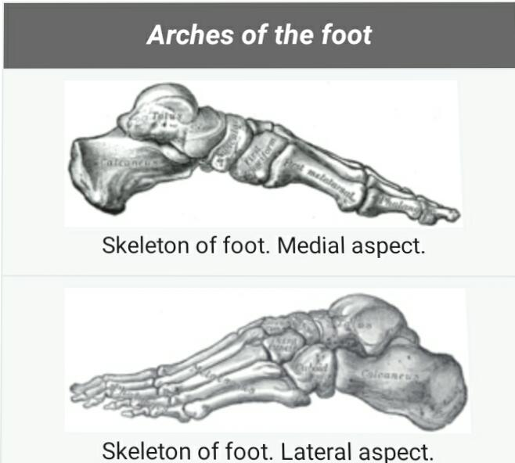
Two notable features of this arch are its solidity and it slight elevation Two strong ligaments the long planter and the planter culcaneocuboid together with the extersor tendons and the shart musles of the litter toes preserve in intergrity

