NAME: UMAIR KHAN
ID NO: 15206
DEGREE: DPT 4th
PAPER: BIOCHEMISTRY
SUBMITTED TO: MAM KULSOOM

QNO 1.WRITE BRIEF NOTE ON STERIOD HORMONES?
ANS:-STERIOD HORMONE:- Any of a group of hormones that belong to the class of chemical compounds known as steroids; they are secreted by three “steroid glands”—the adrenal cortex, testes, and ovaries—and during pregnancy by the placenta. All steroid hormones are derived from cholesterol. They are transported through the bloodstream to the cells of various target organs where they carry out the regulation of a wide range of physiological functions.
These hormones often are classified according to the organs that synthesize them: the adrenal steroids are so called because they are secreted by the adrenal cortex, and the sex hormones are those produced by the ovaries and testes.
The adrenal cortex produces the adrenocortical hormones, which consist of the glucocorticoids and the mineralocorticoids. Glucocorticoids such as cortisol control or influence many metabolic processes, including the formation of glucose from amino acids and fatty acids and the deposition of glycogen in the liver. Glucocorticoids also help to maintain normal blood pressure, and their anti-inflammatory and actions.
Mineralocorticoids such as aldosterone help maintain the balance between water and salts in the body, predominantly exerting their effects within the kidney.

STRUCTURE OF STERIOD:-
Steroid are organic compounds that contain four rings of carbon atoms. Specifically, we see that all steroids have three 6-steriod carbon rings and one 5-sided carbon rings.
However, different steroid have different functional groups attached. We recall that functional groups are groups of atoms that we often find together that have a specific behavior. When we attach different functional groups to the basic steroid rings, we get steroid with different functions. We will talk about the different functions of steroids later in this lesion.
But first, we mentioned that steroids are organic compound, and we know that organic compounds, and we know that organic compounds must contain carbon. Therefore, organic compounds are things like carbohydrates, proteins and lipids. In fact, steroids are classified under the lipid group. This is somewhat interesting because we see that the basic structure of a steroid differs quite a bit from that of other lipids such as triglycerides of phospholipids. However, steroids still fit this category because, like other facts, steroids are made largely of carbon and hydrogen atoms, and they are insoluble in water.

FUNCTION OF STERIOD:-
We see that steroids in the body can act as hormones, and, therefore, their presence can impact a number of things from your growth to your sexual development. For example, steroid hormones are secreted by the testes and ovaries. From the testes, we see testosterone, which is the male sex hormone that guides male sexual development. From the ovaries we see estrogen, which is the female sex hormones that guides female sexual development.
Steroid hormones are also produced by the adrenal cortex, which is the outer portion of your adrenal gland that you can find sitting on of your kidneys.
Cortisol is one important adrenal cortex steroid hormone and it regulates carbohydrate metabolism and has an anti-inflammatory effects on the body.
Aldosterone is another steroid hormone that comes from the adrenal cortex. It helps maintain blood pressure and regulate the salt and water balance in your body.
QNO.2 WHAT IS DEAMINATION AND TRASAMINATION?
ANS:- Deamination:-

Deamination, the opposite of amination, is a type of post-translational modification (PTM) in which an amine group is removed from a protein. Enzymes that catalyze the deamination reaction are called deaminases.
Typically in humans, deamination occurs when an excess in protein is consumed, resulting in the removal of an amine group, which is then converted into ammonia and expelled via urination.
This deamination process allows the body to convert excess amino acids into usable by-products. Although deamination occurs throughout the human body, it is most common in the liver and to a lesser extent in the kidneys.
Deamination is the removal of the amine group as ammonia (NH3), as shown below.
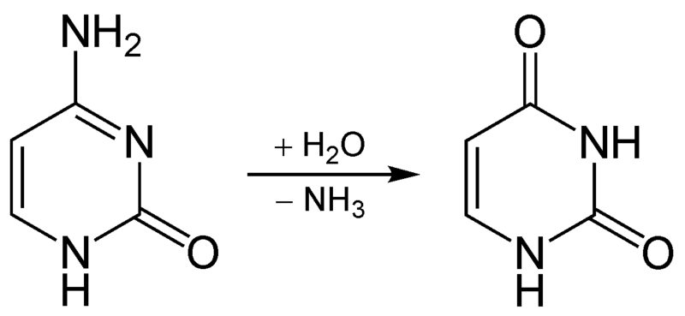

The potential problem with deamination is that too much ammonia is toxic, causing a condition known as hyperammonemia.

TRANSAMINATION:-
Transamination is the transfer of an amine group from an amino acid to a keto acid (amino acid without an amine group), thus creating a new amino acid and keto acid as shown below.
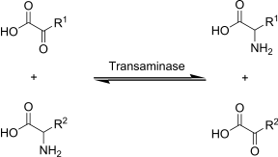

Transamination reactions combine reversible amination and deamination, and they mediate redistribution of amino groups among amino acids. Transaminases (aminotransferases) are widely distributed in human tissues and are particularly active in heart muscle, liver, skeletal muscle, and kidney. The general reaction of transamination is:

The α-ketoglutarate/L-glutamate couple serves as an amino group acceptor/donor pair in transaminase reactions. The specificity of a particular transaminase is for the amino group other than the glutamate. Two transaminases whose activities in serum are used as indices of liver damage catalyze the following reactions:
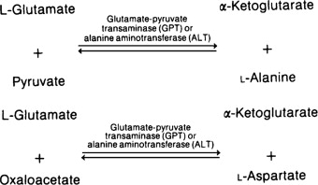

All of the amino acids except lysine, threonine, proline, and hydroxyproline participate in transamination reactions.
Transaminases exist for histidine, serine, phenylalanine, and methionine, but the major pathways of their metabolism do not involve transamination.
Transamination of an amino group not at the α-position can also occur. Thus, transfer of a δ-amino group of ornithine to α-ketoglutarate converts ornithine to glutamate-γ-semi aldehyde.
All transaminase reactions have the same mechanism and use pyridoxal phosphate (a derivative of vitamin B6 Keto acids and/or carbon skeletons are what remains after amino acids have had their nitrogen group removed by deamination or transamination. Transamination is used to synthesize nonessential amino acids.

QNO.3 WRITE DOWEN THE METABOLISM OF PROTEIN?
ANS:-METABOLISM OF PROTEIN:-Protein metabolism denotes the various biochemical processes responsible for the synthesis of proteins and amino acids (anabolism), and the breakdown of proteins by catabolism.

- Dietary proteins are very large complex molecules that cannot be absorbed from the intestine.
- To be absorbed, dietary proteins must be digested to small simple molecules (amino acids), which are easily absorbed from the intestine.
- DIGESTION IN THE STOMACH:
Protein digestion begins in the stomach by gastric juice, pepsin and renin are the enzymes present in stomach.
ii. DIGESTION IN SMALL INTESTINE:
- Digestion of proteins is completed in the small intestine by proteolytic enzymes present in pancreatic juices.
In pancreatic juice trypsin, chymotrypsin, elastase, carboxypeptidase enzymes are present and
In intestine juice amino peptidase, tripeptidase enzymes are present the end products of protein digestion in the small intestine are amino acid.

QNO 4. EXPLAIN BRIEFLY TRANSLATION OF DNA IN EUKARYOTES?
ANS:-TRANSLATION OF DNA IN EUKARYOTES:-
Translation is the process by which the sequence of nucleotide in a messenger RNA molecule directs the incorporation of amino acid into protein is called translation.

TRANSLATION PROCESS:-
- In a eukaryotes cell, translation occurs in the cytoplasm.
- Translation involves three major steps:
- INITIATION
- ELONGATION
- TERMINATION

- INITIATION:-
The initiation of translation of DNA in eukaryotes is complex, involving at least 10 eukaryotic initiation factors (elFs) & divided into 4 steps:

- Ribosomal dissociation.
- Formation of 43s preinitiation complex.
- Formation of 48s initiation complex.
- Formation of 80s initiation complex.

- ELEMINITION:-
- Ribosomes elongate the polypeptide chain by a sequential addition of amino acids.
- The amino acid sequence is determined by the arder of codons in the specific mRNA.
- Elongation, a cyclic process involving certain elongation factors.
- Elongation may be divided into three steps.
- Binding of aminoacyle t- RNA to A-site.
- Peptide bond formation.
- Translation.

- TERMINATION:-
- One of the stop or termination signal (UAA, UAG AND UGA) terminates the growing polypeptide.
- When the ribosomes encounters a stop codon, there is no tRNA available to bind to the A site of the ribosome,
-instead a release factor binds to it.
- In eukaryotes, a single release factor- eukaryotic release factors 1 (eRF1) - recognizes all three stop codons, and eRF3 stimulates the termination events.
- Once release factors binds, the ribosomes unit falls aparts,
-releasing the large and small subunits,
-the tRNA carrying the polypeptide is also released,
Freeing up the polypeptide product.
- Ribosome recycling occurs in eukaryotes.

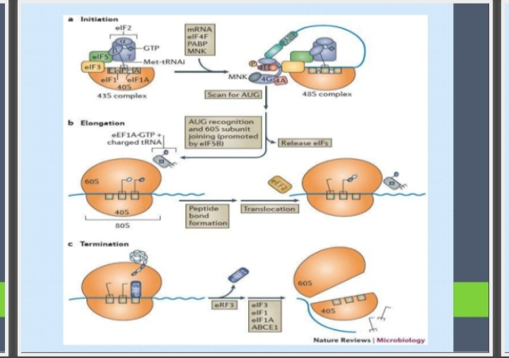

QNO 5. WRITE DOWEN CLINICAL SIGNIFICANCE OF CHOLESTROLE?
ANS:- CLINICAL SIGNIFICANCE OF CHOLESTROLE:-
Normal RANGE; 150-200 mg /dl
Hypercholesterolemia associated with;
- Diabetes Mellitus (increase availability of acetyle CoA due to unavailability of oxaloacetate).
- Nephrotic syndrome (increase globulins & increase in plasma lipoproteins).
- Hypothyroid/ myxedema (associated decrease HDL receptors on hepatocytes).
- Obstructive jaundice (obstruction in excretion of cholesterol through bile).

HYPOTHYROIDISM (Is a condition in which your thyroid gland doesn’t produce enough of certain crucial hormones).
Jaundice
Hyperlipidemia (high level of cholesterol or try glyceride in your body)
Atherosclerosis (buildup of fats, cholesterol and other substances in and on your artery walls (plaque), which can restrict blood flow).
Addition factors for coronary artery disease include – lifestyle
Cigarette smoking, coffe drinking, Emotional Stress, obesity ,Lack of exercise , High blood pressure etc.

THE END

