NAME. = Hussam umar
ID. = 16541
Section. = “A”
Department = BS Dental
Semester = 2nd
Subject = Physiology
Instructor = Dr irfan Ali

Q4ANS / Lymphatic system /
The tissues and organ that produce store and carry white blood cells that fight infections and other diseases. The bone marrow, spleen thymus, lymph nodes, and lymphatic vessels [a network of thin tube that carry lymph and white blood cells ]
Different component lymphatic system
Lymphatic system structures. The major component of the lymphatic system include lymph, lymphatic vessels, and lymphoid tissues.
Lymphatic vessel are structures that absorb fluid that diffuses from blood vessel capillaries into surrounding tissues.
Q5ANS Blood pressure
Blood pressure is the pressure of circulating blood on the walls of blood vessels. Most of this pressure is due to work done by the heart by pumping blood through the circulatory system. Used without further specification, blood pressure usually refer to the in large arteries of the systemic circulation.
Check blood pressure record the patient
Rest the patients arm on a surface that is level with their arm.
Place the stethoscope over the brachial artery [in the bend of the elbow ] and listen to the pulse.
Pump up the cuff slowly and listen for when the pulse disappears. This is indication to stop inflating the cuff.
Instrument stetoscop which is used to measure the blood pressure.

Q2 ANS Factors that influence on respiratory role
The following factors that on respiratory rate it given by
Temperature
When the temper a true increase the respiration rate also increase unit temperature gets to high enzyme denature.
Concentration of glucose
When the concentration of glucose increase until maximum level reached.
Concentration 02
When the contraction of oxygen increase the respiration rate will be reached at maximum levels.
Physical factors
Taking cough and exercise can be modify so it will increase the rate of respiratory.
Volition or conscious control
Signing swallowling holing which is our breath for short time.
Involuntary
Involuntary controls take over and normal respiration begains again.
Medications
Drugs norcaties which decrease the respiration rate in and body.
Stress
Strong emotion will also increase the respiratory rate.
Q1ANS/ Hematopoiesis
Hematopoiesis is the production of all of the cellular components of blood and blood plasma. It occurs within hematopoietic system, which includes organs and tissues such as bone marrow, liver, and spleen. Simply, hematopoiesis is the process through which the body manufactures blood cell.

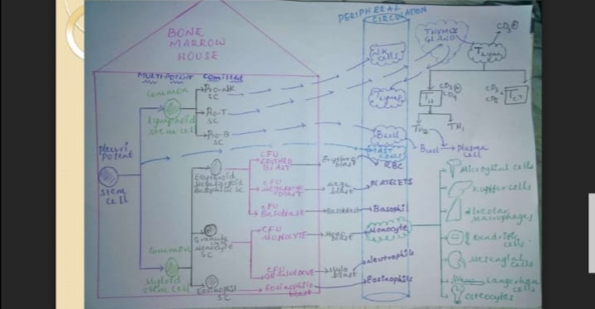
Q3ANS Different layer of skin /
Epidermis is the top layer of skin, the part of the skin you see.
Dermis is the second layer of skin. It is much thicker and does a lot for your body.
Subcutaneous fat is for the bottom layer.
NOTE OF EPIDERMIS
The epidermis is the outermost of the three layer being the dermis and hypodermis. The epidermis layer provides a barrier to infection from environmental pathogens and regulates the amount of water released from the body into the atmosphere through transepidermal water loss.

