DEPARTMENT OF ALLIED HEALTH SCIENCES

NAME: USAMA SIRAJ:

ID NO: 14991:

INSTRUCTER NAME: Muhammad sohail

PROGRAM: BS DT:

SEMESTER: 4^{th:}

Course Title: Medical microbiology DT 4th

Q1. What do you know about parasites explain endo and ecto parasites in detail?

Answer No 1)
Parasite: it is an organism that is dependent another organism (host) for its survival.
- Parasites are not one-size-fits-all.
- There are several main categories of parasites that can affect animals and plants. Probably the most-studied parasites are the ones that affect humans.
- Broadly grouped, they include protozoa, helminths, and arthropods.

Definition:
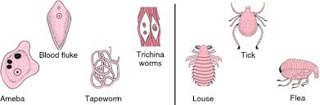
- An animal or plant, which lives in, on or upon another organism and draws its nutrient directly from it.
- Parasitology: study of parasite
Medical parasitology: it is the study of animal’s parasite that infects and produces disease in humans,

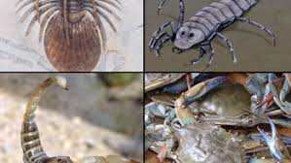
Classification of parasite:
They are classifying into two.
- Ectoparasite.
- Endoparasite

Ectoparasite:
- Live on the outer surface.
- OR: parasite that live outside the body of the host.
- Infection caused by this parasite called infestation.

Types of Endoparasite:
- Obligate parasite: means compulsory/neccory.
- The parasite that cannot exist without host.
- E.g. (toxoplasmic gonodi)
- Facultative: that parasite that may live either a parasite or free life.
- E.g. (naegleria fowleri)
- Accidental parasite: the parasite that attached an unusual host called accidental parasite.
- E.g. (echinococcus granolorus)
- Aberrant parasite: the parasite that during migration in the host.
- Rich a site where they cannot live or develop further.

(2) Endoparasite:
- Endo means inside
- Live within the host.
- Parasite that live inside the body of host.
- Invasion by such parasite called infection.
- E.g. : leishmania.

Q2. Explain protozoa, its characteristics and morphology, also classify protozoa on the basis of motility and reproduction into its types?

Answer no 2:

Protozoa:
- Protozoa word use by gold fuss
- Greek word means “first animal
Protozoa represent the most primitive group of animal organisms.
- They are unicellular eukaryotic cell wall-less motile organisms and form a very large highly diverse group originating from several phylogenetic lines.
- There are about 20,000 living species and many fossils which are now extinct. The majority of protozoa are free-living organisms in aquatic habitats and soil.
- Some are parasitic and pathogenic.
- Others are symbiotic or commensal organisms, living in association with other organisms.
- Protozoa form an important link in the food chain of aquatic environments, both fresh water and marine...
- Eukaryotic microorganism.
- Large group about 65,000 species.
- Most harmless free living and inhibit water and soil
- Few species are pathogenic in nature.
- They parasitize human and other animals.
- Causing hundreds of millions of infection in a year around the world.

Characteristics of protozoa:
- Mostly unicelluer organism
- Fully functional cell.
- Live freely.
- May be parasite or symbiotic.
- Chemo-heterotrophic.
- Motile have locomotive organelle.
E.g. flagella and cilia for movement.

Morphology of protozoa:
- Eukaryotic resemble to animal cell.
- Contain major cell organelles (including nucleus, mitochondria.)
- Microscopic in size less than 50 micrometer.
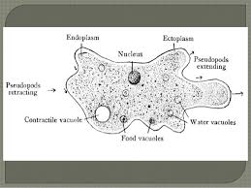
- Organelle highly specialized for feeding.
- Also occur reproduction and movement.
- Cytoplasm divided (outer layer called ectoplasm) (lower layer called endoplasm.
- Ectoplasm helps in movement, feeding and protection.
- Endoplasm houses nucleus, mitochondria, and food.

Classification on the basis of motility:
On the basis of motility they are divided into four main types.
1) Flagellates 2.ciliates 3 sarcodina 4 sporozoate
- Flagellates:
- Move by the help of flagella
- (a tail like structure)
- Movement is whip like.
- E.g. tryponosoma, leishmenia etc.
- Ciliates:
- Movement through cilia.
- Cilia are fine hair like structure attached with their body.
- Some protozoa special kind of cilia for feeding and attachment.
- Most are harmless.
- Only one species balantidium coli are pathogenic.
- Sarcodina:
- Major loco-motor organelles in sarccodina are pseudopodia.
- Common example is (amoeba)
- Most soecies are harmless.
- Enaemobia is a parasitic for human.
- Cause intestinal disease.
- Sporozoities:
- Only non-motile form of protozoa.
- Well-developed sexual and asexual stages.
- All group is parasite in nature and harmful.
- Common example is plasmodium, toxoplasma gondii.

Reproduction in protozoa:
Protozoa can be reproducing their off spring by both sexual and asexual methods:
There are two types of reproduction in protozoa:
Sexual and asexual reproduction:
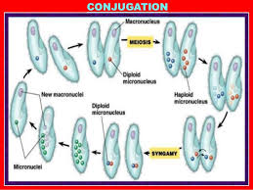
1) Sexual reproduction.
- Sexual reproduction has been observed in some protozoa.
- As in other eukaryotic organism, sexual reproduction in protozoa also involves meiotic division.
- Sexual union between two haploid nuclei results in diploid zygotic nucleus in which meiosis takes place.
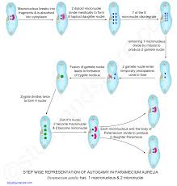
2) Asexual reproduction:
- Protozoa reproduce asexually by cell division producing two equal or sometimes unequal cells.
- The cell division in certain protozoa is longitudinal, while in others transverse.
- Methods that involves:
- Binary fission
- Budding.
- Sclinzogong.

Q3. Write down names of organelles and its functions present in paramecium and euglena?

Answer no 3

Organelles that is present in euglena and its function:

Organelles in euglena:
- Cytoplasm
- Nucleolus
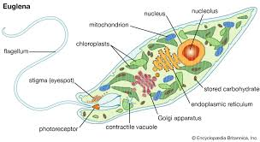
- Flagellum
- Nucleus
- Chloroplast stigma(eyespot)
- contractile vacuole
- photoreceptor

Functions of the organelles:
- cytoplasm:
- supports the internal structure and shape
- Consistency of the cell.
- Nucleolus:
- Contribute to ribosome synthesis.
- Flagellum:
- Help in move movement.
- Nucleus :
- Contain the genetic material
- Brain of the cell.
- Chloroplast:
- Help in photosynthesis.
- Stigma(eyespot)
- Allows the cell to sense light direction
- And intensity and respond to it.
- Contractile vacuole:
- Expels excess water
- Photoreceptor:
- Light sensitive protein.
- Response to light.

Organelles that is present in paramecium and their functions:
- Cytoplasm
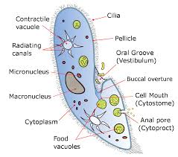
- Anal pore
- Food vacuole
- Oral groove
- Cilia
- Micronucleus
- Macronucleus
- Contractile vacuole.

Organelles functions;
- Cytoplasm:
- Support the internal structure.
- And shape and consistency of cell.
- Anal pore:
- Faces secretion.
- Food vacuole:
- It helps in the digestion.
- Oral groove:
- Food intake through cilia.
- Water currents.
- Cilia:
- Help in movement
- Food intake receptors.
- Micronucleus:
- Help in reproduction.
- Macronucleus:
- Non reproductive cell function
- E.g. metabolism
- Contractile vacuole:
- Expels excess liquid on contraction.
Q4. What is antibiotic resistance? Explain the mechanism of bacterial resistance. Its causes and solutions to the problem?

Answer NO 4

Antibiotic resistance
- Antibiotic resistance occurs when the ability of a microbe to resist the effect of medication that once could successfully treat the medication.
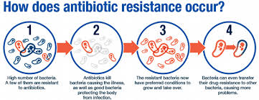
OR
- When an antibiotic has lost its ability to effectively control or kill bacteria growth.

Mechanicham of antibiotic resistance:
1)Denied access: antibiotic wants to pass the bacterial cell membrane becomes impermeable for antibiotic e.g. imipenem.
2)Antibiotic modification: in second step antibiotic becomes modified by the help of bacterial enzyme e.g. beta lactamase inactivate target because the target itself has been modified.
3)Pumping out the antibiotic faster than it gets in e.g. tetracycline.
4)Alternative target typically enzyme e.g. alternative penicillin binding protein PBP2a in MRSA.
Solution to this resistance:
• Only use of antibiotic when prescribe by a certified health professional.
• Never demand antibiotic if your health worker says you don’t need them.
• Never use left-over antibiotic.
• Never share your antibiotic with other.
• Make information available on the impact of antibiotic resistance.

Causes of antibiotic resistance

Over prescription of antibiotics:
- Physician prescribes medicine without detecting the pathogens.
- Prescribe broad spectrum antibiotic when narrow spectrum is actually needed.

Patients not compliance:
- Antibiotic prescribed in a specific dose regiment
- Patient forgets to take medicine on right time.
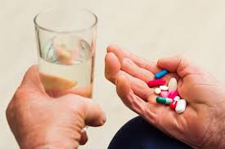
- Unable to afford full course.

Over dose of antibiotic:
- Due to take antibiotic as OTC drug
- Retail drug store presents a chaotic situation during drug distribution.
- Patients are demand for normal infection such is fever or normal cold.

Use of antibiotic on domestic animals:
- In domestic animals a good chance for antibiotic to develop resistance.
- Spreading of resistance microbe through water and food.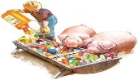

Poor quality of antibiotic:
- Expired and fake antibiotics. 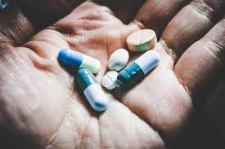
- Due to lack of quality compliance and monitoring.

Poor hygiene and sanitation:
- In some area waste water from hospitals are poorly filtered which allows resistance bacteria to escape.
- So the bacteria spread when people drink this water.

Q5. Explain the mechanism of bacterial pathogenicity. Write down at least two bacterial diseases in detail?

Answer No 5

Bacterial pathogenicity:
The relationship between a host and a pathogen is dynamic, since each can modifies the activate and functions of each other.
The outcome of such a relationship depend on
The virulence of the pathogen and
The relative degree of resistance or susceptibility of the host, mainly due to the effectiveness of the host defiance mechanisms.

Mechanism of bacterial pathogenicity:
- Invasiveness: the ability to invade tissue
- Encompasses mechanism for
- Colonization(adherence and initial multiplication)
- Production of extracelluer substance which facilitate invasion(invasions)and
- Ability to bypass host defense mechanism.

Toxigenesis:
- Ability to produce toxins.
- Bacteria may be produce two types of toxins.
1; Exotoxins. Exotoxins: are released from bacterial cell and may act at tissue sites removed from the site of bacterial growth.
- Exotoxins are secreted into the surrounding medium or released when the bacteria die and the cell wall breaks apart.
2: Endotoxins are the lipid portions of lipopolysaccharides that are part of the outer membrane of the cell wall of gram-negative bacteria. Endotoxins are released when the bacteria lyses which is why after antibiotic treatment, symptoms can worsen at first as the bacteria are killed and they release their endotoxins.

Bacterial pathogenesis:
- Infection/entry
- Virulence factors
- Pathogenesis
- Escape of immune surveillance.

Bacterial disease

1)Meningitis:
Meningitis is in inflammation of the brain and spinal cord. It is usually caused by an infection.
A serious disease in which there is inflammation of the meninges, caused by viral or bacterial infection, and marked by intense headache and fever, sensitivity to light, and muscular rigidity.

Signs and symptoms:
Severe headache | Stiff neck | Stomach/joint/muscle pain | Severe lag pain
Dislike of bright lights | Rapid breathing | Rash-at stage of disease | Cold hands
Fever/vomiting | Drowsy and less responsive | Skin vary pale, blue or dusky around lip | Clod feed with high temperature
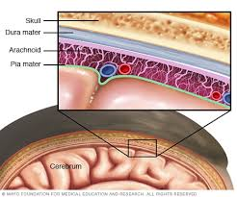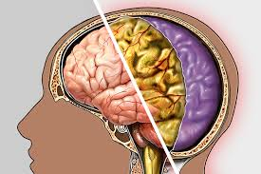

Types of meningitis:
- Viral meningitis
Viral meningitis is the most common type of meningitis. Viruses in the Enterovirus category cause 85 percent of cases. These are more common during the summer and fall.
- Bacterial meningitis:
It is not common. But they are very serious .Its need to be treated right away to prevent brain damage and death.

2)Sinusitis:
- Sinusitis is an inflammation, or swelling of the tissue lining the sinuses. OR
- Inflammation of the lining membrane in any of the hollow areas (sinuses) of the skull around the nose.

Acute sinusitis:
- Sudden onset of cold-like symptoms such as
- Runny, stuffy nose and facial pain.
- Does not go away after 10 to 14 days.
- Acute sinusitis typically lasts 4 weeks or less.
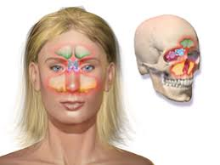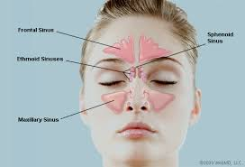

Symptoms and causes:
Symptoms: | Causes
- Facial pain/pressure | - Colds
- Loss of smell | - Bacterial upper respiratory tract infection
- Cough/congestion | - Fungal sinus infection.
- Nasal stuffiness. | - Lack of cilia motility.
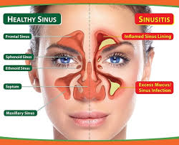

THANKS YOU SO MUCH SIR

