Physiology paper
Name: Rizwan ullah
Class: RAD 2nd
ID: 15973
Instructor: Sir Shahzeb

Q2: What is difference between haemostasis, haematopoiesis and homeostasis?
Answer:
Haemostasis:
Haemostasis is defined as arrest or stoppage of bleeding. It is the arrest of bleeding, whether it be by normal vasoconstriction (the vessel walls closing temporarily), by an abnormal obstruction (such as a plaque) or by coagulation or surgical means (such as ligation).
It occurs in three stages:
ᵒ Vasocontraction, platelet plug formation, coagulation of blood.

Hematopoiesis:
The process of formation of blood cells such that RBCs, WBC’s and platelets is called as haematopoiesis. And the sites where it occurs are known as hemopoietic tissues or organs (bone marrow, liver and spleen).
Hematopoiesis the process through which all cellular components of blood are produced. On an average a healthy human adult has a blood volume of five liters, which carries out a plethora of essential functions within the body, including the transport of oxygen and nutrients as well as the removal of waste.
Hematopoiesis are first seen in yolk sac of embryo in first three weeks of embryo.

Homeostasis:
Homeostasis is the property of human biological system which maintain the internal environment according external environment.
Homeostasis is the state of steady internal chemical and physical conditions maintained by living systems.
Regulation of homeostasis:
The regulation of homeostasis depends on three mechanisms:
- Effector.
- Receptor.
- Control Center.
The entire process continuously works to maintain homeostasis regulation.
Example:
The skin has receptors that detect changes in temperature. If the external temperature rises or drops below the equilibrium, the control center sends signals to the blood vessels and sweat glands in our skin to react accordingly. If the temperature is too hot, the blood vessels dilate (vasodilation) and cause a drop in the body temperature.

Q2(B). What is Erythroblastosis fetalis?
Answer:
Erythroblastosis fetalis:
Erythroblastosis fetalis is the disease of new born baby it is characterized aglunation and phagocytosis of the fetus red blood cell. It is a condition wherein the blood type of the mother and the fetus is not identical. Because of the difference in blood type, the antibodies of the mother attack the red blood cells of the fetus through trans placental transmission. The specific disorder could be due to
Rh incompatibility:
In Rh-incompatibility the mother has Rh-negative blood while the father has Rh-positive blood. Their resulting fetus has Rh-positive blood. The red blood cells of the fetus go to the mother’s blood circulation at pregnancy and delivery. Since the mother has a different Rh type, antibodies are produced against the fetus’ Rh type.
Sings in the fetus:
Enlarge liver spleen and heart.
Sings in born baby:
Pale appearance of baby Anemia
Yellow discoloration of the new-borns skin.
Q1. How stimuli’s of smell moves from nostril to brain? Make a diagram
Answer:

Sense of smell called Olfaction.The nose is the organ responsible for the sense of smell.
The cavity of the nose is lined with mucous membranes that have smell receptors connected to the olfactory nerve.
The smell receptors interact with the molecules of these vapors and transmit the sensations to the brain.
Physiology of smell from nostril to Brain:
Nostrils can detect odors independently from one another and can subconsciously guide you to the source of a smell.
ᵒ Chemical molecule floating in the air which is reached to the nostril of nose. In the nostril there are mucus with the mucus the molecules dissolved.
ᵒ Under the mucus olfactory cells specialized olfactory neurons are present which detect the odor of smell.
ᵒ These neurons have capability to detect thousands of smell odor.
ᵒ The specialized neurons (olfactory neurons) transmit the information to the olfactory bulb which is present in the back of the nose.
ᵒ Olfactory bulb the sensation carried through olfactory tract to the sensation area in the cerebral cortex.
ᵒ The Brain center receive sensation or odor of smell and access the memories to remind to know about the sensation to smell from where and what type of smell.
Diagram:
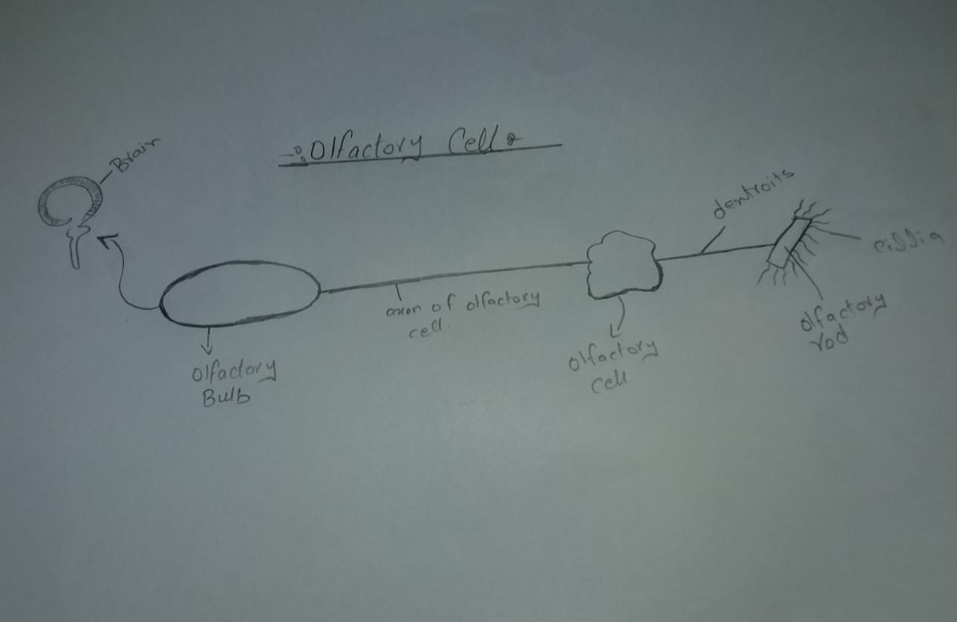

Q3(A). What is immunity? Explain different types of immunity
Answer:

Immunity:
Protection against a particular disease or illness by particular substances in the blood is called immunity of that body.
The term immunity refers to the resistance exhibited by the host towards infection caused by microorganisms and their products.
The lack of immunity is called susceptibility.
Types of immunity:
There are two types immunity
1 Innate immunity
2 Acquired immunity

Innate immunity:
It is the natural resistance components such as intact skin, salivary enzymes, and neutrophils, natural killer cells, which provide an initial response against infection.
This is the natural immunity. this immunity comes with the born.
The natural response to the disease of the body.
It acts as first line of defence against infections, microorganisms, their products before they cause disease.
It come from genetic constitution make up.
There also three types.
- Species immunity; every species have separate immunity against the pathogen.

- Racial immunity is that in which various races show marked difference in their resistance to certain infectious disease. plasmodium falciparum malaria is resistance in Africa.
- Individual immunity: is very specific for each and every individual. Resistance to infection is varies with different individual of same race and species.

- Acquired immunity:
It is that immunity which develops antibodies after an attack of an infectious disease.
Types of Acquired Immunity:
Active
Passive immunity.
Active immunity:
It refers to the method of exposing the body to an antigen for generating an adaptive immune response. The response takes days/ weeks to develop but may be long- lasting.

Natural active immunity:
This immunity develops by natural processes like infections. Example: the infection like small pox are cured by the active function of the immune system.
Artificial active immunity:
Here instead of natural infections. Infection is created artificially by using various types of vaccines. Ex: polio vaccine, cholera vaccine etc.

2 Passive immunity:
It refers to the process of imparting IgG antibodies to keep safe against infection. It gives immediate, but short- lived protection such as several weeks to 3 or 4 months at most. It is occurs during pregnancy.
- Natural passive immunity:
It occurs when anti bodies are transferred from the donor to the recipient in a natural manner. Ex: Transfer of anti-bodies from the mother to the foetus through the placenta.
- Artificial passive immunity:
The transfer anti bodies and sensitised lymphocytes from immunized donor to the no immunized recipient artificially. Example: antibodies produce in the horse serum

Q3(b). What is different between Antigen and Antibody?
Answer:

Antigen:

- “An antigen is a molecule that initiates the production of an antibody and causes an immune response.”
- An antigen is a substance which when introduced into a body evokes an immune response to produce a specific antibody with which it reacts specifically”
- Antigens are large molecules of proteins, present on the surface of the pathogen- such as bacteria, fungi viruses, and other foreign particles. When these harmful agents enter the body, it induces an immune response in the body for the production of antibodies
.
- For example: When a common cold virus enters the body, it causes the body to produce antibodies to prevent from getting sick.

Antibody:
- Antibodies are large Y-shaped proteins. They are recruited by the immune system to identify and neutralize foreign objects like bacteria and viruses.
- It is mainly synthesized by plasma cells.
- Chemically it is protein in nature
- Antibody and the antigen have similar structure at the tips of their “Y” structures.
- Just like every lock has a single key, an antibody has a single antigen key. When the key is inserted into the lock, the antibody activates, tagging or neutralizing its target.

Antibodies and antigen:
Antigens are classically defined as any foreign substance that elicits an immune response. They are also called immunogens. The specific region on an antigen that an antibody recognizes and binds to is called the epitope, or antigenic determinant.

Q4. Write down different functions Antibody?
Answer:
Function of Antibody:
- IgG provides long term protection because it persists for months and years after the presence of the antigen that has triggered their production.
- IgG protect against bacteria, viruses, neutralize bacterial toxins, trigger compliment protein systems and bind antigens to enhance the effectiveness of phagocytosis.
- Main function of IgA is to bind antigens on microbes before they invade tissues. It aggregates the antigens and keeps them in the secretions so when the secretion is expelled, so is the antigen.
- IgA are also first defense for mucosal surfaces such as the intestines, nose, and lungs.
- IgM is involved in the ABO blood group antigens on the surface of RBCs.
- Complement-mediated lysis of pathogens or of infected cells: Antibodies activate the complement system to destroy bacterial cells by lysis.
- ADCC is independent of the immune complement system that also lyses targets but does not require any other cell. ADCC requires an effector cell which classically is known to be natural killer (NK) cells

Q4(b) Write difference between primary and secondary response to an Antigen?
Primary response of Antigen:
- In a primary immune response, naive B cells are stimulated by antigen, become activated, and diferediated into antibody secreting cells that produce into Antibodies specific for eliciting antigen.
- The immune system is evolved to combat various types of infections using diverse mechanisms. These mechanisms work together to respond to the invading pathogen or the antigen. When the antigen meets the immune system for the first time, the reaction that results from the immune cells and fluids is the primary immune response. Here, the immune system is exposed to the threat for the first time. Hence, it takes a longer time to recognize the antigen and react against it. In general, the lag phase of the primary immune response goes several days to weeks without producing antibodies against the pathogen.
- The duration of the lag phase depends on the nature of the antigen it encounters and the site of antigen entry. A low amount of antibodies is produced during the primary immune response by the naive B cells and T cells. The primary immune response appears mainly in lymph nodes and spleen. First antibodies produced are IgMs. Compared to IgG, IgM antibodies are produced more, and these antibodies drastically decline with time.
- . This occurs as a result of primary contact with an antigen.
- Responding cell is naïve B-cell and T-cell.
- Lag phase is often longer (4-7 days), sometimes as long as weeks or months.
- . It takes longer time to establish immunity.
- First antibody produced is mainly IgM. Although small amount of IgG are also produced.

Secondary response:
- The secondary immune response is the reaction of the immune system when an antigen contacts with it for the second and subsequent times. Since the immune cells have been exposed to the antigen previously, the establishment of immunity against the antigen is quick and strong. With the previous immunological memory, the immune response occurs immediately and starts making antibodies. Hence, the lag phase is very short in secondary immune response due to the presence of memory cells produced by B cells. The amount of produced antibodies is high in secondary immune response, and they remain for a longer time, providing a good protection to the body. Within a short time, the level of the antibody rises to the peak. The main type of antibody produced is IgG. However, a small amount of IgM is also produced during the secondary immune response.
- This occurs as a result of second and subsequent exposure of the same antigen
- Responding cell is memory
- Lag phase is shorter (1-4 days) due to the presence of memory cell
- Level of antibody reaches peak in 3 to 5 days
- Takes shorter time to establish immunity.
- Mainly IgG antibody is produced. Although sometimes small amount of IgM are produced.

Q5. Write difference between cell mediated and Antibody cell mediated immunity?
Answer:
Cell mediated:
Cell-mediated immunity is an immune response that does not involve antibodies. Rather, cell-mediated immunity is the activation of phagocytes, antigen-specific cytotoxic T-lymphocytes, and the release of various cytokines in response to antigen. Historically, the immune system was separated into two branches: humoral immunity, for which the protective function of immunization could be found in the humor (cell-free bodily fluid or serum) and cellular immunity, for which the protective function of immunization was associated with cells. CD4 cells or helper T cells provide protection against different pathogens. Naive T cells, which are immature T cells that have yet to encounter an antigen, are converted into activated effector T cells after encountering antigen-presenting cells (APCs). These APCs, such as macrophages, dendritic cells, and B cells in some circumstances, load antigenic peptides onto the MHC of the cell, in turn presenting the peptide to receptors on T cells. The most important of these APCs are highly specialized dendritic cells; conceivably operating solely to ingest and present antigens.
The activated helper T cell, aided by activated macrophages and these cells mediate one important component of cellular immunity i.e Delayed hypersensitivity reaction specifically against Myco Bacterium tuberculosis.

Antibody mediated immunity:
Immunity conferred to an individual through the activity of B cells and their progeny, which produce circulating antibodies in response to the presence of a foreign substance and recognize the substance upon renewed exposure
- It is also called humoral immunity Compare cell-mediated immunity.
  - Main defence against extracellular encapsulated pyogenic bacteria like staphylococci and streptococci.
  - It comes in third line of defence.
  - Antibody synthesis typically involves the cooperation of three cells
  - Macrophage
  - Helper T cells
  - B cells
  - After processing by macrophages, fragements of antigen appear on surface of macrophage in association with class II MHC protein.
  - The antigen-class II MCH protein complex binds to specific receptor om surface of helper T cell which then produce Interlukins 2, 4,5.
  - These factors activate the B cell capable of producing antibodies specific for that antigen.
  - The activated B cell proliferates and differentiates to form many plasma cells that secrete large amounts of immunoglobulins ( antibody)
  - Although antibody formation usually involves helper T cells, certain Antigen (bacterial polysaccharides) can activate B cells directly, without the help of T cells, and are called T cell independent antigens.
  - In this T cell independent response, only IgM is produced by cells
  - While for IgA, IgG and IgE require helper T cell to be produced.

THE END

