Submitted By: Rafi Ullah
ID: 15440
Submitted To: Sir Reza Ahmad Khan
Subject: Basic Statistics
Semester: 3rd BBA

Fill in the blanks:

- Statistics is the word which use to measure data.
- Figures belongs with quantitative data.
- Attributive study of the data belongs with qualitative data
- Stratification is the process which separate data in homogeneous groups.
- The graph which construct on behalf of continuous group of data is called as
Line graph.
- The Grading score of the students belongs with Interval measurement scale.
- Today’s temperature was recorded at 32⁰ F, lies in the category of
Interval measurement scale.
- Statistics has very limited number of usage in advance research studies. (False)
- Number of dots in a single line is very good example of countable data. (True)
- Qualitative data do not belong with the field of Statistics. (False)
Question No: 02
- Describe the relevant fields and branches of Statistics.
Answer
Main branches of statistics are:
Descriptive statistics:
It describes, show or summarizes data in a meaningful way. They are simply a way to describe our data.
Descriptive statistics are very important because if we simply presented our raw data it would be hard to understand what the data was showing especially if there was a lot of it. Descriptive statistics therefore enables us to present the data in more meaningful way which allows simpler interpretation of the data.
inferential statistics
takes data from a sample and makes inference about larger population from which the sample was drawn
relevant fields of statistics are :
- Statistics is used in weather forecasting
- Is used in research
- Statistics is used in insurance
- Plays a very important role in financial market
- Is used in medical field
- Stock market
- Consumer good
- Quality testing

- How could you elaborate the “Importance and Applications of Statistics”.
Answer:
Statistics is important because it is almost used in every aspect of our daily life.
Statistics is applied in various areas;
- Mathematics
The formulas used in math are reliable, but to get more precision and exactness, statistics methods are important. In fact, it is called the branch of applied math.
2. Business:
Business students must be aware of the importance of statistics in the field. There are times when a businessman has to make quick decisions, and this can be done by using its concepts which make the decision-making easy. He strategizes the marketing, finance, production, resource through it. What are the tastes and preferences of consumers? What should be the quality? What should be the target market? All these questions are answered using statistical tools.
- Economics
There are so many concepts of economics that are completely dependent on statistics. All the data collected to find out the national income, employment, inflation, etc., are interpreted through it. In fact, theory of demand and supply, relationship between exports and imports are studied through this subject. The perfect example of this is census; the bureau uses its formulas for calculating a country’s population.
- Country’s Administration
Many national policies are decided using statistical methods, and administrative decisions are taken based on its data. Statistics provides most accurate data which helps government to make budgets and estimate expenditures and revenues. It is also used to revise the pay scale of employees in case cost of living is rising.
- Astronomy
When scientists measured the distance between sun and earth, or moon and earth, they did not use any measurement scale or ruler for that. It was these statistical methods that helped them to find out the best answers and estimates that are possible. It is difficult to measure the mass, size, distance, density of objects in the universe without any error, but statistics formulas do this with the best probability.

6. Banking
When someone deposits his money in banks, the idea is that he will not withdraw the amount in the near future. So, banks lend this money to other customers to earn profit in the form of interest. They use statistical approach for this service.

Question No: 03

- “The initial techniques which are usually prefer during transformation of data towards information are mostly recommendable during presentation of data.” Elaborate the above mentioned statement precisely.
Answer:
Elaboration of the statement above:
The statement above states that the basic techniques that people like while transforming date into information are mostly suggested when putting the data in a useful and attractive manner.

- Construct an appropriate frequency distribution for the following data related to an experimental yield.
93, 89,75, 97,75,47, 73, 40, 100, 42, 39, 75, 13, 39, 89, 78, 32, 72, 51, 21, 92, 45, 29, 58, 16, 31, 6, 82, 76, 10, 10, 32, 2, 25, 98, 94, 93, 91, 68, 20, 19, 61, 37, 98, 72, 61, 72, 19, 81, 78.
Answer:
Classes/group | Class boundaries | Tally | Frequency | Mid point
2_12 | 1.5_12.5 | //// | 4s | 7
13_23 | 12.5_23.5 | //// / | 6 | 18
24_34 | 23.5_34.5 | //// | 5 | 29
35_45 | 34.5_45.5 | //// | 5 | 40
46_56 | 45.5_56.5 | // | 2 | 51
57_67 | 56.5_67.5 | /// | 3 | 62
68_78 | 67.5_78.5 | //// //// // | 12 | 73
79_89 | 78.5_89.5 | //// | 4 | 84
90_100 | 89.5_100.5 | //// //// | 9 | 95
 |  |  | Total: 50

- Construct the followings about the Question 3 (b).
• Simple Bar Graph & Histogram

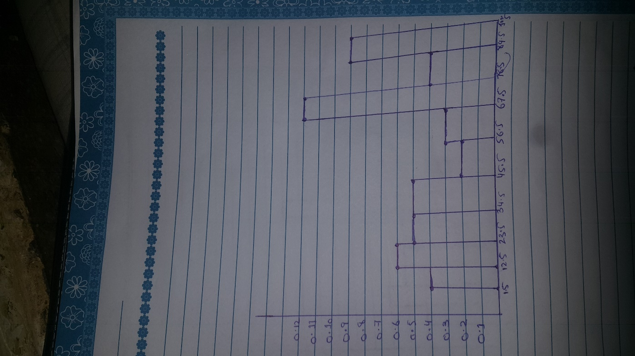
Histogram

Simple bar graph

