16895
Osama Saeed
Bs Cs 1st Semester
INTRODUCTION TO ICT

Q1) What are the relation between hardware and software. And types of software with Logical system architecture.
Answer
Hardware
Hardware refers to the physical device of a computer
Computer hardware includes the physical parts of a computer
Such as the case, central processing unit (CPU), monitor, mouse, keyboard, computer data storage, graphics card, sound card, speakers and motherboard.
Software
Software refers to collect a program.
Computer software, also called software, is a set of instructions and its documentations that tells a computer what to do or how to perform a task.
Software includes all different software programs on a computer, such as applications and the operating system.
Types of Software
System Software are design to control the operation and extend the processing capability of a computer.
Application Software are design to solve a specific problem or to do specific task.
The Relation between Hardware and Software
Both hardware and software are necessary for a computer to do useful job. They are complementary to each other.
Same hardware can be loaded with different software to make a computer system perform different types of job.
Except for upgrades, hardware is normally a onetime expense, whereas software is continuing expense.
Upgrades refer to renewing or changing components like increasing the main memory, or hard disk capacities, or adding speakers, modems, ets.
Logical system architecture.
HARDWARE
(Physical devices/components of the computer system)
SYSTEM SOFTWARE
(Software that constitute the operating and programming environment of the computer system)
APPLICATION SOFTWARE
(Software that do a specific task or solve a specific problem)
USERS
(Normally interact with the system via the user interface provided by the application software)
Q2) Write a note on Multimedia and its type with common media for storage access and transmission in details.
Answer
Multimedia
Media is something that can be used for presentation of information.
Two basic ways to present some information are:
Unimedia presentation: Single media is used to present information
Multimedia presentation: More than one media is used to present information
Multimedia presentation of any information greatly enhances the comprehension capability of the user as it involves use of more of our senses
Common Media
Common media for storage, access, and transmission of information are:
Text (alphanumeric characters)
Graphics (line drawings and images)
Animation (moving images)
Audio (sound)
Video (Videographed real-life events)
Multimedia in information technology refers to use of more than one of these media for information presentation to users
Multimedia Computer System
Multimedia computer system is a computer having capability to integrate two or more types of media (text, graphics, animation, audio, and video)
In general, size for multimedia information is much larger than plain text information
Multimedia computer systems require:
Faster CPU
Larger storage devices (for storing large data files)
Larger main memory (for large data size)
Good graphics terminals
I/O devices to play any multimedia
Multimedia Applications
Multimedia presentation
Foreign language learning
Video games
Special effects in films
Multimedia kiosks as help desks
Animated advertisements
Multimedia conferencing
Transmission
the topic of multimedia transmission over wireless networks highlighting general challenges driving the research on wireless technologies and networking techniques for mobile multimedia support. After an overview of wireless networks and multimedia transmission characteristics, a layered analysis is provided ranging from the application to physical protocol layers. This discussion is extended with a cross-layer perspective focusing on cross-layer design. The chapter also introduces a number of emerging wireless/mobile networking concepts including Cognitive Radio Networks (CRNs), ad hoc and multihop networks, and mobile content delivery with a discussion of key issues from multimedia networking perspective. These approaches are envisaged to increase wireless link rates while also improving system capacity, energy efficiency and spectral efficiency dramatically. Finally, we present and discuss major challenges for modeling and simulation of wireless multimedia networking in this diverse and dynamic environment.
Q3) Write a note on each of the following in details.
(a) Modulation Techniques. (b) Multiplexing
(c)Switching Techniques.(d)Optical Fiber Communication System
Answers
(a) Modulation Techniques:
Amplitude Modulation (AM): Two binary values (0 and1) of digital data are represented by two different amplitudes of the carrier signal, keeping frequency and phase constant
Frequency Modulation (FM): Two binary values of digital data are represented by two different frequencies, while amplitude and phase are kept constant
Phase Modulation (PM): Two binary values of digital data are represented by shift in phase of carrier signal
(b) Multiplexing
Method of dividing physical channel into many logical channels so that a number of independent signals may be simultaneously transmitted.
Electronic device that performs multiplexing is known as a multiplexer.
Multiplexing enables a single transmission medium to concurrently transmit data between several transmitters and receivers.

Two Basic Methods of Multiplexing
Frequency-Division Multiplexing (FDM): Available bandwidth of a physical medium is divided into several smaller, disjoint logical bandwidths. Each component bandwidth is used as a separate communication line
Time-Division Multiplexing (TDM): Total time available in a channel is divided among several users, and each user of the channel is allotted a time slice during which he/she may transmit a message
(c)Switching Techniques
Data is often transmitted from source to destination through a network of intermediate nodes
Switching techniques deal with the methods of establishing communication links between the sender and receiver in a communication network
Three commonly used switching techniques are:
Circuit switching: Dedicated physical path is established between sending and receiving stations through nodes of the network for the duration of communication
Message switching: Sender appends receiver’s destination address to the message and it is transmitted from source to destination either by store-and-forward method or broadcast method
Packet switching: Message is split up into fixed size packets and each packet is transmitted independently from source to destination node. Either store-and- forward or broadcast method is used for transmitting the packets. All the packets of a message are re- assembled into original message at the destination node.
(d)Optical Fiber Communication System
Fiber-optic communication is a method of transmitting information from one place to another by sending pulses of infrared light through an optical fiber.
The light forms an electromagnetic carrier wave that is modulated to carry information. Fiber is preferred over electrical cabling when high bandwidth, long distance, or immunity to electromagnetic interference are required.
This type of communication can transmit voice, video, and telemetry through local area networks, computer networks, or across long distances.
Optical fiber is used by many telecommunications companies to transmit telephone signals, Internet communication, and cable television signals. Researchers at Bell Labs have reached internet speeds of over 100 petabit×kilometer per second using fiber-optic communication.
Q 4 What is OSI reference model explain each layer of OSI model in details.
Answer
OSI
The Open System Interconnection (OSI) model is framework for defining standards for linking heterogeneous computers in a packet switched network.
Standardized OSI protocol makes it possible for any two heterogeneous computer systems, located anywhere in the world, to easily communicate with each other.
Separate set of protocols is defined for each layer in its seven-layer architecture. Each layer has an independent function.
OSI model
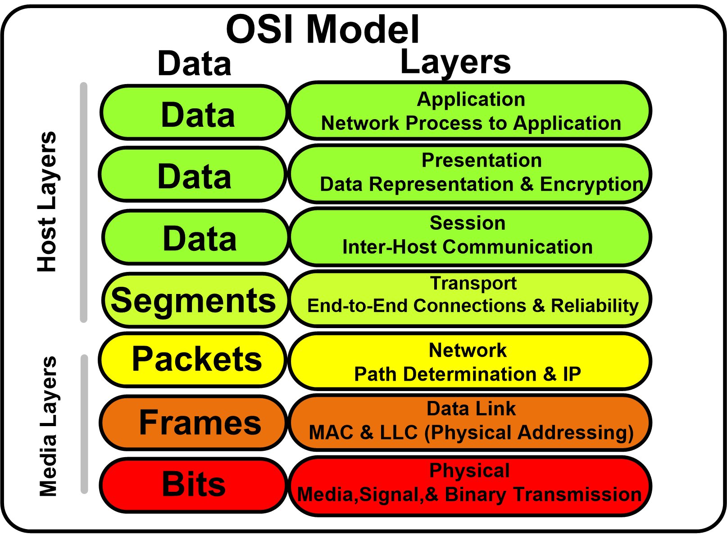

Layer of OSI model
1. The Physical Layer
This layer includes the physical equipment involved in the data transfer, such as the cables and switches. This is also the layer where the data gets converted into a bit stream, which is a string of 1s and 0s. The physical layer of both devices must also agree on a signal convention so that the 1s can be distinguished from the 0s on both devices.
2. The Data Link Layer
The data link layer is very similar to the network layer, except the data link layer facilitates data transfer between two devices on the SAME network. The data link layer takes packets from the network layer and breaks them into smaller pieces called frames. Like the network layer, the data link layer is also responsible for flow control and error control in intra-network communication (The transport layer only does flow control and error control for inter-network communications).
3. The Network Layer
The network layer is responsible for facilitating data transfer between two different networks. If the two devices communicating are on the same network, then the network layer is unnecessary. The network layer breaks up segments from the transport layer into smaller units, called packets, on the sender’s device, and reassembling these packets on the receiving device. The network layer also finds the best physical path for the data to reach its destination; this is known as routing.
4. The Transport Layer
Layer 4 is responsible for end-to-end communication between the two devices. This includes taking data from the session layer and breaking it up into chunks called segments before sending it to layer 3. The transport layer on the receiving device is responsible for reassembling the segments into data the session layer can consume.
5. The Session Layer
This is the layer responsible for opening and closing communication between the two devices. The time between when the communication is opened and closed is known as the session. The session layer ensures that the session stays open long enough to transfer all the data being exchanged, and then promptly closes the session in order to avoid wasting resources.

6. The Presentation Layer
This layer is primarily responsible for preparing data so that it can be used by the application layer; in other words, layer 6 makes the data presentable for applications to consume. The presentation layer is responsible for translation, encryption, and compression of data.
7. The Application Layer
This is the only layer that directly interacts with data from the user. Software applications like web browsers and email clients rely on the application layer to initiate communications. But it should be made clear that client software applications are not part of the application layer; rather the application layer is responsible for the protocols and data manipulation that the software relies on to present meaningful data to the user. Application layer protocols include HTTP as well as SMTP (Simple Mail Transfer Protocol is one of the protocols that enables email communications).

