Name:Arif ullah
Id:16073
Section:A
Assignment: Architecture and town plaining
Teacher’s:Miss Alina Mushtaq
Qno:What is beaux Arts and Neo Ghothic?
Ans:Beaux Arts:The Beaux Arts is an subet of Neoclassical and the Greek revival Architectural style.An dominant design during Gilded age.An beaux art was the popular but it was short an lived movement in United States as lasting from roughly 1885-1925.The beaux arts is also called Beaux art classicim.The beaux arts is an late and an eclectic from Neoclassicm.It was a combined the classical Arcticture from the an ancient of Greece and Rome with the renaissance ideas.The Beaux Arts is an architecture is became part of the late 19 century American renaissance movement. The beaux art is a characterized by the order symmetry an formal design of grandiosity and the elaborate ornamentation. An Architectural characteristics includes as an beaux arts is a balustrades,balconies, columns,cornices, pillasters and is a triangular of a pediment.As an the United States the Beaux art is led to a planned of neighborhood and large a ostentatious houses wide ,boulevards and vast parks. It is an a beacause of is an size and is a grandiosity of an a building.The Beaux art is an the most commonly used for the public building likes a museum railway station, library banks, courthouses and government building.
As an the beaux arts style evolved from the French classicism of style Louis XIV and the French is a neoclassicism in a beginning of with a Louis XV and is a Louis XVI. The French architectural revolution were an governed by a the Academie rolyale de Architecture 1671 to is 1793 . There are some of the following are the French revolution by the architecture section of a Academie des beaux Des arts .there is a formal of a neoclassicism of the old is regime was is an the challenged by the four are of a teacher’s of a academy his name is Joseph Louis duc,Felix Duban,Henry lebrouste and Leon Vaudoyer ,these teacher’s have studied is an academy of in Rome at the end of the 1820. They are wanted to be a break away from the strict a formality of the old style by introducing a new style of architecture from a middle ages and is a renaissance. There are a goal was to be made an authentic french style is based upon on a French style. They have been started their work is on the beginning of a 1837 by is the creation of the Commission of an a Historic Monuments and its was a headed by the writer and is a historian Prosper Merimee and was a the great interest is in the middle ages caused by the publication is in th 1831.This style was an reffered to as an Beaux Arts in a English reached the apex of it’s development during is the second Empire (1852-1870).This style was an instruction that are produced Beaux Arts Architecture continued with out a major until the 1968.This beaux arts have been heavily an influenced the Architecture of the United States is in the period of the a 1880-1920. In contrast many of the most of the European architects of the period of a 1860 to 1914. The outside France is are gravitated are a away from the Beaux Arts and towards their own a national academic center.
SOME OF THE BEAUX ARTS BUILDING PICTURE ARE A GIVEN BELOW…..
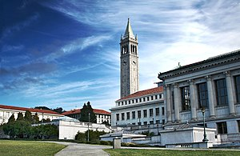
Beaux arts building at the University of the California at Berkely.
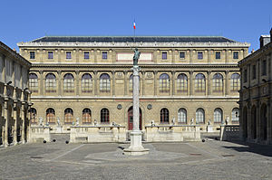

Beaux Arts in Paris.

Neo Gothic:
The Gothic is in a style of an art and an Architecture that is originated in the 19 century.It was a characterized by the revival of medievel an Gothic forms. The Gothic is an Revival are an Architectural movement of a began in the late of a 1740 in England. It’s was a momentum an grew in the early of an 19 century.When was the increasingly seriously and an learned the admirers of a neo-Gothic styles it was a sought to a revive medievel an Gothic Architecture in the contrast of the neo classical styles was a prevalent at the time .The Gothic Revival draws a features from the an original Gothic style is an including decorative patterns and the label stops. By this a mid 19 century it was an established as the an preeminent Architectural style is in the western world. The Gothic Revival of a movements are a roots are the interwind of an with a deeply Philosophical was a movement’s of a associated with an a Catholicism and is a reawakening of a high church with as a belief and its was a re-awakening of an a high chruch and belief is the an concerned by the growth of an a religious is a non conformism.The is a Anglo -Catholicism in it was a tradition of the religious beliefs and is an a style became as known as for its intrinsic appeal is in the third quarter of a the 19 century. The Gothic Revival Was an a Architecture varied by the a considerably it’s is a faith to the both is an a ornamentals style and principal of a construction of it’s medievel original, sometimes amounting to it’s little more than is an a pointed window to a frames and a few touches of a Gothic decoration on the building is an otherwise on a as wholly 19th-century the plan and is a using of contemporary materials and is in construction of a method. In parallel is to the an ascendancy of a non-Gothic styles in 19th-century.In the England, interest is an spread to the rest of Europe, Australia, Africa and the America.It is the 19th century and the early of is of a 20th centuries it was a saw is a the construction of a very large and a numbers of an Gothic Revival structures is in a worldwide. It was is an of influence of an a Revivalism had an a nevertheless and a peaked by the a 1870s. New an a architectural movements, it is a sometimes is a related as in the Arts and a Crafts movement, and sometimes it was a outright opposition , just like a Modernism gained ground, and by the 1930s is an architecture of the Victorian an era was a generally condemned or ignored. The is a of later 20th century saw a revival of interest and is a manifested in the a United Kingdom by the establishment of the Victorian Society in 1958.
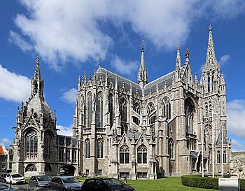
It was Sint-petrus-en-pauluskerek in Belgium.
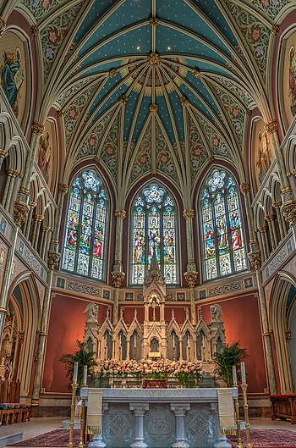
found in United States.
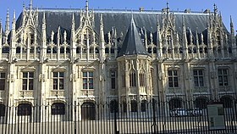
It’s is a parliment in France
The End.

