RAD II and DT II Name: Najeeb Ullah
Final term ID: 16561
BIOCHEMISTRY SECTION: B

Marks 50
Write note on following questions each carries equal marks
1) Write down the 4 steps involve in beta oxidation?
2) Write down clinical significance of the following enzymes
a) Alkaline phosphatase
b) Creatine kinase
c) gamma-glutamyl transferase
3) How many proteins are involve in electron transport chain and how do electrons move in the electron transport chain?
4) Write down the four steps involved in beta oxidation?
5) How uric acid formation takes place in body?

Answer no :1
Beta oxidation take place in four steps:
Dehydrogenation, hydration, oxidation and thyolisis. Each steps is catalyzed by a distinct enzyme. Briefly each cycle of this process beings with an acyl-CoA chain and ends with one acetyl-CoA one FADH2 one NADH and water, and the acyl-CoA chain become two carbons shorter.

Dehydrogenation
In the first step, acyl-CoA is oxidized by the enzyme acyl CoA dehydrogenase. A double bond is formed between the second and third carbons (C2 and C3) of the acyl-CoA chain entering the beta oxidation cycle; the end product of this reaction is trans-Δ²-enoyl-CoA (trans-delta 2-enoyl CoA). This step uses FAD and produces FADH2, which will enter the citric acid cycle and form ATP to be used as energy. (Notice in the following figure that the carbon count starts on the right side: the rightmost carbon below the oxygen atom is C1, then C2 on the left forming a double bond with C3, and so on.)
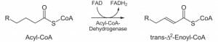

Hydration
In the second step, the double bond between C2 and C3 of trans-Δ²-enoyl-CoA is hydrated, forming the end product L-β-hydroxyacyl CoA, which has a hydroxyl group (OH) in C2, in place of the double bond. This reaction is catalyzed by another enzyme: enoyl CoA hydratase. This step requires water.
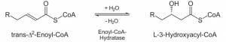

Oxidation
In the third step, the hydroxyl group in C2 of L-β-hydroxyacyl CoA is oxidized by NAD+ in a reaction that is catalyzed by 3-hydroxyacyl-CoA dehydrogenase. The end products are β-ketoacyl CoA and NADH + H. NADH will enter the citric acid cycle and produce ATP that will be used as energy.
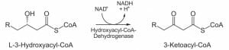
Thyolisis:
Finally, in the fourth step, β-ketoacyl CoA is cleaved by a thiol group (SH) of another CoA molecule (CoA-SH). The enzyme that catalyzes this reaction is β-ketothiolase. The cleavage takes place between C2 and C3; therefore, the end products are an acetyl-CoA molecule with the original two first carbons (C1 and C2), and an acyl-CoA chain two carbons shorter than the original acyl-CoA chain that entered the beta oxidation cycle.
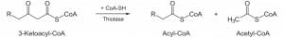
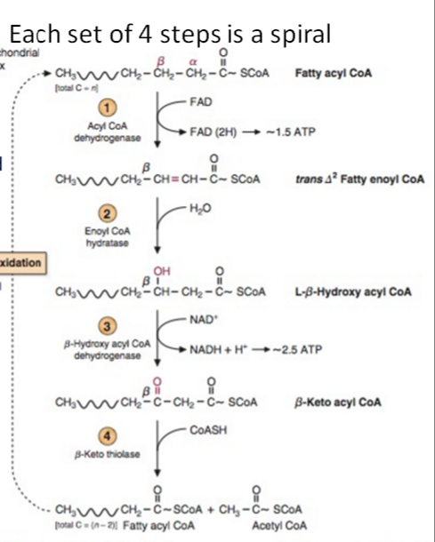
ANSWER NO : 5
URIC ACID :
Is a waste product found in blood. It`s created when the body breaks down chemicals called purines.
Most uric acid dissolves in the blood, passes through the kidneys and leaves the body in urine.
Food and drinks high in purines also increase the level of uric acid.
Normal range of uric acid in the human body
Most of it is excreted (removed from youir body ) in your urine, or passes though your intestines to regulate “normal” levels. Normal uric acid levels are 2.4-6.0 mg/dL (female) and 3.4-7.0 mg/dL (male). Normal values will vary from laboratory to laboratory. Also important to blood uric acid levels are purines.
Uric acid compound
Uric acid formed by break down purine nucleotide, purine nucleotide are (Adenosine, Guanine and Inosine ) generally we have
Uric acid is heterocyclic compound of carbon, nitrogen, oxygen, and hydrogen with the formula C5H4N4O3 it forms ions and salts known as urates and acid urates, such as ammonium acid urate. Uric acid is a product of the metabolic breakdown of purine nucleotides, and it is a normal component of urine. High blood concentrations of uric acid can lead to gout and are associated with other medial condition, including diabetes and the formation of ammonium acid urate kidney stones.
(AM P) Adenosine monophosphate
(GMP) guanine monophosphate (IMP) Inosine monophosphate
(AMP) change form Adenosine
(GMP) change form Guanosine
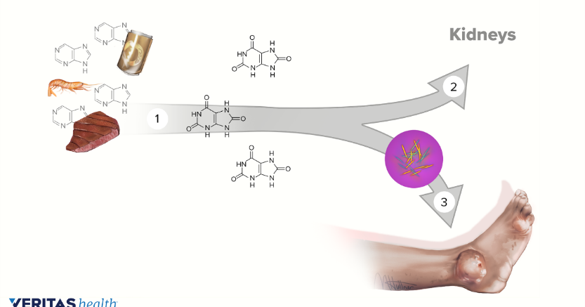
Answer no :2
Alkaline phosphatase:
clinical significance
The majority of sustained elevated ALP levels are associated with disorders of the liver or bone, or both. Therefore, these organ systems are of prime consideration in the differential diagnosis.
A variety of primary and secondary hepatic conditions may be associated with elevated serum ALP levels. Since production is increased in response to cholestasis, serum ALP activity provides a sensitive indicator of obstructive and space-occupying lesions of the liver. The latter includes neoplastic (primary or metastic) and infiltrative diseases (granulomatous hepatitis). Bilirubin excretion is compromised only with extensive biliary obstruction or diffuse hepatic cell disruption; therefore, differential elevation of ALP relative to serum bilirubin provides an early indicator for obstructive or space-occupying conditions. Hepatic cell lesions are manifested by hyperbilirubinemia and dominant serum elevation of parenchymal enzymes, such as aminotransferases; ALP elevations may be only minimal.
Diseases of bone associated with increased serum ALP are restricted to the presence of osteoblastic activity. Elevations are generally detectable prior to roentgenographic abnormalities. Neoplasms involving bone may be associated with marked serum elevations when lesions incite osteoblastic reaction, such as metastatic adenocarcinoma of the prostate. Conversely, osteolytic lesions such as occur within multiple myeloma are not associated with increased serum ALP activity. Metabolic bone diseases usually associated with serum enrichment by the bone isoenzyme include rickets, osteomalacia, and Paget's disease. Levels are usually normal in osteoporosis. Increased serum activity may be observed after bone fractures, rising after 1 week and persisting for up to 3 months.
Elevated serum ALP occurring with neoplastic disease may be due to hepatic metastases, bone metastases, or direct contribution by neoplastic cells. Isoenzymes with physicochemical characteristics similar to the placental isoenzyme have been attributed to ectopic production by a variety of neoplasms; this apparently represents derepression of normally repressed fetoplacental genes.
Clinically obscure elevations of ALP are commonly observed when multitest biochemical panels are performed on hospital populations. Because of the cellular distribution of ALP, increased serum activity may be caused by a wide variety of disorders involving multiple organs. Attempts to define organ source by isoenzyme study may be met with limited success because of technical limitations; accurate measurement of different isoenzymes contributing to total serum ALP activity is not currently possible. However, the presence of the intestinal or placental isoenzyme may be revealed by selected methods. Evaluation of an unexpectedly increased ALP should include the following:
- Exclude physiologic causes. Is the patient pregnant or an actively growing child?
- Observe for the presence of clinical or biochemical clues to the origin of increased enzyme activity. Increased serum bilirubin or aminotransferase (either aspartate or alanine) activity suggests hepatic rather than bone origin. Disproportionate elevation of lactic dehydrogenase (LDH) relative to transaminase usually suggests nonhepatobiliary or multiorgan system disease. The association of elevated LDH, hypercalcemia, and hyperuricemia suggests metastastic neoplastic disease.
- Is the elevation transient such as observed in various tissue reparative processes, healing bone fractures, or passive congestion of the liver?
- Measurement of other enzymes such as 5′-nucleotidase or gamma-glutamyltransferase may assist with identifying the hepatobiliary system as a source of elevated ALP since these enzymes are not significantly present in bone. 5′-Nucleotidase is a highly specific but less sensitive indicator of hepatobiliary disease. Gamma glutamyltransferase is more sensitive; however, with the exception of its absence in bone and placenta, it is a less specific indicator of hepatobiliary disease than ALP.

gamma-glutamyl transferase
clinical significance
Hepatobiliary disease is the predominant source of increased serum GGT activity. Increases are associated with all forms of primary and secondary hepatobiliary disorders. Elevations are moderate (2 to 5 times reference) with diffuse hepatic cell injury due to toxic or infectious hepatitis. Cholestasis due to intrahepatic or extrahepatic biliary obstruction causes higher serum levels (5 to 30 times reference). Increases occur earlier and persist longer than ALP in cholestatic disorders. Since skeletal disease is not associated with increased serum activity, measurement of GGT is of clinical value in identifying the source of obscure ALP elevations. Levels in children after age 1 year and healthy pregnant women are within the usual adult reference range.
Elevated serum levels of GGT are also found in alcoholics and patients receiving certain drugs, such as phenytoin or phenobarbital. This is probably the result of microsomal induction of enzyme activity. Serum measurement can be used to monitor alcoholic patients during therapy; abstinence from alcohol is associated with decrease in serum GGT activity. In addition, alcohol-induced hepatic cell injury may cause significantly higher serum levels than other causes of parenchymal disorders.
Elevated GGT activity also occurs in patients with acute and chronic pancreatitis. Prostatic adenocarcinoma may be associated with increased serum levels. Therefore, although increases are absent with skeletal diseases, GGT activity should not be considered a highly specific indicator of hepatobiliary disease.
Creatine kinase
clinical significance
The early and accurate diagnosis of acute myocardial infarction is obviously a desirable goal for assessment of symptoms and planning of therapy. Additionally, expensive coronary care unit time should be utilized in a cost-effective manner. Chest pain syndromes are not specific, and absolute ECG diagnosis ("Q wave infarction") is specific but insensitive.
Determination of CK–MB isoenzyme has a 98% predictive value for myocardial necrosis with a positive enzyme profile and a 100% negative predictive value for the absence of necrosis with a normal profile. Values must be assessed within 24 hours of symptom onset, however.
For the optimal clinical use of CK–MB determinations, the following suggestions are made:
- The clinician must have access to a quality-controlled laboratory capable of determining CK and CK–MB isoenzymes rapidly and with an acceptable degree of reproducibility.
- Because of the short serum half-life of CK–MB, blood sampling must begin within 48 hours (and preferably within 24 hours) of symptoms. Serum sampling should be obtained at first contact and at 8- to 12-hour intervals for 48 hours to observe the characteristic appearance, peak, and disappearance of CK– MB. Serial sampling is emphasized and single values in the emergency room setting are inadequate to exclude myocardial injury.
- Patients seen more than 48 hours after symptoms should have determination of lactic dehydrogenase (LDH, total and isoenzymes), seeking the characteristic elevation of total LDH and isoenzyme "flip" seen after infarction (LDH-1 isoenzyme to LDH-2 isoenzyme in a ratio of 1.0 or more in the presence of increased total LDH levels). Peak LDH values occur 48 to 72 hours following infarction and remain abnormal for 10 to 14 days. False positives are not uncommon in the measurement of LDH and its isoenzymes. Major pitfalls include hemolysis of the blood sample, hepatic congestion due to CHF, and skeletal muscle damage.
- Clinical judgment must be exercised in the rare instance where CK–MB is elevated in the absence of myocardial necrosis. A prime example is the occurrence of chest pain in an athlete during or after competition, where CK–MB levels may be elevated (both percentages and absolute values) from skeletal muscle sources.
- When the diagnosis of acute MI is strongly entertained, CK–MB levels should be determined in spite of normal CK levels. Small infarctions may release significant levels of CK–MB with normal total CK. This situation is unusual, however, and further samples should be obtained and analyzed.
- Because of the rapid rise and fall of CK–MB levels after a myocardial infarction, it is useful to sample CK–MB again at 8- to 12-hour intervals following recurrent post-MI chest pain in order to detect infarct extension.
- Regardless of the sensitivity and specificity of CK–MB in detecting myocardial injury, the study has no diagnostic power for the diagnosis of severe ischemia without infarction. Clinical acumen and appropriate studies are necessary for accurate diagnosis.
Answer no :4
URIC ACID FORMATION.
MAJOR PATH WAY:
major path way of nitrogen excretion being is urea which is synthesis is the liver release into blood streem and excreted by the kidney.
SITE OF SYNTHESIS:
Urea formation take place in liver and all enzyme involved in urea formation are isolated from liver tissues.
PROCESS OF UREA FORMATION:
part of urea cycle occur in mitochondria and part of it occur in cytoplasm.

SYNTHESIS OF CARBOMYL PHOSPHATE:
In the first step ammonium ion CO2 and phosphate of ATP combine together to from carbomyl phosphate in presence of enzyme C/ D Synthesis I.this reaction occur in the mitochondria.

SYNTHESIS OF CITRULLINE:
in 2nd step the carbomal react with ornithin in presence of catalyst called orinithine Trans carbo my lase which Will from citrulline and organic phosphate.
The above reaction occur in mitochondria wheraas the orinthinne utilized in above reaction is transport from cytoplasm into mitochondria.
Orinthine used in above step as itselp produced in last step of urea cycle.
SYNTHESIS OF ARGININOSUCCINATE:
3TD step the citrulline formed in 2nd step is now trasnfare out of mitochondria into cytoplasm. This prosis occur in the presence of enzyme called Argininoscuinate synthesis.
CLEAVAGE OF ARGININOSUCCINATE:
in 4 step cleavage of argininosuccinate occur in presence of an enzyme called Arginino succinase which result in formations of arginine and fumarate.
The Fumarate formed in above step enter in citric aid cycle.this show a relationship between the urea cycle and citric acid cycle..
CLEAVAGE OF ARGININE:
in last step of urea cycle the arginine form4 steps is cleaved to form orinthine and urea . the reaction is catalyzed by in enzyme called arginine.
The Ornithine priduced in final step is transport to mitochondria where is used a subtrate in 2 step of UC for the formation of citrulline to result the cycle.
The Urea produced in reaction enter blood circulation and is excreted in urea.
ADVNTAGE:
Ammonia is toxic substance which is produced during metabolism of dietory protein, carbohydrates and lipid . so with help of urea cycle toxic ammonia is converted into non toxic substance called urea

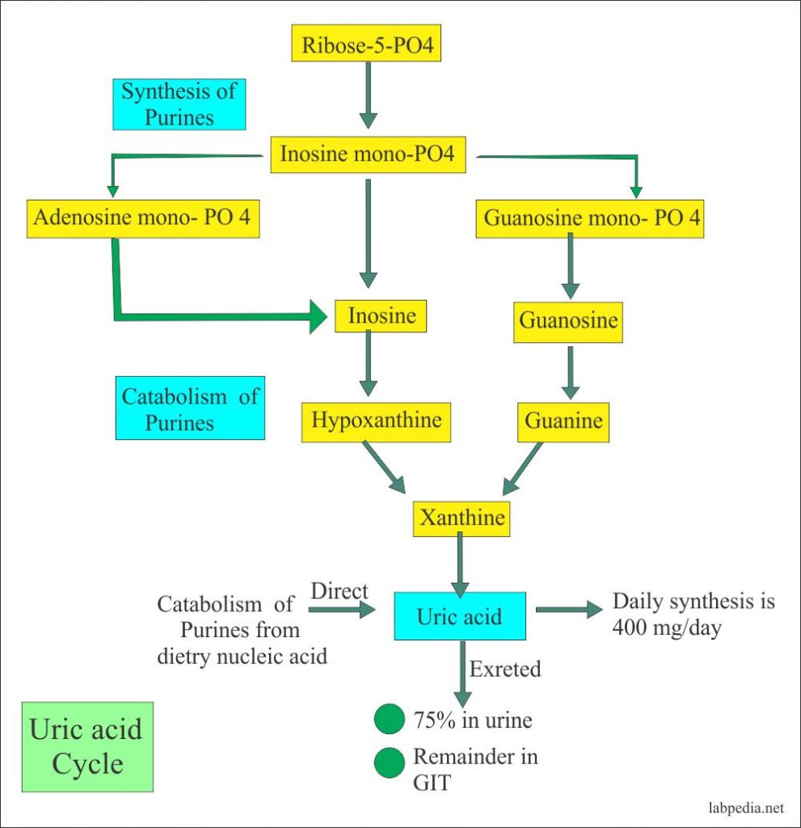

Answer no :3
The electron transport chain: The electron transport chain is a series of electron transporters embedded in the inner mitochondrial membrane that shuttles electrons from NADH and FADH2 to molecular oxygen. In the process, protons are pumped from the mitochondrial matrix to the intermembrane space, and oxygen is reduced to form water.
Complex 1
To start, two electrons are carried to the first complex aboard NADH. Complex I is composed of flavin mononucleotide (FMN) and an enzyme containing iron-sulfur (Fe-S). FMN, which is derived from vitamin B2 (also called riboflavin), is one of several prosthetic groups or co-factors in the electron transport chain. A prosthetic group is a non-protein molecule required for the activity of a protein. Prosthetic groups can be organic or inorganic and are non-peptide molecules bound to a protein that facilitate its function.
Prosthetic groups include co-enzymes, which are the prosthetic groups of enzymes. The enzyme in complex I is NADH dehydrogenase, a very large protein containing 45 amino acid chains. Complex I can pump four hydrogen ions across the membrane from the matrix into the intermembrane space; it is in this way that the hydrogen ion gradient is established and maintained between the two compartments separated by the inner mitochondrial membrane. Complex 2
Complex II directly receives FADH2, which does not pass through complex I. The compound connecting the first and second complexes to the third is ubiquinone (Q). The Q molecule is lipid soluble and freely moves through the hydrophobic core of the membrane. Once it is reduced to QH2, ubiquinone delivers its electrons to the next complex in the electron transport chain. Q receives the electrons derived from NADH from complex I and the electrons derived from FADH2 from complex II, including succinate dehydrogenase. This enzyme and FADH2 form a small complex that delivers electrons directly to the electron transport chain, bypassing the first complex. Since these electrons bypass, and thus do not energize, the proton pump in the first complex, fewer ATP molecules are made from the FADH2 electrons. The number of ATP molecules ultimately obtained is directly proportional to the number of protons pumped across the inner mitochondrial membrane.
Complex 3
The third complex is composed of cytochrome b, another Fe-S protein, Rieske center (2Fe-2S center), and cytochrome c proteins; this complex is also called cytochrome oxidoreductase. Cytochrome proteins have a prosthetic heme group. The heme molecule is similar to the heme in hemoglobin, but it carries electrons, not oxygen. As a result, the iron ion at its core is reduced and oxidized as it passes the electrons, fluctuating between different oxidation states: Fe2+ (reduced) and Fe3+ (oxidized). The heme molecules in the cytochromes have slightly different characteristics due to the effects of the different proteins binding them, which makes each complex. Complex III pumps protons through the membrane and passes its electrons to cytochrome c for transport to the fourth complex of proteins and enzymes. Cytochrome c is the acceptor of electrons from Q; however, whereas Q carries pairs of electrons, cytochrome c can accept only one at a time.
Complex 4
The fourth complex is composed of cytochrome proteins c, a, and a3. This complex contains two heme groups (one in each of the cytochromes a and a3) and three copper ions (a pair of CuA and one CuB in cytochrome a3). The cytochromes hold an oxygen molecule very tightly between the iron and copper ions until the oxygen is completely reduced. The reduced oxygen then picks up two hydrogen ions from the surrounding medium to produce water (H2O). The removal of the hydrogen ions from the system also contributes to the ion gradient used in the process of chemiosmosis.
