Highway and Transportation
Name: Shahab Shah
ID:13020
Submitted to: Atif Afridi

Answer 1. A: The visibility of the road ahead of the driver will help in the safe and efficient operation of the vehicles. This will hence demand the geometric design to be highly efficient so that the length of the road is highly visible to the driver even from a distance ahead. This distance is hence termed as the sight distance.
Types:
• The actual distance that is observed along the road surface which is visible for a driver from a specified height above the carriage way is called as the sight distance at a point. This distance will let the driver see all the stationary and the moving objects in front of the vehicle.
• In the geometric design of road construction, mainly three sight distances are taken into consideration. They are:
• SSD – Stopping Sight Distance or Absolute Minimum Sight Distance
• ISD – Intermediate Sight Distance: This is twice the value of SSD
• OSD – Overtaking Sight Distance
• Whatever be the stopping distance taken into consideration, it is necessary for the driver who is traveling at the design speed to possess sufficient carriage way distance. This distance will be within the line of vision to stop the vehicle from colliding with a moving or stationary object in the traffic lane.
Equations for each type:
• Stopping site distance: Lag Distance = vt
1/2mv² = 1/2 x wv²/g
fWl = Wv²/2g
L = v²/2gf
• Lag Distance + Braking Distance
SSD = vt + v²/2gf
• SSD = vt + v²/2g(f+0.01n)

Answer 1 B.
Given data:
AADT = 400(vpd)
30th = 420 vph
K = ?
Solution:
K-factor = DHV/AADT × 100
K-factor = 240/400 × 100
K-factor = 10.5 Answer

Answer 2: In the field of road transport, an interchange is a road junction that uses grade separation, and typically one or more ramps, to permit traffic on at least one highway to pass through the junction without interruption from other crossing traffic streams. It differs from a standard intersection, where roads cross at grade. Interchanges are almost always used when at least one road is a controlled-access highway (freeway or motorway) or a limited-access divided highway (expressway), though they are sometimes used at junctions between surface streets.
Types:
• Underpass:
▪︎ An underpass or a tunnel is an underground passageway, completely enclosed except for openings for ingress and egress, commonly at each end.
▪︎ A tunnel may be for foot or vehicular road traffic, for rail. traffic .
• Overpass
▪︎ An overpass also known as a flyover, is a bridge, road, railway or similar structure that crosses over another road or railway.
▪︎ A pedestrian overpass allows pedestrians safe crossing over busy roads without impacting traffic.
• Trumpet Interchange
▪︎ Trumpet interchanges have been used where one highway terminates at another highway.
These involve at least one loop ramp connecting traffic either entering or leaving the terminating expressway with the far lanes of the continuous highway.
▪︎ The principal advantages are low construction cost and are useful for highways as well as toll roads.
• Cloverleaf Interchange
▪︎ A cloverleaf interchange is a two-level interchange in which left turns are handled by ramp roads.
▪︎ To go left (in right-hand traffic), vehicles first continue as one road passes over or under the other, then exit right onto a one-way three-fourths loop ramp (270°) and merge onto the intersecting road.
• Partial Cloverleaf Interchange
▪︎ Partial clover leaf is a modification that combines some elements of a diamond interchange with one or more loops of a cloverleaf to eliminate only the more critical turning conflicts.
▪︎ It provides more acceleration and deceleration space on the freeway.
• Directional Interchange
▪︎ A Directional interchange provides direct paths for left turns.
These interchanges contain ramps for one or more direct or semi direct left turning movements.
▪︎ Interchanges of two freeways or interchanges with one or more very heavy turning movements usually warrant direct ramps, which have higher speeds of operation and higher capacities, compared to look ramp.

Answer 3a:
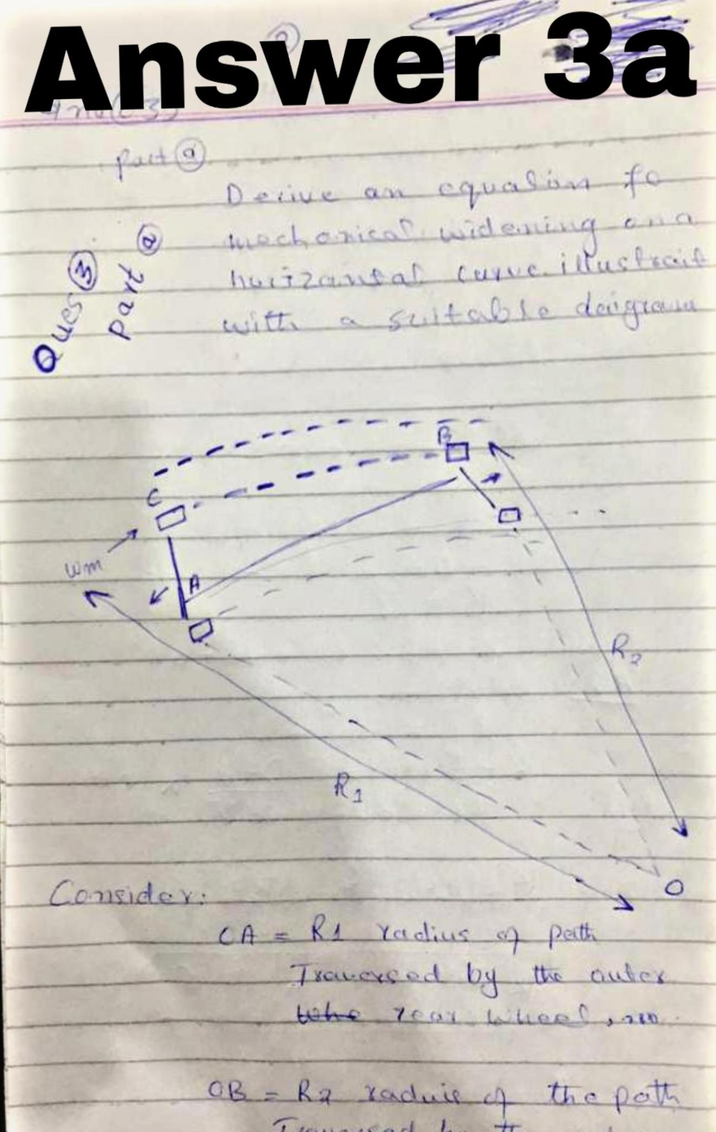

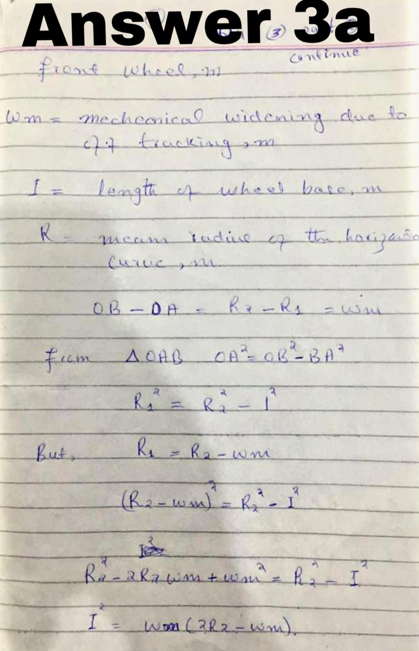

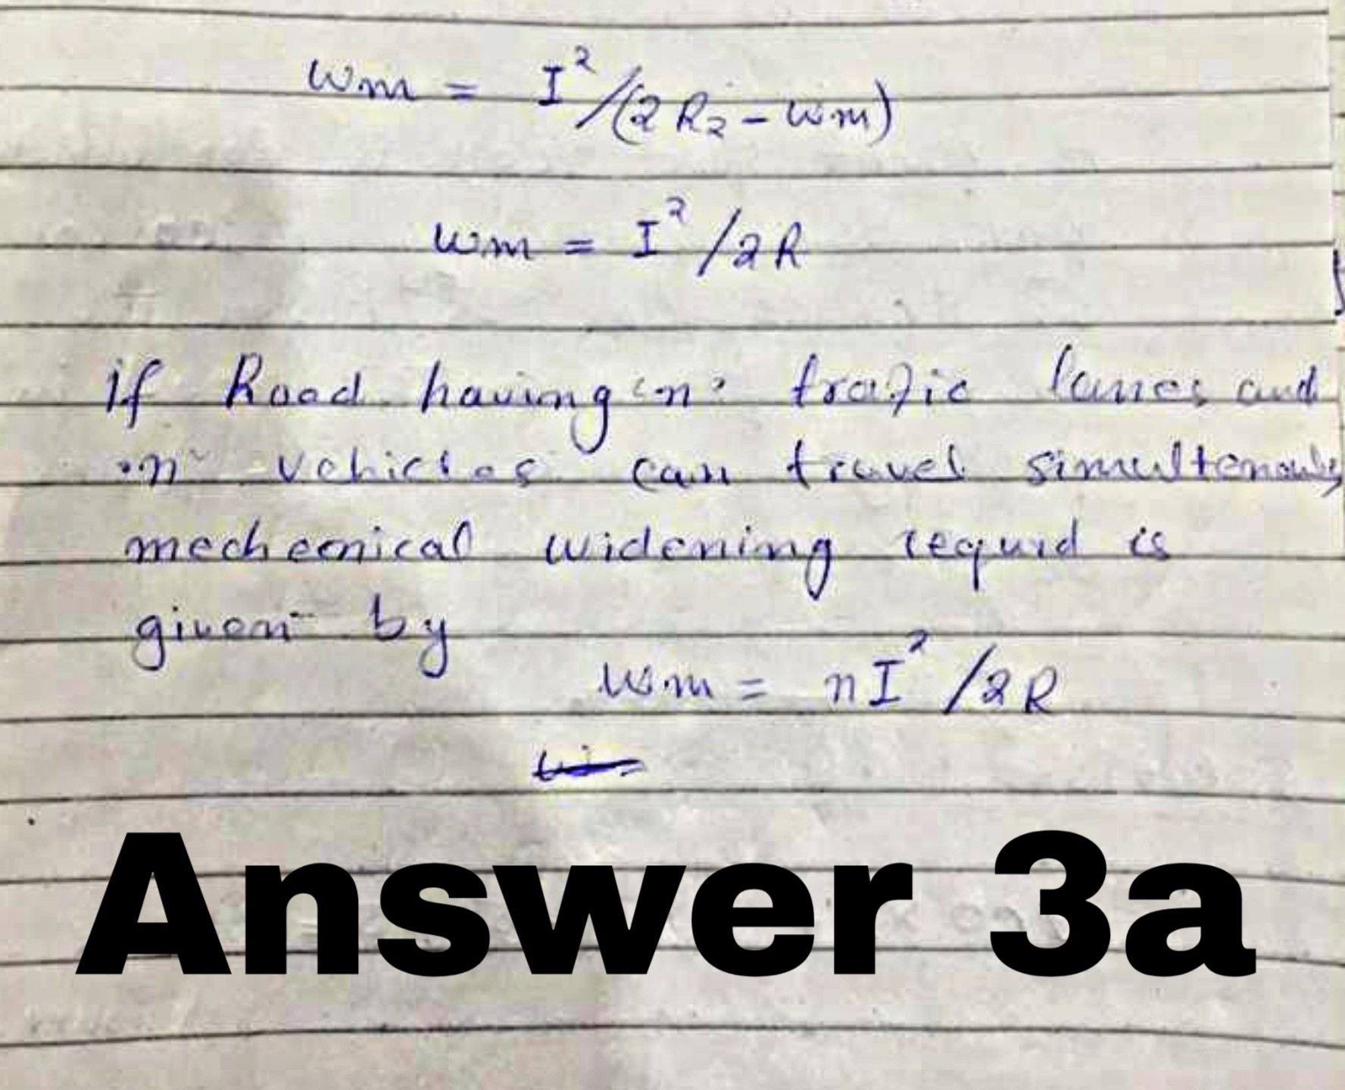

Answer 3b:

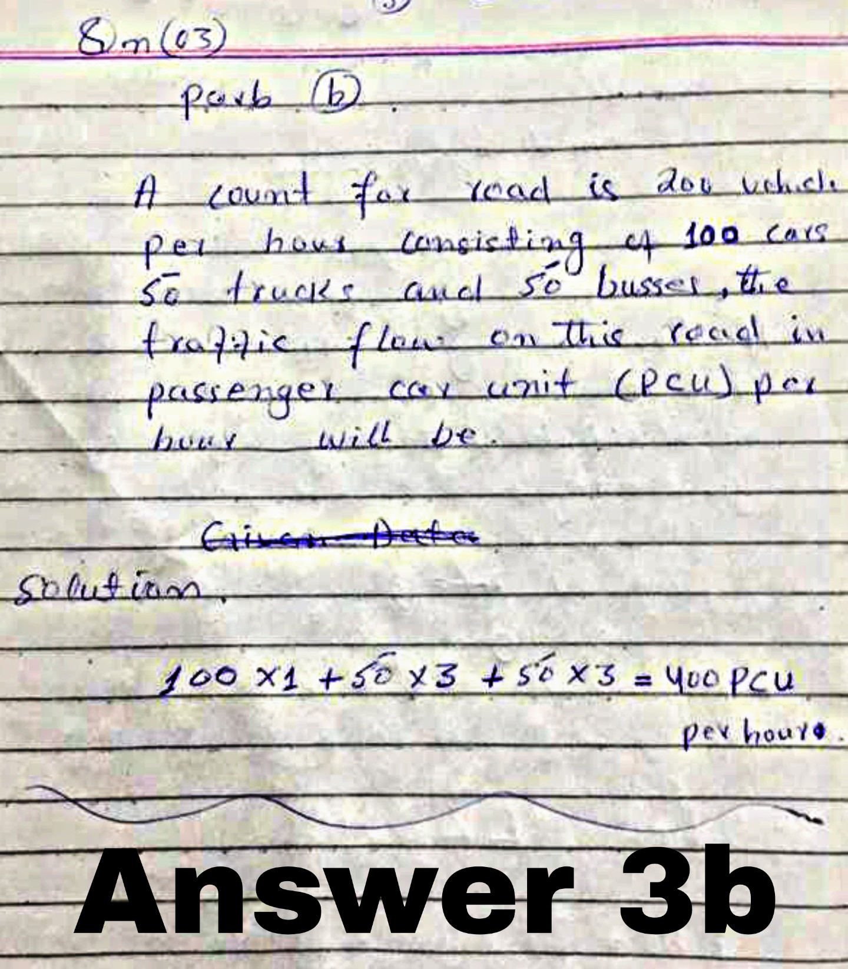
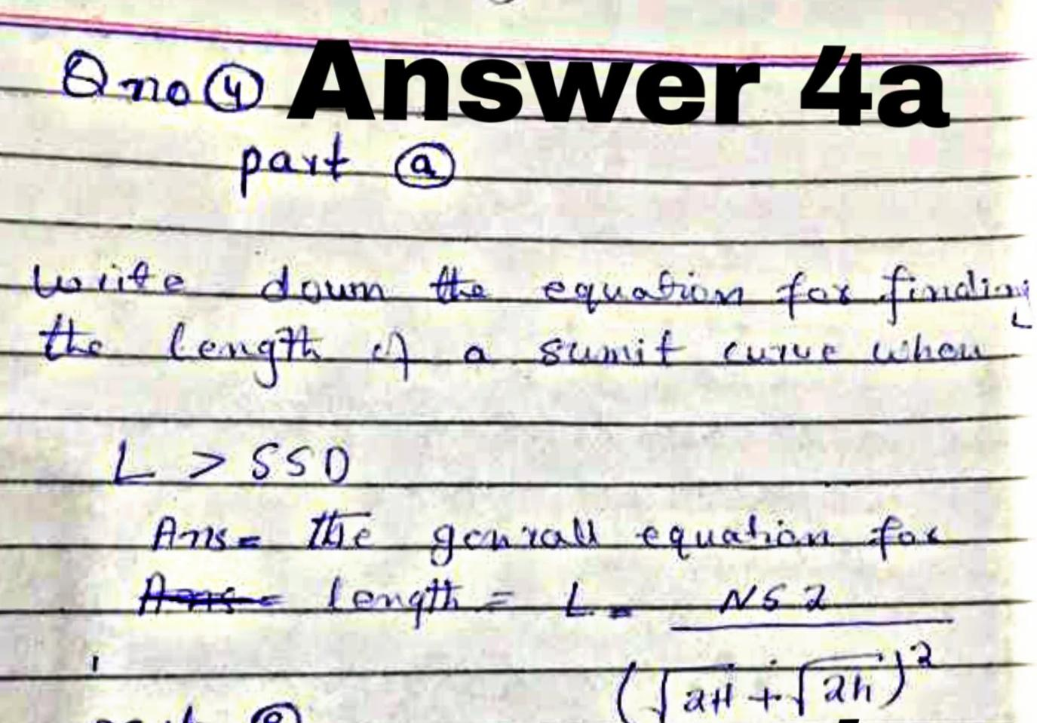
Answer 4e:
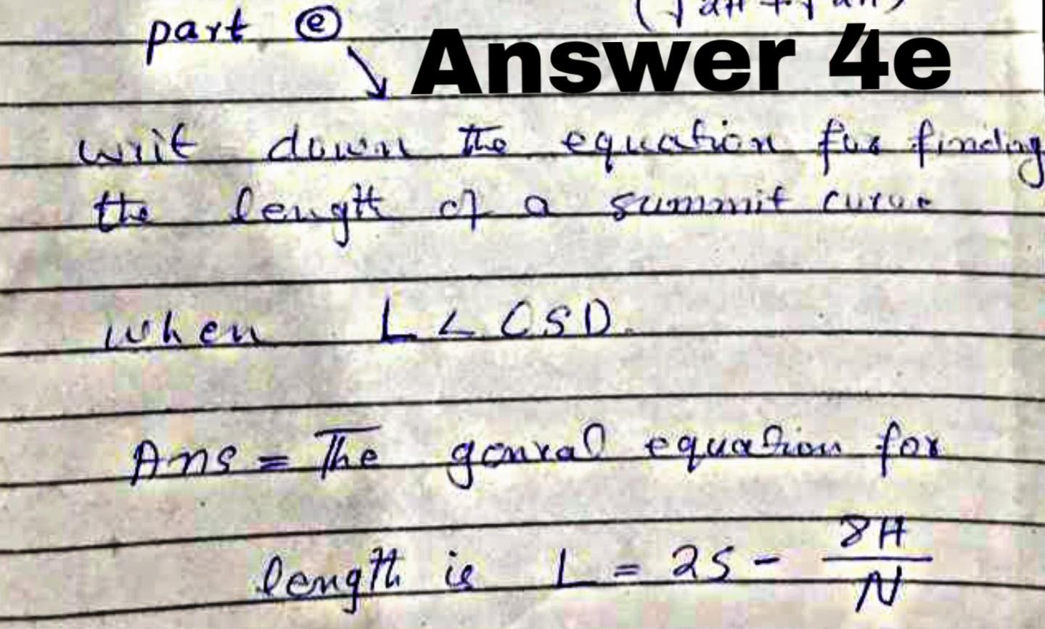

Answer 4b:
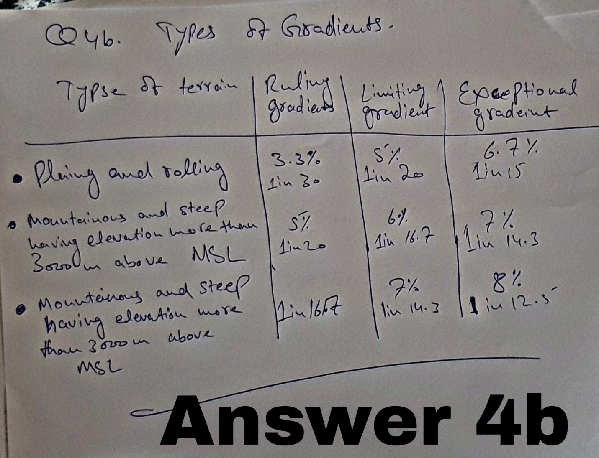

Answer 4c:
On hill road not bound snow a maximum super elevation upto 10% has been recommended.
