Q#1 : A patient come with complaint of difficulty in swallowing barium sallow test or esophagram imaging procedure is best for its diagnosis.
A barium sallow is diagnostic radiology exam using an x-ray to examine the upper Gastrointestinal tract specially the esophagus throat and back of mouth .A barium swallow can help diagnosis structural or functional issue of upper GI Tract.
- STANDARD PROTOCOL FOR ESOPHAGRAM PROCEDURE:
- A patient may be asked not to eat or smoke after mid night before the examination.
- A Patient may be ask to eat a low fibre diet for two three days before barium sallow test.
- Patient will wear a hospital gaoun a told to remove jewelry including body garments and other objects that might be visible on xray.
- Patient will drink about half cup of barium preparation a chalky drink with consistency of a milk shake.
- The barium can be seen on xray as it pases through the digestive tract.
- Patient will be strapped securely on your back on table that tilts forward.xray to examine your lung abdomen heart will be taken before you drink the barium.
- Patient will bw asked to swallow the barium mixture.
- Xray will be taken as the barium moves through the digestive system
- Patient will be asked to take sallows so more pictures can be taken on different position.
- Barium sallow procedure may take about 30 minutes to finished, in some cases it may take about 60 minutes to fill the stomach.
- Coplications:
- allergic reaction or anaphylaxis may occur in people who are allergic the barium drink .
- Constipation may develop.
Q#2: POSITION USED TO TAKE FILM FOR BARIUM MEAL:
The position for the barium meal are as follows:
- 8SPOT FILM OF STOMACH:
RIGHT ANTERIOR OBLIQUE: To demonstrate antrum and greater curvature.
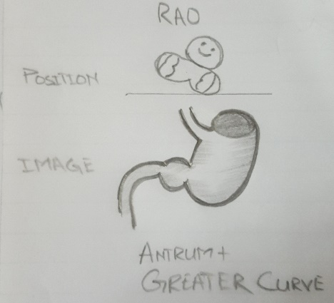

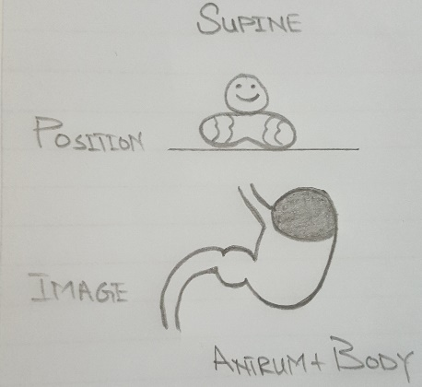
SUPINE: Antrum and body.

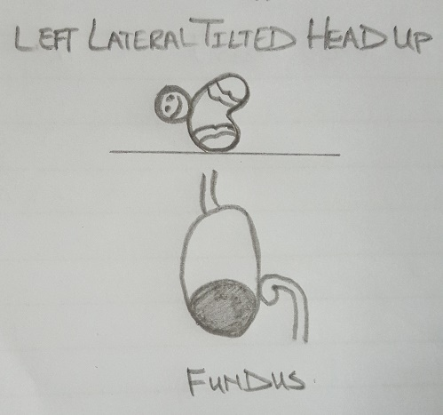
LEFT ANTERIOR OBLIQUE: Lesser curve .
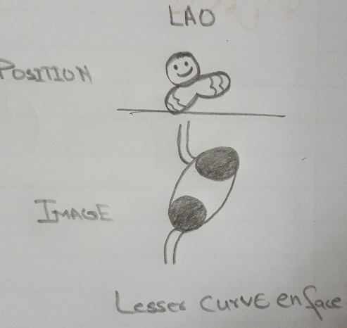

LEFT LATERAL TILTED, head up fundus

- From the left lateral position the patient returns to a supine position and then rolls on to the left side and over into a prone position.
- Left anterior oblique
- Right anterior oblique
- prone
4.Supine
2. SPOT IMAGES OF DUODENAL CAP:
PRONE
RIGHT ANTERIOR OBLIQUE: the patient attain this position by rolling first onto the left side ,the reason mention previously.
SUPINE
LEFT ANTRIOR OBLIQUE
3.SPOT IMAGE OF THE DUODENAL CAP:
PRONE: The patient lies on a compression pad to prevent barium from flooding into the duodenum.
To demonstrate the anterior wall of duodenal loop may be taken in an right anterior oblique position.
4.additional view of fundus in an erect position may be taken at this stage , if there is suspicious of a fundal lesion.
5. spot images of the oesophagus are taken while barium is being swallowed to complete examination.
Q# : 3
CONTRAST AGENTS:
Contrast is a chemical substance which is introduced in human body via entral /parental route to visualize certain structure not seen in plain radiography
Contrast agents are commonly used to improve the visibility of blood vessels and the gastrointestinal tract.
GENERAL CLASSIFICATION OF CONTRAST AGENTS:
General classification of contrast media divided into positive contrast media or negative contrast media.
1.POSITIVE CONTRAST MEDIA:
Positive contrast agent are agent that have the atomic mass and a high rate of obstruction high so these agents are indeed radiopaque material. appear on white film , increased x-ray absorption.
For example: bromine, iodine, barium sulphate
Positive contrast is divided in to water soluble and non water soluble
NON –WATER SOLUBLE CONTRAST MEDIA:
Not soluble in water i.e barium sulphate ,oil based contrast media.
Barium sulphate: is insoluble in water, highly radiopaque,non toxic , non absorbable
Oil based contrast media :
- Made from fatty acid
- Iodine added to ester group
- Insoluble in water
- High viscosity
Long resistance in body
WATER SOLUBLE CONTRAST MEDIA: It is stable in aqueous solution .they are completely miscible with gastrointestinal secretions and with blood.
IODINATED CONTRAST MEDIA:
Iodinated contrast agents that contain iodine atoms used for x-ray based modalities such as computed tomography they are also used in fluoroscopy ,angiography and plain radiography
- Higher osmolar contrast media:
High osmolality contrast media are approximately five to eight times osmolality of serum.
HOCM are ionic compounds that include benzene ring with three iodine atoms and side chain containing a carboxylic acid (COOH) group.
- Lower osmolar contrast media:
Lower osmolality contrast media are less than tree times the osmolality of human serum and preferrd for intravascular and intrathecal administration.
LOCM are not always non ionic monomers composed of tri-iodinated benzene rings with various side chains that contain polar alcohol(OH) groups that make them water soluble.
For example:
Iopamiad (isovne)
Iohexol (omipaque)
Ioxialin (oxilan)
ISO OSMOLAR CONTRAST MEDIA:
Iso osmolar contrast media have same osmolality as serum.
The LOCM category also include in iso osmolar contrast media
The only IOCM is current use in non ionic dimers which is composed of two covalently bound tri-iodinated benzene rings
For example: iodixanol
2.NEGATIVE CONTRAST MEDIA:
Negative contrast material that is not radiopaque .
Low atomic number
Black on film
Less x ray absorption
For example:water air arbon dioxide

