Mid Term Assignment (2020)
Course Title: Basic Physiology (DT– 2nd) Instructor: Dr. Irfan Ali Khan

Multiple Choice Questions Time: 48 hour
NAME IJAZ UL HAQ
I.D 15825
SECTION A
TEACHER DR IRFAN ALI KHAN
PAPER PHYSIOLOGY

- A short Gap in the myelin sheath around a nerve fiber is called
- Dendrite
- Axon terminal
- Node of Ranvier
- None of these
- The maximum amount of carbon dioxide in the human body is transported as:_______________
- Bicarbonate
- Carbide
- Amylase
- None of the above
- The lungs are protected by___________
- Ribcage
- Sternum
- Backbone
- All of the above
- The three different cells found in the stomach
a) Chief cells, renal cells, nephron
b) Renal cells, mucous cells, hepatic cells
c) Nephrons, hepatic cells, parietal cells
d) Chief cells, parietal cells,
- For action potential mucous cells to occur,
- The stimulus should reach or exceed threshold
- Na+ influx must exceed K+ efflux
- Both A & B
- None of these
- During rising phase of action potentzial,
- Voltage gated Na+ channels open
- Voltage gated K+ channels open
- Voltage gated Na+ channels close
- Voltage gated K+ channel close

- The movement of an esophagus to help the food down the GI tract __________
a) Mastication
b) Emulsification
c) Peristalses
d) Ejection
- Simple diffusion is ________.
- Movement of molecules against the conc. gradient
- Movement of molecules down the conc. gradient
- Both A & B
- None of these
- 97% of Oxygen is carried in blood from lungs is __________________
- Bound to Sulphate ion
- Bound to Hemoglobin
- Dissolved in plasma
- All of these
- Intrinsic factor secreted in stomach helps in
- Absorption of vitamin D
- Absorption of vitamin K
- Absorption of vitamin B12
- Removal of vitamin

SECTION B

Q1 Draw and Label the Action Potential in a large myelinated nerve fiber. Which ion channels are involved in its different stages?
Channel in the cell membrane causing action potential
1 voltage gate Na plus channels
. activation gates
. inactivation gates
2 voltage gates K plus channels
3 slow CA plus NA plus channel
Key point
1DEPOLARIZATION
Depolarization is a charge within a cell during which the cell undergoes a shift of in electric charge distribution resulting in less negative charge inside the cell depolarization is essential to the function of many cell

2REPOLARZITION
Repolarization refer to the charge in membrane potential that return it to a negative value just the depolarization phase of a action potential which has the membrane potential to positive value
3Diagram and label

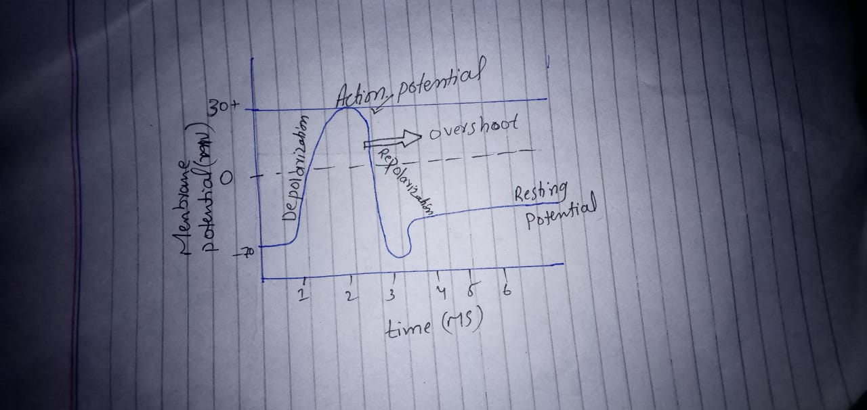

1……… resting potential
2…….. depolarization
3…….. repolarization
4 active shoot

Q2
ANSWER
ROLE OF OXYGEN; Oxygen is important to every cell in your body. oxygen through a process called oxidation . chemically changes food and liquid into energy. Its this oxygen fire that contracts our muscles repair our cells feeds our brain and even clam our nerve not only that but breathing is our body chief cleaning tool without oxygen your cell cant make energy And their metabolism is less effective without sufficient oxygen we perform less efficiently
ROLE OF CARBON DIXOIDE…..
During aerobic respiration complete oxidation of carbohydrates take place glucose is broken down by oxygen to release energy while carbon dioxide and water are the by product of the reaction the release energy is used to make a special energy molecules called adenosine triphosphate ATP. As the respiration take place in the absence of oxygen incomplete oxidation of food occur and muscles less energy release. However carbon dioxide is still product this is called anaerobic respiration and the process occurs in the CYTOPLASM
ROLE OF HYDROGEN…
Hydrogen respiration can be considered either the oxidation H2 TO PLUS with the electron release in channel into a membrane bond respiratory electron chain or as the reduction of H PLUS TO H2 in the terminal reaction of an aerobic low potential electron transport chain system in the both cases the redox reaction involving H2 IS catalyzed by a hydrogenase enzyme and electron transport to or form H2 is translocation of H plus across a membrane

