SALMAN DURRANI
ID : 15613
SUBJECT : PAVEMENT MATERIAL ENGINEERING
Question 1 Part 1 :
Why do we carry out Granular (physical) stabilization ?
Ans. Soils with particle sizes greater than 0.075 mm are designated as medium to coarse-grained soils. These soils, when compacted, form a granular bearing skeleton through a network of grain-to-grain contact points that is able to. Transfer load without Permanent Deformation. Provide Frictional Resistance. Bears Volume Stability. They may also contain material with particle sizes less than 0.075mm without violating the requirements given above if:
(1) the volume of the silt-clay size (< 0.075 mm) fraction plus that of the water, normally required to satisfy the capillary and physicochemical sorption capacity, does not exceed the volume of the pore space left by the stable continuous granular skeleton; and
(2) the ratio of the size of the smallest bearing grain to that of the largest siltclay particle is such as to cause no detrimental interference of grain-grain contact of the granular skeleton. Stabilization of this class of soils is designated “Granular Stabilization”.
It involves preparation of Mixture of Soil-Aggregate consisting of Stone, Gravel, and Sand and containing Silt-Clay and Compacted to maximum density to obtain high strength, stability, and durability in all weather conditions.
Granular stabilization is used in construction of Base, Sub-base, and Surface Courses of paved facilities.
The primary objective is to obtain a well-proportioned mixture of particles with continuous gradation (well graded) and the desired p The requirements for composition of mixtures intended for use as bases generally differ from those for use as wearing surfaces.
For example, the compositions for base and sub-base courses are required to have high stability to transfer load and low capillarity, to resist softening with accumulation of moisture.
The compositions for wearing surfaces, on the other hand, need to satisfy the conditions of resisting abrasion and penetration of water, and of capillarity to replace moisture lost by surface evaporation.
Therefore, the composition of base and subbase soil-aggregate requires less fine-soil fraction than the composition for wearing surface.

Question 1 Part 2:
How do we carry out granular (Physical) stabilization considering Granulometry and callometry, Fabric, Soil Binder, Collameritics and Specifications of gradation and selection of soil elements?
ANS. Granulometry and Collametry; The pore volume and the size of the pores formed by the granular skeleton determine the transition of a particular soil to one with or without a bearing skeleton.
Fundamentals of Granulometry are applied to establish quantitative definitions of granular skeleton with effective compactness.
Grain-size distributions that yield minimal porosity values with small densification effort are best presented by the Talbot formula: s=(d/dmax)m where s = weight percent of the particles with diameter less than d. dmax = maximum particle diameter in the mixture m = exponent determined empirically The factor m varies between 0.11 and 0.66. U.S. Bureau of Public Roads recommends 0.45 as the best overall value for m
- Soil Binder
- Soils with granular bearing skeleton in the densified state possesses volume stability and frictional resistance. They may require Bonding or Cementation, Increase in Cohesio, Decrease in Permeability or Water Storage Capacity (if deficient in fines)
Such stabilized granular soils belong to the class of Collameritic (colla = glue, meros = particle) systems. In the terminology of materials science, such bonded soils belong to the class of “CONCRETES”if the maximum particle size is larger than the openings of No. 4 sieve (4.76 mm), “MORTARS”if the largest particles are of fine sand size or the size of the openings of No. 40 sieve (0.425 mm).
The latter type of materials are also called "soil binder. Complete replacement of natural soil binder in a clay-bonded stabilized gravel (clay concrete) by Portland cement produces Portland Cement Concrete. Partial replacement leads to systems that possess properties intermediate between those of Clay Concrete and a Portland Cement Concrete.
Similarly, partial replacement of the soil binder by asphalt leads to waterproofed granular soil stabilization, and complete replacement by bitumen and filler leads to Bituminous Concrete. The soil binder or the cementing materials tend to surround the coarse-grain particles and/or form bonding bridges between particles such that the granular system attains rigidity and stability. The strength of such a system is dependent on the strength of the cement and on the shear resistance at the cement-particle interface, as well as on the strength of the granular network.
- COLLAMERITICS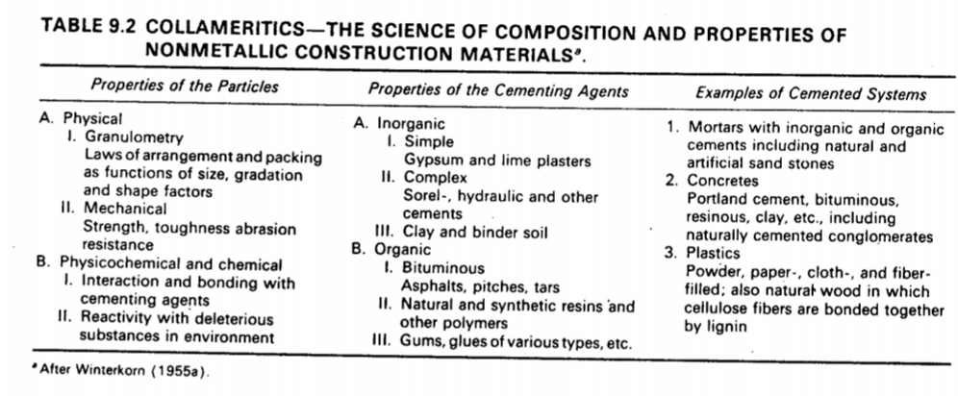

Specifications on Gradation and Selection of Soil Elements
In Nature? More Frequently NO! How to get the Desired Mixtures?? By addition of proper proportions of the aggregates or fines, Treatment with waterproofing of cementing material
The properties of the final mixture are generally controlled and judged by gradation, the liquid limit, and the plasticity index. A granular bearing skeleton may be established by several different methods. The choice depends on the soil and other materials available intended use and special properties desired in the stabilized system  time constraints for planning and construction.
- Soil Binder and Water are the two elements that create the adhesion and bonding between the coarse grains and provide the continuity of the structure by filling in the voids of the bearing skeleton. The continuous granular skeleton is strengthened and stabilized by the added cohesion.
- During dry weather Shrinkage of soil binder develops tensile forces on the surfaces of the coarse grains, which has the desirable effect of increased compression on the granular skeleton.
- During wet weather Swelling of the soil binder might be desirable, as it would reduce the permeability and retard penetration of water. However, introduction of excessive volume change to the system might be detrimental to functioning of the bearing skeleton. Therefore the amount and the properties of the soil binder should be controlled for optimum results.

- Exceptions to Gradation Requirements Cases may occur in which certain natural materials that do not meet gradation requirements may develop satisfactory CBR values in the prototype . Exceptions to the gradation requirements are permissible when supported by adequate in-place CBR tests on similar construction that has been in service for several years.
Question 2 Part 1:
How would you (being a material expert) identify aggregate referring to naturally occurring materials, Igneous rocks, Sedimentary rocks, Metamorphic and residual material and transported deposits?
- Aggregate is the major component of materials used in road making. It is used in Granular Bases and Sub-Bases, Bituminous Courses, Cement Concrete Pavements
- Cement concrete pavement
- A study of the Types of Aggregates, Their Properties and Tests is of great importance to a highway engineer. Aggregates can be obtained from two sources,
- (1) Naturally Occurring Deposits
- (1a) Processed Material (1b) Blends of Natural or Processed Materials .  (1c) Stabilized Materials
- (2) Artificially or Industrially Prepared Deposits (synthetic)
Aggregate Identification
- Aggregates can be identified on the basis of
(1) Origin (Composition) (2) Mode of Formation & Deposition (3) Density (Intra-particle voids) (4) Shape (5) Surface Texture
- Naturally Occurring Materials: The majority of aggregates used in road construction are obtained from naturally occurring deposits. Natural aggregates for road-making are obtained from rock of the following geological groups :
- Igneous Rocks (95% of Earth’s Crust) which are formed by the cooling of molten material
- Sedimentary Rocks (5% of Earth’s Crust & 75% of Earth’s Surface); which are formed by deposition of granular material
- Metamorphic Rocks; which are igneous or sedimentary rocks that have undergone transformations due to heat and pressure  The weathering product may be of two general types:
- Residual Materials which may be either weathered or unweathered, generally occur in large deposits and are obtained by quarrying.
- Transported Deposits are found, for example, in stream beds, sand and gravel bars, and alluvial fans.

- Naturally Occurring Materials
Mineral aggregates may be classified in a number of different ways. Each classification technique is useful in developing an understanding of the type of material to be used in the pavement.
- Pedological It is extremely helpful if the rock can be classified with respect to its general geologic type. It is not necessary that the person involved with highway materials be a geologist to make this classification. An understanding of geology and mineralogy are, however, extremely helpful, particularly in interpreting and predicting the performance of aggregates produced from the various available deposits.
TYPE OF ROCKS
- TABLE OF ROCKS
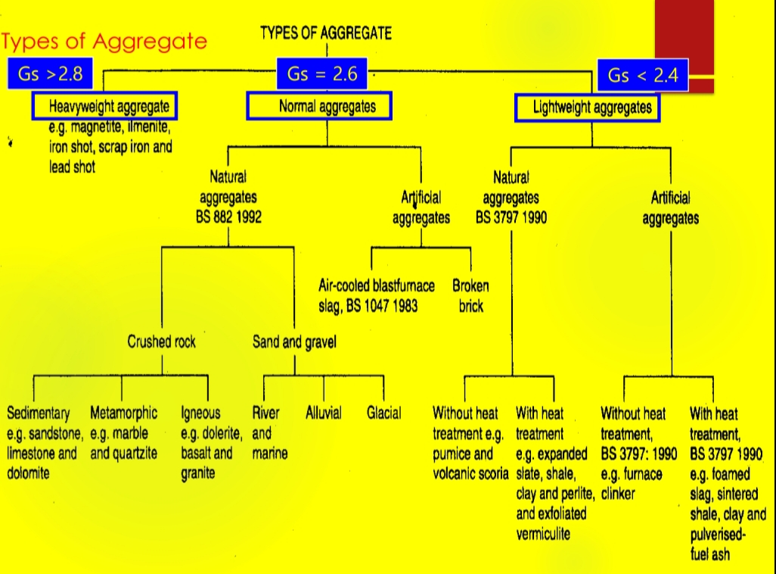

1.Granite
2.Basalt
3.Limestone
4.Dolomite
5.Sandstone
7.Conglomerate
8.Breccia
9.Shale
10.Marble
11.Slate
12.Quartzite
13.Gneiss
- Aggregate from Rock

- Any single rock type could be
- porous or dense
- strong or weak
- hard or soft
- decayed or unweathered
- durable or unsound
- fine or coarse-grained
Type of Rock does not determine the type of required aggregate
- A summary of various types of deposits based on their mode of deposition is as follows.

- Colluvium Deposits (Talus)
- A. formed by gravity and weathering action of a steeply sloping rock face
- b. crushing usually necessary
- c. large angular chunks 
- Glacial Deposits
- true glacial deposits - transported by glacial ice and have not been subjected to river transportation
- b. fluvial-glacial - glacial deposits subjected to stream action. glacial deposits may be unsuitable as aggregate sources since they are heterogeneous and require a great deal of processing before they can be used.
- Fluvial-glacial deposits- are more suitable
- Fluvial Deposits
- materials which have been transported and deposited by running water:
- a. stream-bed - from beds and banks of existing rivers
- b. terrace deposits - older stream bed deposits laid down as a stream bed, earlier age
- c. alluvial deposits - fans or cones deposited at the mouth of ravines, gullies, or canyons, arid and semiarid regions
- d. Flood-plain - deposited outside normal stream channels during flood periods.
Eolian Deposits
a. deposits laid down by the wind
b. finer sands of narrow size range
c. well rounded and hard and durable
- Marine Deposits
- usually contain hard, durable particles as a result of weathering
- b. particles are normally very well rounded
- c. usually narrow size range
- d. wash to remove salts

- SHAPE
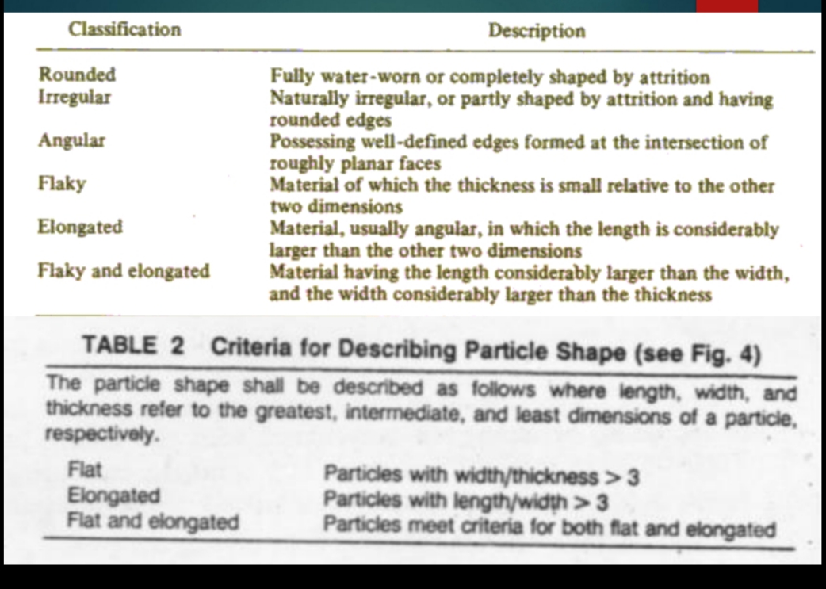

- SURFACE TEXTURE
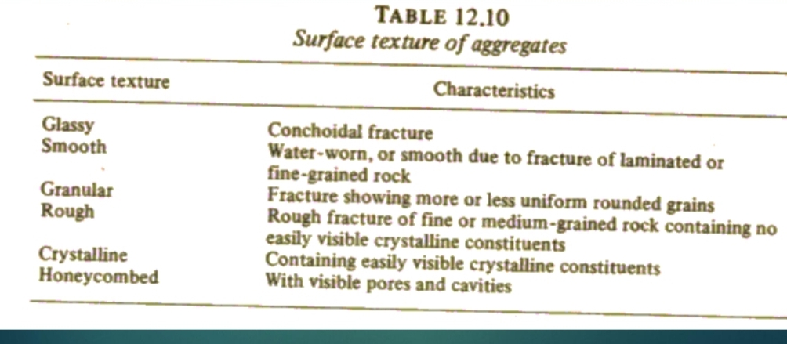
DENSITY
1.Porous 2.Non-Porous
Aggregate Identification
GENERAL USE
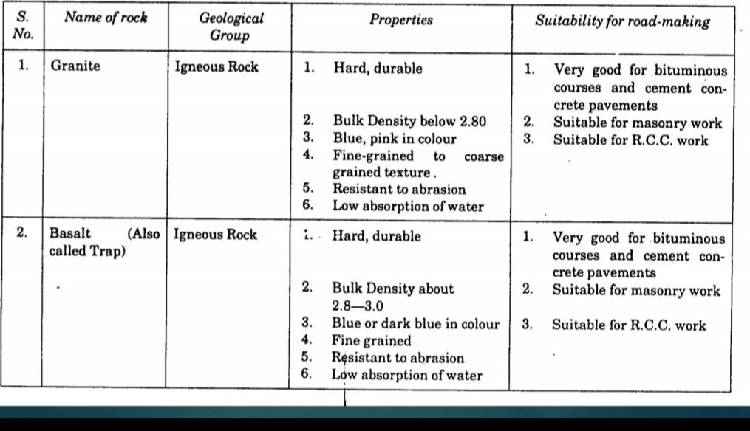
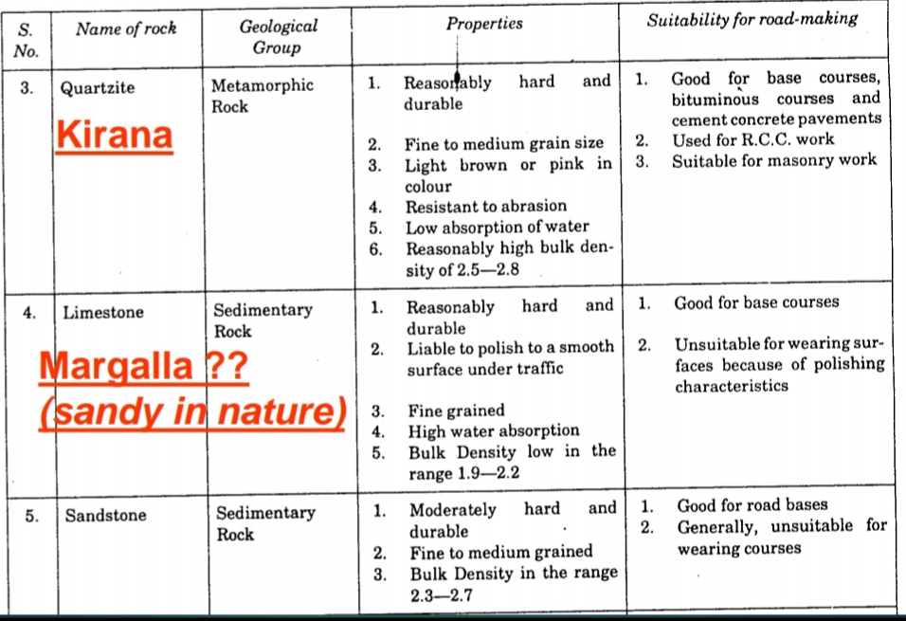

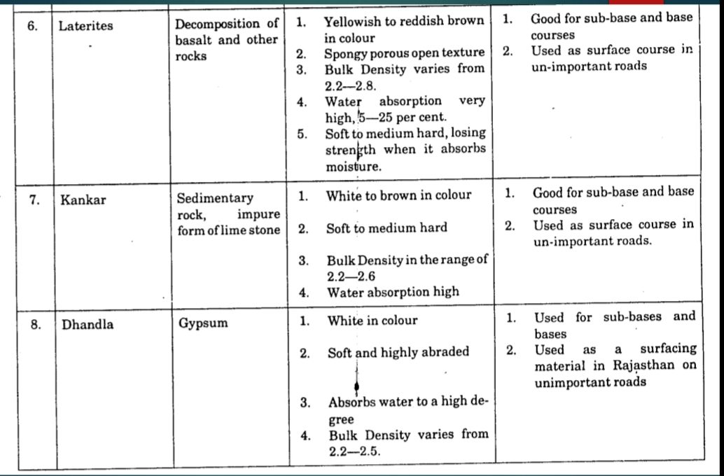

- Artificial Aggregates
- Broken Brick Ballast; Broken brick ballast is soft, water-absorbent and gets powdered under traffic.
- Overburning of bricks increases the hardness.
Slag; is also used as an aggregate in countries abroad.
- In PAKISTAN ??
- Crushed or Processed Aggregate 1 Margalla 2 Khairabad 3 Kirana Other.
- River Run Material ; Gravels and Sand Mixtures

Question 2 Part B:
In aggregate investigation material sourcing is referred to field investigation. Discuss material sourcing in detail.
Ans.
Field Investigation (Material Sourcing)
Field Investigation for concrete materials prior to construction are chiefly confined to 
Prospecting for Aggregates 
Exploration and Sampling of Available Deposits 
Judgement and Thoroughness in conducting preliminary field investigations are usually reflected in the Durability and Economy of the completed structures. 
Awareness of the Effect of different properties of the aggregates on the behavior of pavement layers is must for the Investigation Team

Aggregate Sources 
Natural Aggregate 
Rock Quarries 
Natural Deposits 
Stream/River Deposits 
Glacial Deposits 
Fluvial Glacial Deposits 
Talus Deposits 
Wind Blown Deposits

Prospect Sources 
Existing Sources 
Information is obtained from 
Geological Maps 
Soil Survey Maps 
Aerial Photographs 
Satellite Imageries

Aggregate Sampling 
Sample Reduction for Laboratory Testing 
The main sample is made up of a number of portions drawn from different parts of the whole. 
Two Methods are available
◆ Riffling
◆ Quartering

Riffling
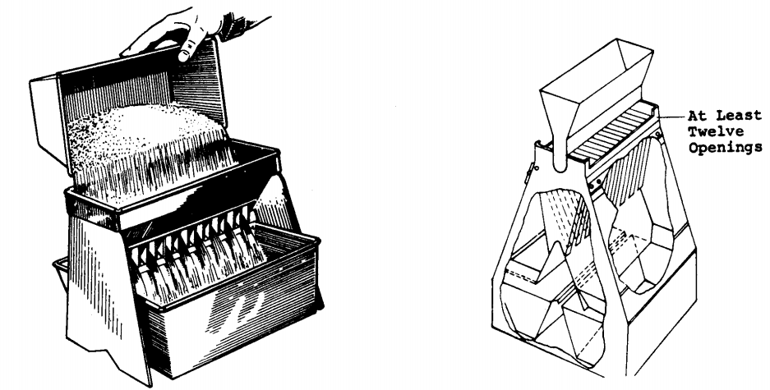

Quartering
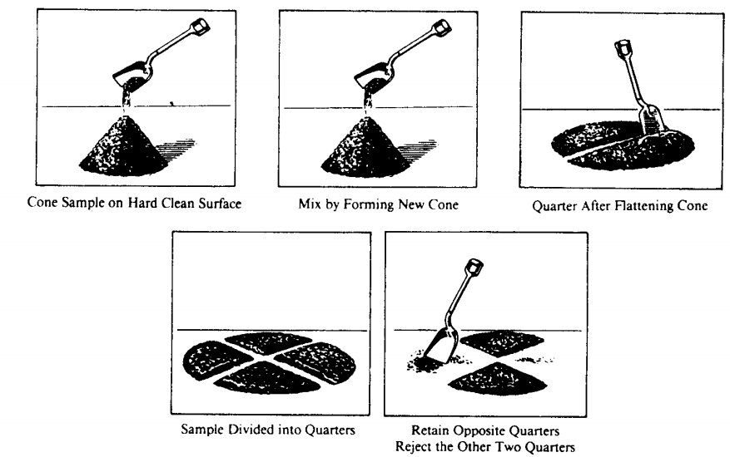

Laboratory Evaluations 
The tests required to be conducted on representative samples of aggregates depend on the Specific Use in a road pavement, so as to ensure that they meet the Specified Requirements laid down for that specific use. 
Subbase 
Base 
Surface Course

◆

Forces on Unbound Layers 
Traffic Forces 
Environment (Moisture) 
Compaction Forces 
Degradation, Crushing  Disintegration, Volume Change 
Crushing, Degradation

Strength 
Stiffness 
Stability 
Factors Affecting…. 
Mineralogical Properties 
Physical Properties 
Chemical Properties

Question 3: Mc-Adam was scottish engineer who introduced…… Wet mixing Mc-Adam?

Answer:
Mc Adam was a Scottish engineer who introduced, in the early nineteenth century, the idea of constructing roads composed of small size stones held together by means of a binding material.
◆ This concept had revolutionized the road building science then, aided as it was by the invention of the stone crusher in 1858 by Blake, the steam road roller by Aveling in 1867 and by the use of bituminous materials early in the twentieth century.

Macadam Bases-Types : 

1.Water Bound Macadam (WBM)
if the stone materials are held together by the addition of water and filler 
2.Dry Bound Macadam
if the aggregates are held together by mechanical interlock only 
3.Wet Mix Macadam
if graded stones are mixed with water and compacted 
Penetration Macadam
if a bituminous material is sprayed over the stones and allowed to penetrate into the course and by "premix" macadam if the bituminous material is mixed with the aggregates prior to laying.

Macadam Bases 
Sequence 
Concept 
Materials 
Construction

Water Bound Macadam 
Concept 
Water bound macadam may be defined as a dense and compact course of a road pavement 
composed of stone aggregates 
bound together by a thin film of cementing medium consisting of fine mineral filler (such as stone screenings or gravel) with cementitious properties and 
containing a minimum laden moisture to impart to the binder necessary cohesive and adhesive properties to enable it to bind the aggregates together. 
The strength of a water-bound macadam course is thus 
Primarily due to the thorough mechanical interlock in the aggregate particles. 
Cohesion between the aggregate particles due to the cementitious film of soil-moisture binder.

Water Bound Macadam 
Materials 
Coarse Aggregate 
Broken Stone Aggregates 
Hard varieties such as Granite, Basalt, Diorite, Quartzite, etc.  Softer varieties such as Sandstone, Limestone, Kankar, Laterite etc.
Over-burnt Bricks 
Screening (Choke) 
Moorum, Other Mixtures 
Binding Material (Soil Binder) 
Limestone Dust, PI => 6

Water Bound Macadam 
Size and Grading Requirements of Coarse Aggregates 
The main source of strength of a water-bound macadam surface is due to the mechanical interlock in the aggregates and it is thus apparent that the aggregates should be well graded. 
Well graded aggregates can be obtained only by a crusher whereas hand breaking can yield single size aggregates. 
For soft aggregates such as kankar, laterite or brick ballast which get crushed excessively under roller, the grading is not very important.  Requirements of Screenings and Binding Material 
The screenings, also known as "choke" materials, fill in the voids left in the coarse aggregates after they are consolidated and help to cement the stone aggregates together. 
To effectively perform these functions, the screenings should be properly graded and also should have some plastic material in them to impart cementitious properties. 
Excess of plasticity is harmful since, 'under the influence of moisture, the material may lose its stability. 
Screening materials may be dispensed with in case of soft aggregates such as kankar, laterite, brick ballast etc.

Water Bound Macadam 
Thickness of courses 
The water-bound macadam is constructed by spreading loose metal which gives a consolidated thickness of 75 mm-100 mm. A compacted layer less than 75 mm thickness is not desirable and a compacted layer more than 100 mm is equally undesirable. 
If the thickness of the base is more than the above value, the construction is done in multiple layers.

Water Bound Macadam 
CONSTRUCTION 
Spreading metal 
Manual Method 
Mechanical Method 
Rolling of Aggregates 
Dry Rolling 
Wet Rolling 
Application of Screenings 
Application of Binding Material

Wet Mix Macadam 
Concept 
Wet-Mix macadam is a specification in which a wellgraded aggregate is mixed with water in a mechanical mixer and the resultant mixture is laid by pavers and compacted. 
The aggregate is generally crusher-run, and includes fines also. Because of the close grading, the course will have good interlock with excellent density. 
Grading 
Well-Graded 
Moisture content 
The optimum moisture content for mixing is determined by conducting suitable density tests. The moisture content during mixing is maintained at this optimum ± 0.5 per cent. The moisture content is usually in the range 2-5% by weight.

Wet Mix Macadam 
Construction 
The mixing can be done in a suitable mechanical mixer. Specially designed mixers can be fabricated for this specification. Otherwise, a bituminous macadam plant can be used. 
Ordinary concrete mixers can also be used. Laying is done by paver-finishers and compaction by 8-10 ton smooth wheel rollers.

Water Bound vs. Wet Mix Macadam 
The main advantage of wet-mix macadam over water-bound macadam is that it is composed of a well-graded mixture. This ensures good interlock and high stability. 
Addition of water while mixing facilitates the handling of the mixture. The operation of laying is much simpler than that of water-bound macadam, where the screenings and binding material have to be added in stages and forced into voids. If a crusher-run material is used, there is no possibility of plastic fines entering into the mixture. 
The compaction is greatly facilitated by the moisture added which lubricates the individual particles. 
One disadvantage of the wet-mix macadam is that it is slightly costlier than water-bound macadam. This is because the specification involves the use of mixing plant and paver. On the other hand, water-bound macadam has been traditionally a labour-oriented specification. 
The aggregates for wet mix macadam will have to be crusherrun, whereas the aggregates for water-bound macadam are generally hand-broken.
Question 4 :
Part 1 : Discuss in detail Bituminous material manufacturing ?
Answer :
Bituminous Materials-Manufacturing 
Manufacturing Processes 
The major methods used for the production of asphalts 
Atmospheric Distillation 
Distillation at Reduced Pressure 
Air Blowing 
Solvent Refining 
Early refinery methods consisted of a simple distillation in a retort with attached condenser. The procedure was to pump a quantity of crude oil into the vessel and apply heat to the bottom causing the lower boiling point fractions to boil off leaving a residue which, depending on the type of crude, could be axle grease, bunker fuel oil, or asphalt. Only certain types of crude containing relative high asphalt contents could be used for the productions of asphalt by this method. 
Distillation remains by far the most common process.

Question 4;
Part 2: Bituminous materials-chemistry is referred chemical composition of bitumen.Elaborate in detail ?

Answer :
Bituminous Materials-Chemistry 
Asphalts are Complex Mixtures of Hydrocarbons 
Hydrocarbons are compounds that contain carbon and hydrogen. 
Organic Chemistry 
In organic chemistry, hydrocarbons are classified on the basis of chemical behavior as saturated or unsaturated. 
Essentially, saturated hydrocarbons have no multiple linkages between carbon atoms. 
Unsaturated hydrocarbons contain one or more double or triple bonds between carbon atoms and, as a consequence, have a great reactivity with other elements.
◆
Asphalt Composition 
Asphalts are a complex mixture of hydrocarbons, varying, in the case of semi-solid asphalt cements, from low molecular weight (approximately 300) materials to very high molecular weight materials (larger than 5000). 

Figure illustrates the molecular weight distribution of four penetration asphalt cements. 
Although these materials have the same consistency at a specific temperature, 77 F (25C), it can be seen that the size distribution is different. It is quite probable that these materials will react differently to changes in temperature and behave differently under load. 
Moreover, the chemical composition of the materials will, in all probability, vary in the different molecular weight ranges, depending upon the crude oil source. 
Hence, suffice it to say that each material is quite complex unto itself and the materials vary considerably among each other chemically.

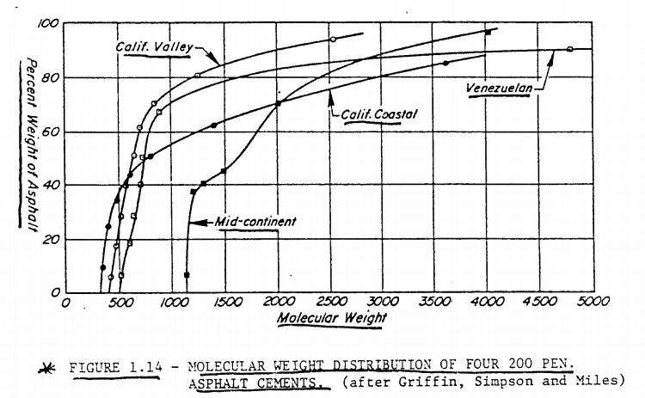

Asphalt Composition 
Some generalizations can be made, however, with regard to the chemical composition of the semi-solid materials. According to Simpson they generally consist of 
Carbon (70-85%) 
Hydrogen (7-12%) 
Nitrogen (0-1%) 
Sulfur (1-7%) 
Oxygen (0-5%) 
and small amounts of metals either dispersed in the form of oxides and salts or in metal containing organic compounds.

◆ The lighter molecular weight materials contain a considerable amount of carbon and hydrogen in the form of chaintype or aliphatic organic compounds. 
As the molecular weight increasesthe tendency toward ring type (naphthenic or aromatic) organic compounds is more apparent with the side chains attached to the ring sections. 
The very high molecular weight compounds consist primarily of the ring type materials with very few side chains of the aliphatic variety present. It is in the higher molecular weight ranges where the other elements mentioned above, i.e., nitrogen, oxygen, sulfur.

ASPHALTENES are the high molecular weight materials and are primarily of an aromatic nature with very few side chains attached. The hypothetical asphaltene molecule shown in Figure illustrates qualitatively, at least, this composition. It will be noted that sulfur and nitrogen are incorporated in the ring structure in this type of material. 

Asphaltenes have been defined by ASTM as: the components of the bitumen in petroleum, petroleum products, malthas, asphalt cements, and solid native bitumens, which are soluble in carbon disulfide but insoluble in paraffin naphthas. 
RESINS are the intermediate molecular weight materials and contain more side chains than the asphaltenes. Some sulfur and nitrogen is also included in these materials, but to a lesser extent than in the asphaltenes. The resins are polar molecules resulting from their aromaticity and the inclusion of sulfur. This polar nature gives resins the ability to be adsorbed by and to dissolve the asphaltenes.
OILS are the lightest molecular weight materials in the asphalt and generally have a large number of chains in proportion to the number of rings. A number of the materials in this range are naphthenic-type closed chains.

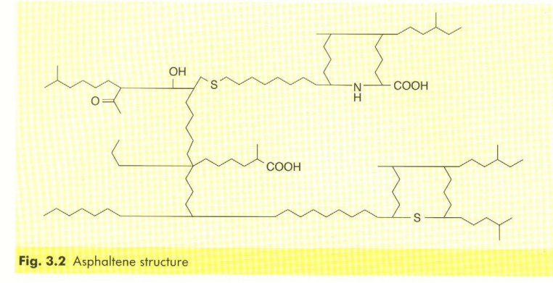

It should be emphasized at this point that the asphaltenes, resins, and oils are not three distinct compounds. Rather, there exists a range in molecular weights in the oil fraction, the resin fraction, and the asphaltene fraction. 
Moreover, the composition of the materials in each fraction and in each asphalt will vary, depending upon the crude source and method of manufacture. 
In addition to the classification listed above, other terminology has also been used to describe the various components of asphalt. For example, the oils plus resins are at times referred to as maltenes. 
Actually, there are many methods used to separate asphalts into components for study. Some separation techniques are based on chemical reactivity while others are based on molecular weight or a combination or both.
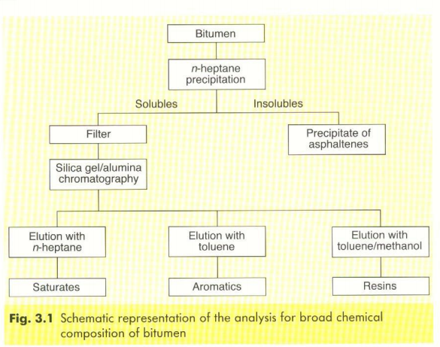

Corbett Method
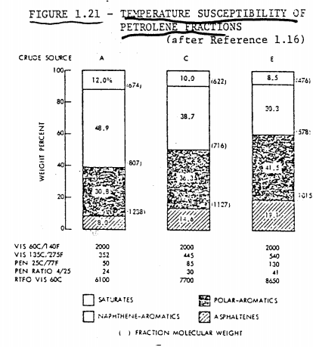
Studies have indicated that  SATURATES are better plasticizers than NAPHTHENE AROMATICS 
ASPHALTENES are solution thickeners 
SATURATES and ASPHLATENES produce low temperature sensitivity 
POLAR AROMATICS control the ductility of the asphalt.

Bituminous Materials-Manufacturing
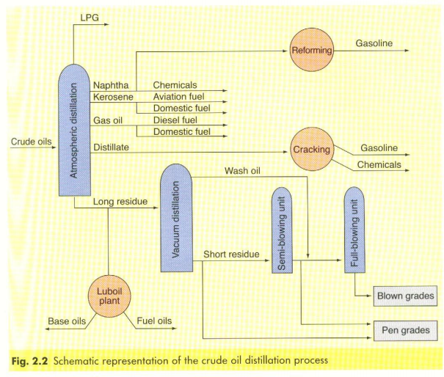

Bituminous Materials-Manufacturing 
The consistency of the material is controlled by 
- Temperature 
- Quantity of Steam 
- Pressure 
- Amount of Reflux 
- Type of Crude 
- Rate or Time of Processing 
It is often, not economical for a refinery to produce asphalt to a number of paving grades directly. Hence, blending is utilized. 

Refineries may stock two grades of asphalt:, one at each end of the viscosity spectrum and blend to produce, intermediate grades. 

Relatively high flash distillates have also been used as blending materials with hard asphalts.

Bituminous Materials-Manufacturing 
Asphalt is a very diverse material and has widespread usage. For convenience, asphalt will be categorized into three classifications which cover the majority of uses.
These are 
- Paving 
- Roofing, and 
- Protective Coatings 
Paving: The paving asphalts are the materials used in road construction and are produced primarily by the vacuum and steam and quite often will contain finely divided mineral fillers, in which case the materials are referred to as filled asphalts. 

Asphalts blown in the presence of special catalysts, such as P2O5, and referred to as catalytically blown asphalts are included in this category

