NAME: KOMAL TARIQ
ID: 16221
DEPT:HND
SUBJECT :PHYSIOLOGY
PHYSIOLOGY VIVA

Q1) Take any viral disease as an example? How will you classify different types of immunity keeping your example in mind?
ANS: IMMUNITY:
Immunity refers to having a resistance to a disease or illness. Two types of immunity exist — active and passive. Active immunity is immunity that develops from creating antibodies to a disease or illness. The first type of active immunity comes from being exposed to the pathogen that causes the disease. The term for this is natural active immunity. When an infectious organism, like a bacteria or virus, enters your body, it will begin to mount an immune response to try to attack the pathogen. The T-cells in your bloodstream will attach to the pathogen and then present the pathogen to the B-cells in the bloodstream. The B-cells are the ones that create the antibody that can attack and kill the pathogen.
Passive immunity occurs when we are protected from a pathogen by immunity gained from someone else. However, passive immunity is short-lived because the antibodies are not continually replenished.

Maternal antibodies
Unborn and newly born babies are protected by antibodies from the maternal immune system. These antibodies are shared in two ways: across the placenta and in breast milk.
- Placenta and circulation — When a woman is pregnant, her blood circulates through the placenta to deliver nourishment and protection to the developing fetus. As the blood circulates, so do the antibodies and immune system cells that travel in blood.

- Breast milk — Babies also get antibodies from breast milk, particularly from a protein-rich version of breast milk supplied in the first few days after birth known as colostrum. Colostrum, which is produced in the first three to five days after birth, contains higher levels of antibodies that protect the intestinal surface (immunoglobulin A or IgA) . This transfer of antibodies from mother to child suggests its importance in the period before a baby’s immune system can generate its own protection.
Measles:
Measles is a highly contagious viral infection. The immune response play an essential role in multiple stages of measles. The initial innate immune response is restricted due to inhibition of the interferon (IFN) response and allows extensive virus replication and spread during a clinically silent latent period of 10–14 days
People can become immune to measles in two ways.
Natural immunity: those who got sick with measles earlier in life will be immune afterward, and they won’t get it again.
Vaccine-based immunity: people who have been vaccinated with 2 doses of measles vaccine have long-term immunity to measles.
Once the virus that causes measles entered your body, your immune system created antibodies to attack the virus. Anytime you were exposed to measles after that, you didn't develop a case of measles because your body fought it off. Years ago, parents would try to have all of their children get the measles at the same time so they could build immunity at the same time. That was, of course, prior to the measles vaccine. That brings us to the other way in which active immunity is acquired.
When a person is actually affected by the virus that causes measles natural active immunity occurs.
When a person gets vaccine composed of inactive version of pathogen to treat measles, artificial or acquired active immunity occurs.

Q2) Explain any medical condition of lymph nodes? Give a lab test report as well if needed?
ANS: MEDICAL CONDITION OF LYMPH NODES

LYMPHEDEMA:
Lymphedema refers to swelling that occurs in arms or legs. Sometimes both arms or legs swell.
Lymphedema is most commonly caused by removal of or damage of lymph nodes. It results from a blockage in lymphatic system. The blockage prevents lymph fluid from draining well, and the fluid buildup leads to swelling.
SYMPTOMS:
Signs and symptoms of lymphedema are:
- Swelling of arm or leg including fingers or toes.
- A feeling of heaviness or tightness.
- Limited extent of motion.
- Aching or discomfort.
- Recurring infections.
- Hardening and thickening of the skin (fibrosis)

The swelling caused by lymphedema ranges from mild changes in the size of arm or leg to extreme changes that make the limb hard to use.
TREATMENT:

There's no cure for lymphedema. Treatment focuses on reducing the swelling and controlling the pain.
- Light exercises in which affected limb is moved to encourage lymph fluid drainage.
- Bandaging entire limb encourages lymph fluid to fliw back towards the trunk of body.
- Special massage is also done.
- Compression garments are also used. Long sleeves or stockings made to compress arm or leg encourages the flow of lymph fluid out of affected limb.
- In severe lymphedema, doctor may consider surgery to remove excess tissue in arm or leg to reduce swelling.

CAUSES:
For people with cancer, the build-up of lymph fluid can be caused by:
- Cancer surgery, especially when lymph nodes are removed
- Radiation therapy that can damage nearby tissue that might include lymph nodes or lymph vessels
- Infections that damage surrounding tissue or cause scarring
- Other health conditions, such as heart or vascular disease, arthritis, and eczema
- Gene changes or mutations that involve the lymph system
- Injury or trauma to a certain area of the body

TESTS OR DIAGNOSIS:

Levels of a set of proteins circulating in the blood may accurately flag the presence of lymphedema.

The most common test for lymphedema is the circumferential measurements taken along the hand, wrist, forearm, and upper arm at regular intervals. These measurements should be taken in the same places every time. Tape measures are widely available, inexpensive, and easy to use.
- Optoelectronic limb volumeter (also called infrared perometry): This technique uses an infrared optical electronic scanner to calculate the volume of the affected arm, which is then compared to the other arm.
- Bioimpedance scanning (BIS): Instead of measuring the volume of the arm, bioimpedance scanning detects the amount of fluid in the arm.
- Tonometry: A tonometer is a device pressed into the skin to measure the amount of force required to make an indent in the tissue. The resulting measurement can help gauge the degree of firmness or fibrosis (tissue scarring) under the skin — a consequence of worsening lymphedema.
- Imaging tecnhnologies: Imaging technologies such MRI, CT, or ultrasounds can be used to see if there is a collection of extracellular fluid in the tissue.
- Lymphoscintigraphy is a type of imaging that uses nuclear medicine to see lymph vessels and lymph nodes. It can show if your lymphatic system has any abnormalities in lymph flow or structure.

LAB REPORT:

- WBC count is raised in a test report of lymphedema patient
- Total leukocytes (TLC) count is also high in lymphedema patient.
- TLC shows that WBC's count in body is high. Normal value of TLC in body ranges from 4000-11000 cmm
- If TLC is higher than 11000 cmm then the lymph nodes are infected.
- Differential leukocytes are also checked in tests of lymphedema
- DLC shows the count of neutrophils, basophils and lymphocytes in body.
- The count of lymphocytes is raised in test report of lymphedema patient.
- Lymphocytes are enlarged in lymphedema.

Q3) Give different type of ECG's for heart diseases.
ANS:
ECG:
An electrocardiogram (ECG) is a medical test that detects cardiac (heart) abnormalities by measuring the electrical activity generated by the heart as it contracts. The machine that records the patient’s ECG is called an electrocardiograph.

The electrocardiograph records the electrical activity of the heart muscle and displays this data as a trace on a screen or on paper. This data is then interpreted by a health professional.
ECGs from healthy hearts have a characteristic shape. Any irregularity in the heart rhythm or damage to the heart muscle can change the electrical activity of the heart so that the shape of the ECG is changed.
A doctor may recommend an ECG for people who may be at risk of heart disease because there is a family history of heart disease, or because they smoke, are overweight, or have diabetes, high cholesterol or high blood pressure.

They may also recommend an ECG if a person is experiencing symptoms such as:
- chest pain
- shortness of breath
- dizziness
- fainting, or
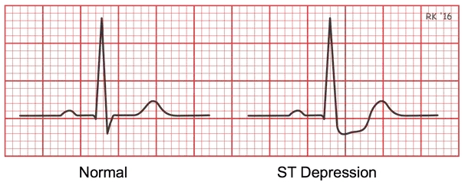
- fast or irregular heartbeats (palpitations).Electrodes (sensors) are attached to the chest, arms and legs with suction cups or sticky gel. These electrodes detect the electrical currents generated by the heart – these are measured and recorded by the electrocardiograph.

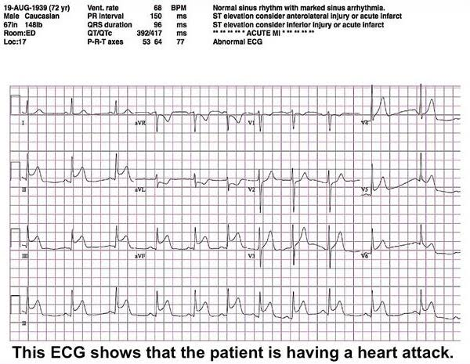

TYPES:
The three major types of ECG are:
- resting ECG – you lie down for this type of ECG. No movement is allowed during the test, as electrical impulses generated by other muscles may interfere with those generated by your heart. This type of ECG usually takes 5 to 10 minutes
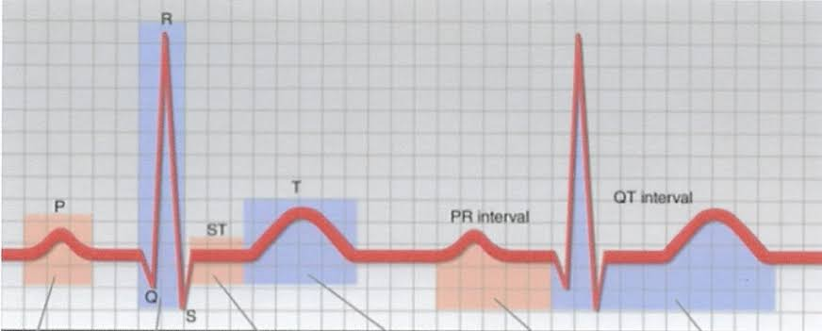

- ambulatory ECG – if you have an ambulatory or Holter ECG you wear a portable recording device for at least 24 hours. You are free to move around normally while the monitor is attached. This type of ECG is used for people whose symptoms are intermittent (stop-start) and may not show up on a resting ECG, and for people recovering from heart attack to ensure that their heart is functioning properly.

- cardiac stress test – this test is used to record your ECG while you ride on an exercise bike or walk on a treadmill. This type of ECG takes about 15 to 30 minutes to complete.
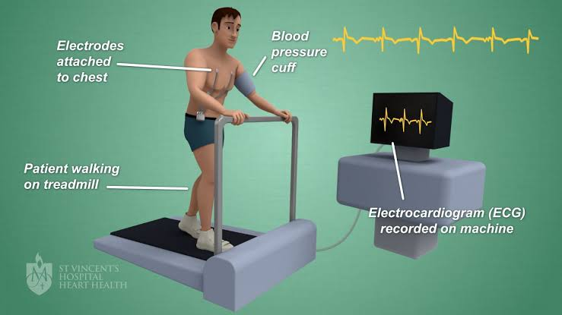

Q4) Give different medical ways of management of kidney stones?
ANS:
KIDNEY STONES
Kidney stones are hard deposits made of minerals and salts that form inside the kidneys.
Diet, excess body weight, some medical conditions, and certain supplements and medications are among the many causes of kidney stones. Kidney stones can affect any part of urinary tract. Often, stones form when the urine becomes concentrated, allowing minerals to crystallize and stick together.
Doctor may recommend preventive treatment to reduce the risk of recurrent kidney stones if the patient is at increased risk of developing them again.

Symptoms
Signs and symptoms of kidney stones are:
- Severe, sharp pain in the side and back, below the ribs
- Pain that radiates to the lower abdomen and groin
- Pain that comes in waves and fluctuates in intensity
- Pain or burning sensation while urinating
Other signs and symptoms may include:
- Pink, red or brown urine
- Cloudy or foul-smelling urine
- A persistent need to urinate, urinating more often than usual or urinating in small amounts
- Nausea and vomiting
- Fever and chills if an infection is present.

Causes:
Kidney stones form when your urine contains more crystal-forming substances — such as calcium, oxalate and uric acid.

Management of kidney stones:
Kidney stones are diagnosed and then treated by the health professionals.

Diagnosis
If the doctor suspects that the patients has kidney stone, the patient must have diagnostic tests and procedures, such as:
- Blood testing. Blood tests may reveal too much calcium or uric acid in your blood. Blood test results help monitor the health of your kidneys and may lead doctor to check for other medical conditions.
- Urine testing. The 24-hour urine collection test may show that the patient is excreting too many stone-forming minerals or too few stone-preventing substances.
- .Imaging. Imaging tests may show kidney stones in your urinary tract. High-speed or dual energy computerized tomography (CT) may reveal even tiny stones. Simple abdominal X-rays are used less frequently because this kind of imaging test can miss small kidney stones. Ultrasound, a noninvasive test that is quick and easy to perform, is another imaging option to diagnose kidney stones.

Treatment
Treatment for kidney stones varies, depending on the type of stone.

Small stones:
Most small kidney stones won't require invasive treatment. You may be able to pass a small stone by:
- Drinking water. Drinking as much as 2 to 3 quarts (1.8 to 3.6 liters) a day will keep your urine dilute and may prevent stones from forming.
- Pain relievers. Passing a small stone can cause some discomfort. To relieve mild pain, your doctor may recommend pain relievers such as ibuprofen (Advil, Motrin IB, others)
- Medical therapy. Your doctor may give you a medication to help pass your kidney stone. This type of medication, known as an alpha blocker, relaxes the muscles in your ureter, helping you pass the kidney stone more quickly and with less pain.

Large stones:
Kidney stones that are too large to pass on their own or cause bleeding, kidney damage or ongoing urinary tract infections may require more-extensive treatment. Procedures may include:
- Using sound waves to break up stones. For certain kidney stones — depending on size and location — your doctor may recommend a procedure called extracorporeal shock wave lithotripsy (ESWL).
ESWL uses sound waves to create strong vibrations (shock waves) that break the stones into tiny pieces that can be passed in your urine. The procedure lasts about 45 to 60 minutes and can cause moderate pain.
- Surgery to remove very large stones in the kidney. A procedure called percutaneous nephrolithotomy involves surgically removing a kidney stone using small telescopes and instruments inserted through a small incision in the patient's back.
- Using a scope to remove stones. To remove a smaller stone in your ureter or kidney, doctor may pass a thin lighted tube (ureteroscope) equipped with a camera through urethra and bladder to ureter.
Once the stone is located, special tools can snare the stone or break it into pieces that will pass in your urine. Doctor may then place a small tube (stent) in the ureter to relieve swelling and promote healing.
- Parathyroid gland surgery. Some calcium phosphate stones are caused by overactive parathyroid glands, which are located on the four corners of thyroid gland. When these glands produce too much parathyroid hormone, calcium levels can become too high and kidney stones may form as a result.

Prevention:
- Drinking water throughout the day.
- Eating less oxalate rich foods.
- Reducing the amount of salts and animal protein in diet.

Medications:
Medications can control the amount of minerals and salts in the urine and may be helpful in people who form certain kinds of stones. The type of medication doctor prescribes will depend on the kind of kidney stones.
- Calcium stones. To help prevent calcium stones from forming, doctor may prescribe a thiazide diuretic or a phosphate-containing preparation.
- Uric acid stones. Doctor may prescribe allopurinol to reduce uric acid levels in blood and urine and a medicine to keep urine alkaline. In some cases, allopurinol and an alkalizing agent may dissolve the uric acid stones.
- Struvite stones. To prevent struvite stones, doctor may recommend strategies to keep urine free of bacteria that cause infection, including drinking fluids to maintain good urine flow. For instance, doctor may recommend an antibiotic before and for a while after surgery to treat kidney stones.
- Cystine stones. Along with suggesting a diet lower in salt and protein, doctor may recommend drinking more fluids so that a lot more urine is produced. Doctor may also prescribe a medication that increases the solubility of cystine in urine.

