Final-Term Assignment/Paper (spring -2020)
Therapeutic exercises
DPT 4th semester
Instructor: Dr. M.Jaffar
Name: Aftab Ahmad
I.D.: 15096

Time: 6-hours (9am-3pm) Max Marks: 50

Q1. Define following.(10)
- Flexibility
- Mobility
- Indications and contraindications of stretching.
- Isometric contraction
- Isotonic contraction
Flexibility:

Ability to move a single joint or series of joints smoothing and easily through an unrestricted, pain-free ROM.
- Flexibility exercise help stretch muscles, protect against injury and allow the maximum range of motion for joints
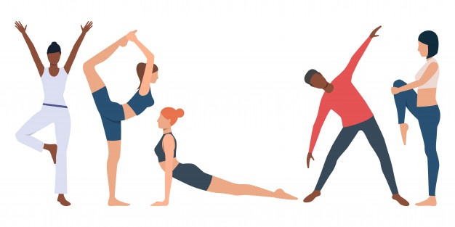
Types:
- Dynamic flexibility

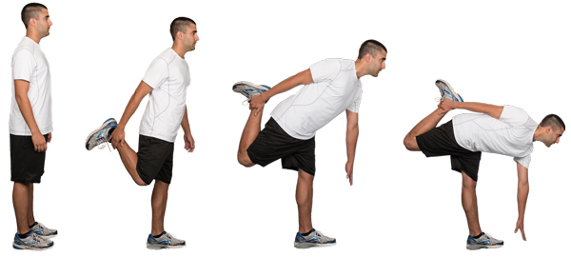

- Passive flexibility
Mobility:
The ability of structures or segments of the body to move and allow the presence of range of motion for functional activities (functional ROM).
OR
The ability of an individual to initiate, control or sustain active movements of the body to perform simple to complex motor skills.
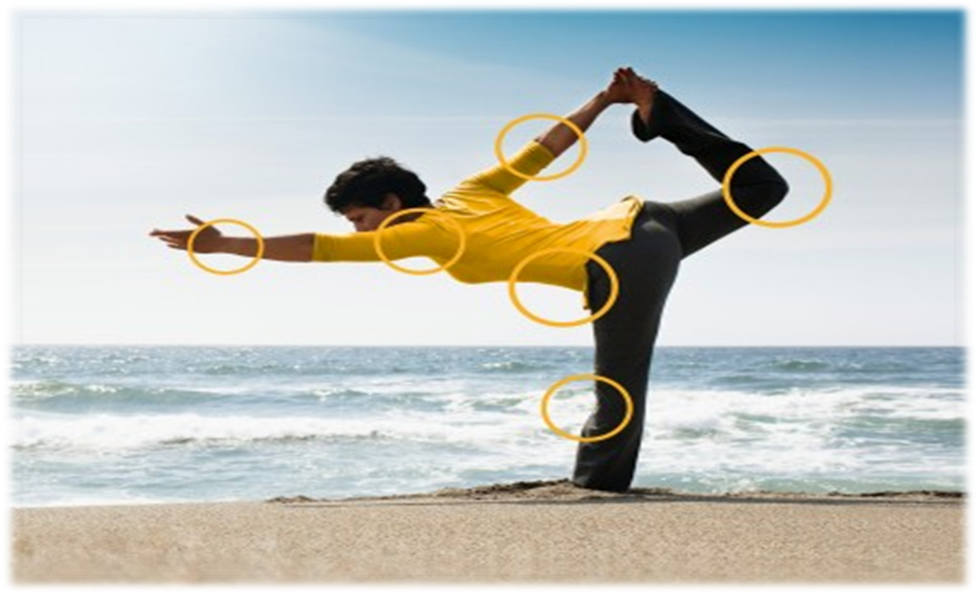
Indications of stretching:
Following are the indications of stretching:
- Limited range of motion (ROM).
- Structural deformities.
- Muscle weakness.
- Muscle shortening.
- Part of a total fitness program designed to prevent musculoskeletal injuries.
- Prior to and after vigorous exercise potentially to minimize post-exercise muscle soreness.
Contraindications of stretching:
Contraindications of stretching are listed below:
- Bony block
- Recent
- Evidence of acute inflammatory or infectious process
- Sharp pain (acute stage of bum)
- Evidence of tissue trauma
- When contracture is needed to develop stability
- Exposed joints
- Exposed tendon
- Thrombophlebitis
- D.V.T
- Compartment syndrome
- Fresh skin graft (kottke, 1971)
Isometric contraction:
Isometric contraction is an increase in intramuscular tension without any change in length of the muscle.
Isotonic contraction:
Isotonic contraction means an increase in intramuscular tension with a change in length of the muscles.
Q2. Define contracture? Discuss types of contractures? (10)
Contracture:
Adaptive shortening of the muscle, tendon and other soft tissues that cross or surround a joint resulting in significant resistance to stretch and limitation of ROM.
- Can be reversible or irreversible.
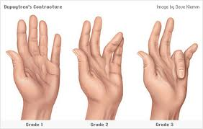
Types of contracture:
- Myostatic contracture
- Pseudomyostatic contracture
- Arthrogenic contracture
- Fibrotic contracture
Myostatic contracture:
- No specific muscle pathology.
- A reduction in the number of sarcomere units in series, there is no decrease in individual saromere length.
- Resolved in a relatively short time with stretching.
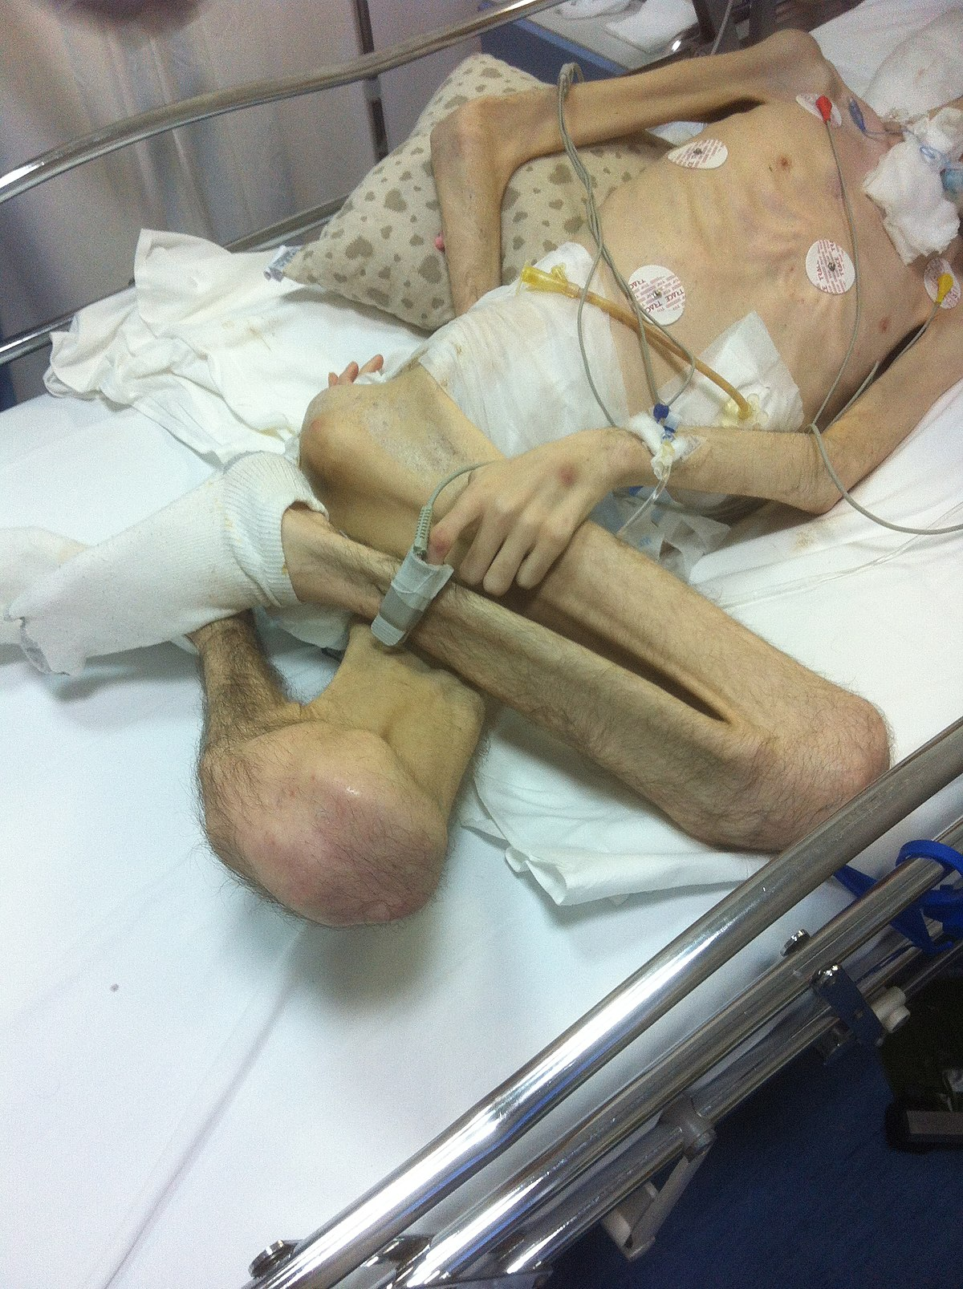
Pseudomyostatic contracture:
- Muscle in a constant state of contraction, Hypertonicity (i.e., spasticity or rigidity) associated with a CNS lesion such as a CVA a spinal cord injury.
- Muscle spasm and pain
- These contracture may be a result of hyper tonicity (i.e. spasticity or rigidity) associated with, a central nervous system lesion such as a cerebral vascular accident, a spinal cord injury or traumatic brain injury.
- Muscle spasm or guarding and pain may also cause a pseudomyostatic contracture.

Arthrogenic contracture:
- An arthrogenic contracture is the result of intra-articular pathology.
- These changes may include:
- Adhesions: (band of scar like tissues, Adhesions cause tissue and organs to stick together)
- Synovial proliferation: (is the enlargement of the fibro cartilaginous pad)
- Joint effusion
- Irregularities in articular cartilage
- Osteophyte formation
- Restricted arthrokinematics.
Fibrotic contracture:
- It may occur when normal muscle tissue and connective tissue are replaced with a large amount of non extensible, fibrotic adhesions and scar tissue or even heterotopic bone.
- Permanent loss of extensibility of soft tissues occur that cannot be reversed by nonsurgical intervention.
- Healed by stretching and surgical intervention.
Q.3. what is stretching? What are types of stretching? (10)
Stretching:
Stretching is a general term used to describe any therapeutic maneuver designed to increase the extensibility of soft tissues, there by improving flexibility by elongating structures that have adaptively shortened and have become hypo mobile over time.
Types of Stretching :
- Static stretching.
- Cyclic /Intermitted stretching.
- Ballistic stretching.
- Propioceptive Neuromuscular stretching
- Facilitation Stretching stretching procedure (PNF stretching)
- Manual stretching
- Mechinical stretching
- Self stretching
- Passive stretching
- Active stretching

Mechanical /Passive or Assisted Stretching:
- A sustained or intermittent external, end-range stretch force, applied with overpressure and by manual contact or a mechanical device, elongates a shortened muscle tendon unit and periarticular connective tissues by moving a restricted joint just past the available ROM
- If the patient is as relaxed as possible, it is called passive stretching.

Self Stretching:
- If the patient assists in moving the joint through a greater range, it is called assisted stretching Any stretching exercise that is carried out independently by a patient after instruction and supervision by a therapist is referred to as self-stretching.

- Neuromuscular facilitation and inhibition technique:
- Active stretching is another term sometimes used to denote self-stretching procedures Neuromuscular facilitation and inhibition procedures are designed to relax tension in shortened muscles reflexively prior to or during muscle elongation
- Because the use of inhibition techniques to assist with muscle elongation is associated with an approach to exercise known as proprioceptive neuromuscular facilitation (PNF)
- Combination of active and passive technique
Passive stretching :
- It is a type of stretching in which partner provide force for stretching
- It may be a trained professionalist or any colligue .
Bassistic or dynamic:
- These are quick movements or bouncing using momentum
- Best for those above 15 years
Static stretching :
- These are slow unsustained stretches held for 10 -30 sec.
- Authors called such stretches as PNF stretching 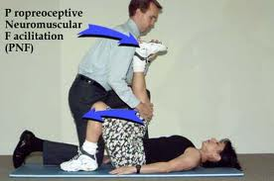
Joint mobilization and manipulating method:
- Joint mobilization/manipulation methods are manual therapy techniques specifically applied to joint structures and are used to stretch capsular restrictions or reposition a subluxed or dislocated joint 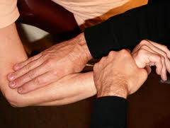
M anual Stretching:
Application of Manual stretching:
- Move the extremity slowly through the free range to the point of tissue restriction.
- Firmly stabilize the proximal segment and move the distal segment.
- To stretch a multijoint muscle, stabilize either the proximal or distal segment to which the range-limiting muscle attaches.
- Consider incorporating a prestretch, isometric contraction of the range-limiting muscle (the hold–relax procedure) to relax the muscle prior to stretching it.
- Apply a low-intensity stretch in a slow, sustained manner.
- Remember, the direction of the stretching movement is directly opposite the line of pull of the range-limiting muscle
- The patient should experience a pulling sensation, but not pain,
- Maintain the stretched position for 30 seconds or longer.
  - Gradually release the stretch force.
Q.4. what is Nagi Model? Discuss disablement and impairment? (10)
Nagi Model:
A conceptual explanation of a process and underlying mechanism by which disease, injury or birth defect impacts a person’s ability to function (perform their expected role in society).
Nagi experimental hypothesis:
Disease → Cause → Impairment
Impairment → Cause → Functional limitation
Functional limitation → Cause → Disability
Nagi described four basic phenomena that he considered fundamental to rehabilitation as follows:
- Active pathology
- Impairment
- Functional limitations
- Disability
Active pathology:
Active pathology is an interruption in normal body processes tht leads to a deviation from the normal state such as infection, trauma, disease processes or other degenerative conditions.
Impairment:
it is a loss or abnormality at the tissue, organ, and body system level.
Functional limitations:
it relates to individual’s inability to perform the tasks and obligations of his usual roles and normal daily activities.
Disability:
it’s a physical and/or mental limitation in performing socially defined roles and tasks expected of an individual.

Nagi model

Primary pathology
↓
Primary impairment
↓
Functional limitations
↓
Disability

Disablement:
Disablement is a term that refers to the impacts and functional consequences of acute or chronic conditions, such as disease, injury, and congenital or developmental abnormalities, on specific body systems that compromise basic human performance and an individual’s ability to meet necessary, expected, and desired societal functions and roles.

Impairment:
Impairments are the consequences of pathological conditions; That is, they are signs and symptoms that reflect abnormalities at the body system, organ, or tissue level.

Types of pairment:
- Musculoskeletal
- Neuromuscular
- Cardiovascular / pulmonary
- Integumentary.

Q.5.What is Aerobic exercises? Write down Principles of aerobic exercise. (10)
Aerobic exercises :
Aerobic exercises is sometime known as cardio exercises that require pumping of oxygenated blood by the heart to deliver oxygen to working muscles .
Aerobic exercises stimulate the heart rate and breathing rate to increase in a way that can be sustained for the exercise session .
Example of aerobic exercises include :
- Cardiomachine
- Spinning
- Running
- Swimming
- Walking
- Hiking
- dancing
aerobic exercises can become anaerobic if performed at a level of intensity yhat is very high .
Aerobic exercises not only include fitness it also has known benefits for both physical and emotional health.
Aerobic exercises can help prevent or reduce the chance of developing some :
- cancers
- Diabetes
- Depression
- Cardiovascular diseases
- Osteoporosis
Aerobic exercises for age group 6-9:
- Games that involve running and chasing
- Hiking
- Jumping rope
- Karate
- Cycling
- Running
- Skateboarding
Aerobic exercises for older age :
- Experts recommended 150 min of exercises a week . approximately 20 min a day
- Cycling or walking every week
- Strength exercises on two or more days a week
- That work at major muscles like hip, legs ,back ,abdomen , chest ,shoulder and arms .
Principles of aerobic exercises :
- Intensity
- Duration
- Frequency
- Modes
Intensity :
Intensity of exercise means how hard is the exercise or how hard your body is working .
Example
An example of intensity is how quickly a treadmill is moving .
Types on the basic of intensity :
On the basic of intensity aerobic exercises are of two types :
- Moderate intensity aerobic exercises .
- Vigorous intensity aerobic exercises / high intensity aerobic exercises .
Moderate intensity aerobic exercises :
As its name indicate those aerobic exercises which required less effort these exercises are mostly for older age people .
Its example include doing treadmill at slow speed .
Vigorous intensity aerobic exercises :
These are hard aerobic exercises that require more effort and energy .
An example of vigorous intensity aerobic exercises include trade mill at high speed.
Duration :
It means for how much time the exercise is being performed or how long the performance is .
20 -30 min is optimal for a particular exercise .
If high intensity exercises are performed the lower will be the duration of that exercises .
Frequency :
How much times the exercises should be repeated indicates the frequency of that exercise 3-4 times a week or may depend on your goal .

