Doctor of Physiotherapy second semester: section A
Instructor: DR: MALIK ATTAULLAH KHAN
Student: ARBAB HABIB ULLAH
Id: 16692
Date: 13-April-2020

SECTION-A
1. C/ Fovea capitis.
2. C/ 135.
3. A/ Greater trochanter.
4. B/ Lesser trochanter.
5. D/ None of the above.
6. A/ Intracapsuler fracture.
7. B/ Medial direction.
8. C/ Multiple fracture.
9. C/ 1000-1500ml.
10. C/ Tibia.
11. D/ Three boarders and three surfaces.
12. B/ Axial loading.
13. C/ Acetabular labrum.
14. A/ Illiofemoral ligament.
15. C/ Radial artery.

SECTION-B
Q 1: Anatomy of Hip Joint.
Hip joint may be define as the ball and socket type of joint between the head of the femur and acetabular cavity which is a cup like structure in the pelvic bone.
Function:
Its function is to hold weight of the body and can help in running, jumping.
It also provides the ground support to the upper body.

Articulating Surfaces:
The hip joint is the articulation, between head of the femur and acetabulum of the pelvis.
There is a cup like shape depression on the inferolateral side of pelvis.
There is an articular cartilage, around the head of the femur and acetabulum that bind it together.
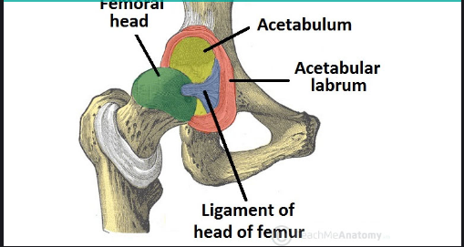
There is also a ring shape rim in the acetabulum that increases its area called as acetabular labrum.

Ligaments:
The ligaments of the hip joint is responsible for the stability of the joint, there are been apart by two groups.
Extracapsular
Three further ligaments are arising from here which are;

Illiofemoral ligament
It starts from anterior inferior iliac spine and end before intertrochanteric line of femur.
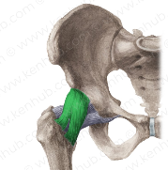
Pubofemoral ligament
It arises from the pubic ramus and merges iliofemoral ligaments.
Ischiofemoral ligament
It elongates from the between the body of ischium and the greater trochanter of femur.

Stability of Hip joint
There are many factors that increase the stability of the hip joint, like as;
The acetabulum of the hip bone strong enough to catch the head of the femur that prevent it from dislocation.
There is also horseshoe like shape in the acetabular cavity known as acetabulum labrum, that increase the surface area of the cavity for binding of with the head of the femur.
There is also a spiral orientation which is unique because of iliofemoral, pubofemoral, ischiofemoral ligaments, as they are very strong.
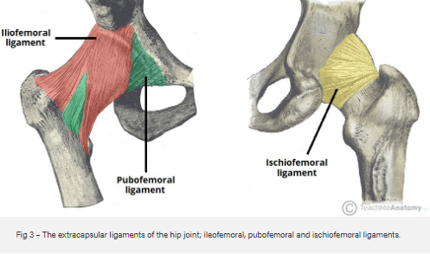
Blood supply of hip joint
Two sets of arteries are responsible for the contribution of major and minor vascularisation of the joint capsule of hip joint,
Major contribution set.
The medial and lateral circumflex arteries which arises from the deep branch of the femoral artery.
Minor contribution set.
It is the single artery supplying to the head of the femu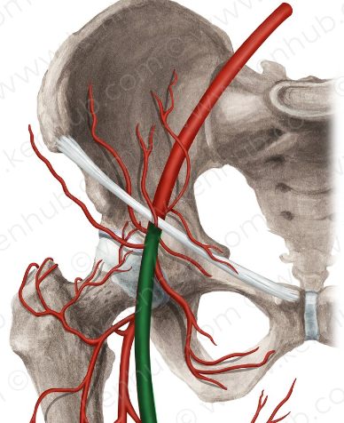
Nerve supply of the hip joint
From femoral nerve the innervation of the hip joint comes anteriorly, and from obturator nerve come inferiorly, and laterally from the articular branch of the sciatic nerve, and superior gluteal nerve posteriorly came across.
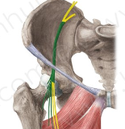

Q : 2/a Explanation of Cruciate ligaments.
Cruciate ligaments also called cruciform ligaments, these are two pairs of ligaments araanged in X like shape, they occurred in several body joints, such as knee joint and atlanto-axial joint, the crossed ligaments stabilizes the joint while allowing a very large range of motion. 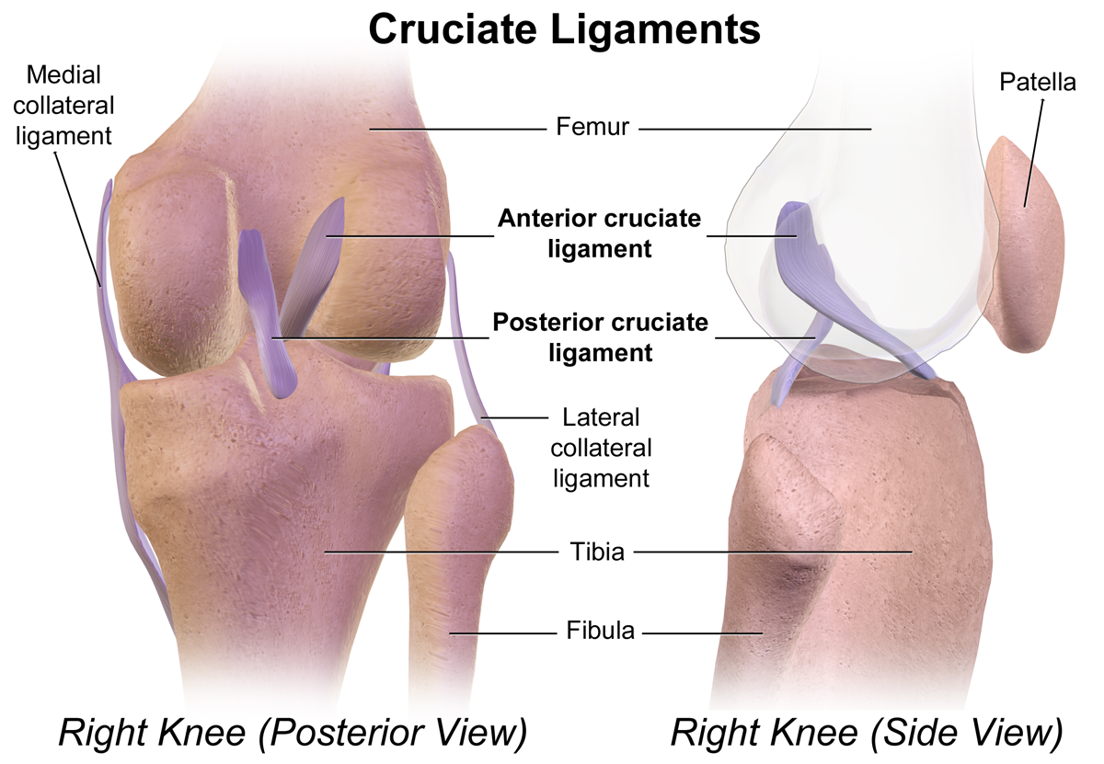
There are two type of CL the anterior cruciate ligament and posterior cruciate ligament.
Clinical significance:
Rapturing of ACL is one of the most occuring in the diseases of stifle joint.
Q:2/b Menisci.
There is a structure medially and laterally in the knee joint which is made of fabrocartilage named as, menisci that serve two functions:
It depend the articular surface of the tubia to increase the stability of it.
It also increase the surface area of the articulation to act as a shock absorbers and for forces.
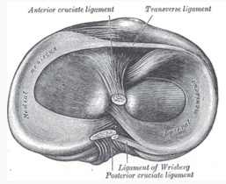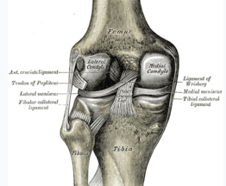

Q : 3 Ligaments fo Ankle joint:
Ligaments may be define as” a sheet or band of tough fibrous tissues connecting bones or cartilages or suppoerting muscles or organs’’ it is achually connection or unifying bond between bones,
In ankle joint there are many ligaments in the between bones of ankle complex, but mainly they are catogorized as, medial ligaments and lateral ligaments.
Medial ligaments:
The medial ligaments are so called deltoid ligaments attached to the medial malleolus, which is the bony prominence projecting from the medial aspect of the distal tibia.
It do have four ligaments that attaches to the talus, and calcaneus and navicular bones.
The function of these ligaments is to resist over eversion of foot bones.
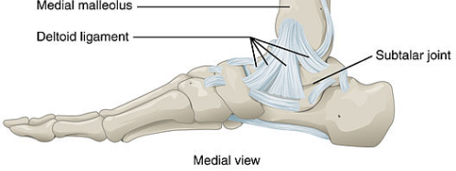
Lateral Ligaments:
The lateral ligaments attached to the lateral malleolus, which is the bony prominence
projecting from the lateral aspect of the distal fibula.
It do also presist the foot bone to not eversion and inversion.
There are three distict type of ligamets of it , which are as follows,
Anterior talofibular – these elangates between the lateral malleolus and the posterior aspect of the talus.
Posterior talofibular –these elangates between the lateral malleolus and the posterior aspect of the talus.
Calcaneofibular –these elagates between the lateral malleolus and calcaneus.
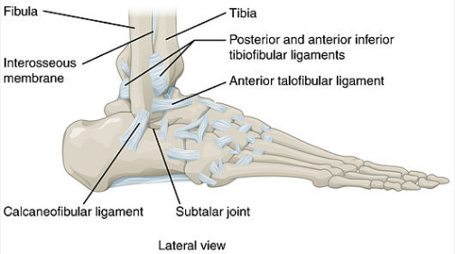
THE END

