Name: Rehan Ullah
ID: 15929
Department: BS (Radiology) second semester
Section: B
Assignment: Biochemistry
Submitted To: Mam kalsoom

Uric acid formation:
A white odorless and tasteless nearly insoluble acid C5H4N4O3 that is the chief nitrogenous waste present in the urine especially of birds, reptiles, and insects, is present in small quantity inhuman urine, uric acid is a product of metabolic breakdown of purine nucleotides and it is a normal component of urine. High blood concentration of uric can lead to gout and are associated with other medical condition, including diabetes and formation of ammonium acid and orate kidney stone.
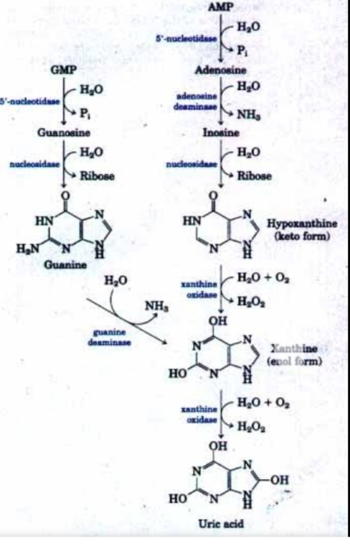

THE END
THANK YOU

