NAME:QAZI MUHAMMAD AZEEM ID:16199
SECTION:B PAPER:ARCHITECTURE AND TOWN PLANNING
DEPARTMENT:CIVIL ENGINEERING SEMSTER:2

Q1: Take any building from internet, put its picture in Microsoft Word and explain its positive and negative points according to the principles of design. What could be done to make the building more attractive? Answer must be at least 200 words

ANS: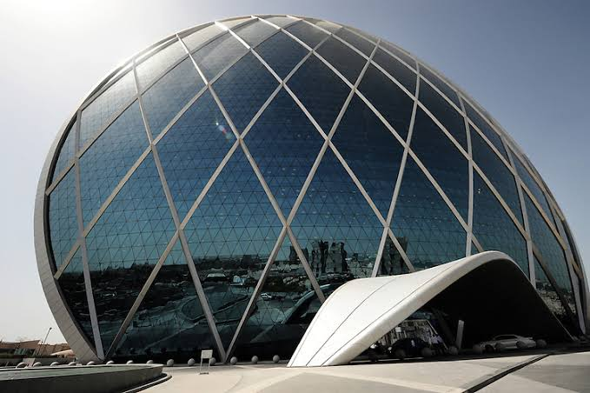
POSITIVE POINTS:
1) In the given building symmetric balance is used.Good looking attractive
2) Repetition is also used in the building due to which it become beautifull
3) Pattern is used throughout the building

NEGATIVE POINTS:
1) Sharp edges must be used to avoid air resistance
2) Highly resistive to hard winds because of simple design
3) Very much quantity of glass is used
4) Only one tye of colour is used
5) No movement shows in art work

WHAT MAKES THIS BUILDING MORE ATTRACTIVE:
- Black and white colours should be used
- Visual movement should use in pattern

Q2: Design and sketch an ideal single storey house on the site shown below. The design should be free hand and can be drawn on graph paper. If a graph paper is not available then make a grid of 5’x5’ on a separate white A4 size paper. The house should be naturally ventilated and have natural lighting. Also, it should be free of noise. The site is located in Peshawar. Label or explain the Plan neatly.
ANS: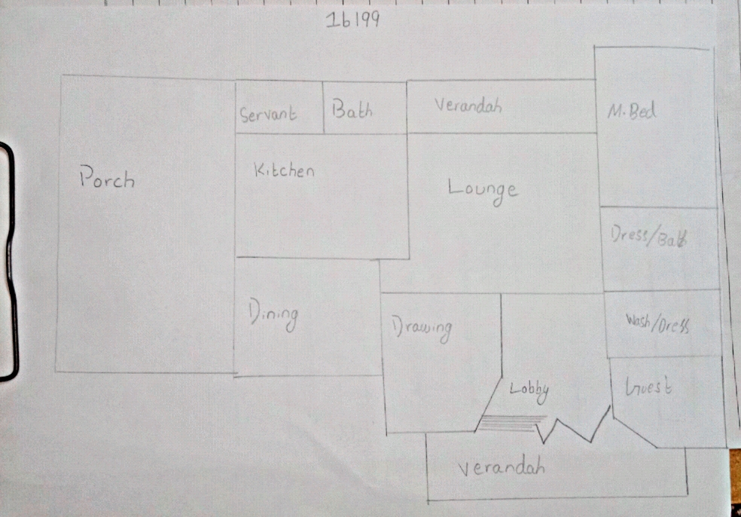

Q3: Select a site at the place where you live. Do Micro site analysis of Site and make its sketch on another A4 paper and write about it in detail. You can take your own lawn as a site for analysis or any other site in the neighborhood. Additionally, make a solar path diagram for your area on a separate piece of paper to find the exact sun angles for both winter and summer. Watch videos on YouTube to understand and make Solar Path diagram. Use these sun angles to make a rough sketch of a room. Show window height, type of fixed sun shade used, angle and height of shade as well as its depth and width by keeping sun angles in mind. The purpose for the sketch is to show how winter sun is allowed and summer sun is blocked.

ANS: