Student Name:M.Naeem Student ID: 16213
Subject: Object Oriented Program Instructor:Sir M.Ayub Khan
Degree:BS(Cs) Semester: 2nd

QNo 1:What is class and role of object in a class, Explain in detail with the help of a suitable program?
Ans:CLASS:The collection of objects is called class.(OR) A class also be defined as ablueprint from which you can creat an individual object.It is a logical entity.It does not consume any space.
Role of object in a class.
An object is a real entity.By the help of object we can perform the method.(OR) An object can be defined as an instance of class.
An object contains an address and take up some space in memory.Example Program:

Public class MyFirstProgram{
Public static void main (String args[]){
ac pia=new ac( );
}
}
In this program MyFirstProgram is public class and public static void main(String args[]) ismain method class.pia is an object which is used for calling to method.
QNo 2 Write a program about table printing which takes input from the user on the bases of OOP and explain in detail?
Ans:A program which print a table:

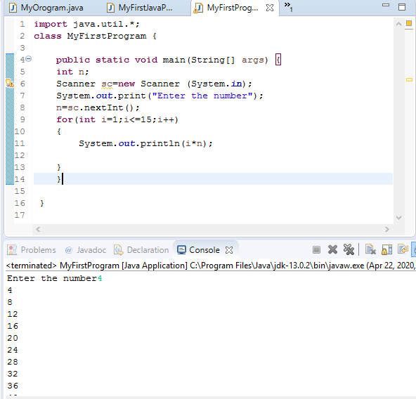

- import java.util.*; is the package where the scanner class will find which is used to take input from user.
- public class Table:public class is the class and Table is the class name.
- public static viod main (String[]args) is the main method.
- n is the variabl of intiger data type.
- Scanner is the class and sc is the object of the class.scanner is used to take the input from user.
- System.out.println is used to print the string.
- For(int i=1;i<=15;i++) is a for loop used to print table.
QNo3:Write a progam about any two cars which can calculate the performance of both of them and explain in detail?
ANS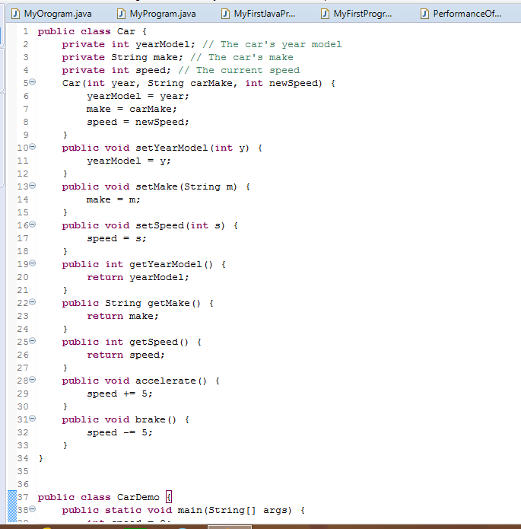

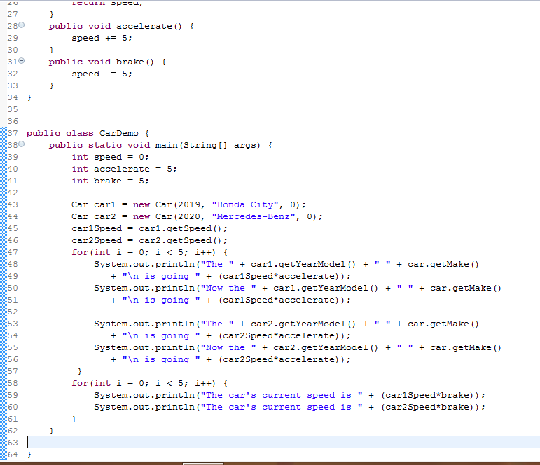
End of the paper

