Name : ANEES AHMAD
ID : 16886

PAPER : PHYSICS

SUBMITTED TO
MUHAMMAD KHALID HAMID

Q-1a) Discuss the significance of the knee of the characteristic curve in forward bias?

Ans) Figure below shows the characteristic curve of forward biasing. In this figure, it can be clearly observed that the forward current increases very little until the forward voltage across the PN Junction reaches approximately 0.7V at the knee of the curve. The physical significance of the knee of the curve is that after this point i.e. the knee of the curve, the forward voltage remains at approximately 0.7V but I_{f} increases rapidly. There do comes a slight increase in V_{f} above 0.7V as the current increases but normal operations for forward biased diode is above this knee of the curve.
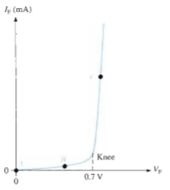
Q-1b) What happens to the barrier potential when the temperature increases?

Ans) Barrier potential is inversely proportional to the temperature. Higher the temperature, greater will be the mobility of charge carriers and lower potential difference across the junction can break the potential barrier.

Q-2a) Compare the depletion regions in forward bias and reverse bias?

Ans) Forward Bias:
Forward bias is the condition that allows current through the PN junction. A PN junction diode is said to be in forward biased condition when the p region forms the connection with positive terminal and n region forms the connection with the negative terminal of the battery. Figure below shows a dc voltage source connected across a diode in the direction to produce forward biasing.

Depletion Region

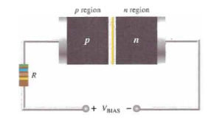

Reverse Bias:
Reverse bias is the condition that essentially prevents current through the diode. A PN junction diode is said to be in reverse biased condition when the p region is connected to the negative terminal of the battery and n region is connected to the positive terminal of the battery. Figure below shows a dc voltage source connected across a diode in the direction to produce reverse biasing.
Depletion Region
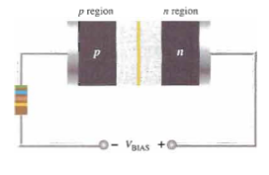
Comparison between the Depletion Regions of Forward and Reverse Bias:
Joining n-type material with p-type material causes excess electrons in the n-type material to diffuse to the p-type side and excess holes from the p-type material to diffuse to the n-type side.Movement of electrons to the p-type side exposes positive ion cores in the n-type side while movement of holes to the n-type side exposes negative ion cores in the p-type side, resulting in an electron field at the junction and forming the depletion region. Both the figures above shows the comparison between the depletion regions of forward and reverse biasing. On applying a forward voltage to a PN junction device the depletion width decreases with the increase in supplied voltage which means that it narrows the depletion region. While, when reverse biasing is provided to a PN junction device then the width of the depletion region increases with supplied voltage which means that the depletion region in the reverse biasing gets wider.

Q-2b) When does reverse breakdown occur in a diode?

Ans) The reverse current in a diode is normally very small. If the external bias voltage is increased so on, the reverse current increases drastically at a particular value of the reverse bias voltage. This particular value of the reverse bias voltage is known as breakdown voltage and this stage the reverse breakdown occurs.

Q-3a) Find the difference between electric potential energy and electric potential?

Ans) The basic difference between electric potential energy and electric potential is that electric potential energy is the energy that is needed to move a charge against the electric field whereas the electric potential at a point in an electric field is the amount of work done to bring the unit positive charge from infinity to that point.
Electric potential energy can be defined only for conservative force. The work done by a conservative force in moving an object between any two positions is independent of the path taken. The electrostatic force between any two charges is conservative because the dependence of positions is just like the gravitational force which is conservative force. Hence we can define potential energy for electrostatic force.We can define the change in electric energy between any two points as the negative of work done by the conservative force on an object as it moves from initial point to the final point;
Δ U =U_{f} – U_{i} = -W
Whereas the Electric potential is defined as the potential energy per unit charge at a point in an electric field, which can be written as;
V =$\frac{U}{q}$

Q-3b) How to find Potential Difference between any two points in the electric field lines?

Ans) A potential difference of one volt exists between two points when one Joule of work is required to move one Coulomb of charge from one point to the other.

Potential difference ΔV_{AB} depends only on points A and B.
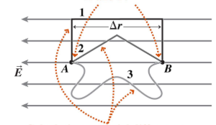
Calculating Potential Difference along any path (1, 2 or 3) gives ΔV_{AB} = EΔr.
Between two points A and B we may write

W_{AB} = -V_{AB} q
Where V_{AB} = V_{B} - V_{A}is the potential difference between A and B.
Note that W_{AB} is the work done by the electric field in moving the charge. The work done by the "external agent” is -W_{AB}.
Units of potential difference are volts
1 Volt = 1 Joule/Coulomb (J/C)
In a region of space where there is an electric field, the work done by the electric fielddW, when a positive point charge, q, is displaced by ds is given by,
dW = q E∙ds
Therefore,
$$ΔV= V_{AB}= V_{B}-V_{A}= -\frac{W_{AB}}{q}= -\frac{\int_{A}^{B}{q E.ds}}{q}= - \int_{A}^{B}{ E.ds}$$
By this equation we can find the potential difference between any two points in the electric field lines.

