Course Title: Medical Biochemistry II
DT2nd, Sec A
Lab Assignment

Student Name: Kainat Nasir

Student ID: 16557

Note:Avoid copy paste material, as it may deduct your marks.

Q1. Explain the process of Uric Acid Formation

Ans : Uric Acid :

Uric acid is the final breakdown product of purine degradation in humans.
Uric acid is synthesized from compound containing purines ,and it is a waste product derived from purines of the diet such is liver ,rthymus , and organ meat.uric acid is mainly excreted in urine by glomerular filtration.
Serum uric acid determination is used to diagnose gout.
A part of it is reabsorbed by the renel tubules .in gout the blood levels of uric acid are increased and also abnormal deposition of uric acid crystal occur in joints ,tendons bone , leading to painful condition of these structure.

Primary Gout :
Is a condition in which a uric acid is synthesized in excess and decreased ability of plasma to retain uric acid in solution. The cause for primary gout is un known , but there is a metabolic disorder.

Secondary Gout :

Is accumulation of uric acid in plasma than other tissue ,due to increased purines catabolism it is not due to excessive synthesis of uric acid.
O 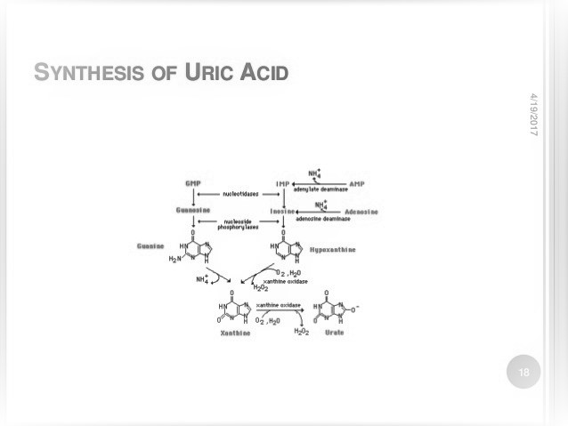

Synthesis of Uric Acid :

The end product of purine metabolism in human is uric acid ,the nucleotide monophophate (AMP,IMP,and GMP) are converted to their respective nucleotide froms (adenosine,inosine ,guanosine) by the action of nucleotidase.
The amino group either from AMP or adenosine cann be removed to produce IMP or
Inosine and guanosine are converted to hypoxanthine and guanine by purine nucleoside phosphorylase.
Adenosine is not degraded by this enzyme it has to be converted to inosine .
Guanine undergo deamination by guanase to from xanthine .
Xanathine oxidase converts hypoxanthine to xanthine and oxanthine to uric acid.
Xanthine oxidase librates H2O2 which is harmful to the tissue.
Catalase cleaves H2O2 to water and oxygen.
Uric acid is the final product of purine metabolism.

Clinical significant of Uric Acid:

Normal uric acid levels are 2.4-6.0 mg/dl (female) and 3.4 -7.0 mg/dl (male) normal value will vary laboratory to laboratory.

CAUSES OF HIGH URIC ACID LEVEL:

PRIMARY HYPERURICEMIA:

Increased production of uric acid from purine.
When kidney cannot get rid of the uric acid in your blood ,resting in high levels.

SECONDARY HYPERICEMIA:

Kidney disease
Certain cancers
Medication can cause increased levels of uric acid in the blood .
Certain from of diabetes(type 2 diabetes ),or acidosis can cause hperuricemia.

GOUT:
Gout is due to elevatedlevel of uric acid in the blood this occure due to a combination of diet and genetics factors .

Control of Uric Acid:

Adjust diet
Limit alcohol
Water.

TREATMEN:T OF GOUT:
Nosteroidal anti inflammatory drugs (NSAIDs ) NSAIDs include over the counter option such as ibuprofen and naproxen sodium.
The drugs allopurinol is used for primary gout.
Alloxanthnie is more effective inhibitor of xanthine oxidase.

Q2. Discuss all the protein complexes used in Electron transport chain.

Ans: ELECTRON TRANSPORT CHAIN (ETC):

ETC couple a chemical areaction b/w an electron donor and electron acceptor to the transfer of H+ ions across a membrane, through a set of mediating biochemical reactions.
These H+ ions are used to produce ATP.
ETC used for extracting energy from sunlight photosynthesis and from redox reactions such as the oxidation of suger (respiration).

COPOSITION OF THE ETC:

Four large proteins complex,
1)complex 1- NADH-coenzyme Q reductase
2)complex 2-succinate –coenzyme Q reductase
3) complex 3-cytochrome c reductase
4)complex 4-cytochrome c oxidase
Many of the components are proteins with prosthetic groups to move electrons.

COMPLEX 1 (NADH DEHYDROGENASE):
Electron pass from
NADH FMNFe- S clusterubiquinone
(flavin mononuceotide) (coenzyme Q)

COMPLEX 2 (succinate dehydrogenase):
Entry point for FADH2.
Succinate dehydrogenase (from the citric acid cycle) directs transfer of electrons from succinate to CoQ via FADH2 .
Acyl-coA dehydrogenase : (from beta-oxidation of fatty acids) also transfer electron to CoQ via FADH2.

COMPLEX 3 ( cytochromes b , c1 and c):

Electron transfer from nbiquinol to cytochrome c.

COMPLEX 4:

Combination of cytochromes a and a3, 10 protein subunits 2 types of prosthetic groups : 2 heme and 2 cu.
Electrons are delivered from cytochromes a and a3 to o2 .
Several chemicals can inhibit the pathway at different locations.
Cyanide and co can block e transport between a/a3 and O2.

FUNCTIONING OF ETC:

In ETC the constituent molecule are arranged in the order of
increasing redox potential
decreasing e-pressure
diminishing free energy level
So along the chain there would be a step by step flow of e-from most –ive initial donor to most +ive terminal acceptor (o2)
e-entiring to ETC are energy rich
as the flow down ,they loss free energy
much ofthis energy get conserved in ATP.
There are four protein complexes (labeled complex 1-4)in the the electron transport chain ,which are involved in moving electrons from NADH and FADH2 to molecular oxygen complex.complex 3 pumps protons through the membrane and passes its electrons to cytochrome c for transport to the fourth complex of proteins and enzymes.

