Mid term lab Assignment
Fall 2020

Submitted By: Irfan Ullah
ID Number: 17553

Assignment Topic: Joints of Upper Limb

Date: 27/11/2020

Joints of upper limb

The shoulder joint (glenohumeral joint) is a ball and socket joint between the scapula and the humerus. It is the major joint connecting the upper limb to the trunk.
It is one of the most mobile joints in the human body, at the cost of joint stability. In this article, we shall look at the anatomy of the shoulder joint and its important clinical correlations.

Articulating Surfaces
The shoulder joint is formed by the articulation of the head of the humerus with the glenoid cavity (or fossa) of the scapula. This gives rise to the alternate name for the shoulder joint – the glenohumeral joint.
Like most synovial joints, the articulating surfaces are covered with hyaline cartilage. The head of the humerus is much larger than the glenoid fossa, giving the joint a wide range of movement at the cost of inherent instability. To reduce the disproportion in surfaces, the glenoid fossa is deepened by a fibrocartilage rim, called the glenoid labrum

Joint Capsule and Bursae
The joint capsule is a fibrous sheath which encloses the structures of the joint.
It extends from the anatomical neck of the humerus to the border or ‘rim’ of the glenoid fossa. The joint capsule is lax, permitting greater mobility (particularly abduction).
The synovial membrane lines the inner surface of the joint capsule, and produces synovial fluid to reduce friction between the articular surfaces.
To reduce friction in the shoulder joint, several synovial bursae are present. A bursa is a synovial fluid filled sac, which acts as a cushion between tendons and other joint structures.
The bursae that are important clinically are:
- Subacromial – located deep to the deltoid and acromion, and superficial to the supraspinatus tendon and joint capsule. The subacromial bursa reduces friction beneath the deltoid, promoting free motion of the rotator cuff tendons. Subacromial bursitis (i.e. inflammation of the bursa) can be a cause of shoulder pain.
- Subscapular – located between the subscapularis tendon and the scapula. It reduces wear and tear on the tendon during movement at the shoulder joint.
There are other minor bursae present between the tendons of the muscles around the joint, but this is beyond the scope of this article.

Ligaments
In the shoulder joint, the ligaments play a key role in stabilising the bony structures.
- Glenohumeral ligaments (superior, middle and inferior) – the joint capsule is formed by this group of ligaments connecting the humerus to the glenoid fossa. They are the main source of stability for the shoulder, holding it in place and preventing it from dislocating anteriorly. They act to stabilise the anterior aspect of the joint.
- Coracohumeral ligament – attaches the base of the coracoid process to the greater tubercle of the humerus. It supports the superior part of the joint capsule.
- Transverse humeral ligament – spans the distance between the two tubercles of the humerus. It holds the tendon of the long head of the biceps in the intertubercular groove.]
- Coraco–clavicular ligament – composed of the trapezoid and conoid ligaments and runs from the clavicle to the coracoid process of the scapula. They work alongside the acromioclavicular ligament to maintain the alignment of the clavicle in relation to the scapula. They have significant strength but large forces (e.g. after a high energy fall) can rupture these ligaments as part of an acromio-clavicular joint (ACJ) injury. In severe ACJ injury, the coraco-clavicular ligaments may require surgical repair.
The other major ligament is the coracoacromial ligament. Running between the acromion and coracoid process of the scapula it forms the coraco-acromial arch. This structure overlies the shoulder joint, preventing superior displacement of the humeral head.

Movements
As a ball and socket synovial joint, there is a wide range of movement permitted:
- Extension (upper limb backwards in sagittal plane) – posterior deltoid, latissimus dorsi and teres major.
- Flexion (upper limb forwards in sagittal plane) – pectoralis major, anterior deltoid and coracobrachialis. Biceps brachii weakly assists in forward flexion.
- Abduction (upper limb away from midline in coronal plane):
  - The first 0-15 degrees of abduction is produced by the supraspinatus.
  - The middle fibres of the deltoid are responsible for the next 15-90 degrees.
  - Past 90 degrees, the scapula needs to be rotated to achieve abduction – that is carried out by the trapezius and serratus anterior.
- Adduction (upper limb towards midline in coronal plane) – pectoralis major, latissimus dorsi and teres major.
- Internal rotation (rotation towards the midline, so that the thumb is pointing medially) – subscapularis, pectoralis major, latissimus dorsi, teres major and anterior deltoid.
- External rotation (rotation away from the midline, so that the thumb is pointing laterally) – infraspinatus and teres minor.

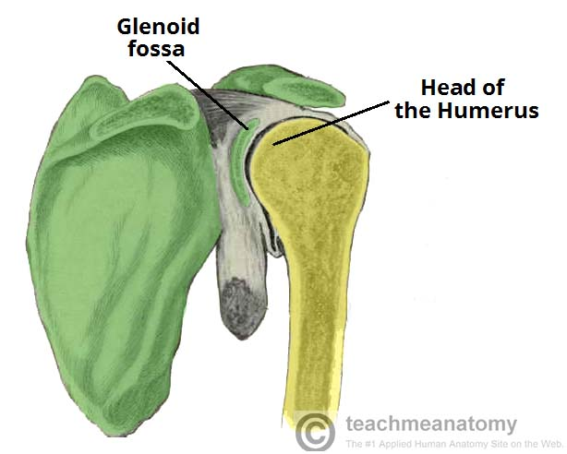

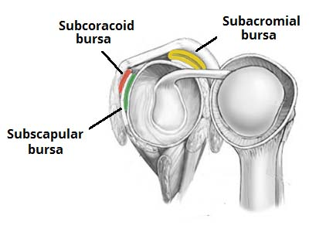

The elbow is the joint connecting the upper arm to the forearm. It is classed as a hinge-type synovial joint.
In this article, we shall look at the anatomy of the elbow joint; its articulating surfaces, movements, stability, and the clinical relevance.

Structures of the Elbow Joint

Articulating Surfaces
It consists of two separate articulations:
- Trochlear notch of the ulna and the trochlea of the humerus
- Head of the radius and the capitulum of the humerus
Note: The proximal radioulnar joint is found within same joint capsule of the elbow, but most resources consider it as a separate articulation.

Joint Capsule and Bursae
Like all synovial joints, the elbow joint has a capsule enclosing the joint. This in itself is strong and fibrous, strengthening the joint. The joint capsule is thickened medially and laterally to form collateral ligaments, which stabilise the flexing and extending motion of the arm.
A bursa is a membranous sac filled with synovial fluid. It acts as a cushion to reduce friction between the moving parts of a joint, limiting degenerative damage. There are many bursae in the elbow, but only a few have clinical importance:
- Intratendinous – located within the tendon of the triceps brachii.
- Subtendinous – between the olecranon and the tendon of the triceps brachii, reducing friction between the two structures during extension and flexion of the arm.
- Subcutaneous (olecranon) bursa – between the olecranon and the overlying connective tissue (implicated in olecranon bursitis).

Ligaments
The joint capsule of the elbow is strengthened by ligaments medially and laterally.
The radial collateral ligament is found on the lateral side of the joint, extending from the lateral epicondyle, and blending with the annular ligament of the radius (a ligament from the proximal radioulnar joint).
The ulnar collateral ligament originates from the medial epicondyle, and attaches to the coronoid process and olecranon of the ulna.

Movements of the Joint
The orientation of the bones forming the elbow joint produces a hinge type synovial joint, which allows for extension and flexion of the forearm:
- Extension – triceps brachii and anconeus
- Flexion – brachialis, biceps brachii, brachioradialis
Note – pronation and supination do not occur at the elbow – they are produced at the nearby radioulnar joints.

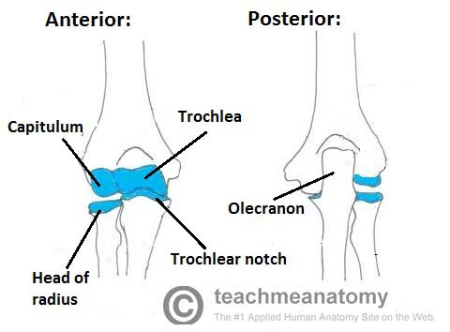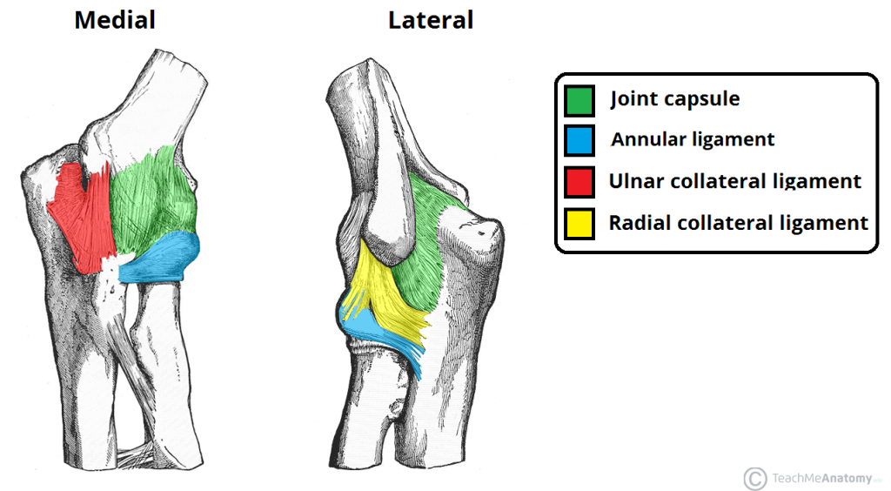

Joints of wrist
The bones of the hand provide support and flexibility to the soft tissues. They can be divided into three categories:
- Carpal bones (Proximal) – A set of eight irregularly shaped bones. These are located in the wrist area.
- Metacarpals – There are five metacarpals, each one related to a digit
- Phalanges (Distal) – The bones of the fingers. Each finger has three phalanges, except for the thumb, which has two.
In this article, we shall look at the anatomical features of the bones of the hand.

Carpal Bones
The carpal bones are a group of eight, irregularly shaped bones. They are organised into two rows: proximal and distal.

Proximal Row (lateral to medial) | Distal Row (lateral to medial)
- Scaphoid  - Lunate  - Triquetrum  - Pisiform (a sesamoid bone, formed within the tendon of the flexor carpi ulnaris) | - Trapezium  - Trapezoid  - Capitate  - Hamate (has a projection on its palmar surface, known as the ‘hook of hamate’
Collectively, the carpal bones form an arch in the coronal plane. A membranous band, the flexor retinaculum, spans between the medial and lateral edges of the arch, forming the carpal tunnel.
Proximally, the scaphoid and lunate articulate with the radius to form the wrist joint (also known as the ‘radio-carpal joint’). In the distal row, all of the carpal bones articulate with the metacarpals.

Metacarpal Bones
The metacarpal bones articulate proximally with the carpals, and distally with the proximal phalanges. They are numbered, and each associated with a digit:
- Metacarpal I – Thumb.
- Metacarpal II – Index finger.
- Metacarpal III – Middle finger.
- Metacarpal IV – Ring finger.
- Metacarpal V – Little finger.
Each metacarpal consists of a base, shaft and a head. The medial and lateral surfaces of the metacarpals are concave, allowing attachment of the interossei muscles.

Phalanges
The phalanges are the bones of the fingers. The thumb has a proximal and distal phalanx, while the rest of the digits have proximal, middle and distal phalanges.
