Submitted By: Mohammad Yousuf
ID: 15396
Submitted To: Maryam Saleem
Subject: Intro to financial Acc
Semester: 3^{rd BBA}

Answer of question 1:
- A
- C
- B
- C
- D
- B
- D
- A
- A
- A

Answer of question 2:

Caroline XYZ
Statement of cash flow
For the year ended Dec 31, 2017

Cash flows from operating activities:
Cash received from customers________________800,000
Interest and dividends received_______________30,000 __________
830,000

Cash paid to suppliers and employees__________(500,000)
Interest paid______________________________(15,000)
Income taxes paid__________________________(40,000) __________

(555,000)

Net cash provided by operating activities__________________275,000

Cash flows from investing activities:
Loans made to borrowers___________________(7000)
Collection on loans_________________________12,000
Cash paid to acquire plant assets______________(10,000)
Proceeds from sale of plant assets_____________20,000

Net cash provided by investing activities_________15,000

Cash flows from financing activities :
Proceeds from short term borrowing___________25,000
Dividends paid_____________________________(50,000)

Net Cash flow used by financing activities___________(25,000)

Net increase in cash and cash equivalents this year_____________ 265,000

Cash and equivalents beginning of year(jan, 1)__________________70,000

Cash and cash equivalents by the end of year___________________ 335,000

Answer of question 3
- Normal Differences between Bank Records and Accounting Records:
The balance shown in a monthly bank statement seldom equals the balance appearing in the depositor’s accounting records. Certain transactions recorded by the depositor may not have been recorded by the bank. Most common examples;
•Outstanding Checks (Checks issued and recorded by the company but not yet presented to the bank for payment)
•Deposits in Transit (Cash Receipts recorded by the depositor that reached thebank too late to be included in the bank statement for the current month)In addition, certain transactions appearing in the bank statement may not have been recorded by the Depositor. Most common examples
;•Service Charges.
•Charges for depositing NSF (Not Sufficient Funds) Checks.•Credits for Interest Earned.
•Miscellaneous Bank charges and credits.

errors of commission are often caused due to the mistake committed by the clerk, they are also called as clerical errors. Also known as error of inadvertence.
If we debit or credit an account, other than the correct account, but with the correct amount, the total debits and credits in the ledger will remain equal and hence the trial balance will not disclose the error.

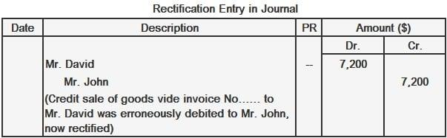

- Common uses of cash flow statement:
- Cash Flow Statement facilitates to prepare sound financial policies. It also helps to evaluate the current cash position.
- A projected Cash Flow Statement can be prepared in order to know the future cash position of a concern so as to enable a firm to plan and coordinate its financial operations properly.
- It helps in taking loan from Banks and other financial institutions. The repayment capacity of the firm can be understood by going through the Cash Flow Statement.
- It helps the management in taking short-term financial decisions.
- Cash is the soul and heart of the business. Cash is pivot of all business activities. Everyone is cash minded. The aim of business is to gather cash. Business is a source while cash is the end. Therefore, it is very useful.

Alice incorporation
Bank reconciliation
Dec, 31

Balance per bank statement----------------------------15,981
Add: Deposit Dec, 31, not recorded by bank yet-----------4353

20,334

Deduct: Outstanding checks No 620------------978
No 630------------2052
No 641------------483 3513

Adjusted cash balance 16,821

Balance per depositor record Dec 31 17,445

Deduct: NSF--------------------------------600
Service charges------------------24
624

Adjusted cash balance 16,821

Answer of question 4:

