Name : Liaqat Ali
Id 14942
Bs DT
PAPER ORAL HISTOLOGY
QUESTION NO : 03
ANSWER NO:03
FACTORS THAT PLAY ROLE IN SHEDDING
- Odontoclast
- Pressure

ODONTOCLAST
- When root resorption is almost complete , these odontoclast degenerate, mononuclear cell emerge from pulpal vessels and migrate to the predentin surface.
- Less is known about the resorption of soft tissue as it sheds.
ODONTOCLAST
- Just before exfoliation , resorption ceases as the odontoclast migrate away from the dentine surface.
- The tooth sheds with some pulpal tissues intact.

PRESSURE
- The pressure exerted by the erupting permanent teeth seem to play an important role in resorption of deciduous teeth
- The local pressure is responsible for initiation of resorption .
- In addition to this local pressure , heavy masticatory and mascular forces play a role in resorption.

QUESTION NO : 05
ANSWER NO : 05
FUNCTION OF TMJ
- Speech and mastication
- Ligaments;
The main component of the TMJ are as follows.

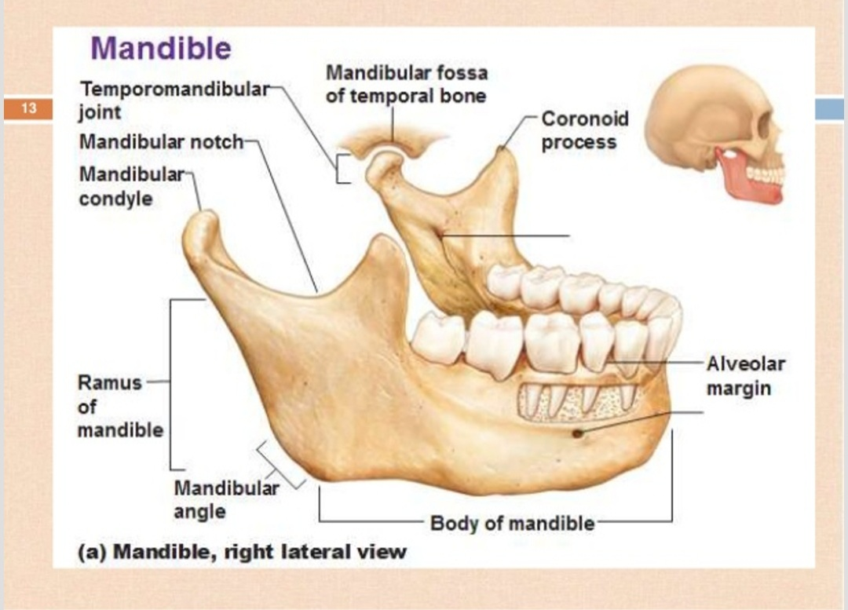

- Liagaments
- Fibrous capsule
- Articular disc
- Lateral ligament of jaw
- Sphenomandibular ligament
- Sytlomandibular ligament
(1)FIBROUS CAPSULE
- Above to the interior edge of the preglenoid plane.
- Posteriorly to the squamo tympanic fissure, between these to edges of the articular fossa.
- Below to the periphery of the neck of mandible.
(2)ARTICULAR DISC
- Fibro cartilaginous disc dividing joint cavity upper and lower component.
- Shape : oval
- Its make articular surface

FUNCTION OF ARTICULAR DISC
- Stabilize the tmj
- Make articular surface
- Reduce wear of tmj
- Lubrication
LATERAL LIGAMENT OF JAW
- Attached above the articular tubercle on the root of zygomatic process of temporal bone
- Extended down word and up word angle of 45degre to horizontal attached to the lateral surface
- FUNCTION; prevent posterior displacement of the resting condyle .
QUESTION NO :02
ANSWERV NO :02
CLINICAL CONSIDERATION OF SALIVARY GLANDS;
Careful examination of a parents medical history and profile can lead clues to dysfunction of silavery gland because they are often associated with other systemic disorder such as hormonal imbalances, diabetes mellitus, arterosclerosis , and neurological disorders.
FOR EXAMPLE:
Xerotomia (dry mouth ) , sialorrhea (increase salivary flow), both could result from dysfunction of the medullary salivary center, automatic innervations to the glands , damage to the itself, or imbalances in fluid and electrolyte.
CLINICAL CONSIDRATION
RADIATION CARRIES :
- Radiation carries is a rampant from of dental decay that may occur in individuals who recives a course of radiotherapy that include exposure of salivary glands.
ETIOLOGY (CAUSES)
Carious lesions are produced due to exposure of salivary glands and reduced flow of saliva , decreased pH, decreased buffering capacity , and increased viscosity.
SIGNS :
Superficial lesions (abnormal change in structure ) attack the buccal , occlusal ,incisal ,and lingual surfaces.it includes cementum and dentin in cervical lesions.
SJOGREN’S SYNDROME
It consist of keratoconjuctivitis (inflammation of cornea and conjunctiva), xerostomia (dry mouth) ,and rheumatoid arthertis (inflammation of joint ) . the cause of the diease can be genetic , autoimmuniological, etc
XEROSTOMIA (DRY MOUTH)
It is defined as a subjective complaint of dry mouth that may result from a decrease in the production of saliva. It is not a disease but a symptom caused by many factors.
ETIOLOGY (CAUSES )
- Sjogren’s syndrome (immune system disorder )
- Therapeutic radiation of head and neck
- Surgical removal of salivary glands
- Diabetes mellitus
- Anxiety , mental stress and depression may temporarily decrease salivary glands.
SYMPTOMS:
- Oral dryness (most common )
- Halitosis (un-attractive odor/smell from mouth )
- Burning sensation (pain type )
- Loss of sense of taste or bizarre taste
- Difficulty in swallowing
- Tongue tends to sick to the palate
SIGNS:
- Saliva pool disappears
- Mucosa become dry
- Rampant carries at the cervical or cusp tip
- Periodontitis
- Candidiasis (fungal infection )

QUESTION NO :01
ANSWER NO : 01
(1)FIBROUS CAPSULE
- Above to the interior edge of the preglenoid plane.
- Posteriorly to the squamo tympanic fissure, between these to edges of the articular fossa.
- Below to the periphery of the neck of mandible.
(2)ARTICULAR DISC
- Fibro cartilaginous disc dividing joint cavity upper and lower component.
- Shape : oval
- Its make articular surface

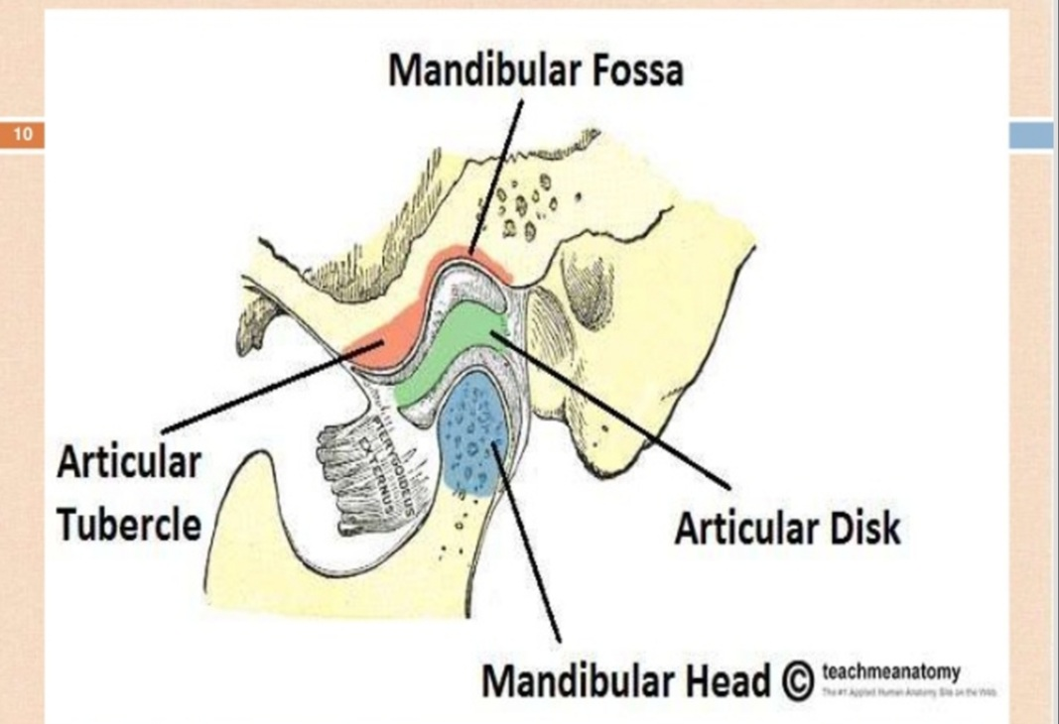

QUESTION NO :04
ANSWER NO :04

CLASSIFACATION OF TOOTH MOVEMENT
- PHYSIOLOGIC TOOTH MOVEMENT
.Eruption
.drifting
- PATHOLOGIC TOOTH MOVEMENT
.Periodontal pathology
.Oral pathologies (cysts ,tumors etc)
- Orthodontics tooth movements
.tooth movements under external clinical forces
- PHYSIOLOGIC TOOTH MOVEMENTS
Naturally occurring tooth movements that take place during and after tooth eruption .
This include ;
- Tooth eruption
- Migration or drift of teeth
- Change in tooth position duration mastication .
- Orthodontic Tooth Movements
- It is pathological process of which the tissue recovers .
HISTOLOGY OF TOOTH MOVEMENTS :
- Orthodontics movements brings about areas of pressure and tension around the tooth.the histologic changes seen during tooth movements wary according to the amount and duration of force applied.

CHANGES ON TENSION SIDE :
- PDL stretched
- Distance between alveolar process and tooth is widened .
- Increased vascularity
- Mobilization of fibroblast and osteo clast
- Lightly calcified bone mature to form woven bone
ON THE TENSION SIDES:
- Over starched PDL
- Tearing of blood vessels and ischaemia
- Extreme forces applied net increase in osteoclast activity and tooth loosened in socket.
PHASES OF TOOTH MOVEMANT
Buastone categorize the stages as ;
- Initial phase
- Lag phase
- Post lag phase
INITIAL PHASE:
- Rapid tooth movements is observed over a short distance which then stops.
- Both light and heavy forces displace the tooth to same extent
- Between 0.4 to 0.9 mm usually occurs in a weeks time
- Both light and heavy forces displaced the tooth to the same extent during this phase
LAG PHASE
- Little or no tooth movements occurs
- Formation of hyalinized tissue
- Extent upto 2-3 weeks
POST LAG PHASE ;
- Tooth movements progresses rapidly as the hylanized zone is removed and bone undergoes resorption
- Osteoclast are found over a large surface area.

