Name : Rabia ahmed zai
Department: DPT 4th semester
Subject : Anatomy
Submitted to : Mam Aruba
ID: 15310

Q#1
“BRAIN"
_ It is an organ of nervous tissue contained in the skull of vertebrates, functioniing as the coordinating centre of sensation and intellectual and nervous activity.
“Types":
- Fore Brain
- Mid Brain
- Hind Brain
“Blood supply of the Brain"
_ Continous blood supply to the brain is very important because of its high metabolic demands for oxygen and glucose. It is highly sensitive to hypoxia and hypoglycemia ( sub normal concentration of glucose in blood ) (inadequate O2).so our brain receives blood from two sources:
- 2- internal carotid artery
- 2- vertebral artery
“Internal carotid artery":
- Middle cerebral
- Anterior cerebral
- Anterior communicating
- Posterior communicating
“Vertebral artery":
- Basilar
- Posterior cerebral artery
The two vertebral arteries unite at the lower border of the pons to form the basilar artery. Which ascends in the midline on the ventral surface of the pons and at its upper border terminates by dividing into right and left posterior cerebral arteries.
Each internal carotid artery ends in the region of anterior perforated substanceby dividing into a large middle cerebral artery , and a smaller anterior cerebral artery.
Thus the brain is supplied by two systems of arteries:
- Vertebral system, consisting of a pair of vertebral arteries, and
Carotid system, consisting of a pair of internal carotid arteries.

“ Vertebral artery":
- Branch of first part of subclavian artery -passes – foramen transvesarium(C6-C1)- enters through foramen magnum – perforates dura and arachnoid matter- enters sub arachnoid- turns upward, farward, medially- medulla oblongata- lower border of pons joins opposite side- basilar artery.
“ Internal carotid artery":
- Start – bifurcation of common carotid artery- perforates base of skull – carotid canal – enters middle cranial fossa beside dorsum sellae – in the cavernous sinus
_ horizontal – emerge out – medial side of anterior carotid process – perforates dura and arachnoid mater – enters sub arachnoid space – turns posteriorly – below optic nerve – turns upward – lateral to optic chiasma- now is under anterior perforated substance divides into anterior and middle cerebral arteries.

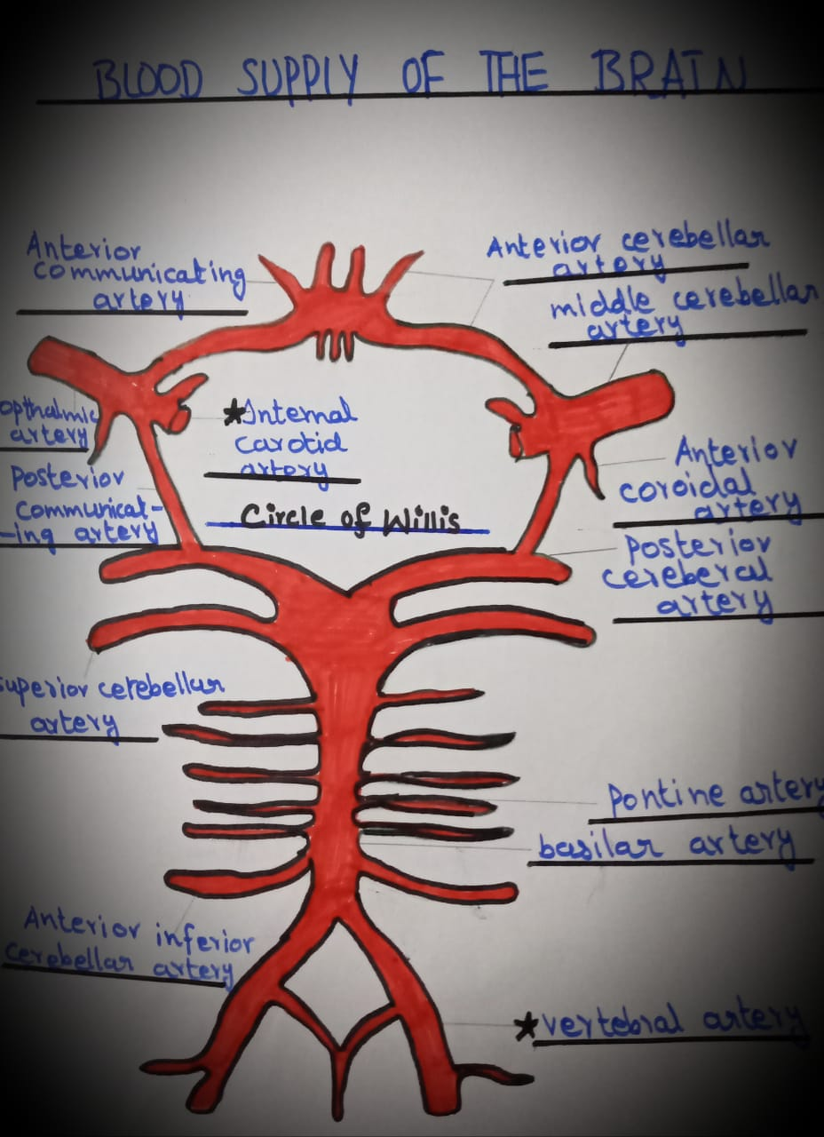
“Diagram"

_ The circle of willis allows blood to flow across the midline of the brain if an artery on one side is ocluded it also act as a safety valve function for the brain.

Q#2
“STROKE"
It is an act of hitting or striking someone or something , ablow. It is an abrupt onset of neurological deficit it persists more than 24 hour.

“Types":
- Ischemic stroke (85%)= a clot blocks blood flow to an area of the brain.
- Hemorrhagic stroke(5%)= bleedings occours inside or around brain tissue. It occours when a blood vessel bursts with in the brain.
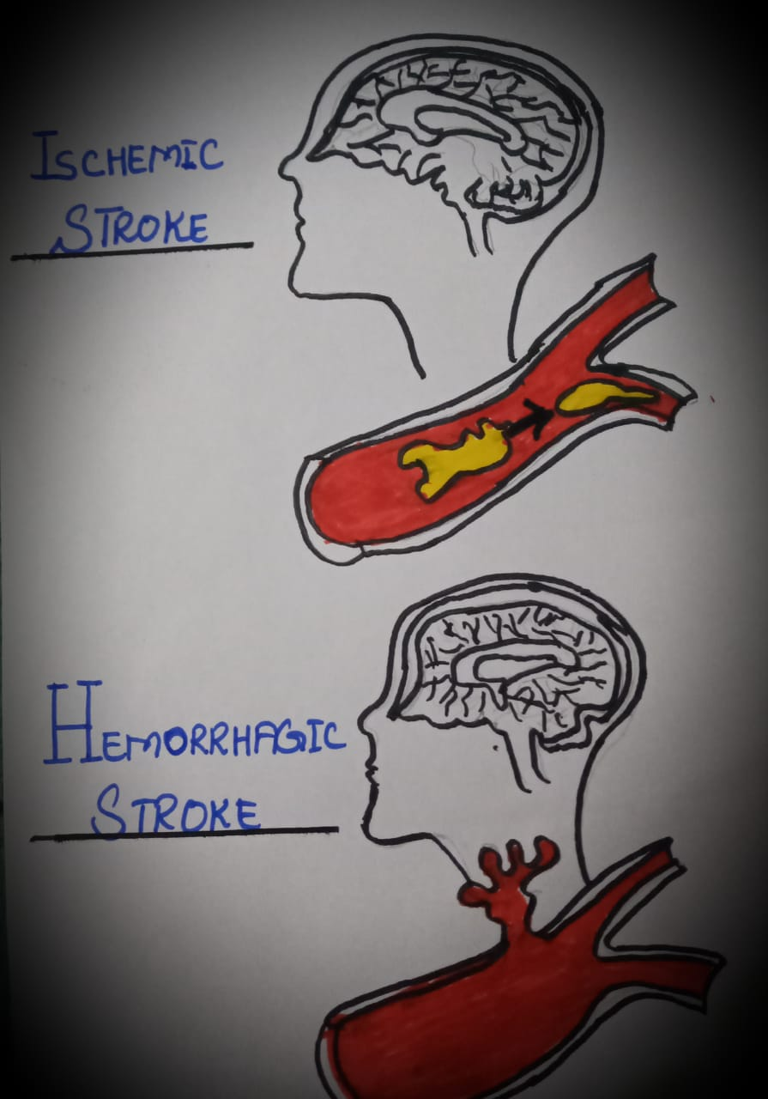
_ Ischemic stroke is the most common type of stroke. It occours when a blood clot blocks or narrows an artery lead into the brain or plugs a blood vessel in the brain. This keeps blood from flowing to the brain. With in minutes, brain cells begin to die. It occours when an artery that supplies blood to the brain is blocked by a blood clot or fatty builbup, called plug. These blockage can appear at the neck or in the skull. Clots isually starts in the heart and travel to the circulatory system.
“Types of ischemic stroke":
- Thrombolic stroke= In this type of ischemic stroke a part of the brain gets injured because the artery that normally supplies blood to it gets blocked. So, blood flow is reduced or stopped completely.

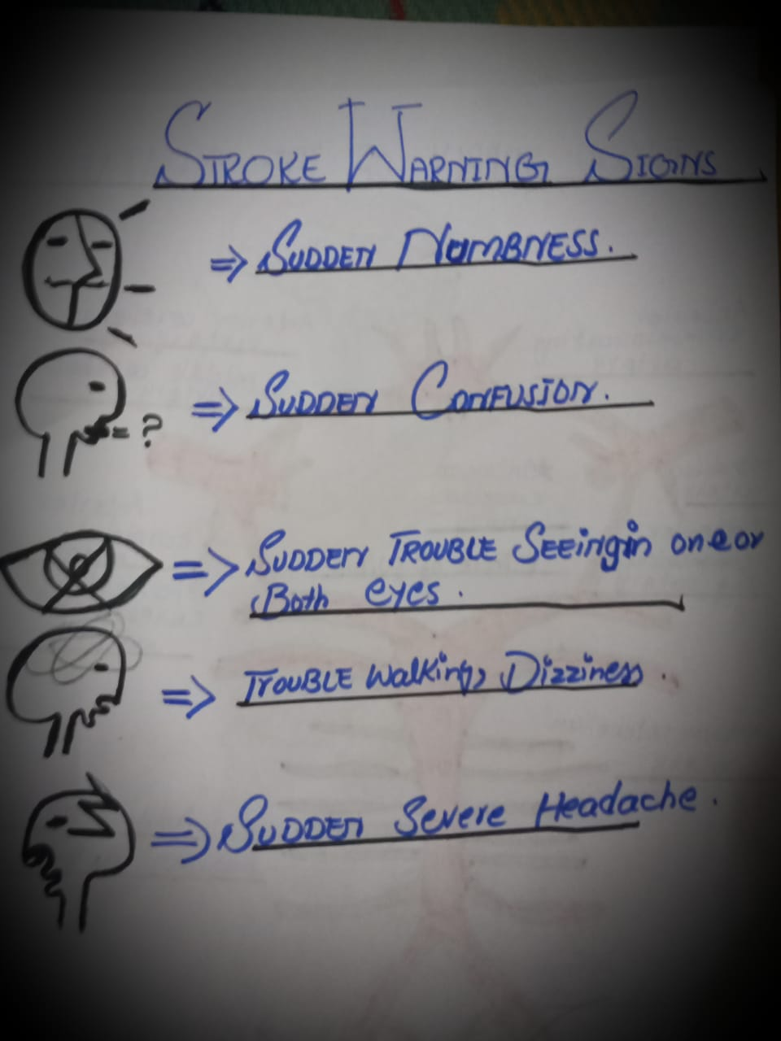
“TESTS":
- Ct scan
- MRI
- Cerebral angiography
- ECG
- Echo-cardiogram
- Carotid duplex
- Heart monitors
“TREATMENTS":
Tssue plasminogene activator can be given with in 3 hours.
“Other preventive measures “:
- Anti- coagulants
- Carotid endarterectomy
- Angioplasty.

Q#3

“THALAMUS":
Thalamus is a paired structure located in the centre of the brain. Each side can be divided into three groups of thalamic nuclei:
- A lateral nuclear group
- A medial nuclear group
- Anterior nuclear group
It is likened to a small hen's egg.
“Situation"
It is a largest component of the diancephalon, situated between the brain stem and cerebral hemisphere.
“Function":
It act as a cells station to all the main sensory system ( except the olfactory pathway).
“Structure":
It is a large ovaid mass of grey mater that forms the major part of the diencephalon. It is composed of two END:
- Anterior end= forms posterior boundry of the inter ventricular foramen.
- Posterior end= it is expended to form the pulvinar.
“Surfaces":
It is composed of four surfaces:
- Superior surface
- Inferio surface
- Medial surface
- Lateral surface
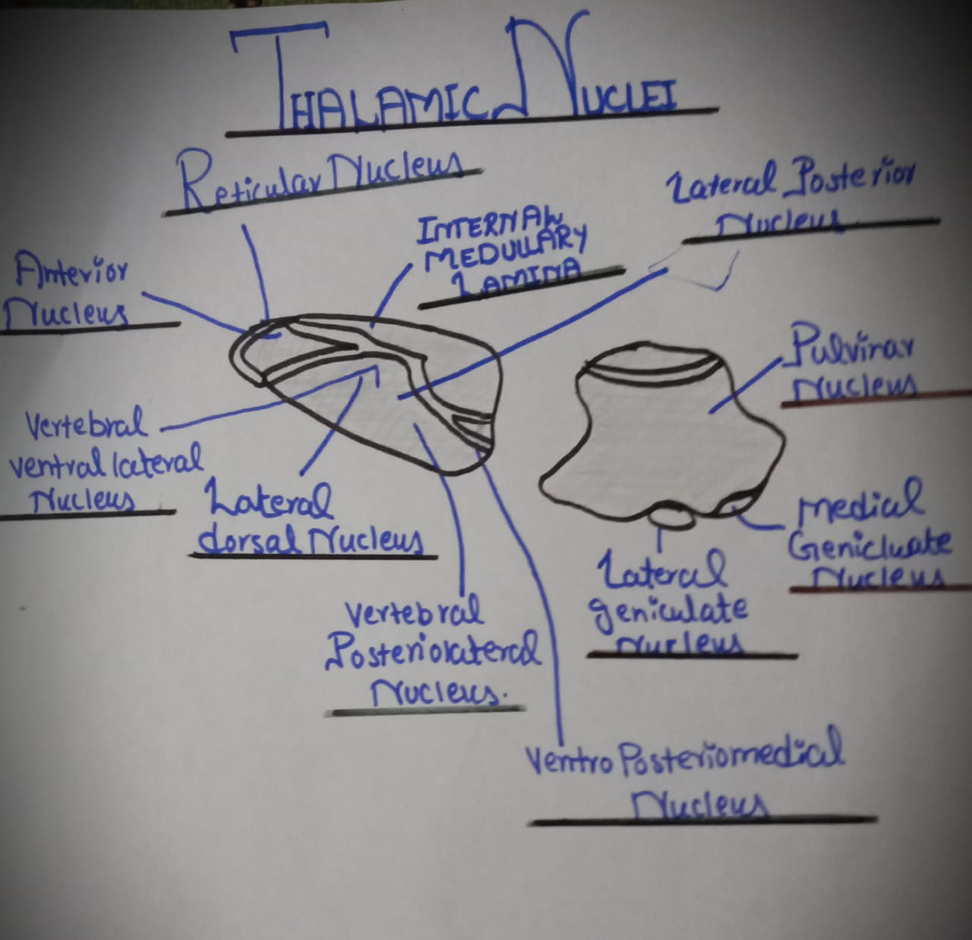
“Diagram"
“NUCLEI OF THE THALAMUS"
The thalamus is covered on its :
- Superior surface by stratum zonale
- Lateral surface by external medullary lamina
Grey matter of the thalamus is divided by vertical sheet of white matter, INTERNAL MEDULLARY LAMINA, into medial and lateral halves.
Almost all thalmic nuclei have rich reciprocal connection with the cerevral cortex.
The thalamus is divided into three principal nuclear masses (ANTERIOR, MEDIAL and LATERAL) by the internal medullary lamina.
_ Embeddded with in the internal medullary lamina .
_ On the lateral aspect of the thalamus lies the thin reticular nucleus.

Q#4

“Spinal cord “:
The cylindrical bundle of nerve fibres and associated tissue which is enclosed in the spine and connects nearly all parts of the body to the brain, with which it forms the central nervous system.
“DESCENDING TRACTS":
The nerve fibres that descend in the white matter from the different supraspinal nerve centres are segregated into nerve bundles called descending tracts
_LATERAL WHITE COLOMN:
“TRACT”
- Lateral corticospinal tract
“Situation"
Anterior to the posterior grey column and medial to the spinocerebral tract.
“Function”
Motor pathway concerned with voluntary , skilled movementss especially of the distal part of the limbs.
- Rubraspinal tract
“Situation"
Anterior to the lateral corticospinal tract.
“Function"
Facialtates activity of the flexor muscle and inhibits activity of the extensor muscle.
- Lateral reticulospinal tract
“Situation"
Its situation is not esteblished.
“Function"
Convey impulses concerned with muscle activity.
- Descending autonomis fibres
“Situation"
Mainly in the lateral white column.
“function"
Concerned with controlling visceral function.
- Olivospinal tract

“Situation"
Lateral to the anterior nerve roots.
“Function"
Associated with muscular activity.
_ANTERIOR WHITE COLUMN
- Anterior corticospinal tract
“Situation"
Along side the anterior median fissure.
“Function”
Motor pathway cocerned with voluntary, skilled movements especially of the distal part of the limbs.
- Vestibulospinal tract
“Situation"
At the periphery of the anterior white column.
“Function"
Facialtates activity of the extensor muscles and inhibits activity of the flexor muscles and maintain postures.
- Tectospinal tract
“Situation"
Lateral to the margin on the anterior median fissure.
“Function"
Concerned with reflex postural movements in response to the stimuli.
- Reticulo spinal tract
“Situation"
Through out the anterior white column.
“Function"
Involved in the control of the reflex activities, muscle tones and vital functions.

Q#5
“NERVOUS SYSTEM"
The network of the nerves cells and fibres which transmits nerve impulses between parts of the body.
“Types":
- PNS
- CNS= brain +spinal cord
“Types of PNS":
- Autonomic nervous system
- Somatic nervous system
“Autonomic types”:
- Sympathetic nervous system
- Parasympathetic nervous system

“AUTONOMIC NERVOUS SYSTEM"
It is a self controlling system, it is that part of the nervous system which regulate most of the involuntary activities of the body . Such as the activities of yhe smooth muscles of bronchial tree, gut genitourinary system, pupil, arrector pili of the hair, cardiac muscles and secretion of the glands.
Thus it represent the visceral component of the nervous system , hence sometime also called"VISCERAL NERVOUS SYSTEM".

“ DIFFERENCE BETWEEN SYMPATHETIC AND PARASYMPATHETIC NERVOUS SYSTEM"
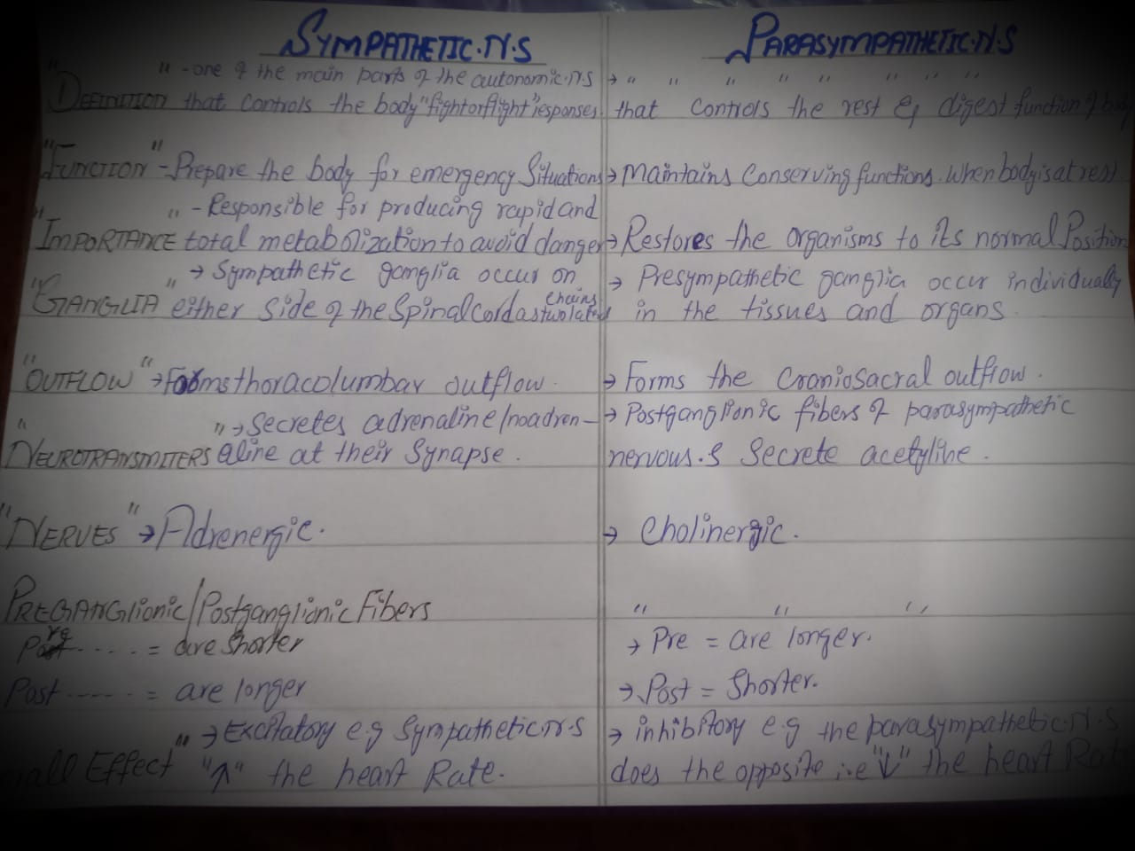

“Diagram of sympathetic nervous system"
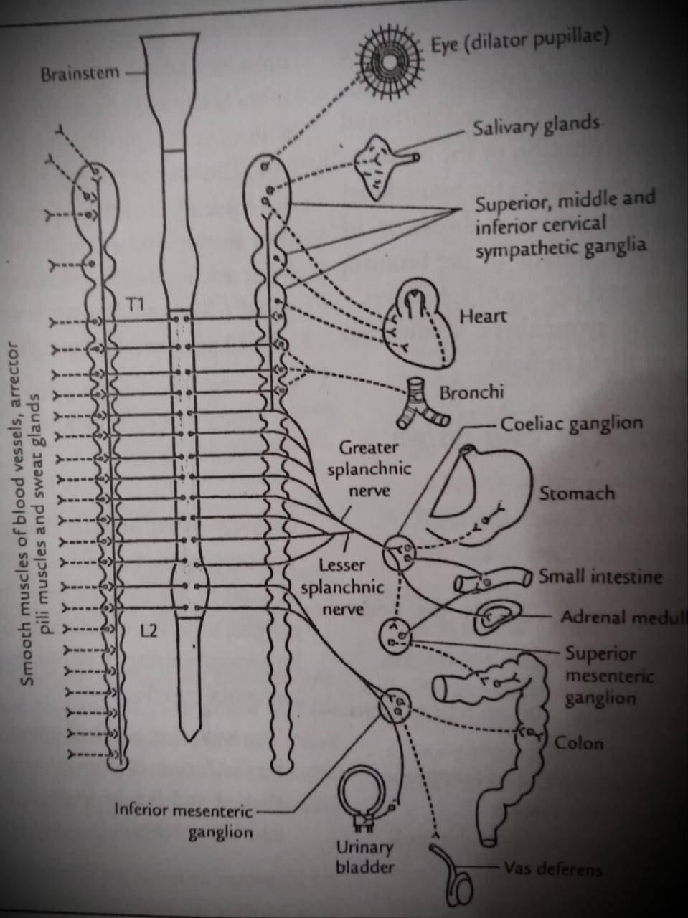
“Diagram of parasympathetic nervous system"
