MID TERM ASSIGNMENT

Student Name: | GULDANA
Student ID Number: | 15970
Lecturer’s Name: | Marium Saleem
Date of Submission: | 27THAPRIL 2020
Course Name: | Financial Management

BBA

Q1) If the expected return is 9% and the standard deviation is 8.38%, what is the probability that return will be more than 10 percent? Also find the probability for return to be less than 40 percent.
(PART A)
Solution
Expected return=R=9%=0.9
Standard deviation=J=8.38%=0.0838
What is the probability that the return will be more than 10 percent?
z=R-R bar /standard deviation
z=0.1-0.09/0.0838
z=0.1/0.0838
z=0.1193
z=0.4602
z=46.02%
So,
There is the 46.02% probability that the return will be more than 10 %.
Expected return=R=9%=0.09
Standard deviation=J=8.38=0.0838
What is the probability that the return will be more than 40 percent?
z=0.4-0.09/0.0838
z=0.31/0.0838
z=3.6992
z=0.0013
z=0.13 %
There is 0.13% probability for the return to be less than 40 percent.

Q1)
(PART B)
- Keeping the current pandemic in mind, which type of risk i.e. systematic or unsystematic risk is faced by stocks traded on Pakistan Stock Exchange and why?
If we see that the COV19 are spreading all over in the world. This pandemic are also damage the Pakistan stock exchange. And due to this pandemic the Pakistan stock exchange are in abnormal situation. The index point are decreasing day by day due to this pandemic. Because the business holders and the shareholders are not investing in the stock exchange. The interest rate are decreases and also the prices of shareholders are also decreases. So this is why investor and the business holders will not be investing money in the stock exchange due this current situation. And this is why this will be a systematic risk.

Q2)
- Calculate coefficient of variation for both investment A and B. Identify which of the two investments is more risky and why?

 | Investment A | Investment B
Expected Return | 0.09 | 0.20
Standard deviation  Ans | 0.05  0.55 | 0.10  0.5

Solution:
- Calculate the co-efficient of variation of investment A
CV= Standard deviation/ R bar
CV= 0.05/0.09 = 0.55

Investment B
CV = standard deviation/ R bar
CV = 0.10/0.20 = 0.5

So, investment A is more riski as it has greater variation relative to the size of expected Return.

- Briefly explain the difference between the characteristic line and security market line.

Security Market Line
Security Market Line is a line that describes the linear relationship between expected rates and of return for individual securities and portfolio and systematic risk as measured by beta. And security market line is also shows the expected return of the individual assets. This line also that will be drawn on a chart that can be sieves as a graphical representation of the capital asset pricing model. Which have shown that different levels of systematic or market risk.

Characteristics line
Characteristics line is defined as the relationship between an individual security's return and return on the market portfolio. The slop of this line is beta. Characteristic line is also graphical representation of the market's risk and at a given time. This line may be short and may be long and also will be straight or curved

Q3) Keeping the pros and cons of different goals in mind, what should be the ultimate goal of a firm? Give reasons for your answer.
(PART A)

How to Set a Goal
Goal setting is a powerful process for thinking about your ideal future, and for motivating yourself to turn your vision of this future into reality.
The process of setting goals helps you choose where you want to go in life. By knowing precisely what you want to achieve, you know where you have to concentrate your efforts.
Top-level goals to successful businessman achievers to set goals. Setting goals gives you long-term vision and short-term motivation . It focuses your acquisition of knowledge, and helps you to organize your time and your resources can make the most of your life.

How to Achieving Goals
When you achieved a goal, take the time to enjoy the satisfaction of having done. The implications of the goal achievement, and observe the progress that you made towards other goals.
If the goal was a significant one, reward yourself appropriately. All of this helps you build the self-confidence.
If you achieved the goal too easily, make your next goal harder.If the goal took a dispiriting length of time to achieve, make the next goal a little easier.If you learned something that would lead you to change other goals, do so.If you noticed a deficit in your skills despite achieving the goal, decide whether to set goals to fix this.

Q3) Why do agency problems arise? How can they be avoided?
(PART B)
Introduction
Agency Theory is defined as risk-sharing between Principle and Agent. For a company Principle means owners or shareholders and Agent means managers. Managers are the decision making authority in an organization and shareholders are the owners of the organization.
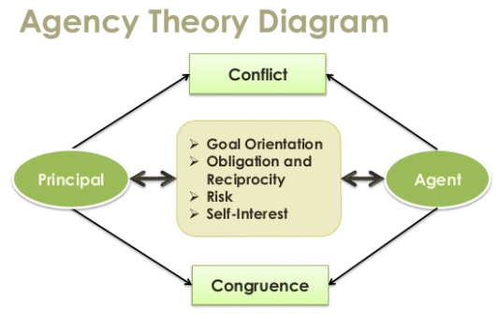

Agency Theory work

In agency theory the managers should act in the best interest of shareholders their actions and decisions should lead to shareholders wealth maximization. In practice, managers may not necessarily act in the best interest of shareholders and they may pursue their own goals.
Managers may maximize their own wealth at the cost of shareholders or may play safe and create satisfactory wealth for shareholders than the maximum. They may avoid taking high investment and financing risks that may otherwise be needed to maximize shareholder wealth.
Managers may sometime think they need to enter into a growing business segment. For that reason they focus most of their attention on it. In the beginning years, they may not earn a huge profit. But they calculated in the long run it will be very profitable.
Agency Problem
Agency problem is that type of problem that they giving their most attention building new company may decrease a little of their profitability in the existing business and it lowers Earning Per Share for their shareholders. And that may create a glitch between their understanding. Because shareholders always want to maximize their earning. And, managers need to think about future sustainability and long term. It creates an agency problem in the organization.

How to Avoid Agency Problem
Monitiring
-Stickholders
-Bondholders
-Board of directors

Outside Auditors
-Issue opinion rdgarding wheather reports are consistent with generally accepted accounting standards.

-Qualified or unqualified opinion.

