PRINICIPLES OF MANAGMENT
ASSIGNMENT 01
November 15, 2020
MUHAMMAD YOUSAF
ID NO 16887

Assignment 01
Q :: 01 How can you prepare yourself to become an effective manager in an increasingly uncertain and global business environment?
ANS: The main thing that a manager needs to be able to do is to be flexible. As you say, the business environment today is uncertain, which means that it is likely to change at any time. In such a climate, managers need to be able to easily throw off old ideas about how things work to embrace new realities. Managers in today's world also need to be flexible because they may well be working with people from different cultures who have different attitudes and expectations. This is another situation in which flexibility is key.

Q:: 02

ANS:: 02
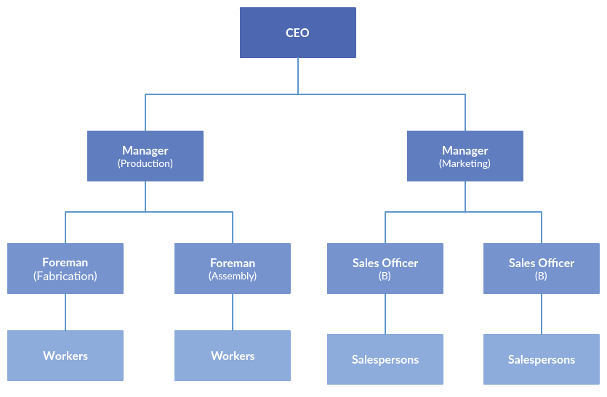

FIRST LEVEL MANAGER…
First-level managers are also called first-line managers or supervisors. These managers have job titles such as: Office manager, Shift supervisor, Department manager, Foreperson, Crew leader, Store manager.
First-line managers are responsible for the daily management of line workers—the employees who actually produce the product or offer the service. There are first-line managers in every work unit in the organization. Although first-level managers typically do not set goals for the organization, they have a very strong influence on the company. These are the managers that most employees interact with on a daily basis, and if the managers perform poorly, employees may also perform poorly, may lack motivation, or may leave the company.
In the past, most first-line managers were employees who were promoted from line positions (such as production or clerical jobs). Rarely did these employees have formal education beyond the high school level. However, many first-line managers are now graduates of a trade school, or have a two-year associates or a four-year bachelor's degree from college.

MIDDLE LEVEL MANAGER…
Middle-level managers, or middle managers, are those in the levels below top managers. Middle managers' job titles include: General manager, Plant manager, Regional manager, and Divisional manager.
Middle-level managers are responsible for carrying out the goals set by top management. They do so by setting goals for their departments and other business units. Middle managers can motivate and assist first-line managers to achieve business objectives. Middle managers may also communicate upward, by offering suggestions and feedback to top managers. Because middle managers are more involved in the day-to-day workings of a company, they may provide valuable information to top managers to help improve the organization's bottom line.
Jobs in middle management vary widely in terms of responsibility and salary. Depending on the size of the company and the number of middle-level managers in the firm, middle managers may supervise only a small group of employees, or they may manage very large groups, such as an entire business location. Middle managers may be employees who were promoted from first-level manager positions within the organization, or they may have been hired from outside the firm. Some middle managers may have aspirations to hold positions in top management in the future.

TOP LEVEL MANAGER…
Top-level managers, or top managers, are also called senior management or executives. These individuals are at the top one or two levels in an organization, and hold titles such as: Chief Executive Officer (CEO), Chief Financial Officer (CFO), Chief Operational Officer (COO), Chief Information Officer (CIO), Chairperson of the Board, President, Vice president, Corporate head.
Often, a set of these managers will constitute the top management team, which is composed of the CEO, the COO, and other department heads. Top-level managers make decisions affecting the entirety of the firm. Top managers do not direct the day-to-day activities of the firm; rather, they set goals for the organization and direct the company to achieve them. Top managers are ultimately responsible for the performance of the organization, and often, these managers have very visible jobs.
Top managers in most organizations have a great deal of managerial experience and have moved up through the ranks of management within the company or in another firm. An exception to this is a top manager who is also an entrepreneur; such an individual may start a small company and manage it until it grows enough to support several levels of management. Many top managers possess an advanced degree, such as a Master’s in Business Administration, but such a degree is not required.

