Course Title: Biochemistry I
Micro 2nd Lab Assignment
Student Name: JALAL AHMAD
Student ID: 16945

Watson and Crick DNA Model

The structure of DNA, as represented in Watson and Crick's model, is a double-stranded, antiparallel, right-handed helix. The sugar-phosphate backbones of the DNA strands make up the outside of the helix, while the nitrogenous bases are found on the inside and form hydrogen-bonded pairs that hold the DNA strands together.
In the model below, the orange and red atoms mark the phosphates of the sugar-phosphate backbones, while the blue atoms on the interior of the helix belong to the nitrogenous bases.
DNA stands for Deoxyribonucleic acid which is a molecule that contains the instructions an organism needs to develop, live and reproduce.
It is a type of nucleic acid and is one of the four major types of macromolecules that are known to be essential for all forms of life.
DNA Model
The three-dimensional structure of DNA, first proposed by James D. Watson and Francis H. C. Crick in 1953, consists of two long helical strands that are coiled around a common axis to form a double helix.
Each DNA molecule is comprised of two biopolymer strands coiling around each other.
Each strand has a 5′end (with a phosphate group) and a 3′end (with a hydroxyl group).
The strands are antiparallel, meaning that one strand runs in a 5′to 3′direction, while the other strand runs in a 3′to 5′direction.
The diameter of the double helix is 2nm and the double helical structure repeats at an interval of 3.4nm which corresponds to ten base pairs.
The two strands are held together by hydrogen bonds and are complementary to each other.
The two DNA strands are called polynucleotides, as they are made of simpler monomer units called nucleotides. Basically, the DNA is composed of deoxyribonucleotides.
The deoxyribonucleotides are linked together by 3′- 5′phosphodiester bonds.
The nitrogenous bases that compose the deoxyribonucleotides include adenine, cytosine, thymine, and guanine.
The structure of DNA -DNA is a double helix structure because it looks like a twisted ladder.
The sides of the ladder are made of alternating sugar (deoxyribose) and phosphate molecules while the steps of the ladder are made up of a pair of nitrogen bases.
As a result of the double helical nature of DNA, the molecule has two asymmetric grooves. One groove is smaller than the other.
This asymmetry is a result of the geometrical configuration of the bonds between the phosphate, sugar, and base groups that forces the base groups to attach at 120-degree angles instead of 180 degrees.
The larger groove is called the major groove, occurs when the backbones are far apart; while the smaller one is called the minor groove, and occurs when they are close together.
Since the major and minor grooves expose the edges of the bases, the grooves can be used to tell the base sequence of a specific DNA molecule.
The possibility for such recognition is critical since proteins must be able to recognize specific DNA sequences on which to bind in order for the proper functions of the body and

Q2. Draw the structure of following saccharides:
Fructose
Maltose
Table sugar
Stachyose
Milk sugar
Glyceraldehyde

Structure of Fructose
Fructose has a cyclic or chair-like structure. The chair form of fructose is similar to that of glucose but in the structure of fructose, there are few exceptions. Fructose has a ketone functional group and the ring closure occurs from 2nd carbon position. This result in the rise to 5-membered ring or there is a formation of intramolecular hemiacetal in fructose. The OH at 5th carbon combines with carbon in the 2nd position.
The five-membered ring has four carbons and one oxygen. There is basically a formation of chiral carbon and two arrangements of CH2OH and OH group. In essence, fructose displays ster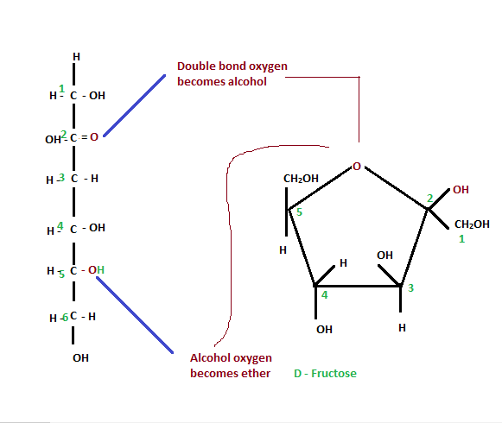isomerism.

MALTOSE

Maltose is a carbohydrate (sugar). Carbohydrates are a class of biological molecules that contain primarily carbon (C) atoms flanked by hydrogen (H) atoms and hydroxyl (OH) groups (H-C-OH). They are named according to the number of carbon atoms they contain, with most sugars having between three and seven carbon atoms termed triose (three carbons), tetrose (four carbons), pentose (five carbons), hexose (six carbons), or heptose (seven carbons).
The single most common monosaccharide is the hexose D-glucose, represented by the formula C6H12O6. In addition to occurring as a free monosaccharide, glucose also occurs in disaccharides, which consist of two monosaccharide units linked covalently. Each disaccharide is formed by a condensation reaction in which there is a loss of hydrogen (H) from one molecule and a hydroxyl group (OH) from the other. The resulting glycosidic bond—those that join a carbohydrate molecule to an alcohol, which may be another carbohydrate—is the characteristic linkage between sugars, whether between two glucose molecules, or between glucose and fructose, and so forth. When two glucose molecules are linked together, such as in maltose, glycosidic bonds form between carbon 1 of the first glucose molecule and carbon 4 of the second glucose molecule. (The carbons of glucose are numbered beginning with the more oxidized end of the molecule, the carbonyl group.)
Three common disaccharides are maltose, sucrose, and lactose. They share the same chemical formula, C12H22O11, but involve different structures. Whereas maltose links two glucose units by an α(1→4) glycosidic linkage, lactose (milk sugar) involves glucose and galactose bonded through a β1-4 glycosidic linkage, and sucrose (common table sugar) consists of a glucose and a fructose joined by a glycosidic bond between carbon atom 1 of the glucose unit and carbon atom 2 of the fructose unit.

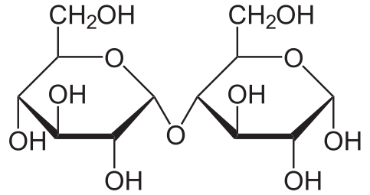

Table sugar

The white stuff we know as sugar is sucrose, a molecule composed of 12 atoms of carbon, 22 atoms of hydrogen, and 11 atoms of oxygen (C12H22O11). Like all compounds made from these three elements, sugar is a carbohydrates.
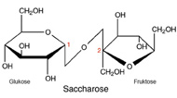

STACHOSE

Stachyose is a tetrasaccharide consisting of two α-D-galactose units, one α-D-glucose unit, and one β-D-fructose unit sequentially linked as gal(α1→6)gal(α1→6)glc(α1↔2β)fru. Together with related oligosaccharides such as raffinose, Stachyose occurs naturally in numerous vegetables (e.g. green beans, soybeans and other beans) and other plants.
Stachyose is less sweet than sucrose, at about 28% on a weight basis. It is mainly used as a bulk sweetener or for its functional oligosaccharide properties. [additional citation(s) needed] Stachyose is not completely digestible by humans and delivers 1.5 to 2.4 kcal/g (6 to 10 kJ/g).
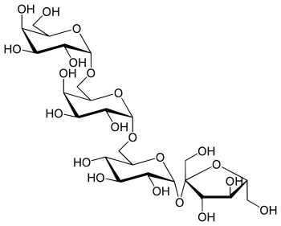
Milk sugar

This page describes the properties of milk carbohydrate. There is a brief introduction to General Carbohydrate Chemistry, followed by sections on Milk Carbohydrate (Lactose) Chemistry, Lactose Physical Properties, and the Influence of Heat Treatments on Lactose Properties. For more details on lactose properties see references by Fox and McSweeney (1998), Holsinger (1988, 1997), and O'Brien (1995, 1997).

Milk contains approximately 4.9% carbohydrate that is predominately lactose with trace amounts of monosaccharides and oligosaccharides. Lactose is a disaccharide of glucose and galactose. The structure of lactose is:

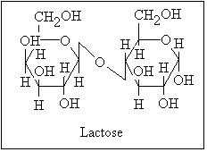

Glyceraldehyde (glyceral) is a triose monosaccharide with chemical formula C3H6O3. It is the simplest of all common aldoses. It is a sweet, colorless, crystalline solid that is an intermediate compound in carbohydrate metabolism. The word comes from combining glycerol and aldehyde, as glyceraldehyde is glycerol with one alcohol group oxidized to an aldehyde.

Glyceraldehyde has one chiral center and therefore exists as two different enantiomers with opposite optical rotation:
In the d/l nomenclature, either d from Latin Dexter meaning "right", or l from Latin Laevo meaning "left"
In the R/S nomenclature, either R from Latin Rectus meaning "right", or S from Latin Sinister meaning "left"
 | d-glyceraldehyde  (R)-glyceraldehyde  (+)-glyceraldehyde | l-glyceraldehyde  (S)-glyceraldehyde  (−)-glyceraldehyde
Fischer projection | 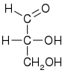 | 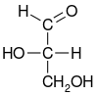
Skeletal formula | 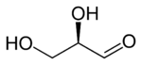 | 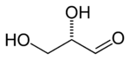
Ball-and-stick model | 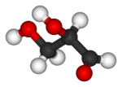 | 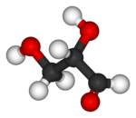
While the optical rotation of glyceraldehyde is (+) for R and (−) for S, this is not true for all monosaccharides. The stereochemical configuration can only be determined from the chemical structure, whereas the optical rotation can only be determined empirically (by experiment).

