Course title: Electric circuit design

Module : 4th

Instructor : sir mujtaba Ahmad

Name : Farhan Ali

Id : 14873

Q(4)(a):

For Class A:
- And class A is always ON .it is used for “signal" level circuits (where power requirements are small) because they maintain low distortion.
- They are very inefficient and are rarely used for high power designs.
- 75% (or more) of the supplied power is dissipated by DC

For Class B:
- Peak efficiency of the class B output stage is 78.5 %, much higher than class A.
- Class B amplifiers are used in low cost designs or designs where sound quality is not that important.
- Class B amplifiers are significantly more efficient than class A amplifiers.
- Before the advent of IC amplifiers, class B amplifiers were common in clock radio circuits, pocket transistor radios, or other applications where quality of sound is not that critical.

For class C:
- Class C amplifiers are never used for audio circuits.
- They are commonly used in RF circuits.
- Class C amplifiers operate the output transistor in a state that results in tremendous distortion (it would be totally unsuitable for audio reproduction).
- So the class C isn’t able for audio circuits

- Q(4)(b):
Outline the differences between an amplifier and a rectifier.
- Answer:
- Amplifiers:
“It is a device which increases the strength / voltage of the signal (By strength, it is generally the power of the signal). There are many types of amplifiers like voltage, power, current etc. (Refer to Sedra and Smith for more.). In practice (there may be exceptions) voltages of the order of milli volts or microvolts is amplified (to 1V or near 1V). In general they work on the principle of cross-conductance / voltage dependent current source / current dependent voltage source etc.
Application:
Audio amplifiers, hearing aids, music systems, Operational Amplifiers.
- Rectifiers:
- It is a device which converts a AC signal to DC. Although at class 12 level one might be knowing about half wave rectifier and full wave rectifier using transformers, diodes and capacitors, there are other types also which uses thyristors and whole full semester course on this topic. Rectifiers are generally used to convert AC voltages of 100V or greater (generally) to DC voltages. This can be explained in a simple fashion as making the average of the signal non zero. In plane AC , the average voltage is zero but consider a rectified AC, the average is non-zero.
- Applications: The primary application of rectifiers is to derive DC power from an AC supply (AC to DC converter). Rectifiers are used inside the power supplies of virtually all electronic equipment. AC/DC power supplies may be broadly divided into linear power supplies and switched-mode power supplies.

- Uses:
A rectifier is a electrical device that converts alternating current to direct current, a process known as rectification. Rectifiers are used as components of power supplies and as detectors of radio signals. Rectifiers may be made of solid state diodes, vacuum tube diodes, mercury arc valves, and other technologies

- Question (1):
Explain the trans conductance curve for n-channel JFET given below.

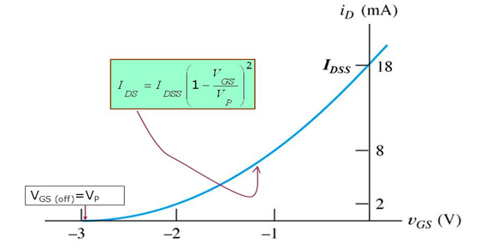
- Answer:
The transconductance cruve of a JFET transistor is the the graph of the drain current, ID verses the gate-source voltage, VGS.
The ratio of change in drain current, ∆ID, to the change in gate-source voltage, ∆VGS, is the transconductance, gm.
The unit of transconductance is the siemen (S). It is the reciprocal of resistnace (Ω).
The transconductance curve, as for all semiconductor devices, is nonlinear, for most of the curve, meaning changes to VGS do not directly increase or decrease drain current, ID.
Below are the transconductance curves of N-Channel JFET transistors and P-Channel JFET Transistors.
The Regions that make up a transconductance curve are the following:

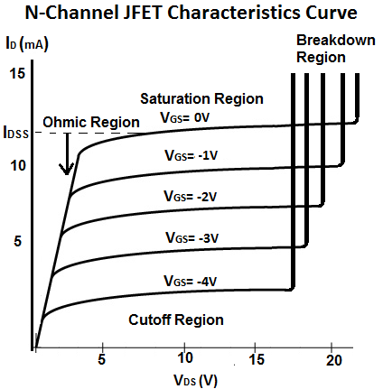

- Cutoff Region: This is the region where the JFET transistor is off, meaning no drain current, I D flows from drain to source.
- Ohmic Region: This is the region where the JFET transistor begins to show some resistance to the drain current, Id that is beginning to flow from drain to source. This is the only region in the curve where the response is linear.
- Saturation Region: This is the region where the JFET transistor is fully operation and maximum current, for the voltage, VGS, that is supplied is flowing. During this region, the JFET is On and active.
- Breakdown Region: This is the region where the voltage, VDD that is supplied to the drain of the transistor exceeds the necessary maximum. At this point, the JFET loses its ability to resist current because too much voltage is applied across its drain-source terminals. The transistor breaks down and current flows from drain to source.
- you know, a JFET operates with its gate-source junction reverse-biased, which makes the input resistance at the gate very high. This high input resistance is one advantage of the JFET over the BJT. (Recall that a bipolar junction transistor operates with a forward-biased base-emitter junction.) JFET datasheets often specify the input resistance by giving a value for the gate reverse current, IGSS, at a certain gate-to-source voltage. The input resistance can then be determined using the following equation, where the vertical lines indicate an absolute value (no sign):
- RIN = VGS/IGSS
- For example, the 2N5457 datasheet in FIG. 14 lists a maximum IGSS of -1.0 nA for VGS =-15 V at 25°C. IGSS increases with temperature, so the input resistance decreases.
- The input capacitance, Ciss, is a result of the JFET operating with a reverse-biased pn junction. Recall that a reverse-biased pn junction acts as a capacitor whose capacitance depends on the amount of reverse voltage. For example, the 2N5457 has a maximum Ciss of 7 pF for VGS = 0

- Question(2):
State the characteristics of a practical operational amplifier.
- Answer:

- Practical Op Amp Characteristics:

1) It has both voltage and current limitations
2) High voltage gain
3) High input impedance
4) Very Low output impedance
5) Generation of unwanted signals (noise).

The Practical Op Amp Characteristics can be approximated closely enough, for many practical op-amps But basically the Practical Op Amp Characteristics are little bit different than the ideal op-amp characteristics.The various characteristics of a practical op-amp can be described as below.

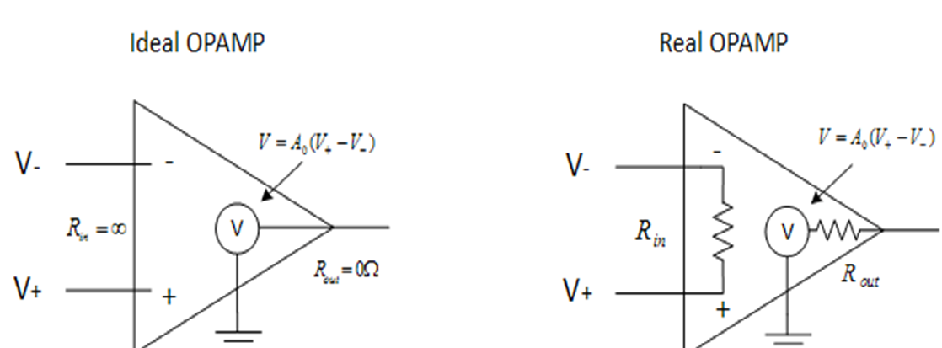

- Open loop gain : It is the voltage gain of the op-amp when no feedback is Practically it is several thousands.
- Input impedance : It is finite and typically greater than 1 M 0. But using FETs for the input stage, it can be increased upto several hundred M
- Output impedance : It is typically few hundred ohms. With the help of negative feedback, it can be reduced to a very small value like 1 or 2 ohms.
- Bandwidth : The bandwidth of practical op-amp in open loop configuration is very small. By application of negative feedback, it can be increased to a desired value.
- Input offset voltage : Whenever both the input terminals of the op-amp are grounded, ideally, the output voltage should be zero. However, in this condition, the practical op-amp shows a small non zero output voltage. To make this output voltage zero, a small voltage in millivolts is required to be applied to one of the input Such a voltage makes the output exactly zero. This d.c. voltage, which makes the output voltage zero, when the other terminal is grounded is called input offset voltage denoted as V ios. How much voltage, to which terminal and with what polarity, to be applied, is specified by the manufacturer in the datasheet. The input offset voltage depends on the temperature.
- Input bias current : For ideal op-amp, no current flows into the input The practical op-amps do have some input currents which are very small, of the order of 10– 6 A to 10-14 A.
Most of the op-amps use differential amplifier as the input stage. The two transistors of the differential amplifier must be biased correctly. But practically, it is not possible to get exact matching of the two transistors. Thus, the input terminals which are the base terminals of the two transistors, do conduct the small d.c. current. These small base currents of the two transistors are nothing but bias currents denoted as Ibi and 42•
So input bias current can be defined as the current flowing into each of the two input terminals when they are biased to the same voltage level i.e. when the op-amp is balanced.
The two input currents, when op-amp is balanced, are shown in the
The two bias currents are never same hence the manufacturers specify the average input bias current Ib, which is found by adding the magnitudes of lb/ and Ib2 and dividing the sum by 2.
- Mathematically it is expressed:
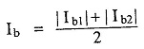
- g) Input offset current : The difference in magnitudes of Ibi and Ib2 is called as input offset current and is denoted as IQ Thus,
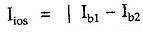
The magnitude of this current is very small, of the order of 20 to 60 nA. It is measured under the condition that input voltage to op-amp is zero.
If we supply equal d.c. currents to the two inputs, output voltage of op-amp must be zero. But practically, there exists some voltage at the output. To make it zero, the two input currents are made to differ by small amount. This difference is nothing but the input offset current.
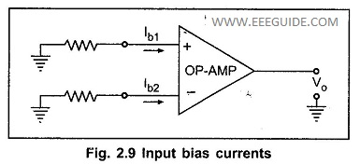

- Question(3):
Calculate output voltage for summing amplifier if V1 = 0.2V, V2 = 0.
0.5V and V₃ = 2V and R₁=R₂=R₃=R_{f} = 6kΩ
Given:
V₁=0.2V
V₂=0.5V
V₃=2V
R₁=R₂=R₃ =Rf= 6k Ohms
Required:
Vout=?
Solution:
Formula: Vout= -( Rf/R) * (V1+ V2)
=-(6k/6k)* (0.2+0.5+2)
= -2.7V Answer

