Course Title: Morphology ll Instructor: Ms. Salma Ishaq
Max Marks: 50
NOTE:
Final term
Name: Abbas
ID: 15063

Each question carry (10) marks
Q1: Briefly explain the palatal aspect of maxillary 1st molar.
Ans. PALATAL ASPECT OF 0F FIRST MOLAR:
- Outlines are reversed from the Buccal Aspect, and the shape is still Trapezoidal.
- The largest cusp is present on the Mesiopalatal Side.
- The smallest cusp is present on Distopalatal Side.
- Theres a Palatal Pit present at the end of the Distopalatal Groove.
- There may be a cusp on the Palatal Surface of the Mesiopalatal Cusp.
- This is the Fifth Cusp called Cusp Of Carabelli, which is visible in addition to the four cusps on the occlusal surface.

P.T.O
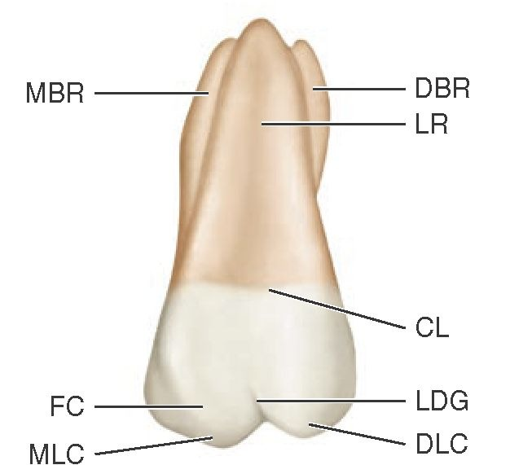
ROOTS ON PALATAL SIDES
- Maxillary First Molar has three roots
- Two on Buccal Side and one on Palatal Side
- Palatal Root is long and slender.
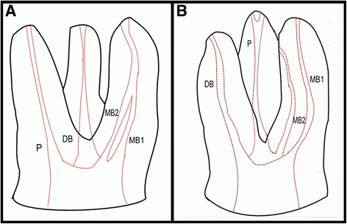

Q2: Specify the function of permanent maxillary canine and 1st pre-molar?
Ans. Function of Permanent Maxillary Canine
- Esthetics: It have a little function in maintaining the shape of the face. But it don’t have to relate with it too much.
- Phonetics: It helps in maintaining the sound and its quality. But it have very less function in phonetics.
- Cutting and biting, mastication: The canine have a lot of function in the cutting, biting and mastication of food.
- Support for lips: It give support to the lips and the face as well.
Function of 1st Pre-Molar
- The canine and First pre molar have the same functions.
- Esthetics: It have a little function in maintaining the shape of the face. But it don’t have to relate with it too much.
- Phonetics: It helps in maintaining the sound and its quality. But it have very less function in phonetics.
- Cutting: It helps in the cutting of food material.
- Biting, Mastication: It helps a person to Bite and masticate a hard food particle to make it ready to swallow.
- Support for lips: It give support to the lips and the face as well.
Q3: what is the chronology of mandibular central incisor?
Ans.
First Evidence of calcification: 3-4 months
Crown completion: 4-5 years
Eruption: 6-8 years
Root completion: 10 years
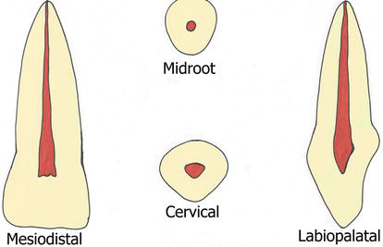
According to the book “Pathology of the Hard Dental Tissues.” Written by Albert Schuurs.
Initiation of the tooth germ: 5-5.3 months
First Evidence of calcification: 3-4 months after birth
Enamel formation complete: 4-5 years
Root completion: 9 years

_____________________________________________________________________________________
Q4: simplify the geometrical outline of occlusal aspect of mandibular 2nd pre-molar?
Ans. Geometrical outline of Mandibular 2nd Pre-molar:
- The facial and lingual aspect have trapezoidal shape.
- But wider cervicaly.
There are two types of occlusal aspects of the 2nd premolars
- The three cusp type
- The two cusp type
The Three Cusp Type:
- The geometrical outline is square.
- It has one buccal cusp and two lingual cusp.
- The arrangement of the cusp according to the size is: the buccal the mesiolingual and the distolingual.
- Every cusp has triangular ridges.
- Y shape developing groove separating the cusps.
- There is a central fossa, central pit, mesial and distal triangular fossae, mesial and distal marginal ridges. 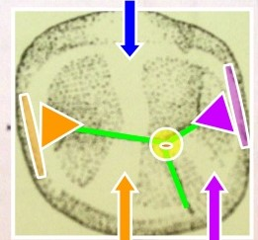
The two cusp type:
- The geometrical outline is round
- There’s a lingual convergence
- There’s one buccal and one lingual cusp.
- There may be a transverse ridge.
- The central developmental groove may be H or U shape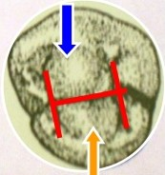
- The surface has supplemental grooves.
- The mesial distal fossa are round. 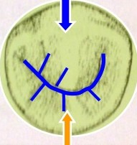

Q5: Why we have molars?
Ans. Teeth are categorized by their placement and function. The sharper teeth tear the food into small particles. While the molars that are the flat teeth have the ability to grind and masticate the food.
Molars are so important for us due to its functions.
Function of Molars:
- Grinding: It helps us to grind food and other hard particles.
- Chewing: With the help of molars we are able to chew our food.
- For solidified food: We would be unable to swallow the hard food if there was no molars.
- For crushing: It helps to crush hard food particles.
- For cutting: It helps to tear and cut the hard and ruby food particles.
- For mastication: It helps in mastication
- For minerals processing: It is able to grind minerals containing food.
- Also for matrix material
_____________________________________________________________________________________
The end

