Summer- Semester 2020 (FINAL TERM)
Course Title: Talent Management
Instructor: Zeeshan Ibrahim
Student ID: 12653
Student Name: Shoaib Gul Awan
Program: MS (HRM)
Date: September 24, 2020
Answer 1:
STEPS OF A TALENT MANAGEMENT PROCESS: -
The following steps cover what you need to do to develop a continuous talent management process for your organization. It covers how to find the most talented people available and then help them stay in your company.
Step 1: Specify What Skills You Need
What is the first step in the talent management process? Before you can go any further, you must determine what kinds of hires you need and what requirements they should fill. Consider if it would be possible to teach existing employees to avoid the need to hire anyone new.
Step 2: Attract the Right People
There are several stages to attracting talent:
Create targeted advertisements and post them on top job sites — HR branding is helpful here.
Plan interviews and other means to identify the best person for the job. In addition to regular questions, consider using personality assessments, references, and tests that require candidates to perform in real-life situations.
Step 3: Onboard and Organize Work
Help new employees feel orientated by being ready for them as soon as they enter the company. Know what tasks you will set them, have training sessions scheduled, and assign current employees to support new workers settle in.
Step 4: Organize Learning and Development
Remember, it is often easier to develop the skills of your current employees than to hire new talent. Plus, even if you do hire top talent, they will likely want to learn something in their new role. Plan ways for your workers to learn and grow, such as through conferences, courses, and a learning management system to create a learning environment.
Step 5: Hold Performance Appraisals
Checking employee performance regularly allows you to see if workers could manage additional responsibilities. This could save you hiring new talent and it may help an employee prepare for a promotion.
Step 6: Strategize to Retain Your Best Talent
Keep employees satisfied at work through promotions, benefits, motivating tactics, ensuring job satisfaction, and improving company culture.

Step 7: Plan for Successions
Nurture employees for successions, such as for when a senior member of staff retires. Enable employees to perform to their best through continuous learning opportunities, including knowledge management. If an employee decides to leave the company, conduct an exit interview to find out what went wrong — this will help you prevent the same issue occurring again in the future.
Answer 2:
TALENT MANAGEMENT MODEL: -
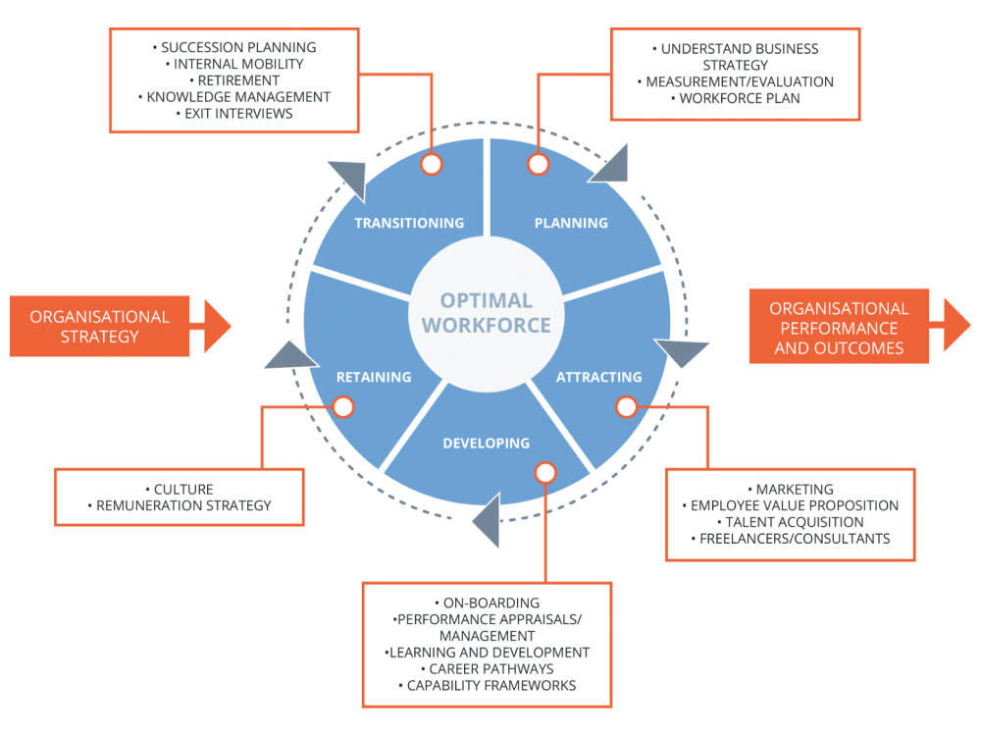
Whereas there is no standardized model for talent management, some HR professionals have proposed excellent models that any company can use. However, you choose to develop your model, it must include the following.
1. Planning
Planning aligns your talent management model in line with the overall goals of your organization. Only with the correct planning can you ensure that you seek talent with the right skills and experience. In addition, it assesses current employees to see what is working well for the company. For instance, if employees with certain characteristics tend to stay at the organization for longer, you should plan to hire more workers like them.
2. Attracting
It is not always as simple as when one person leaves the company, you start a search for someone else to fill the role. For instance, your needs may change or employees may take on new responsibilities. Talent management ensures that you always have sufficient staff to carry out all your operations and prevent heavy workloads that could cause demotivation.
The right strategy will attract just the kind of workers you want at your business. Such hires will be driven, skilled, and seeking to advance within the company. Attracting talent is all about branding your company as an employer. You’ll need to find ways to increase visibility in ways that allow you to present company as a best place to work. The main consideration here is to make your business more approachable.
Even if you choose not to hire someone for a particular position, you still need to create a positive experience. This will give you the opportunity to hire these candidates for other jobs or use them as ambassadors to acquire other talent.
3. Developing
The development part of the model involves taking steps to help talent grow within the company. It should be aligned with the employee development plan and includes identifying roles where particular employees could move to in the future as well as considering how to expand workers’ skills and knowledge to fulfill new challenges facing your organization.
Talent management also looks at what will keep employees at your company enthusiastic and willing to go the extra mile. It is necessary to provide employees with value. Motivation also requires the correct onboarding — to give new hires a great impression of your company from the very beginning. This will increase the chance that they stay with the company and work hard.
4. Retaining
Another purpose of talent management is to keep people at your company for longer. Employees need to continue feeling that the company is an enjoyable, meaningful place to work. Through training and other types of engagement, employees have the chance to create a career without leaving the company. You may achieve this by focusing on compensation (monetary and otherwise) as well as company culture.

5. Transitioning
After hiring and developing their skills, you need to plan for employees’ transitions. Your aim at this stage is to keep their knowledge within the company. This is called knowledge management. You need to have a plan in place to promote employees or move them to another role, department, or office. If a worker does decide to leave, you need to know why.
Answer 3:
DRAWBACKS IN ORGANIZATION IN MAINTAINING TALENT MANAGEMENT
Talent management is a human resources system used to hire, manage, train and compensate top talent. Such programs include strategic planning to align HR needs with the goals and vision of the organization, and ensure that top performers are recruited, developed and retained. While proactive planning is valuable, talent management does have some challenges to overcome.
- Costs
The time, resources and financial costs to operate a talent management program can be high. This is a burden for small business that don't necessarily have the resources to implement such a system. Many companies have one or more HR professionals spending much of their time to develop and implement talent management, but a business with few employees may find those labor hours best spent in other ways. Talent management programs also involve the use of software solutions to map out talent needs at all levels or departments, which can be expensive.
- Worker Conflicts
Several workplace realities impede the impact of talent management. Many small businesses rely on part-time and temporary workers. Keeping them motivated while trying to focus on the long-term tenure of full-time, permanent employees is difficult. If your business relies on workers who you don't need or expect to be around for long, it may not be worth the effort to install a formal talent management program. Multi-generational workplaces also present challenges. Companies of all sizes struggle to come up with effective recruiting strategies that don't discriminate by age, and offering rewards for workers at varying ages that may have different motivations can be difficult.
- Leadership Limitations
A June 2008 "Bloomberg Businessweek" article pointed out that the leadership pipeline is often not full enough to carry out talent management. HR professionals often map out the leadership needs for the business and the skills required at each level. Small businesses may struggle to bring in and develop enough effective store managers or business unit leaders to complete with other small companies as well as larger competitors. To recruit more aggressively, including in other geographic areas, only adds to the costs of talent management.
- HR and Management Conflicts
A core drawback of talent management for small companies is that the programs are often developed and coordinated by human resources professionals. Smaller companies may not have full HR staffs. Instead, managers often hire, train, motivate and fire their own workers while also performing critical business duties. This means managers don't have the time in many cases to implement talent management.

