Yaseen Khan 14461 BS SE 4th Semester Section A

Q1) ERD of NHL

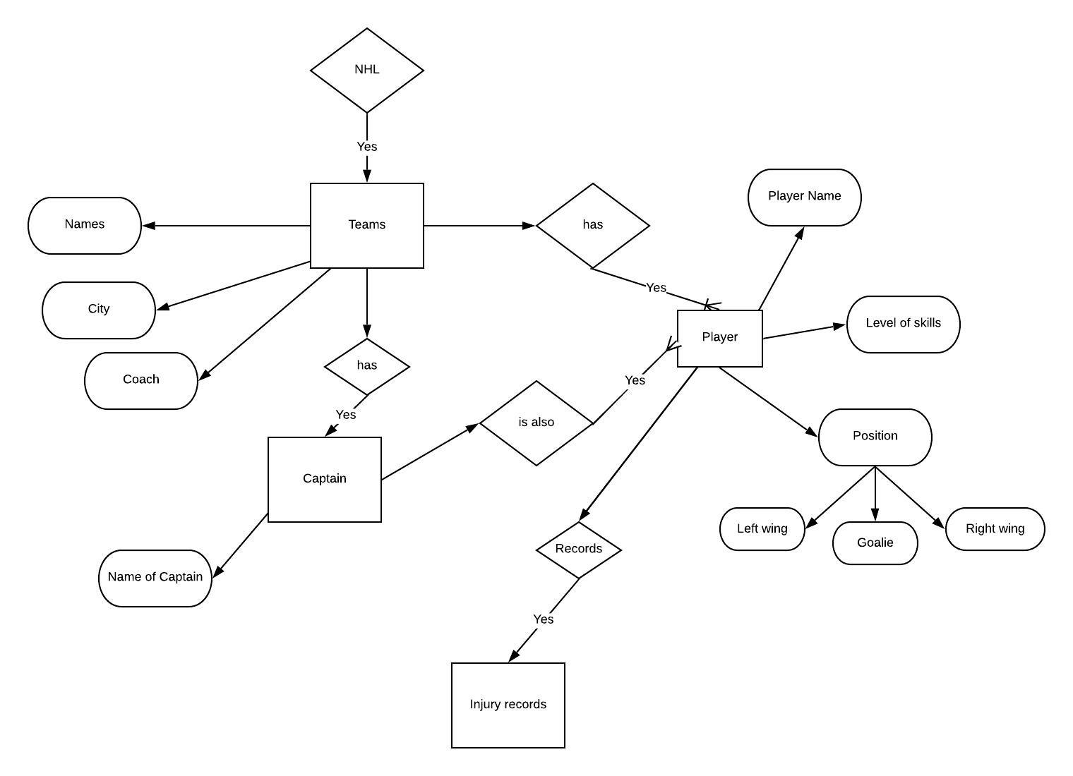

Q2) Relational Model of NHL
