Hematology MLT 2nd semester
Name malak saad khan
ID 16872
Q 1 ;
Ans ; Erythropoiesis (from Greek 'erythro' meaning "red" and 'poiesis' meaning "to make") is the process which produces red blood cells (erythrocytes), which is the development from erythropoietic stem cell to mature red blood cell.
It is stimulated by decreased O₂ in circulation, which is detected by the kidneys, which then secrete the hormone erythropoietin.]This hormone stimulates proliferation and differentiation of red cell precursors, which activates increased erythropoiesis in the hemopoietic tissues, ultimately producing red blood cells (erythrocytes). In postnatal birds and mammals (including humans), this usually occurs within the red bone marrow. In the early fetus, erythropoiesis takes place in the mesodermal cells of the yolk sac. By the third or fourth month, erythropoiesis moves to the liver. After seven months, erythropoiesis occurs in the bone marrow. Increased level of physical activity can cause an increase in erythropoiesis. However, in humans with certain diseases and in some animals, erythropoiesis also occurs outside the bone marrow, within the spleen or liver. This is termed extramedullary erythropoiesis.
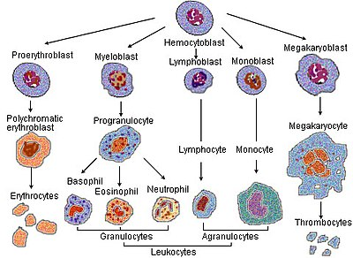
Haematopoiesis

The bone marrow of essentially all the bones produces red blood cells until a person is around five years old. The tibia and femur cease to be important sites of hematopoiesis by about age 25; the vertebrae, sternum, pelvis and ribs, and cranial bones continue to produce red blood cells throughout life. Up to the age of 20 years RBCs are produced from red bone marrow of all the bones (long bones and all the flat bones). After the age of 20 years, RBCs are produced from membranous bones such as vertebrae, the sternum, ribs, scapulas, and the iliac bones. After 20 years of age, the shaft of the long bones becomes yellow bone marrow because of fat deposition and loses the erythropoietic function.

STAGES OF ERYTHROPOIESIS

The various stages between stem cell and matured red blood cell are as follows :
1 Proerythroblast
2. Early normoblast
3. Intermediate normoblast
4. Late normoblast
5. Reticulocyte and
6. Matured erythrocyte.

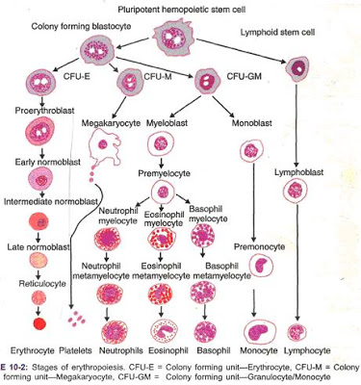

1. PROERYTHROBLAST (MEGALOBLAST)
This is the first cell derived from the stem cell (CFU-E). It is also called megaloblast. It is very larger in size with a diameter of about 20 microns. Its nucleus is large and occupies the cell almost completely. The nucleus has two or more nucleoli and a reticular network. The proerythroblast does not contain hemoglobin. The cytoplasm is basophilic in nature. The proerythroblast multiplies several times and finally forms the cell of next stage called early normoblast.

2. EARLY NORMOBLAST
This cell is slightly smaller with a diameter of about 1; microns. In the nucleus, the nucleoli disappear. Condensation of chromatin network occurs. The condensed network becomes dense. The cytoplasm is basophilic in nature and stains with basic dyes. So, this cell is also called basophilic erythroblast. This cell develops into intermediate normoblast.

3. INTERMEDIATE NORMOBLAST
This cell is smaller than the early normoblast with the diameter of 10 to 12 microns. The nucleus is still present But, the chromatin network shows further condensation. The hemoglobin starts appearing.The cytoplasm is already basophilic. Now, because of the presence of hemoglobin, it stains with both acidic as well as basic stains. So this cell is called polychromophilic erythroblast. This cells develops into late normoblast.

Q 2 ;
Ans: More in Blood Disorders
- White Blood Cell Disorders
- Anemia
- Polycythemia Vera & Myelofibrosis
A blood smear, also referred to as a peripheral smear for morphology, is an important test for evaluating blood-related problems, such as those in red blood cells, white blood cells, or platelets. It has a wide range of uses, including distinguishing viral infections from bacterial infections, evaluating anemia, looking for causes of jaundice, and even diagnosing malaria.
Unlike automated tests (such as a CBC), a technician or physician looks at a blood smear under the microscope in order to detect a wide range of changes that give clues to underlying diseases.

Purpose of Test
A blood smear involves looking at a sample of blood under the microscope after applying special stains and looking for abnormalities or changes in red blood cells, white blood cells, and platelets.
There are many reasons why your doctor may order a blood smear. Some of these include:1﻿
- to further evaluate abnormalities found on a complete blood count (CBC) such as a high or low red blood cell count, white blood cell count, or platelet count.
- to evaluate an infection (identifying the types of white blood cells present can help determine if an infection is viral, bacterial, or parasitic, as well as the severity)
- to look for causes of unexplained jaundice
- as part of a work-up for people who have unexplained weight loss (defined as a loss of 5 percent of body weight over a 6 month period without trying)
- to evaluate symptoms of lightheadedness and palor (paleness)
- to look for causes of petechiae, bruising, or excess bleeding
- with a low platelet count, to determine if the cause is increased degradation or decreased production (based on the size)
- to investigate findings suspicious for blood-related cancers
- to look for malaria
- to confirm sickle cell disease
- to evaluate symptoms of bone pain
- to look for causes of enlargement of the spleen, liver, or lymph nodes.
A blood smear looks for the numbers and characteristics of the three types of blood cells:
- Red blood cells (RBCs) are the cells that transport oxygen to the tissues
- White blood cells (WBCs) are cells that fight infection among several other functions
- Platelets are cell fragments that play an important role in blood clotting
Findings that are noted include:1﻿
- The number of the type of blood cells
- With white blood cells, the number and proportion of the different subtypes of white blood cells, including lymphocytes, neutrophils, basophils, eosinophils, and monocytes
- The relative size of the cells, as well as a variation in size
- The shape of the blood cells
- Other characteristics such as inclusions in the blood cells, clumping of cells, or cell fragments other than platelets
- Other findings in the blood such as the presence of malaria parasites
In addition to information about the different types of blood cells, a blood smear (especially when combined with a reticulocyte count) can often be a good measure of how well the bone marrow is functioning.
There are a few limitations to a blood smear. If a person has received a blood transfusion, the smear will include a combination of native and donated blood cells.

Q3

Ans : Introduction
Granulopoiesis is a complex process by which primitive blood precursors differentiate into fully differentiated, functionally active granulocytes. Studies on the production of neutrophilic granulocytes and other myeloid cells have provided important paradigms for understanding differentiation. In particular, this work has revealed the intricate and often essential roles played by various transcription factors – both those specific to the granulocytic lineage, as well as more widely expressed molecules – in the control of differentiation. Such transcription factors can act both positively and negatively to regulate the expression of a wide range of important genes, including growth factors and their receptors, other transcription factors, as well as various molecules important for the function of the mature cells. In addition, the activity of several transcription factors is controlled by external stimuli, such as cytokines. Finally, there is a complex interplay between all of these factors – synergistic and antagonistic – which allows for the exquisite control of granulocytic cell production that is observed.

Transcription factor cooperativity in granulopoiesis
While no single transcription factor is expressed only in early myeloid cells (monocyte and granulocyte precursors), the combination of C/EBPα with PU.1, CBF and c-Myb is unique to these lineages. Indeed, it appears that it is the cooperation between these factors – together and with other factors – which is the major driving force in mediating granulopoiesis. C/EBPβ and c-Myb cooperate to activate the endogenous mim-1 gene in avian cells.

Cytokine receptor signals and granulopoiesis

Cytokine receptors expressed in cells of the granulocytic lineage
The production of granulocytic cells is also regulated by a network of hematopoietic growth factors and cytokines. One of these, granulocyte colony-stimulating factor (G-CSF), is a major regulator of neutrophilic granulocyte production, and augments the proliferation, survival, maturation and functional activation of cells of this lineage

Role of G-CSF-R signals in granulopoiesis
Mice lacking G-CSF, the G-CSF-R, or G-CSF in combination with GM-CSF have at most a two-fold reduction in immature granulocytic precursors and marrow neutrophils.264265 Peripheral neutrophils are reduced approximately five-fold, perhaps due in part to a defect in their release from the marrow.303 Redundant signals from other cytokine receptors may compensate for the lack of G-CSF-R signals in these mice. Additional evidence for a direct role of G-CSF-R signals in granulopoiesis comes from patients with severe congenital neutropenia (SCN).

Transcriptional collaboration with cytokine receptor signals
It is presumed that the bulk of signals emanating from cytokine receptors ultimately converge in the nucleus to affect myeloid gene transcription, largely via stimulation, suppression and collaboration with a range of transcription factors

Q4:
Ans: Anemia occurs when you have a decreased level of hemoglobin in your red blood cells (RBCs). Hemoglobin is the protein in your RBCs that is responsible for carrying oxygen to your tissues.
Iron deficiency anemia is the most common type of anemia, and it occurs when your body doesn’t have enough of the mineral iron. Your body needs iron to make hemoglobin. When there isn’t enough iron in your blood stream, the rest of your body can’t get the amount of oxygen it needs.
While the condition may be common, many people don’t know they have iron deficiency anemia. It’s possible to experience the symptoms for years without ever knowing the cause.
In women of childbearing age, the most common cause of iron deficiency anemia is a loss of iron in the blood due to heavy menstruation or pregnancy. A poor diet or certain intestinal diseases that affect how the body absorbs iron can also cause iron deficiency anemia.

Causes of iron deficiency anemia
According to the ASH, iron deficiency is the most common cause of anemia. There are many reasons why a person might become deficient in iron. These include:

Inadequate iron intake
Eating too little iron over an extended amount of time can cause a shortage in your body. Foods such as meat, eggs, and some green leafy vegetables are high in iron. Because iron is essential during times of rapid growth and development, pregnant women and young children may need even more iron-rich foods in their diet.

Pregnancy or blood loss due to menstruation
Heavy menstrual bleeding and blood loss during childbirth are the most common causes of iron deficiency anemia in women of childbearing age.

Internal bleeding
Certain medical conditions can cause internal bleeding, which can lead to iron deficiency anemia. Examples include an ulcer in your stomach, polyps in the colon or intestines, or colon cancer. Regular use of pain relievers, such as aspirin, can also cause bleeding in the stomach.

Inability to absorb iron
Certain disorders or surgeries that affect the intestines can also interfere with how your body absorbs iron. Even if you get enough iron in your diet, celiac disease or intestinal surgery such as gastric bypass may limit the amount of iron your body can absorb.

Endometriosis
If a woman has endometriosis she may have heavy blood loss that she cannot see because it is hidden in the abdominal or pelvic area.

Q5 :
Ans .
“Anaemia is an+aemia (no+blood). It is a condition wherein there is decreased oxygen-carrying capacity by the blood.”
Red blood cells carry oxygen to different parts of the body. They have an iron pigment namely hemoglobin to do that.
Anemia can occur either due to a decreased RBC count, decreased hemoglobin or the decreased blood volume. All these lead to the insufficient oxygen-carrying capacity to the tissues and cells by the blood
This anemia is mostly found in women and children. The rate of incidence is as below.
Pregnant women (38%
Childwrn below two years of age (14%)
Elderly people above 65 years (10%
Women age between 12 to 49

But of them, anemia is seen mostly in women with abnormal menstruation, during pregnancy and also in children with poor nutrition.

Morphology in the assessment of microcytic anemia
Medical students often learn that there are five main causes of microcytic anemia, which together form the easily remembered acronym TAILS:
T = Thalassemia.
A = Anemia of chronic disease.
I = Iron deficiency.
L = Lead poisoning.
S = congenital Sideroblastic anemia. his image also shows examples of the teardrops and schistocytes which can be seen in thalassemia trait.
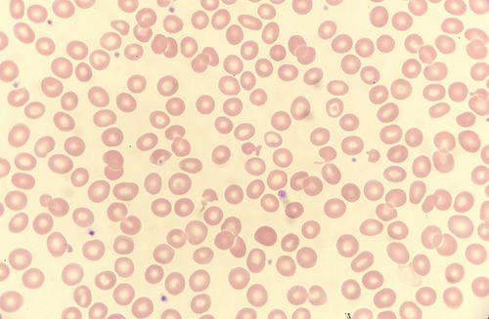
Figure 1
Open in figure viewerPowerPoint
A ‘fish cell’ and other poikilocytes in a case of thalassemia trait. Wright stain, ×100.

Morphology in the assessment of normocytic anemia
Most cases of normocytic anemia are caused by blood loss, suppressed production of RBCs, or hemolysis. In hemorrhage the RBC morphology is entirely unremarkable, except for the polychromasia that typically arises after the first twelve to 24 h. In patients with reduced RBC production, red cell morphology may be normal where the cause is extrinsic to the red cell itself: for example, because of low erythropoietin in a patient with renal failure. But where erythropoiesis is intrinsically disordered (e.g., myelodysplasia) and in cases of hemolysis, RBC morphology may be diagnostically significant.

The end .
Dear sir
mira corona teste positive aya hai sir bhot moshkil see paper hal kya hai agr koi ghalti hoye hai tu plz sir sorry

