Final-Term Assignment(Spring-2020) (BS-MLT 4th)

Course Title: Molecular Biology Instructor: Mr. Fazli Zahir Mian
Time: 6 Hours

Q1: Fill in the Blanks.
- The three main steps of PCR are _____________, ______________ and _______________
- The word “vaccine” originates from the Latin word _______________________________.
- _________________________ is the oldest microbes exploited by humans for their benefit.
- Restriction endonucleases are also called as ______________________________________.
- _____________ is a diagram or map of DNA molecule of an organism that shows specific sites of cleavage restriction sites.
- A forensic technique used to identify individuals based on the variations in their DNAsequences is known as _____________________.
- Restriction modification system is mainly composed of ____________ and ______________

notes on the following Q2: Write short
- Vaccines and its types
- Biotechnology and its scope

Q3:Explain in detail the Restriction modification system.

Q4: What are Different types of retraction enzymes? Recombinant DNA,Recombinant DNA technology and its application

Q5: As students of MLT how will you use Restriction endonuclease in lab?

_________________________________________________________________________________

Good luck.
Name ASIF SHAH
ID 14742

Q1: Fill in the Blanks.
- Denatruation , annealing and extension
- Vaccine
- Yeast
- Molecular scissors
- Restriction map
- DNA finger printing
- Restriction endonuclease , methylease enzymes

QNO3 : Explain in detail the Restriction modification system.

ANS;
RESTRICTION MODIFICATION SYSTEM
- RESTRUCTION MODIFICATION system are important component of prokaryotic defense mechanism against invading genomes.
- They occur in a wide variety of unicellular organism including bacteria and archea.
- They comprise two contrasting enzymatic activities;
Restriction endonuclease (REase)
Methyltransferase (MTase)
- Phage (or viruses )invade all type of cell.
- Bacteria are one favorite target.
- Defense mechanism have been developed by bacteria to defend themselves from thes invasions.
- The system possess for this defense is the restriction modification system.
- This system is composed of a;
- RESTRICTION ENDONUCLEASE
- METHYLASE ENZYME
- Each bacteria species and strain has their own combination of restriction and methylating enzymes.
- RESTRICTION ENZYME—An enzyme that cuts DNA at internal phosphodiester bonds; different type exist and the most useful ones for molecular biology (types ) are those which cleave at a specific DNa sequence.
- METHYLASE—an enzyme that add a methyl group to a molecule; in restriction modification system of bacteria a methyl group adds to DNA at a specific site to protect the site from restriction endonulease cleavage.
- NUCLEASE
- The enzyme that cleaves nucleic acids.
- Nuclease which belong to the class of enzyme called hydrolases.
- Nuclease are futher described by the addition of the prefix ,endo, or ,exo,to the name.
- ENDONUCLEASE break the nucleic acid chain somewhere in the interior, rather than at the ends, of the molecule. Also called restriction endonuclease.
- EXONULEASE;
- Removing nucleotide from the ends of the molecule.
- RESTRICTION ENDONUCLEAS;
- In 1968 the discovery of thes enzyme marked the beginning of recombinant DNA research and sequence specific modification of molecules.
- Each type is chareterized by a slightly different mode of action on DNA.
- RESTRICTION SITES
- The restriction site or the recognition sequence are usually four to eight nucleotides in length and are palindromic.
- The palindromic sequence read the same on both the strands of DNA in a 5—3 Direction.
- FOR EXAMPLE
- THE direction site of ecori is 5’GGATCC3’and the cleave site is between the G and A on the complementary strands, which is demonstrated in figure below.

Q2: Write short notes on the following ?
- Vaccines and its types.
Vaccine suspetion of weakend killed or fragmented microorganism are toxine or of antibodies or lymphocytes that is adminstreed primarily to prevent disease.
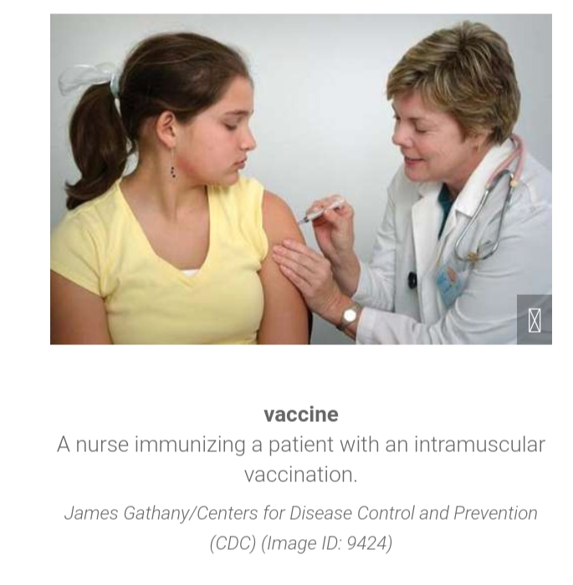

Vaccines:IS A BIOLOGICL Preprationthat provides active acquired immunity to a particular infectious disease.a vaccine tyoiclly contains an agent that resembles a disease-causing microorgainsiim and is often made from weakened or killed from of the microb,its toxins,or ,one of its surface protein.

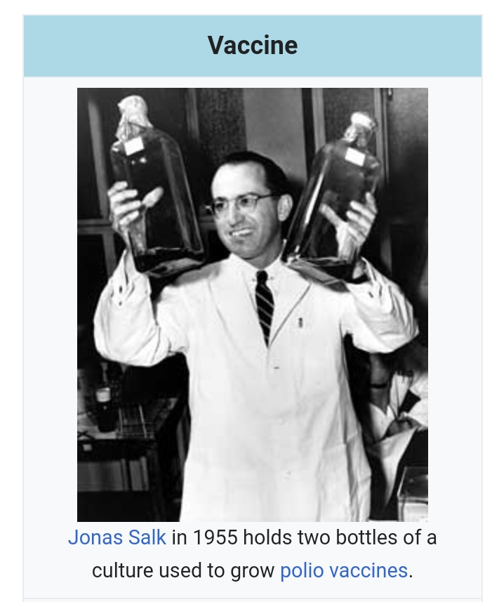
The Administration of vaccine is called vaccinistration.vaccine is the most effective method of preventing infection disease.
TYPE OF VACCIN
THERE ARE FOUR MAIN TYPES OF VACCEN
- Live attenuated vaccines
- Inactivated vaccines
- Subunit, recombinant, polysaccharide and conjugate vaccine
- Toxiod vaccine.

- Biotechnology and its scope.
The term biotechnology was conied in 1917,by Hungarian engineer ,karl erk, to describe a process for large scale producton of pigs.
Biotechnology can be difined as application of techanlolgy using the living organism to obtain useful products.

Scope of biotechnology:
Biotechnology it the technologies applied to biology ,molecular biology ,genetics,and many other filed of biology.biotechnology utilizes cellulr and biomolecular processes to crete technologyies and products the helps improve our lives and the nature. By making useful food such as bread and cheese ,and preserving diary products we have done these for many year by no .
  - As you see recent advance in biotechnology are helping us prepare for and meet society’s most difficult challenges and alts biotechnology aims at braining the most efficient environment friendly biotechnology products.
Biotechnology is a multidiscipline pursuit that has emerged as a demanding industry during the recent past.
Besides being a branch of advanced biological sciences, it has attracted many multinational companies including those are concerned with;
The production of pharmaceutical product for the cure or control of many human disease. These products include antibiotics, vaccines, life saving drugsand gene therapy.
Improvement of clinical testing and diagnostic tools.
Production of novel varieties of crop plant and animals.

Q4: What are Different types of retraction enzymes? Recombinant DNA,Recombinant DNA technology and its application
Ans according to the type of reacton of the enzyme catalyze are classified ito seven categories ,which are.
- oxidorductasese
- transferasese
- hydrolesses
- lyases
- isomerases
- ligases
- and translocasese.
Oxidoreductasese,transfrsae and hydrolases are most abduntan from of enzymes.

Recombinant of DNA technology:
The first recombinant DNA was produced by Stanley N. Cohen and Herbert boyer in 1973
- in ther experiment they combined to plasmids Psc-101 and-Psc 102 and they newly created recombined DNA were incorporated E.co/i.
- the PSC-101 Contain the agent for tetracycline resistance.
- The psc 102 contain the agent for kanamycine resistance.
- The transformed bacteria after recombination sho resisrance to both these antibioticse
- Many divers techniques are now available in recombinant DNA technology.

Step of recombinant DNA technology;
- The first is the extract totak DNA of the organism which contain the desired gene of onterst.
- Next step is the generation of fragmention of the above DNA with suitable restriction enzyme.
- Then the Dna fragment contain the gene of interest in inserted to clonig vector to create recombinate or chimeric DNA.
- The cloning vector can be a plasmid bacteriaophages viruse or small artificial chromosomes such as yas and bac.
- After cloning introduce the recombine vectoe into a host cell such as bacterium (E .coil)

Application of DNA Recombinate;
- Distant hybridization:advertisements
- Development of trandgenic plant
- Development of root nodules in cereal crops
- Development of C4 plant
Application in medicines:
- Production antibiotics
- Production of human insulin
- Production of vaccine
iv.Production of interferon
v.production of enzyme.
vi.gene therapy.
vii.solution of disputed parentage

application.
- Relates article
- Note on genetic engineering
- Recombination DNA technology.

Q5: As students of MLT how will you use Restriction endonuclease in lab?

In the laboratory restriction enzyme (or restriction endonuclease )are used to cut DNA into sammer fragment. The cut are always made at specific nucleotide sequences. Different restriction enzyme recognize and cut different DNA sequences.
- WHERE DO RESTRICTION ENZYMES COME FROM;
Restriction enzymes are found in bacteria use restriction enzyme to kill viruses the enzymes attack the viral DNA and break it into useless fragments.

How do reaction enzymes work?

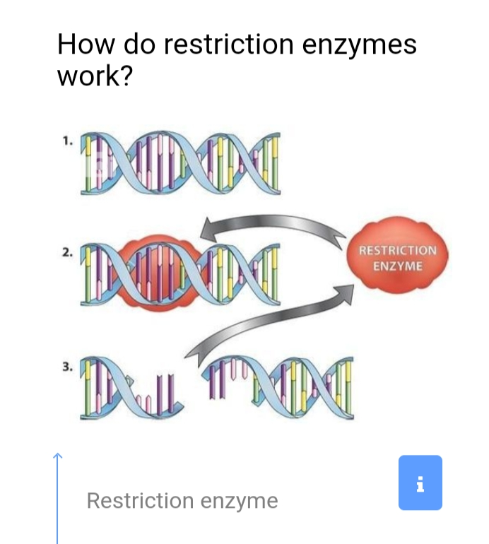
Lika all enzyme a restriaction enzyme works by shape –to-shape matching .when it come into contect with DNA sequnace with with a shape tahat matches a part of the enxym.

When are restriction enzymes used.
Restriction enzyme are a basic tool for biotechnology research. They are used for DNA cloning ans DNA fingerprinting.

