Name Muhammad jawad
Id 14845
Module 4th semester
Course DPT
SUBJECT pharmacology
Date 25.06.2020

Answer 1:
Neurotransmission ....
Is the process in which the signalling molecule called the neurotransmitter are released by the axon terminal of neuron and bind to and react with the receptor of the dendrites of another neuron which is near to him with a short distance.
Neurotransmission is regulated by several different factors such as ,
- The availability
- Rate of synthesis of neurotransmitter
- The release of the neurotransmitter
- The number of postsynaptic receptor
- Presynaptic reuptake
- The baseline activity of postsynaptic cell .

In response to threshold action potential and graded electrical potential here the neurotransmitter are released at presynaptic terminal .the release neurotransmitter then may move across the synapse to be detected by and be bind with the postynaptic neuron they will exhibit either inhibitory or excitatory. This process can makes changes on the neurotransmitter junction such as change in membrane potential called postsynaptic potential , or longer term changes on the singling cascades .
Stages in the neurotransmission at synapse
- Synthesis of the neurotransmitter. This can take place in the cell body , in the axon and on the axon terminal.
- Storage of the neurotransmitter In storage granule .
- Calcium enter the Amazon terminal during an action potential , causing release of neurotransmitter into the synaptic cleft.
- After its release the neurotransmitter binds to activate the receptor in postsynaptic membrane .
- Deactivation of the neurotransmitter .the neurotransmitter be either destroyed enzymatically or taken back to the terminal from where it come , where it can be roused, degrated or removed .

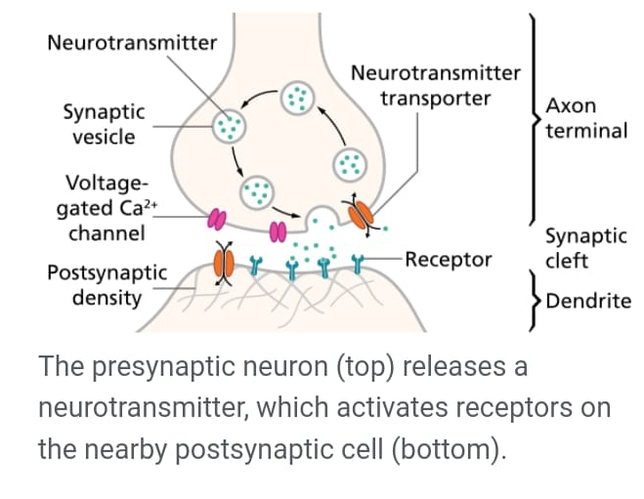

Answer 2:
Cholinergic agents ....
These are drugs which leads to the stimulation of the cholinergic receptor which contain nicotinic and muscarinic receptor .cholinergic agents have broad function in the autonomic nervous system , neuromuscular junction Because it’s limits it therapeutic function .
These agents are divided into to types direct and indirect cholinergic agents .
Direct cholinergic agents
- These drugs directly binds and activate the nicotinic and muscarinic receptor with variable amount of selectivity.
Indirect cholinergic agents
- These drugs inhibits anticholinesterase the enzyme which destroyed acetylcholine secreted into the synapse by the cholinergic neuron . By inhibiting the destruction these drugs extends the half life of synaptic acetylcholine and thus boosts the cholinergic activity .

.
Answer 3:
Therapeutic application of cholinergic agents
Because of its high potency , receptor non selectivity and realtor long duration if action , carbachole is rarely used therapeutically axept in the eye as a mitotic agents to treat glaucoma by causing papillary contraction and decrease in the intraocular pressure .

Adverse effects ;
It doses indeed opthalomogically , little or no side effect occur due lack of systematic penetration.

Drugs effect of cholinergic agents
- Cardiovascular effect
_ vasodilation
_ decreased heart rate .
- Stimulate intestine and bladder
_ increase gastric recreation
_increase urinary frequency
_increase gastrointestinal motility .
- Stimulate pupils
_constriction, spasm accommodation
_ increase intraocular pressure.
- Respiratory effect
_bronchial constriction , narrowed airways.

_ increase in salivation and sweatiness.

Also if it given unmonitored at can cause .
Hypertension
Giddiness
Cerreberal vain can be effect badly .
Answer 3: .
Algorithmic treatment for stable angina:

1.Offer a short-acting nitrate for preventing and treating episodes of angina
2.Offer people optimal drug treatment for the initial management of stable angina.
3.Offer either a beta blocker or a calcium channel blocker as first-line treatment for stable angina.
4.Consider referral for revascularisation (coronary artery bypassgraft [CABG] or percutaneous coronary intervention [PCI] for people with stable angina whose symptoms are not satisfactorily controlled with optimal medical treatment.
5.Offer aspirin 75mg daily for people with stable angina
6.Offer statin treatment in line with CCG lipid modification –secondary prevention guideline
7.Offer treatment for high blood pressure in line with CCG hypertension guidelines.
8.Consider angiotensin-converting enzyme (ACE) inhibitors for people with stable angina and diabetes.
9.Do not:
•Exclude people from treatment based on their age alone.
•Investigate or treat symptoms differently based on gender or ethnic group
•Offer vitamins or omega-3 fish oil. Inform people there is no evidence that they help stable angina
•Offer transcutaneous electrical nerve stimulation (TENS), enhanced external counterpulsation (EECP) or acupuncture to manage stable angina.
Q4) A)
Difference between primary and secondary hypertension.
- Primary (essential) hypertension is diagnosed in the absence of an identifiable secondary cause. Approximately 90-95% of adults with hypertension have primary hypertension, whereas secondary hypertension accounts for around 5-10% of the cases
- Primary (essential) hypertension is diagnosed in the absence of an identifiable secondary cause. Approximately 90-95% of adults with hypertension have primary hypertension, whereas secondary hypertension accounts for around 5-10% of the cases. However, secondary forms of hypertension, such as primary hyperaldosteronism, account for 20% of resistant hypertension (hypertension in which BP is >140/90 mm Hg despite the use of medications from 3 or more drug classes, 1 of which is a thiazide diuretic).

B) Effect of renin on hypertention :
- Renin's primary function is therefore to eventually cause an increase in blood pressure, leading to restoration of perfusion pressure in the kidneys. Renin is secreted from juxtaglomerular kidney cells, which sense changes in renal perfusion pressure, via stretch receptors in the vascular walls.
- Renin converts angiotensinogen, which is produced in the liver, to the hormone angiotensin I. An enzyme known as ACE or angiotensin-converting enzyme found in the lungs metabolizes angiotensin I into angiotensin II. Angiotensin II causes blood vessels to constrict and blood pressure to increase.
C) Importance of pharmacological treatment of hypertention.
Hypertension, or high blood pressure, is dangerous because it can lead to strokes, heart attacks, heart failure, or kidney disease. The goal of hypertension treatment is to lower high blood pressure and protect important organs, like the brain, heart, and kidneys from damage.
To measure your blood pressure, your doctor or a specialist will usually place an inflatable arm cuff around your arm and measure your blood pressure using a pressure-measuring gauge.
Changing your lifestyle can go a long way toward controlling high blood pressure. Your doctor may recommend you make lifestyle changes including:
- Eating a heart-healthy diet with less salt
- Getting regular physical activity
- Maintaining a healthy weight or losing weight if you're overweight or obese
- Limiting the amount of alcohol you drink

Q5A)
Difference between right heart failure and left heart failure?
- In heart failure, the heart can no longer pump enough blood around the body. The heart muscle is either too weak or not elastic enough. Different parts of the heart may be affected too. The type of medication people use for the treatment of heart failure will depend on the type of heart failure they have.
- Heart failure often only affects the left or right side of the heart, but can affect both. Doctors differentiate between three types of heart failure, accordingly:

- Left-sided heart failure:
left ventricle of the heart no longer pumps enough blood around the body. As a result, blood builds up in the pulmonary veins (the blood vessels that carry blood away from the lungs). This causes shortness of breath, trouble breathing or coughing – especially during physical activity. Left-sided heart failure is the most common type.

- Right-sided heart failure:
Here the right ventricle of the heart is too weak to pump enough blood to the lungs. This causes blood to build up in the veins (the blood vessels that carry blood from the organs and tissue back to the heart). The increased pressure inside the veins can push fluid out of the veins into surrounding tissue. This leads to a build-up of fluid in the legs, or less commonly in the genital area, organs or the abdomen (belly).
B) pharmacotherapy for heart failure
- An ACE inhibitor should be given to all patients with heart failure unless there are contraindications. In patients intolerant of ACE inhibitors, ARBs are an alternative (level of evidence, A).
- In symptomatic patients with heart failure, beta-blockers are recommended to reduce mortality rates (level of evidence, A).
- Aldosterone antagonists are recommended to reduce mortality rates in certain patients with heart failure. These include patients with current or recent history of dyspnea at rest, and patients with recent myocardial infarction who have systolic dysfunction with either clinically significant signs of heart failure or with concomitant diabetes mellitus (level of evidence, B).
- For persistently symptomatic black patients with heart failure, direct-acting vasodilators reduce overall mortality rates when added to background therapy with ACE inhibitors, beta-blockers, and diuretics (if needed). Direct-acting vasodilators are also an alternative for patients with heart failure who are intolerant of ACE inhibitors (level of evidence, B).
- For patients with heart failure and volume overload, diuretics are recommended

