NAME : IHSAN ULLAH
I:D : 15193
VIVA : R . POSITIONING

ANS : 1

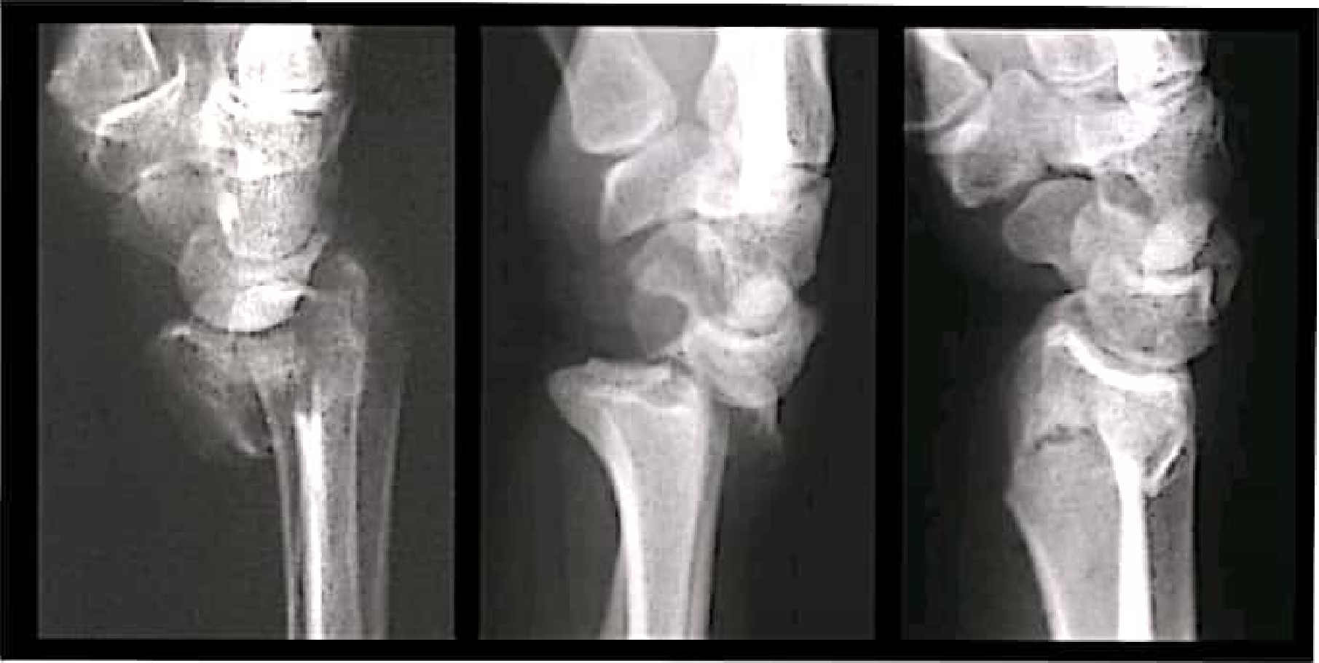
Pathology:
In the above mentioned radiograph the pathology detected is "Radiocarpal Fracture/dislocation" or we also say "Distal Radius Fracture".
This fraction is in the wrist area, and here the carpal and radius bone from a
joint.
Radiological Finding:
The following are the radiological finding of the above radiograph.
1 Distal radius Fracture.
2 Radius bone dislocation.
- carpel fracture.

4 lunate dislocation.

5 capitate pathologies.

ANS:2

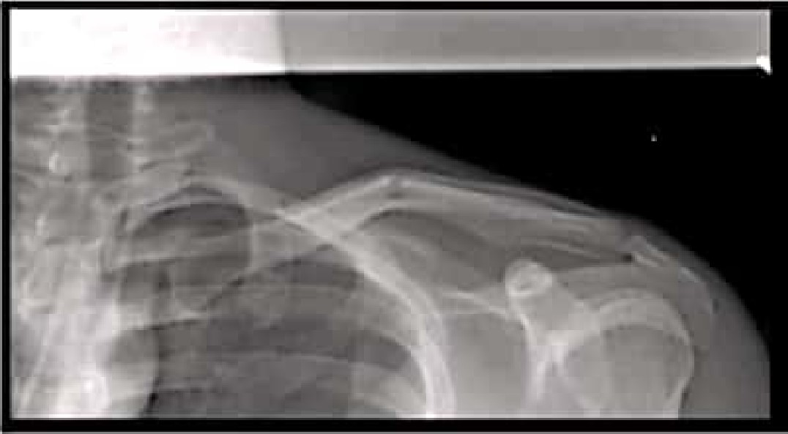
Pathology:

In the above mentioned radiograph the pathology detected is *Fracture of

clavicle/collar bone".
This fraction can occur at any part of the collar bone. But mostly it occurs at the mid-shaft or near the junction of the outer and middle third.
This Fracture is caused due to direct blow to the shoulder, outstretched arm. and fall onto the shoulder.
Radiological finding:
The following are Radiological findings in the above radiograph.
I Clavicle Fracture.
2 Shoulder Dislocation.
3 Ribs Fracture.
- Coraco-clavicutar Distance.
- Proximal Humerous.
6 vertebral fracture.
7 Gleno-Humeral joint.

ANS : 3

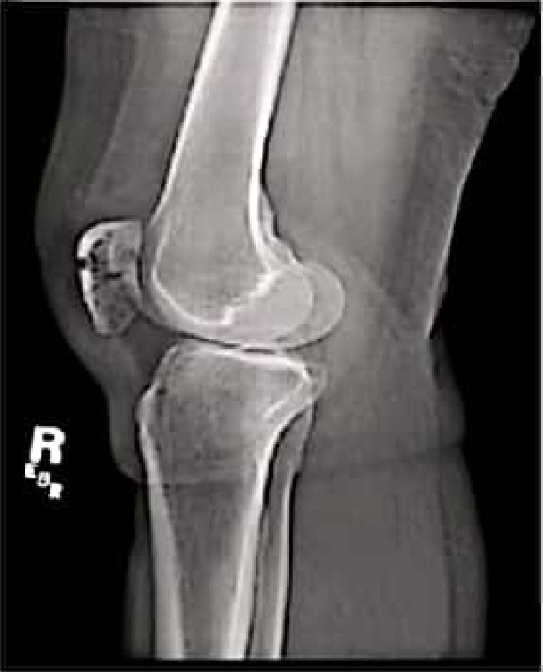
Pathology:

In the above mentioned radiograph the pathology Detected is 'knee swelling Or knee effusion-.
Lateral view IS shown in the radiograph given above, shows the supra• patellar knee joint effusion.
In the radiograph the knee gets swelled and accumulation of soft tissue occur around the knee joint. Well defined rounded homogenous soft tissue,
PATHOLOGY:
The pathology detected In the above radiograph is the dislocation of patella, dislocation of Joint between the tibia, fibula and femur and there is a slight fracture on distal femur.
Above radiograph shows, Lateral view of knee. There is a slightfracture of patella and distal femur and bone lesion identified jn the radiograph,
ACL ligaments got splits because of the fracture or high pressure/iorce.
In this pathology, the knee gets swelled. It causes peln to the person like this.
Knee surgery will be performed in this case.
Radiological :
The following are the radiological finding of the mentioned radiographi
Infrapatellar [at pad.
- The length of the tibia! Tubercle.
- Patellofemoral joint.
3 Posterior supra-Pateltar fot pad.
4 Tibia tubercle.
- Distal femur Fracture.
- Proximal tabial.
7 Femoral condyles.

ANS : 4

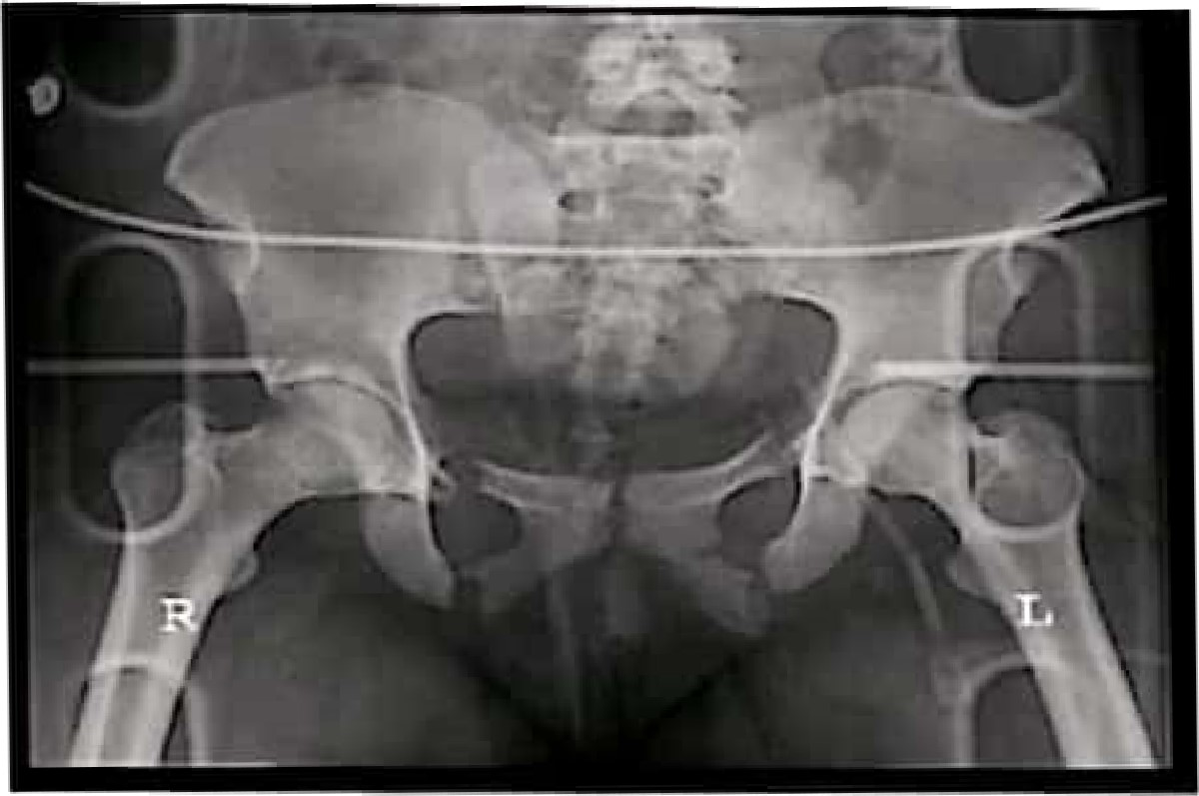
Pathology:
The pathology detected in the given radiograph is "Pubic Rami Fracture" i l is the most common fracture of the pelvtc about 40% of the pelvic fracture is pubic rami fracture.
This type of fracture is more likely to occur due to high energy event. stress and also possible due to collision.
Radiological Finding:

The following radiological finding should be seen on radiograph.
1 Pubic Ramj Fracture.
2 Pubic rami and Ischium Fracture.
- Complex pelvic Fracture.
- Open book Fracture.
- Femoral Neck Fracture .
- Hip dislocations (antero-inferior) .
- Hip Dislocation (posterior).
8 Acetabutar Fracture.

