Iqra National University
Name: Sajawal Hussain
Id: 1406
Subject: Pakistan-Studies
Teacher name: Ma’am Beenish
Submitted to: Ma’am Beenish
Submitted By: Sajawal Hussain
Date: 20-09-2020

Q1. Experience of democracy in Pakistan
Pakistan is sixth most populous country in the world, created on the basis of popular will of people in 1947 with the vision to have a liberal, moderate and democratic parliamentary federation. Soon after independence, Pakistan adopted British legacy constitutional framework and introduced the parliamentary democracy, following much from the Government of India Act 1935 – the last constitution of British India. However, Pakistan being a postcolonial state, the democratic experience was underpinned by the steel frame of bureaucracy and political stability and institutionalized democratic set up remained a distant dream. The country has a checkered history with a few interludes of democratic rule during the sixty eight years of its existence.
The first Constitution of Islamic Republic of Pakistan was adopted in 1956 which was abrogated just two years later by the martial law. During the first eleven years, eight successively governments were formed and sooner collapsed. Unfortunately, the inconsistent democratic history continued till 2008, alternating between elected governments and long spells of military dictators since its inception.
Pakistan has travelled a long distance towards its march on the path of democracy. The parliamentary democracy collapsed four times primarily due to mismanagement, disproportionate development of institutional matrix and the mounting political ambitions of the military generals. The military dictators have always sabotaged political development and mainstream political parties; and have advocated religious, ethnic and tribal politics to legitimize their regimes by rigged referendum. Over the years, the support to religious and ethnic groups has led to underground nurseries for breeding of extremism and terrorism. During military regime there was considerable economic development and prosperity, however, Pakistan democratic institutions were crushed and country had to endure two wars with India. On the other hand elected politicians have not much contributed towards democracy rather have been involved in incessant cycle of corruption, dynastic politics, nepotism and money laundering during the short duration they were at the helm of affairs. The fruit of democracy – good governance – albeit remained a dream.
With the outcome of general elections 2013, it was for the first time that a politically elected government successfully completed its tenure was replaced by another democratically elected government. However, the credibility and acceptability of these elections remained questionable by some parties in the opposition, till an “Inquiry Commission” comprising Supreme Court Judges which declared the 2013 elections were in large part organized and conducted justly and fairly in accordance with the law and reflection of the true mandate given by the electorate. Even now, the people of Pakistan have to undergo a long way in quest for the thirst of true democracy, leading to ultimate goal of good governance.
Q2. Period of any dictator in Pakistan
Zulfikar Ali Bhutto:
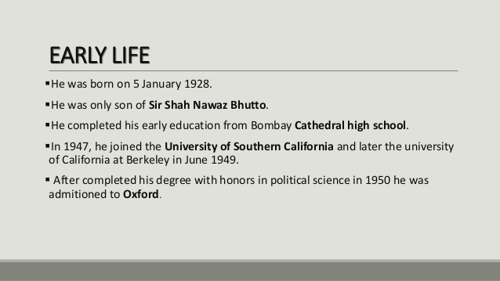
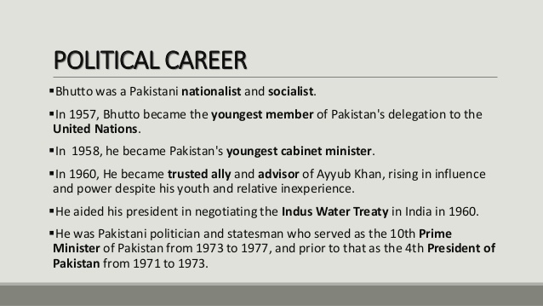
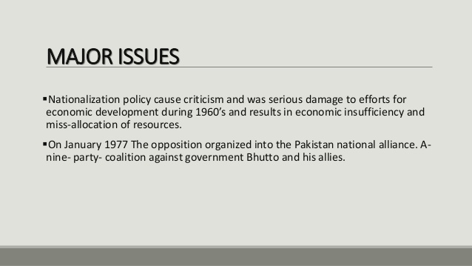
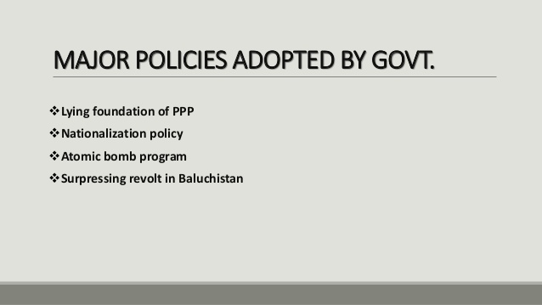
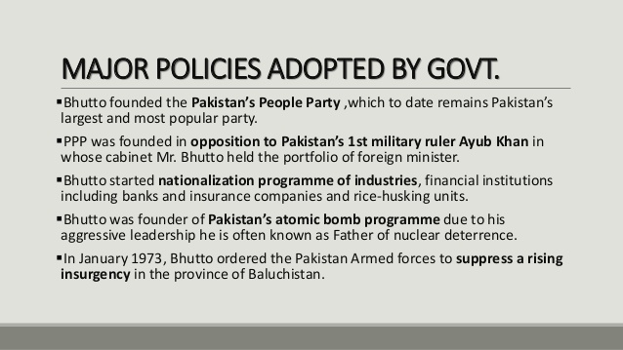
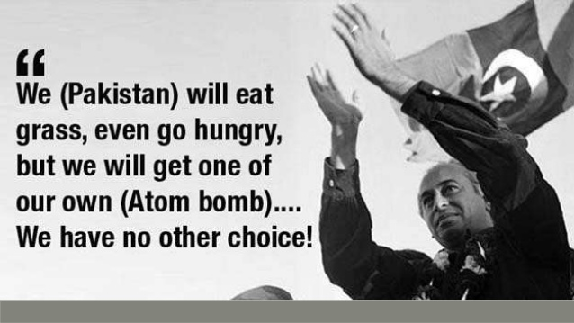
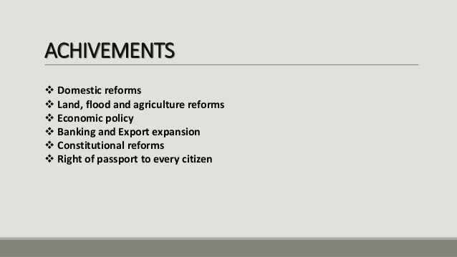
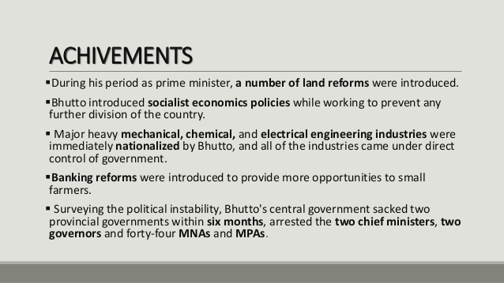
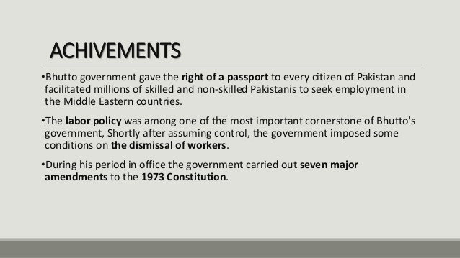
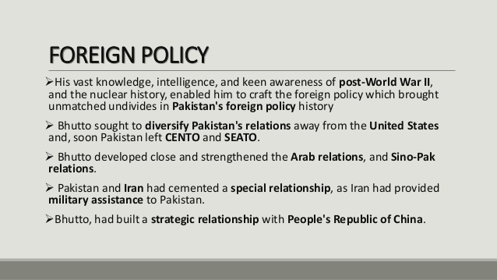
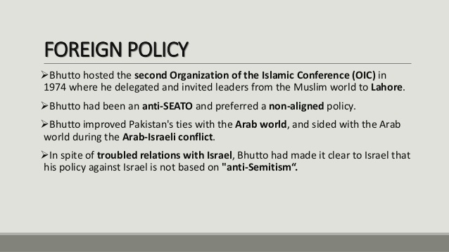
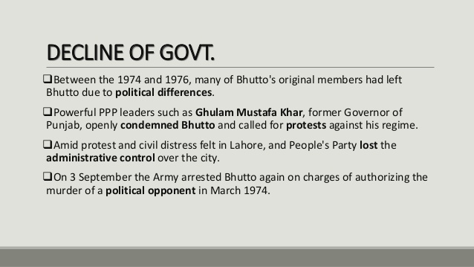
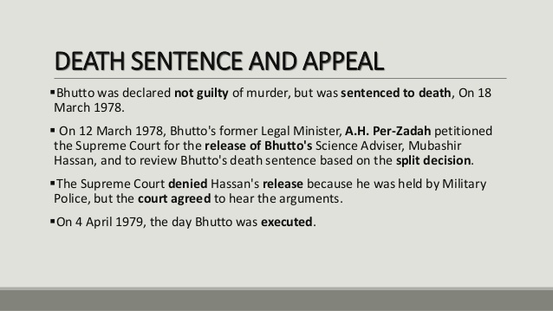

Q3. Women empowerment and Islam and also write down a note on any Pakistani female life history and her struggle.
Women empowerment and Islam
Islam gives credence to women, certifying towards them respect, honor, dignity and equality. In the centuries prior to Islam, women were illtreated, looked upon as commodities and were given very little or any value at all. The status of women in Islam can only really be appreciated when the position of women is examined pre-Islam, known as Jahiliyyah (the period of ignorance). Conversely, the Quran generally speaks about women with high regard, respect and dignity.
In the context of the days of ignorance, women through Quranic revelation were uplifted and given a new leash of life. Since Islam was revealed to mankind, a new page was turned and women were lifted out from a darkness to a shining ray of light. They were given rights, fairness, justice, and were held in high esteem. Allah orders proper treatment and deference to women in the Quran in Surat An-Nisa (4:1):
"Fear Allah through whom you demand your mutual (rights) and (revere) the wombs (That bore you): for Allah Ever watches over you."
During the time of the Prophet (peace be upon him) social change with respect to gender relations was implemented. The wider Arabian socio-cultural society ill treated women and Islam and bought about radical change and enhancement to the lives of women who were now seen as individuals with hope and aspirations.
Many women have taken leaps and strides in the developed world where we see Muslim women who have obtained an education, deliberate their own future and make choices which can enhance and improve their quality of life. Yet in stark contrast in the developing world, many women have not had this opportunity.
The history of Islam is replete with examples of women who achieved excellence. They were empowered to excel by the teachings of Islam. These women demonstrated flair to achieve and make a contribution to their own well being and others, thus feeling empowered. Examples include Khadijah bint Khuwaylid, the Prophet Muhammad’s first wife, a wealthy business woman in her own right and financially independent. Other notable women include Shaff’a Bint Abdullah, who was appointed by Khalifah Umar to supervise the market and Arwa bint Ahmad who headed an Islamic province and served as governor of Yemen under the Fatimid Khalifahs in the late fifth and early sixth century.

Pakistani female life history and her struggle.
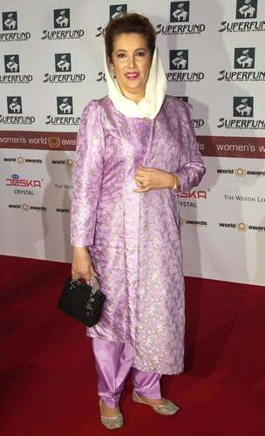
Benazir Bhutto, (born June 21, 1953, Karachi, Pakistan—died December 27, 2007, Rawalpindi), Pakistani politician who became the first woman leader of a Muslim nation in modern history. She served two terms as prime minister of Pakistan, in 1988–90 and in 1993–96.
Bhutto was the daughter of the politician Zulfikar Ali Bhutto, who was the leader of Pakistan from 1971 until 1977. She was educated at Harvard University (B.A., 1973) and subsequently studied philosophy, political science, and economics at the University of Oxford (B.A., 1977).
After her father’s execution in 1979 during the rule of the military dictator Mohammad Zia-ul-Haq, Bhutto became the titular head of her father’s party, the Pakistan People’s Party (PPP), and endured frequent house arrest from 1979 to 1984. In exile from 1984 to 1986, she returned to Pakistan after the lifting of martial law and soon became the foremost figure in the political opposition to Zia. President Zia died in August 1988 in a mysterious plane crash, leaving a power vacuum at the centre of Pakistani politics. In the ensuing elections, Bhutto’s PPP won the single largest bloc of seats in the National Assembly. She became prime minister on December 1, 1988, heading a coalition government.
Bhutto was unable to do much to combat Pakistan’s widespread poverty, governmental corruption, and increasing crime. In August 1990 the president of Pakistan, Ghulam Ishaq Khan, dismissed her government on charges of corruption and other malfeasance and called for new elections. Bhutto’s PPP suffered a defeat in the national elections of October 1990; thereafter she led the parliamentary opposition against her successor, Nawaz Sharif.
In elections held in October 1993 the PPP won a plurality of votes, and Bhutto again became head of a coalition government. Under renewed allegations of corruption, economic mismanagement, and a decline of law and order, her government was dismissed in November 1996 by Pres. Farooq Leghari.
Voter turnout was low in the 1997 elections, in which Bhutto’s PPP suffered a decisive loss to Sharif’s Pakistan Muslim League party. With British and Swiss cooperation, Sharif’s administration continued to pursue the corruption charges against Bhutto. In 1999 Bhutto and her husband, the controversial businessman and senator Asif Ali Zardari—jailed since 1996 on a variety of additional charges—were both convicted of corruption by a Lahore court, a decision overturned by the Supreme Court in 2001 because of evidence of governmental interference. Bhutto did not achieve political accommodation with Gen. Pervez Musharraf’s seizure of power in a 1999 coup d’état; her demands that the charges against her and her husband be dropped were denied, undercutting negotiations with the Musharraf government regarding a return to the country from her self-imposed exile. Facing standing arrest warrants should she return to Pakistan, Bhutto remained in exile in London and Dubai from the late 1990s.
Because of Musharraf’s 2002 decree banning prime ministers from serving a third term, Bhutto was not permitted to stand for elections that same year. In addition, legislation in 2000 that prohibited a court-convicted individual from holding party office hindered her party, as Bhutto’s unanimously elected leadership would have excluded the PPP from participating in elections. In response to these obstacles, the PPP split, registering a new, legally distinct branch called the Pakistan People’s Party Parliamentarians (PPPP). Legally separate and free from the restrictions brought upon the PPP by Bhutto’s leadership, the PPPP participated in the 2002 elections, in which it proceeded to earn a strong vote. However, Bhutto’s terms for cooperation with the military government—that all charges against her and against her husband be withdrawn—continued to be denied. In 2004 Bhutto’s husband was released from prison on bail and joined Bhutto in exile. Just before the 2007 elections, talk began to circulate of Bhutto’s return to Pakistan.
Shortly before Musharraf’s reelection to the presidency, amid unresolved discussions of a power-sharing deal between Bhutto and Musharraf’s military regime, he finally granted Bhutto a long-sought amnesty for the corruption charges brought against her by the Sharif administration. The Supreme Court challenged Musharraf’s right to grant the amnesty, however, criticizing it as unconstitutional; nevertheless, in October 2007 Bhutto returned to Karachi from Dubai after eight years of self-imposed exile. Celebrations marking her return were marred by a suicide attack on her motorcade, in which numerous supporters were killed. Bhutto was assassinated in December in a similar attack while campaigning for upcoming parliamentary elections.
Bhutto’s autobiography, Daughter of the East, was published in 1988 (also published as Daughter of Destiny, 1989); she also wrote Reconciliation: Islam, Democracy, and the West, which was published posthumously in 2008.
Q4. Kashmir issue and your views
Kashmir is a disputed region between India and Pakistan, which has vitiated the political environment of the Indian Subcontinent. The Kashmir issue stands as a debacle for nearly six decades and there has been almost no progress in resolving the problem.

Introduction
Kashmir is a mountainous region, which enjoys a very important geo-political situation. It is surrounded by Pakistan in the west and China embraces it in the east. The Indian provinces of Himachal Pradesh and Punjab are in the south. Its northern fringes touch the borders of Afghanistan too. The area is famous for its extra-ordinary natural beauty and resources. Presently, the northern and western sides of the region are occupied by Pakistan while the southern and eastern parts are controlled by the Indian Union. For over six decades, the region has been devastated by confrontations between the two countries. Both India and Pakistan are nuclear powers and in the case of another shooting war between them; the entire subcontinent including Kashmir may be destroyed. Presently, it is at the diplomatic hyper point of the bilateral relationships between the two countries.

Pre-history of the Conflict
The British Indian Empire was formed of hundreds of princely states spread all over the Indian Subcontinent. After the World War II, when the British finally decided to bring their rule to an end, the fate of these princely states was brought under scrutiny. The Princely states were now supposed to join either India or Pakistan after the British authorities leave. In regards of this process of the evolution of India and Pakistan, Jyoti Trehan remarks, “The process of integration of princely states was not without its highs and lows.”(Trehan 201)
Finally in June, 1947, the British accepted Pakistan Plan. But the Hindu Maharajah Sir Hari Singh (the ruling monarch of the erstwhile princely state of Kashmir) was hesitating to join either Pakistan or India. However, the census of 1941 shows that almost 77% of the population of Kashmir was comprised of Muslims (Das 264). Since the Maharajah had acceded to neither side until the formation of India and Pakistan in August, 1947, Pakistan decided to act along communal lines. Being a Muslim dominated state, it decided to ‘liberate’ Kashmir and backed the Azad Kashmir Force. In October, 1947, Pakistan invaded Kashmir and captured its northern and western parts. On the Maharajahs request and accession to India, the authorities in Delhi now reacted by sending troops to the region and Pakistani advances were arrested soon. Thus, the southern and eastern parts of the region were retained in the Indian Union and constituted as the state of Jammu and Kashmir.

Causes of the Conflict
To understand the causes of the conflict, the historic Partition of India has to be referenced. Under the British Rule, Indian Subcontinent was mainly inhabited by the two major religious groups, Hindus and Muslims. The two communities had friendly relationships and they offered a united struggle to achieve independence from the British Rule during the later half of the Nineteenth Century. But undercurrents of tension between the two communities became forceful with the lapse of time. Power politics between All India Muslim League and Indian National Congress (the two major political powers of the undivided India) culminated at widespread communal tension and violence during the 1930s and early 1940s. Consequently, the colossal task of partitioning India became unavoidable. After the Partition in 1947, Pakistan emerged as a Muslim dominated state while India emerged as a secular, democratic country. And the province of Kashmir, which is situated at the border of the two countries, got tangled and entrapped between them.

The Current State of Affairs
With the lapse of time, Pakistan has shown tendencies towards Military Rule and autocratic governance. On several occasions, India has alleged that Pakistan has sponsored the different terrorist organizations in Kashmir. Moreover, India holds Pakistan responsible for several devastating terrorist attacks directed against India. On the other hand, Pakistan affirmatively sticks to its policy of extending ‘moral support’ to the separatists in Kashmir. In such a state of affair, the common Kashmiris are suffering most. The innocent people are being victimized by baneful separatist propaganda. Confrontations between Indian military and armed separatists have caused huge loss of property, money, and lives so far. Moreover, the specter of Al Qaeda and Taliban has made the situation more complicated and dangerous in this part of the world.

Conclusion
Kashmir issue has been the primary cause of diplomatic, political, and military stand off between India and Pakistan. Of late, both the sides are showing interest to begin bilateral talks once again. According to Farah Ibrahim, the solution of the issue lies in a planned conflict Resolution (Ibrahim 289). The way to this conflict resolution lies in the methods of psychological intervention. Psychological perspective of the problem is more propound than its military, political, and diplomatic dimensions and interpretations. Unlike the “sharp rise in the ideal of Hindu nationalism” (Wirsing 163), solution to Kashmir issue lies in the acceptance of the fact that the common Kashmiris deserve to live a normal and peaceful life. India and Pakistan both must come forward to eradicate the terrorist organizations functional in Kashmir, and continue the bilateral talks. The confidence building measures must be initiated meaningfully. In this way, by mutual goodwill, the political authorities of India and Pakistan can bring peace to the doomed province.

