IQRA NATIONAL UNIVERSITY PESHAWAR
DEPARTMENT OF SOFTWARE ENGINEERING
ASSIGNMENT

NAME: HASNAN KHAN
SEMESTER: 2ND
ID:16106
COURSE: PRINCIPLE OF MANAGEMENT
SUBMIT TO: MAM MEHWISH

QUESTION #1

How can you prepare yourself to become an effective manager in an increasingly uncertain global business environment?
The world as it is today is much different than it was when our parents’ parents were in managerial positions. In fact, the way companies market products has changed more in the past five years than in the previous one-hundred combined! With such rapid, dramatic change in the business place, it is abundantly clear that managers must take necessary steps to be an effective manager in this current global business environment. Managers can adapt to changes by boundary-spanning roles, inter organizational partnerships, and mergers or joint ventures. According to the online text book for Activated Logic, “Understanding the marketing environment in which your organization competes and also understanding how the micro & macro-economic forces impact your organization is very important, as these factors present both opportunities and threats.” As upcoming managers prepare themselves to be effective in the increasingly uncertain global business environment, it is evident that knowledge of the following is important: competitors, customers and other elements of the environment. One key component, not to be over looked, is the concept of team work (i.e. joint ventures, partnerships and mergers).

QUESTION #2
Explain the difference between efficiency and effectiveness and their importance for organizational performance.

EFFICIENCY | EFFECTIVENESS
Efficiency refers to doing things in a right manner. Scientifically, it is defined as the output to input ratio and focuses on getting the maximum output with minimum resources. | Effectiveness, on the other hand, refers to doing the right things. It constantly measures if the actual output meets the desired output.
Efficiency is all about focusing on the process, importance is given to the ‘means’ of doing things | Effectiveness focuses on achieving the ‘end’ goal.
Efficiency is concerned with the present state or the ‘status quo’.  This can build inflexibility into the system. | Effectiveness, on the other hand, believes in meeting the end goal  Effectiveness, on the other hand, keeps the long term strategy in mind
Efficiency is about doing things right, it demands documentation and repetition of the same steps. Doing the same thing again and again in the same manner will certainly discourage innovation. | On the other hand, effectiveness encourages innovation as it demands people to think, the different ways they can meet the desired goal.
Efficiency will look at avoidi frng mistakes or errors | Effectiveness is about gaining success.

IMPORTANCE IN ORGANIZATIONAL PERFORMANCE:
Efficiency was the most important performance indicator for any organization. However, with consumers facing an increasing number of choices, effectiveness of an organization is always questioned. In order to be a successful organization, there needs to be a balance between effectiveness and efficiency. Only being efficient and not meeting the requirements of the stakeholders of the organization is of little use to anybody.

QUESTION #3
Draw organogram / organization chart of any organization and explain the role of first line manager, middle line manager, and top level manager from this chart.

ORGANIZATIONAL CHART OF UFONE:

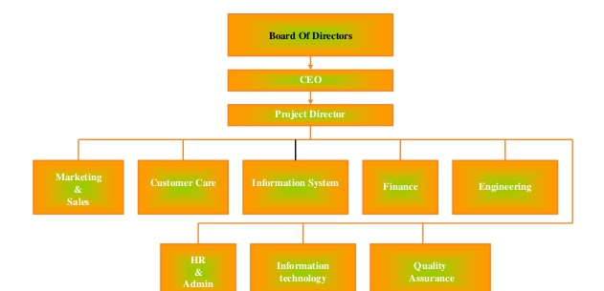

It states that HRM should have two characteristics first, line manager should take and accept the responsibility for ensuring the alignment of competitive strategies and personnel policies,, and second, personnel has the mission of setting goals that govern how personnel policies are developed and implemented.
General Managers are the key members to implement the policies to achieve the strategic goals with the help of their employees, they should have a view point that how to involve and develop employees ability and skills to achieve the strategic goals.
As the world become global village and the competition among the organizations very tough, therefore the human resources demand broader in the market as compare to earlier.

