NAME SHOUKAT ALI
ID 16425
DEPERTMENT SOFTWARE ENGERRING
SECTION B

Q2) What are the relation between hardware and software. And types of software with Logical system architecture.
Relationship Between Hardware and Software

- Both hardware and software are necessary for a computer to do useful job. They are complementary to each other
- Same hardware can be loaded with different software to make a computer system perform different types of jobs
- Except for upgrades, hardware is normally a one- time expense, whereas software is a continuing expense
- Upgrades refer to renewing or changing components like increasing the main memory, or hard disk capacities, or adding speakers, modems, etc.
Types of Software

▪ Most software can be divided into two major categories:
▪ System software are designed to control the operation and extend the processing
capability of a computer system
Application software are designed to solve a specific problem or to do a specific task
System Software

- Make the operation of a computer system more effective and efficient

- Help hardware components work together and provide support for the development and execution of application software

- Programs included in a system software package are called system programs and programmers who prepare them are called system programmers

- Examples of system software are operating systems, programming language translators, utility programs, and communications software
Application Software

- Solve a specific problem or do a specific task
- Programs included in an application software package are called application programs and the programmers who prepare them are called application programmers
- Examples of application software are word processing, inventory management, preparation of tax returns, banking, etc.
Logical System Architecture
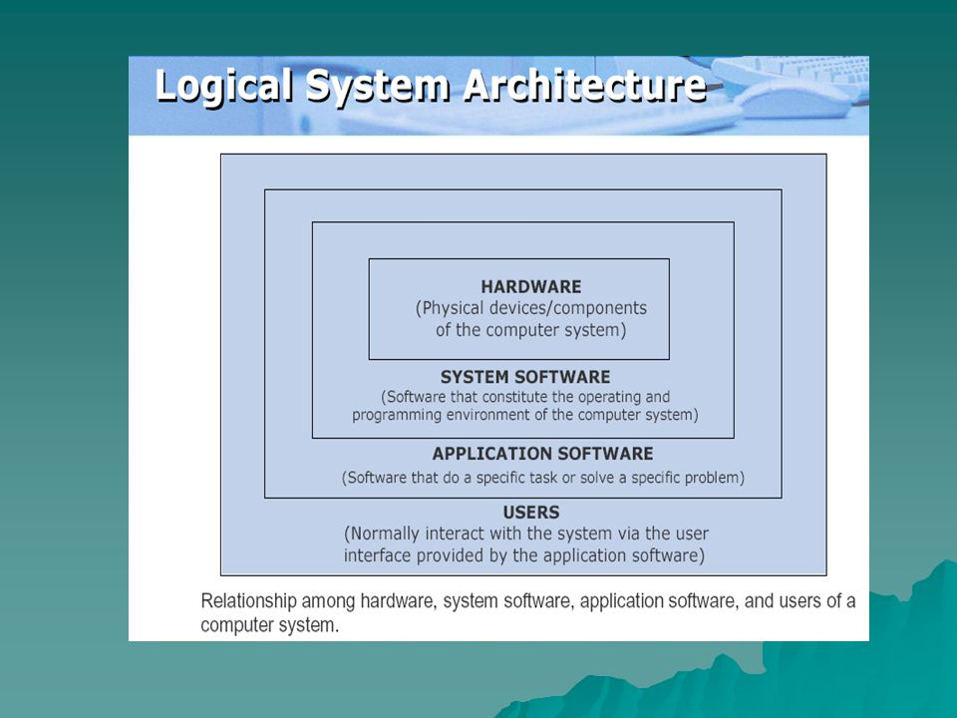
Relationship among hardware, system software, application software, and users of a computer system.

APPLICATION SOFTWARE
(Software that do a specific task or solve a specific problem)

Q3) Write a note on each of the following in details.

( A) Modulation Techniques.

- Amplitude Modulation (AM): Two binary values (0 and
of digital data are represented by two different amplitudes of the carrier signal, keeping frequency and phase constant
- Frequency Modulation (FM): Two binary values of digital data are represented by two different frequencies, while amplitude and phase are kept constant
- Phase Modulation (PM): Two binary values of digital data are represented by shift in phase of carrier signal

(B) Multiplexing?
Multiplexing (Muxing) is a term used in the field of communications and computer networking. It generally refers to the process and technique of transmitting multiple analog or digital input signals or data streams over a single channel. Since multiplexing can integrate multiple low-speed channels into one high-speed channel for transmission, the high-speed channel is effectively utilized. By using multiplexing, communication carriers can avoid maintaining multiple lines, therefore, operating costs are effectively saved.
Multiplexer (Mux) is a device which performs the multiplexing process. It is a hardware component that combines multiple analog or digital input signals into a single line of transmission.
Demultiplexing
Demultiplexing (Demuxing) is a term relative to multiplexing. It is the reverse of the multiplexing process. Demultiplex is a process reconverting a signal containing multiple analog or digital signal streams back into the original separate and unrelated signals.
Although demultiplexing is the reverse of the multiplexing process, it is not the opposite of multiplexing. The opposite of multiplexing is inverse multiplexing (iMuxing), which breaks one data stream into several related data streams. Thus, the difference between demultiplexing and inverse multiplexing is that the output streams of demultiplexing are unrelated, while the output streams of inverse multiplexing are related.
Demultiplexer (Demux) is a device that performs the reverse process of multiplexe

(C) Switching Techniques

- Data is often transmitted from source to destination through a network of intermediate nodes
- Switching techniques deal with the methods of establishing communication links between the sender and receiver in a communication network
- Three commonly used switching techniques are:
  - Circuit switching: Dedicated physical path is established between sending and receiving stations through nodes of the network for the duration of communication
  - Message switching: Sender appends receiver’s destination address to the message and it is transmitted from source to destination either by store-and-forward method or broadcast method
  - Packet switching: Message is split up into fixed size packets and each packet is transmitted independently from source to destination node. Either store-and- forward or broadcast method is used for transmitting the packets. All the packets of a message are re- assembled into original message at the destination node

Dotted line indicates establishment of physical path

- Circuit Switching Method

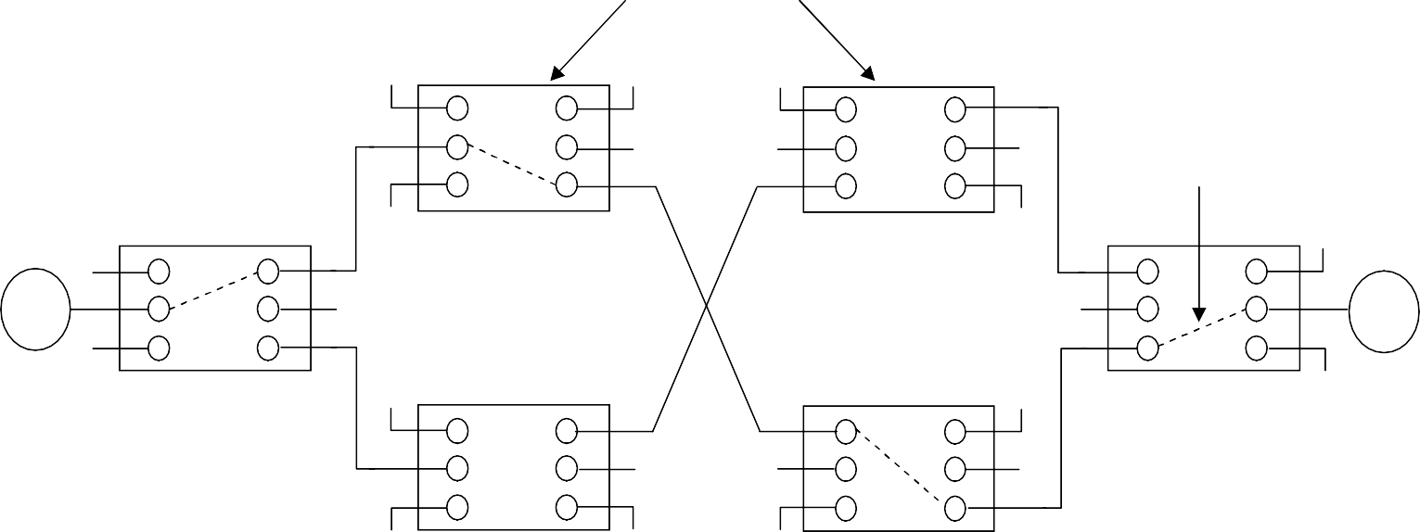
Source node Destination
Node

Source node

Store-and-Forward Method of Message Switching

5
1
4
3
2
C
A
B
D

(D)Optical Fiber Communication System
Fiber-optic communication is a method of transmitting information from one place to another by sending pulses of infrared light through an optical fiber. ... Optical fiber is used by many telecommunications companies to transmit telephone signals, Internet communication, and cable television signals

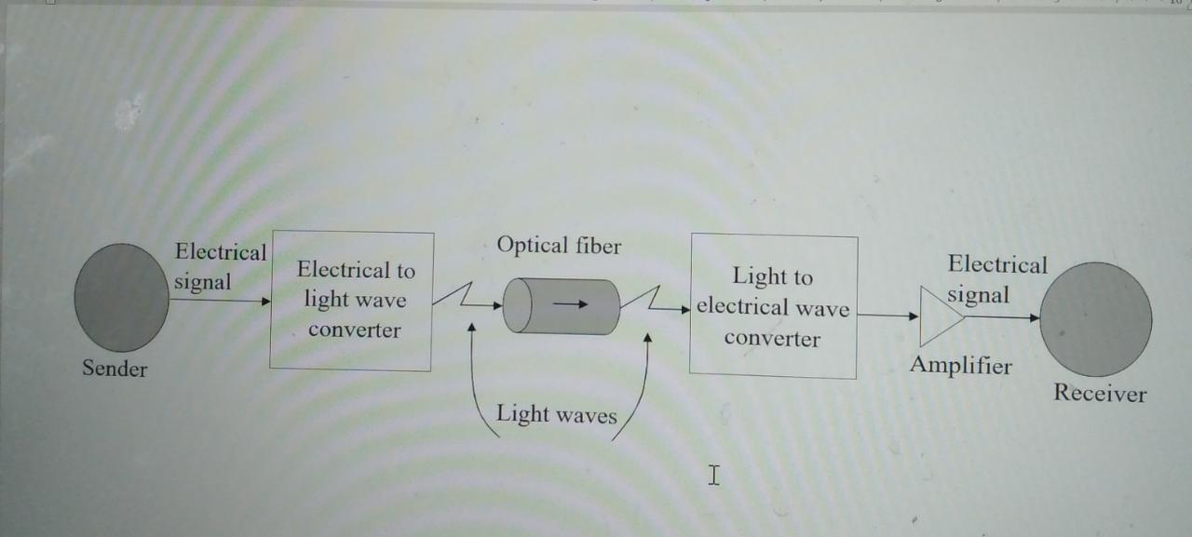

(Q4) What is OSI reference model explain each layer of OSI model in details.
OSI Model
  - The Open System Interconnection (OSI) model is framework for defining standards for linking heterogeneous computers in a packet switched network
  - Standardized OSI protocol makes it possible for any two heterogeneous computer systems, located anywhere in the world, to easily communicate with each other
  - Separate set of protocols is defined for each layer in its seven-layer architecture. Each layer has an independent function

Layers, Interfaces, and Protocols in the OSI Model
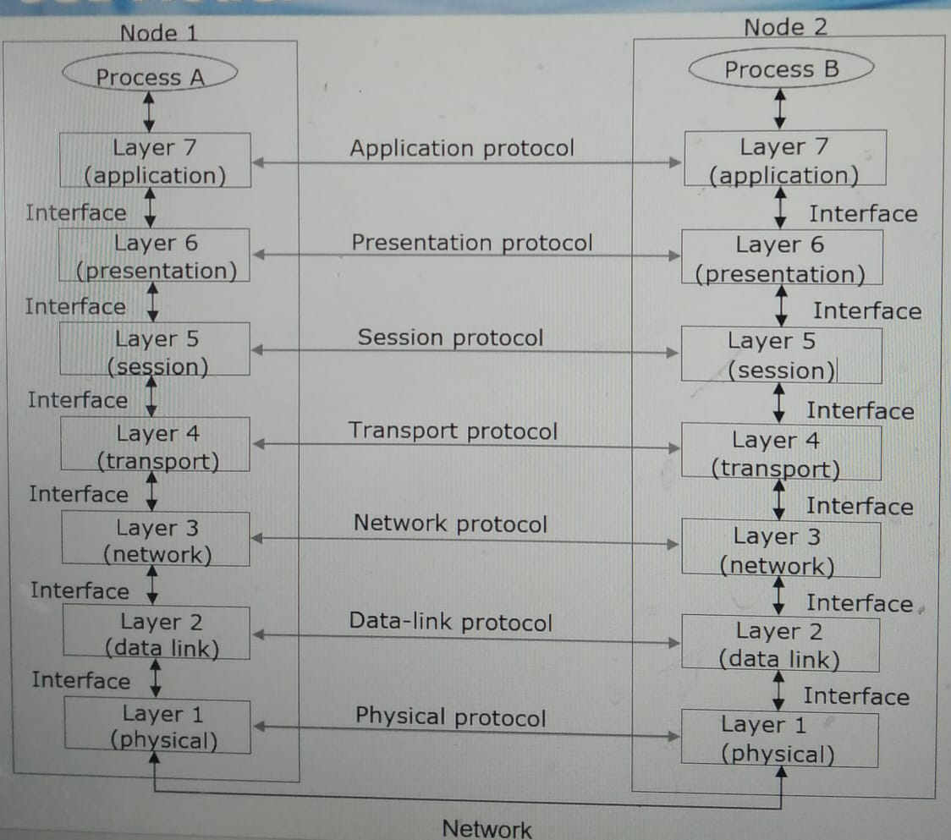

Q 1) Write a note on Multimedia and its type with common media for storage access and transmission in details

Multimedia is a form of communication that combines different content forms such as text, audio, images, animations, or video into a single presentation, in contrast to traditional mass media, such as printed material or audio recordings. Popular examples of multimedia include video podcasts, audio slideshows, animated shows, and movies.

Multimedia can be recorded for playback on computers, laptops, smartphones, and other electronic devices, either on demand or in real time (streaming). In the early years of multimedia, the term "rich media" was synonymous with interactive multimedia. Over time, hypermedia extensions brought multimedia to the World Wide Web.
The commands determine the type of storage media needed to hold the data, based on its ... Storage media can be arranged for access in many ways. HDDs remain popular in enterprise disk arrays due to their increasing capacities
... Actifio Data Driven sessions detailed guidelines for your recovery plan that could save.

In computers, a storage medium is any technology -- including devices and materials -- used to place, keep and retrieve electronic data. It refers to a physical device or component in a computing system that receives and retains information relating to applications and users. The plural form of this term is storage media.

Early forms of storage media included computer paper tape. Holes punched in the paper corresponded to a single bit of data. A paper tape reader would interpret each punched hole and convert it to a number. Paper tape was supplanted by magnetic tape, which eventually evolved to magnetic floppy disk.
There are two methods used to transmit data between digital devices: serial transmission and parallel transmission. Serial data transmission sends data bits one after another over a single channel. Parallel data transmission sends multiple data bits at the same time over multiple channels

