Program :  Course Name :  Course Code :  Name:Muhammad Zaigham Afridi  ID:14545 | BS (Hons)  Introduction to Intercultural Communication  JMC201  Final Exam Summer 2020

Attempt All Questions:
Q1. Define Intercultural Adaptation, and what are the Stages of intercultural adaptation?
Ans: The intercultural adaptation is how one person adjusts their communication with persons perceived to be from a different culture based on previous experiences. Intercultural adaptation refers to the adjustment of communicative behavior to decrease the probability of being misunderstood when speaking with someone from a different culture.
STAGES OF INTERCULTURAL ADAPTATION:
*Honeymoon phase: Excitement and fascination with the new culture. This is where they will overlook minor problems and look forward to learning new things.
*Crisis period (culture shock): This is where excitement turns to disappointment and there are more and more differences that occur. Problems start to be overwhelming and irritating and may use the "fight-back" technique by saying rude remarks or making jokes.
*Adjustment phase: This is where they learn to accept the culture and to change their negative attitude to a positive one.
*Acceptance and Adaptation phase: This is where they will feel at home and become involved in activities and may enjoy some of that countries customs.
*Reentry shock: This is experienced upon returning to the home country and the return may follow with initial euphoria, crisis or disenchantment. It may be hard to readjust and may feel like they are not accepted.

Q2. Define Models of intercultural adaptation and also draw three models.
Ans: The Intercultural Adaptation Model (IAM) describes how one person adjusts their communication with persons perceived to be from a different culture based on previous experiences. The model describes the adaptation process during initial cross-cultural encounters between individuals.
There are different models for the intercultural adaptation process.
• A process model of intercultural adaptation:
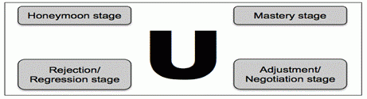
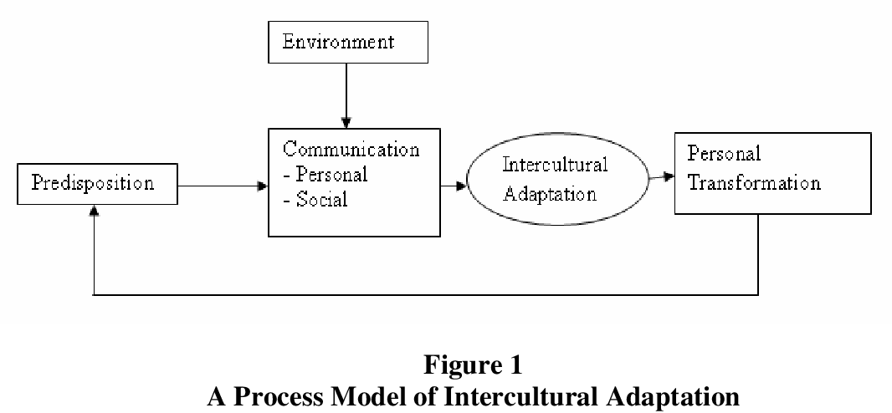
*Oberg u.continenuum Model:

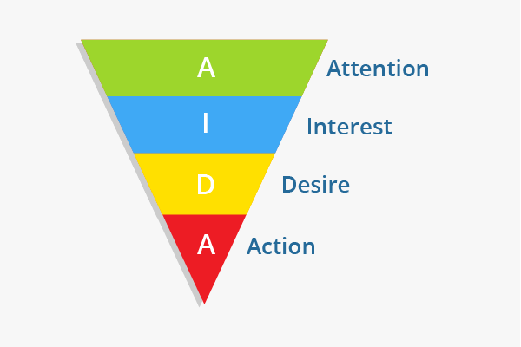
*AIDA model:
Q3. How to communicate effectively with strangers?
Ans: 1. Don't assume other people don't want to talk to you.
When we see people standing or sitting alone on a bus, on a train or in a waiting room, we often believe they would rebuff any attempt to start a conversation – and that's a mistake. It may not be a good idea to try to start a conversation if someone looks like they are in a hurry.
2. Go on an expedition and notice the shoes people are wearing.
To develop experience talking to strangers, walk around the block or down the street and say hello to everyone you pass by. It may feel silly or awkward, but it loosens you up and makes it easier for you to start conversations with strangers.
Giving a compliment is also a good way to initiate a chat.
3. Try the triangulation method.
Notice something or someone that is near you and a stranger and make a comment about it. Pick out something that both of you could see easily. Comment on a piece of public art, for example, or something in the sky or kids who are riding their skateboards.
4. Disclose something personal about yourself.
Telling a stranger something personal about yourself can lead to a rewarding conversation. If you feel comfortable talking to a stranger, tell them something about yourself that is deeply personal. For example, talking about the death of a loved one could lead to a feeling of being understood.

Q4. What is the future of Intercultural Communication?
Ans: The future of intercultural communication should stand on practical knowledge – not on the polls/surveys.
The intercultural communication in the future should be freed from the academic intellectualization for the sake of academic intellectualization itself.
Intercultural communication should be more interrelated with psychology and spirituality. There is a whole academic field that has grown up since the Second World War to tackle these enormous questions, Intercultural Studies, which remains woefully under-appreciated, including by many who would hugely benefit from it. But the techniques – and most importantly, the mindset – it espouses is, thankfully, used by pretty much anyone seeking to do good and reaching out to our fellow human beings in a positive way every day on this planet.
It is one of the great, lesser-known, forces that can and will shape our world.
To gain the prominence it deserves however, I’d argue what it really needs is to do is:
(i) Ensure it’s covering the full spectrum of cultural dimensions, not just the national which preoccupied it for the first decades of its development
(ii) Demonstrate its benefits beyond its current focus on values and diversity, both of which are not only static but divisive, and move to a standpoint of addressing motivations, which you have a far greater chance of working with dynamically and - hence - fruitfully
(iii) Do a better job of communicating its fundamental importance to everything we do, not just in theory but in everyday practice……again, well beyond just the national differences which have been the mainstay of intercultural for so long: These are absolutely critical business, social and human skills.

Q5. Write Characteristics of culture.
Ans: Culture has been defined in a number of ways, but most simply, as the learned and shared the behavior of a community of interacting human beings. Actually, culture is defined as the shared patterns of behaviors and interactions, cognitive constructs, and effective understanding that are learned through a process of, socialization.
Characteristics of Culture:
All organizations have the culture in the sense that they are embedded in specific societal cultures and are part of them.Some values create a dominant culture in the organizations that help guide the day to day behavior of employees. Culture has various characteristics. From various definitions, we can deduce the following characteristics of culture:
*Learned Behavior
Not all behavior is learned, but most of it is learned; combing one’s hair, standing in line, telling jokes, criticizing the President and going to the movie, all constitute behaviors that had to be learned.Sometimes the terms conscious learning and unconscious learning are used to distinguish the learning.
*Culture is Abstract
*Culture exists in the minds or habits of the members of society.
*Culture is the shared ways of doing and thinking. There are degrees of visibility of cultural behavior, ranging from the regularized activities of persons to their internal reasons for so doing.
*Culture Includes Attitudes, Values, and Knowledge
Culture is Shared by the Members of Society
Culture is Super-Organic
Culture is Pervasive
Culture also Includes Material Objects
Culture is a Way of Life.
Culture is Idealistic.
Culture is Transmitted among Members of Society.
Culture is Continually Changing.
Language is the Chief Vehicle of Culture.
Culture is Integrated.
Culture is Dynamic.
Culture is Transmissive.
Culture Varies from Society to Society.
Culture is Gratifying.

