Assignment
Name: Abeer Ahmad Khan
Section: (A)
Semester: (Second)
Department: (BBA)
Subject: Sociology
Roll Number: 15721
Dated: 26th june 20
Submitted to: ZAFaR UL HAQ

Q:1) Differentiate between child labor and child work. What are the causes and effect of child labor in Pakistan?
Child labor:
The term child labor is often defined as work that deprives children of their childhood, their potential and dignity and that is harmful to physical and mental development.
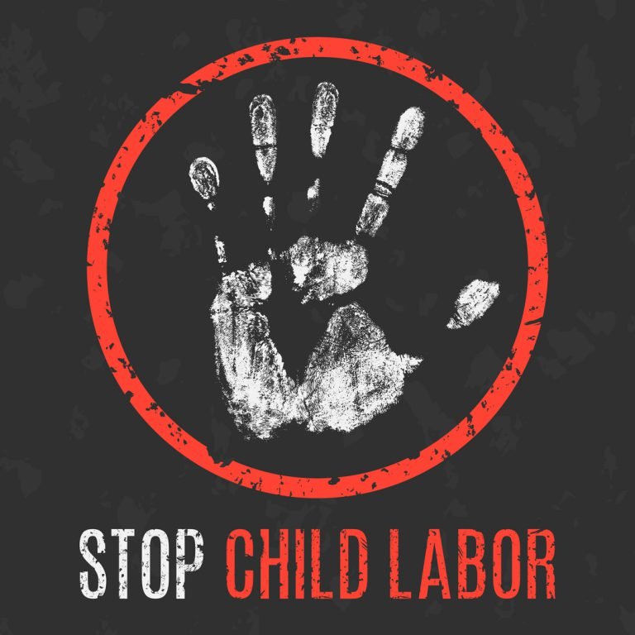
Explanation:
The employment of children in less than legally specified age 15 is called child labor. Most of the children work under the age of 15 work because of Poverty to help their parents and to fulfill their family needs. Child labor is more prevalent in developing countries. Where young children work in mines, factories and service enterprises etc. to fulfill their needs. Child labor is very harmful for the country and for children because child labor harm children physically, mentally and harm their future because of lack of studies. This indirectly damages our countries value because they are the future of the country.
Child work:
Child work refers to a minor’s salutary employment with in the family. The idea being that a child work with in the family unit may be a positive experience. Because child work does not effect’s the children mentally or physically and don’t effects their future to.
Explanation:
Child work is totally opposite to child labor. Child work don’t effect’s the children mentally and physically. It not has any impact on their future. Young children naturally start taking part in social activities like work through which they get social and technical skills. This learning process through work continue as children growth, experience and spread their relations beyond the family. This help them is future to get a good job.
Causes of child labor in Pakistan:
Child labor is a problem in developing countries. Poor children and their families may rely on child labor to fulfill their family needs. The causes of child labor is poverty and lack of jobs and education in country. High level of poverty in Pakistan increases the ratio of child labor. which damages the future of children and country because they are the future of the country. Most of the parents have employed their children for some extra money to fulfill their family daily expenses due to poverty.
Effect of child labor of Pakistan:
Child labor deprives a child of a proper childhood. Children in child labor suffers from the mentally and physical torture. Child labor effect the children. Children becomes mentally and emotionally mature too fast. Which is very dangerous. Child labor increases the ratio of poverty because of lack of knowledge. It takes children towards a life of unskilled and badly paid work.
Q1:B)
What is social Research? Explain what are the steps involved in social research and also highlight the qualities of good social Research.
Social Research:
Social research is a method by why social scientists and researchers learn about people and society and about their social problems. So then can design products or services which can fulfill their needs and solve their social problems. Social research is a main way to know about thinking and behavior of human being about social world.
steps involved in social research:

2)Review of related literature
3)formulative of research objectives
4)devising Hypotheses
5)making the research design methodology
6)sampling procedure
7)Data collection
8)Data analysis and interpretation
9)Hypotheses testing
10)Deriving findings, conclusion and suggestions.
Qualities of good social Research:
Factors are recognized, procedure are described in detail, reference are carefully documented, results are objectively recorded and conclusions are presented with scholarly caution and restraint.it is interdisciplinary in nature. It sometimes requires courage.

Q2) What is Poverty? What are the methods to measure Poverty?
Poverty:
Poverty is a state of condition which the person have lacks the finance resources to fulfill his family daily base needs. Poverty damages persons respect. It’s a state in which person have very less Income level to fulfill his daily base needs. They can not afford their proper housing, clean water, healthy water and medical attention.
Method to measure poverty:
Poverty can be measured by comparing a person’s or families income to set a poverty threshold or minimum amount of income needed to cover their basic needs. who’s income falls under their threshold are considered poor. This method is used by government while distributing food through PDS at the local level.
Q2:B)
What are the causes of Poverty in Pakistan? Being student of Sociology suggest some possible solutions to eradicate poverty?
What are causes of poverty in Pakistan:
Pakistan is a poor country. Its economy is facing hurdles and variation now a days. When Pakistan come in to being so it was having very low resources of progress. The politicians were not aware about the modern global system and the progress process and about the needs of the country. Due to bad policies made by politicians now a days Pakistan is facing problems financially and physically. Pakistan does not have good education system and lack of jobs due to which Pakistan has a high rate of poverty. Which is very dangerous for the economy and future of Pakistan. Due to have taxes which crush the people and make them to live under line of poverty.
Being student of Sociology suggest some possible solutions to eradicate poverty?
- We should try our best to educate our children well. Instead of making them employee of the company to fulfill por needs.
- Government should give equal rights to poor as it gives to high profile.
- We should try to finish the unemployment from our country.
- Hardworking is most important thing for us to make our future bright.
- Our government should make strong policies to make their future bright.
Q3:a)
What is Socialization? What are the Agents of Socialization and how it has an effect one’s Personality?
Socialization:
The act of adapting behavior to the norms of a culture or society is called socialization. It also means going out meeting new people and to get information about society thinking and problems.

Agents of socialization:
• The Family:
It is the center of the child's life, as infants are totally dependent on others.
• Religion:
Agents of socialization differ in effects across religious traditions.
• Peer Group:
A peer group is a social group whose members have interests, social positions and age in common.
• Legal systems:
Children are pressured from both parents and peers to conform and obey certain laws or norms of the group/community
• Mass media:
The mass media are the means for delivering impersonal communications directed to a vast audience.
How it effects personality:
Personality is a part of society. Sociology is a method by which we design the personality of a new born child it also help to develop his individuality. The child go out met people in society and transfer good things from others personality to his personality.

Q3B)
Highlight any 5 major Social Problems prevailing in your locality.

5 major problems are:
- Unemployment
- Lack of education
- Corruption
- Child labor
- Bad policies
Unemployment:
In our society there is a high of unemployment. Which give a band impression on our society. Due to which most of people move towards robbery.
Lack of education:
In our society people don’t pay attention towards education due which they face many problems in face of jobs and to fulfill their daily needs

Corruption:
Due to corrupt politicians our government is full of corruption. Because of that our country is facing major problems. If corruption get finished so our country will move towards success
Child labor:
Child labor consist because of poverty. Our government should give free facility to poor to educate their children.

Bad policies:
Our government should make good policies to take our country towards success.

