RAD II and DT II
Zabih ullah Final term ID=15834 Radiology section (B)
BIOCHEMISTRY
Marks 50
Write note on following questions each carries equal marks
1) Write down the 4 steps involve in beta oxidation?
Ans: Beta oxidation take place in four steps.
De hydrogenation, hydration, oxidation and tholisis. Each step is catalyzed by a distinct enzymes.
1.De hydrogenation : In the first step acyl-COA is oxidised by enzyme acyl-COA dehydrogenase. A double bound is formed between the second and third carbons(c2 andc3) of the acylCOA chain entering the beta oxidation cycle. The end product of this reaction is trans-delta 2 enyol COA. This step uses FADand produces FADH2, which will enter in citric acid cycle and form ATP to be used as energy.
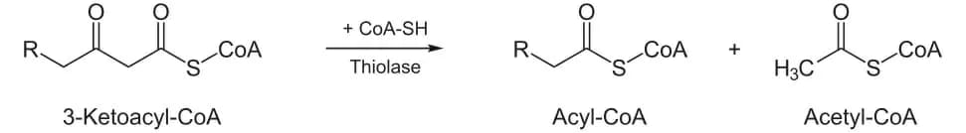

2.HYDRATION : in the second step, the double between C2 and C3 of trans delta 2 enyol CoA forming the end product L-betta-hydroxyacylCoA, which has a hydroxyal group (OH) in C2, in place of double bound. This reaction is catalyzed by another enzyme, enyol CoA hydratase. This step requires water.

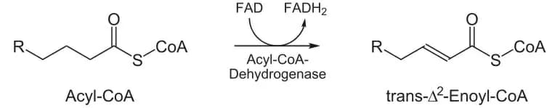

3.OXIDATION : in step third the hydroxyal group in C2 of L-betta-hydroxyacylCoA is oxidised by NAD+ in a reaction that is catalyzed by 3-hydroxyacylCoA dehydrogenase. The end product is beta-ketoacyl CoA and NADH+H. NADH will enter in citric acid cycle and produce ATP.

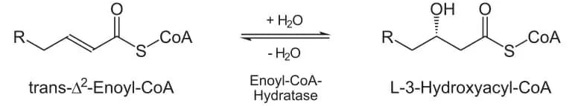

4. THYOLOISIS :in the fourth step, beta-ketoacyl CoA is cleaved by thiol group (SH) of another COA molecules. The enzyme that catalyzed this reaction is beta-ketothiloase. The cleavage take place between C2 and C3, therefore the end product is acetyl CoA moleculewith the original first two carbon (C1 and C2).

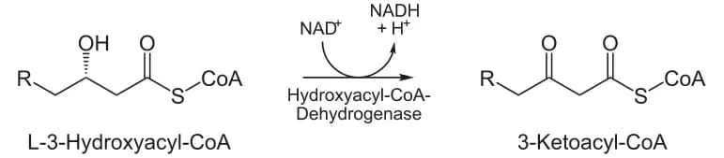

2) Write down clinical significance of the following enzymes
a) Alkaline phosphatase
b) Creatine kinase
c) gamma-glutamyl transferase
Ans:
A: Alkaline phosphates:
Alkaline phosphates (ALP) is an enzyme found in the liver and bone and its important for breaking down proteins. higher than normal levels of ALP may indicate liver damage or disease such as blockage of bile duct, or certain bone disease .
B:creatine kinase:
Creatine kinase (ck) is an enzyme found in hear, brain, skeletal muscle and other tissues.
Increased amount of( CK) are realsed into the blood when there is muscle damage this tast measure the amount of creatine kinase in the blood the small amount of creatine kinase that is normally in the blood comes primarily from skeletal muscle. Any condition that causes muscle damage. And/or interferes with muscle energy production or use can cause an increase in (ck)
Muscle disease caused by high level of creatine kinase .
C:Gamma_glutamyl transferase (GGT)
GGT tast may be used to be used to determine the cause of elevated alkaline phosphates (ALP)both ALP and GGT are elevated in disease of bile and ducts and in some liver diseases but ALP will be elevated in bone disease.

3) How many proteins are involve in electron transport chain and how do electrons move in the electron transport chain
Ans: There are four proteins complexes in electron transport chain which are as follow :
1)FMN (flavin mono nucleotide)
2) Fe.su( iron sulphur l
3) Ubiquinone
4) Cytochrome (cyt ,c,b,a,a³)
(B) How electron move in ETC: when NADH is converted into NAD + 2H,hydrogen is released and it will remove it's two electrons and is moved in complex 1 which is FMN.Electrons from complex 1 is now move to Ubiquinone.In second complex which is Fe.S ,FADH is converted into FAD+2H and two electrons is released which is moved into complex 2.now electrons are moving from complex 1 and complex 2 towards Q.There are 5 electrons in Ubiquinone and is moved towards Cytochrome C which third complex and then move to Cytochrome b and finally to Cytochrome a.a³ which fourth complex .Electrons then move outside complex four where is oxygen present and gained electrons and get negative charge as –1.Oxygen then combine with water to formed water and energy is produced through FAD and NAD.
4) Write down the steps involved in uric acid formation?
Ans:Step in uric acid formation :
1.Synthesis Of Carbomyl Phosphateb:
In the first step Ammonium ion, CO2 and phosphate of ATP combine together to form
carbomyl phosphate in the presence of enzyme called Carbomyl Synthetase I.
This reaction occurs in the mitochondria.
2.Synthesis Of Citrulline:
In the second step the carbomyl reacts with ornithine in the presence of catalyst called
Ornithine Transcarbomylase, which will form Citrulline and inorganic phosphate.
The above reaction occurs in Mitochondria whereas the Ornithine utilized in
the above reaction is transported from Cytoplasm into Mitochondria.,
Ornithine used in the above step is itself produced in the last step of urea cycle.
3.Syntesis of Argininosuccinate
In the third step the citrulline formed in the 2
nd step is now transported out of the
Mitochondria into Cytoplasm, where it reacts with amino group of aspartate to form Argininosuccinate.
This process occur in the presence of enzyme called Argininosuccinate synthetase.
4.Cleavage of Argininosuccinate
In the fourth th step the cleavage of Argininosuccinate occur in the presence of an enzyme
called Arginino succinase which results in the formation of Arginine and Fumarate.
The Fumarate formed in the above step, enters in Citric acid cycle. This
shows a relationship between the urea cycle and citric acid cycle.
5.Cleavage of Arginine
In the last step of urea cycle, the Arginine formed in the 4
th step is cleaved to form
Ornithine and Urea. The reaction is catalyzed by an enzyme called Arginase.
The Ornithine produce in the final step is transported to Mitochondria where
it is used as a substrate in the 2
nd step of Urea cycle for the formation of
Citrulline to restart the Cycle.
The Urea produced in the reaction enters blood circulation and is excreted in urine.
5) How uric acid formation takes place in body?
Ans: Uric acid formation: Uric acid is formed by the breakdown of Purine nucleotide .
purine nucleotide are guannine,adenosine and iuosine.Uric acid is a heterocyclic Purine derivative that is the final oxidation product of Purine metabolism.It is produced by the enzyme xanthine oxidase ,which is which oxidizes oxypurine such as xanthine into Uric acid .Uric acid is also end state of nitrogen metabolism in birds and reptiles.
NORMAL RANGE OF URIC ACID:The normal range of Uric acid in body is 2.4 to 6.0 mg/dl in female and in male is 3.4 to 7.0 mg/do.The excessively high Uric acid range is called hyperuricemia .

