Name: Asad Ali
ID: 14875
Department: BS Microbiology 4th semester
Subject: Bacterial genetics
Submitted to: Mam Pashmina
Date: 26, June, 2020
Final term Examination

Q1: Diffrentiate between
- Positive and negative regulation

Positive regulation | Negative regulation
- In positive gene regulation, genes are expressed due to the binding of a transcription factor to the promoter of the gene.  - Example : lac operon | - In negative gene regulation, genes are not expressed due to the binding of repressor proteins to the operator site of the gene  - Example : Tryptophan operon

- Glucose and galactose

Glucose | Galactose
- It is a simple sugar which is an important energy source in living organisms and is a component of many carbohydrates.  - Glucose comes from the Greek word for "sweet."  - Formula: C₆H₁₂O₆  - It's a type of sugar you get from foods you eat, and your body uses it for energy.  - As it travels through your bloodstream to your cells, it's called blood glucose or blood sugar.  - In human liver, glycogen is the storage form of glucose.  - Glucose is the primary metabolic fuel for the brain,  - Insulin is a hormone that moves glucose from your blood into the cells for energy and storage. | - Galactose is one of the products of lactose (milk sugar) hydrolysis in the intestine.  - Galactose is a monosaccharide when combined with glucose (monosaccharide), through a condensation reaction, the result is the disaccharide lactose.  - Galactose. Galactose is nearly identical to glucose in structure except for one hydroxyl group on carbon atom number four of the six-sided sugar.  - Galactose is a monosaccharide and has the same chemical formula as glucose, i.e., C₆H₁₂O₆.  - It is similar to glucose in its structure, differing only in the position of one hydroxyl group.  - Galactose is known as an epimer of glucose.  - This difference, however, gives galactose different chemical and biochemical properties than glucose.

- Probiotics and Prebiotics

Probiotics | Prebiotics
- Probiotics: live microorganisms (usually bacteria) that are similar to beneficial microorganisms found in the human gut that are taken as dietary supplements or found in foods.  - Most probiotics are bacteria similar to those naturally found in the intestine.  - Common examples are Lactobacillus and Bifidobacterium. | - Prebiotic fiber is a non-digestible part of foods like bananas, onions and garlic, Jerusalem artichoke, the skin of apples, chicory root, beans, and many others.  - Prebiotic fiber goes through the small intestine undigested and is fermented when it reaches the large colon.  - This fermentation process feeds beneficial bacteria colonies (including probiotic bacteria) and helps to increase the number of desirable bacteria in our digestive systems (also called the gut) that are associated with better health and reduced disease risk.

- Ionizing radiation and Non-ionizing radiation
Ionizing radiation | Non-ionizing radiation
- Ionizing radiation is short wavelength/high frequency higher energy  - Example:  - x-rays/gamma rays  - alpha particles  - beta particles  - neutron particles | - Non-ionizing radiation is longer wavelength/lower frequency lower energy.  - Example:  - Near ultraviolet  - visible light  - infrared  - radio waves

- Chromosome rearrangement and recombination
Chromosome rearrangement | Recombination
- A chromosomal rearrangement is a mutation that is a type of chromosome abnormality involving a change in the structure of the native chromosome.  - Classes of chromosome rearrangements include:  - Deletion  - Duplication  - Insertion  - Inversion  - Translocation  - Transposition  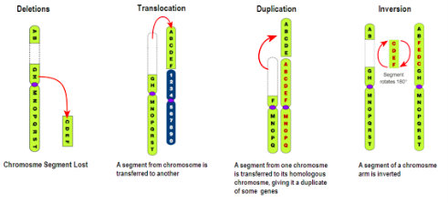 | - Recombination is a process by which pieces of DNA are broken and recombined to produce new combinations of alleles.  - Genetic recombination is the exchange of genetic material between different organisms which leads to production of offspring with combinations of traits that differ from those found in either parent.

-***-

Q2: What are the importance of bacterial genetics, B-galactosidase assay, gene regulation, recombination and mutation?
Answer:

Importance of bacterial genetics:
Bacterial genetics is important because if you know you would be able to know
- How the bacterial infection will extend further.
- How the daughter cells are formed.
- Which drug will be effective and till how long.
- Resistance makes drug ineffective, so if you know how resistance is there it will be helpful knowing it's genetics will help you in its assay and in diagnosis. Like in PCR and blotting techniques

Importance of B-galactosidase assay:
- β-galactosidase is important for organisms as it is a key provider in the production of energy and a source of carbons through the breakdown of lactose to galactose and glucose.
- It is also important for the lactose intolerant community as it is responsible for making lactose-free milk and other dairy products.
- The β-galactosidase gene functions well as a reporter gene for two major reasons: its protein product is extremely stable and resistant to proteolytic degradation in cellular lysates, and most importantly, the enzyme is easily assayed.
- Beta-galactose is used in such dairy products as yogurt, sour cream, and some cheeses which are treated with the enzyme to break down any lactose before human consumption.
- In recent years, beta-galactosidase has been researched as a potential treatment for lactose intolerance through gene replacement therapy where it could be placed into the human DNA so individuals can break down lactose on their own.

Importance of Gene regulation:
- To control the amount of gene product present in the cell.
- To allow cells to adjust with changing conditions.
- Specialization and division of labor among cells.
- Expression of appropriate genes at proper time.
- Synchronized regulation of multiple genes encoding products with interdependent activities.
- Prevent the wastage of cellular energy.

Importance of Recombination:
- Recombination is 2nd factor considered important for evolution.
- The process of introducing genetic variation: Genetic variation is crucial to allow organisms to evolve in response to a changing environment. E.g., genetic recombination results in the exchange of genes between paired homologous chromosomes during meiosis.
- An important mechanism for repairing damaged DNA.
- Involved in rearrangements of specific DNA sequences that alter the expression and function of some genes during development and differentiation.
- Mutation is the ultimate source of variability. Mutation build up a large storehouse of variation.
- Recombination of this genetic variation provides the many possible genotypes that might mean the difference between survival and extinction for a given population.
-***-

Q3: What is Electroporation? Briefly explain the types of recombination?

Answer: Electroporation: It is a microbiology technique in which an electrical field is applied to cells in order to increase the permeability of the cell membrane, allowing chemicals, drugs, or DNA to be introduced into the cell.
- It is also called electrotransfer.
- Electroporation is a physical transfection method that uses an electrical pulse to create temporary pores in cell membranes through which substances like nucleic acids can pass into cells.

Advantages of Electroporation:
- Versatility: Electroporation is effective with nearly all cell and species types.
- Efficiency: A large majority of cells take in the target DNA or molecule. In a study on electro transformation of E. coli, for example, 80% of the cells received the foreign DNA.
- Small Scale: The amount of DNA required is smaller than for other methods •

Disadvantages of Electroporation:
- Cell Damage: If the pulses are of the wrong length or intensity, some pores may become too large or fail to close after membrane discharge causing cell damage or rupture.
- Nonspecific Transport: The transport of material into and out of the cell during the time of electro- permeability is relatively nonspecific. This may result in an ion imbalance that could later lead to improper cell function and cell death.

Recombination: Recombination is the process in which one or more nucleic acid molecules are rearranged or combined to produce a new nucleotide sequence.
- Genetic material from two parents is combined to produce a recombinant chromosome with a new, different genotype.
- Recombination results in a new arrangement of genes or parts of genes and normally is accompanied by a phenotypic change.
- Recombination occurs between precisely corresponding sequences, so that a single base pair is added to or lost from the recombinant chromosomes.

Types of recombination: Four types of naturally occurring recombination have been identified in living organisms:
- General or homologous recombination:
- Homologous recombination is the exchange of DNA strands of similar or identical nucleotide sequence.
- It can be used to direct error-free repair of double-strand DNA breaks and generates sequence variation in gametes during meiosis.

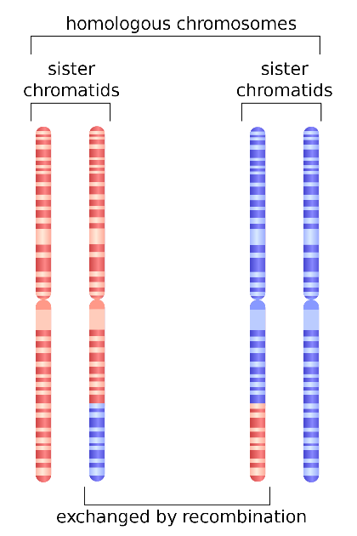
- Illegitimate or nonhomologous recombination:
- Illegitimate recombination refers to any DNA rearrangement that leads to the covalent joining of non-homologous linear DNA segments.
- Illegitimate recombination occurs at DNA sequences that share little or no homology
- The main difference between homologous and non-homologous chromosomes is that homologous chromosomes consist of alleles of the same type of genes in the same loci whereas non-homologous chromosomes consist of alleles of different types of genes.

- Site-specific recombination:
- Site-specific recombination is a type of genetic recombination in which DNA strand exchange takes place between segments possessing at least a certain degree of sequence homology.
- It is also known as conservative site-specific recombination.
- Site-specific recombination requires a special enzymatic machinery, basically one enzyme or enzyme system for each particular site.
- Replicative recombination:
- It is a type of recombination which generates a new copy of a segment of DNA. Many transposable elements use a process of replicative recombination to generate a new copy of the transposable element at a new location.
- It is seen for some transposable elements, shown as red rectangles, again using a specific enzyme, in this case encoded by the transposable element.
- Step 1 - Replicative Integration
- Step 2 – Resolution

-***-

Q4:
- What are importance of transformation, transduction and conjugation?

Transformation: Transformation is the process by which foreign DNA is introduced into a cell.

Importance of transformation:
- By this process a non virulent bacteria can be transformed into virulent form.
- The purpose of this technique is to introduce a foreign plasmid into bacteria, the bacteria then amplifies the plasmid, making large quantities of it
- Transformation of bacteria with plasmids is important not only for studies in bacteria but also because bacteria are used as the means for both storing and replicating plasmids
- Transformation is usually used in laboratories for mapping of chromosome of the bacteria.
- The frequency of transformation of two genes at the same time is an indication of the distance between these genes on the chromosome.

Transduction: Transduction is the process by which foreign DNA is introduced into a cell by a virus or viral vector.

Importance of transduction:
- Transduction is especially important because it explains one mechanism by which antibiotic drugs become ineffective due to the transfer of antibiotic-resistance genes between bacteria.
- It transfers genetic material from one bacterial cell to another and alter the genetic characteristics.
- For example: In specialized transduction the gal gene, a cell lacking ability to metabolize galactose could acquire the ability.
- It shows the evolutionary relationship between the prophage and host bacterial cell.
- Prophage can exist in a cell for a long period suggests a similar possible mechanism for the viral origin of cancer.
- It provides a way to study the gene linkage

Conjugation: Conjugation is the process by which one bacterium transfers genetic material to another through direct contact.
Importance of conjugation:
- Plasmid carry genes that enable bacteria to survive in new environments
- Those genes also resist antibiotics that may otherwise prove fatal
- This transfer increases genetic diversity in populations of prokaryotes

-***-

- Discuss the process of Generalized and specialized Transduction?
Answer: Generalized transduction: It is the process by which any bacterial gene may be transferred to another bacterium via a bacteriophage, and typically carries only bacterial DNA and no viral DNA.
- In generalized transduction, the bacteriophages can pick up any portion of the host's genome

Process of Generalized Transduction:
- A lytic bacteriophage adsorbs to a susceptible bacterium.
- The bacteriophage genome enters the bacterium. The genome directs the bacterium's metabolic machinery to manufacture bacteriophage components and enzymes
- Occasionally, a bacteriophage head or capsid assembles around a fragment of donor bacterium's nucleoid instead of a phage genome by mistake.
- The bacteriophages are released.
- The bacteriophage carrying the donor bacterium's DNA adsorbs to a recipient bacterium
- The bacteriophage inserts the donor bacterium's DNA it is carrying into the recipient bacterium.
- The donor bacterium's DNA is exchanged for some of the recipient's DNA.

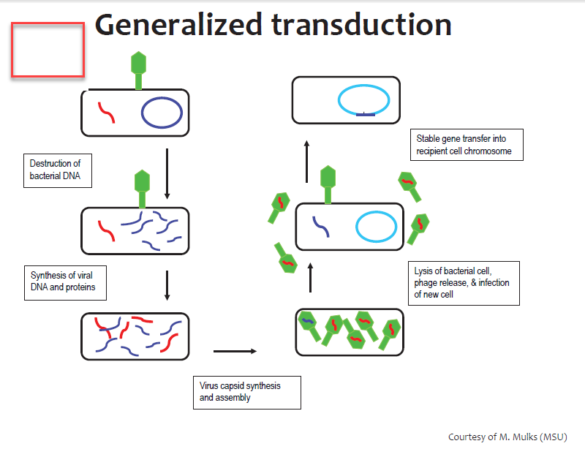

Specialized Transduction: Specialized transduction is the process by which a restricted set of bacterial genes are transferred to another bacterium.
- In specialized transduction, the bacteriophages pick up only specific portions of the host's DNA.

Process of specialized Transduction:
- A temperate bacteriophage adsorbs to a susceptible bacterium and injects its genome.
- The bacteriophage inserts its genome into the bacterium's nucleoid to become a prophage.
- Occasionally during spontaneous induction, a small piece of the donor bacterium's DNA is picked up as part of the phage's genome in place of some of the phage DNA which remains in the bacterium's nucleoid.
- As the bacteriophage replicates, the segment of bacterial DNA replicates as part of the phage's genome. Every phage now carries that segment of bacterial DNA.
- The bacteriophage adsorbs to a recipient bacterium and injects its genome.
- The bacteriophage genome carrying the donor bacterial DNA inserts into the recipient bacterium's nucleoid.
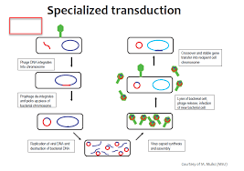

-***-

Q5: What is Genetically Modified Organism? Write down advantage and Disadvantages of Genetically Modified Foods?
Answer: Genetically modified organisms: Genetically modified organisms (GMOs) are living organisms whose genetic material has been artificially manipulated in a laboratory through genetic engineering.
- In conventional livestock production, crop farming, and even pet breeding, it has long been the practice to breed select individuals of a species in order to produce offspring that have desirable traits.
- In genetic modification recombinant genetic technologies are employed to produce organisms whose genomes have been precisely altered at the molecular level, usually by the inclusion of genes from unrelated species of organisms that code for traits that would not be obtained easily through conventional selective breeding.
- Thousands of years, humans have used breeding methods to modify organisms.
- Corn, cattle, and even dogs have been selectively bred over generations to have certain desired traits.

Purposes:
Purposes of GM crops generally include resistance to certain pests, diseases, or environmental conditions, or resistance to chemical treatments (e.g. resistance to an herbicide). Other purposed of genetic modification of crops is to enhance its nutritional value, as seen in the case of golden rice.

Advantages of GM food:
- Higher yield of crops due to less crops damaged by insects and disease
- Less pesticides need to be purchased and used, causing more economically productive tarmers and less pollution
- Food production increased, causing decreasing starvation in LDCs
- Added nutritional value in food due to incorporating additional vitamins into crops
- Smell of GMO foods are often enhanced
- GMO foods do not need as fertile land as natural foods in order to grow
- Less additives are needed to keep GMO foods fresh
- GMO crops are less likely to get sicknesses
- GMO crops that freeze less in the winter can be produced

Disadvantages of GM food:
- GMO foods don't taste as natural as non GMO foods
- Some organisms (such as butterflies and bees) are harmed by pesticides in GMO foods
- Labeling GMO toads causes additional expenses in processing.
- Possible cross pollination of GMO foods with non GMO foods result in the inability to track GMOs
- Insects can possibly evolve to be resistant to insect resistant GMO crops
- Cross pollination of GMO crops with weeds could result in "super weeds
- New allergies could develop to GMO food
- Possible health complications could arise due to unknown long term affects of GMO foods
- GMO crops sometimes fail like normal crop (genetically modified cotton has failed in India)
The End

